Lesson 37

Objective: Transition from four partial products to the standard algorithm for two-digit by two-digit multiplication.

Suggested Lesson Structure

 Fluency Practice (10 minutes)

 Application Problem (5 minutes)

 Concept Development (35 minutes)

 Student Debrief (10 minutes)

**Total Time (60 minutes)**

Fluency Practice (10 minutes)

* Decompose 90 and 180 **4.MD.7**  (4 minutes)
* Multiply by Multiples of 10 Written Vertically **4.NBT.5** (6 minutes)

Decompose 90 and 180 (4 minutes)

Materials: (S) Personal white board

Note: This fluency activity prepares students for composing and decomposing benchmark angles of 90 and 180 degrees in Module 4.

T: (Project a number bond with a whole of 90 and a part of 10.) On your personal white boards, fill in the unknown part in the number bond.

S: (Fill in 80.)

T: (Write 90 – 10 = .) Say the subtraction sentence.

S: 90 – 10 = 80.

Continue decomposing 90, taking away the following possible suggested parts: 20, 30, 85, 40, 45, 25, 35,   
and 15.

Using the same process, take away the following possible suggested parts from 180: 10, 100, 90, 70, 150, 60, 5, 15, 75, 65, and 45.

Multiply by Multiples of 10 Written Vertically (6 minutes)

Materials: (S) Personal white board

Note: This fluency activity reviews Lesson 35’s content.

T: Solve 30 × 23 vertically as you say the unit form: 3 tens times 3 ones plus 3 tens times 2 tens. You have one minute. If you finish early, go on to 40 × 23.

T: (Allow students a minute to work.) 3 tens times 3 ones is…?

S: 9 tens. (Write 90.)

T: 3 tens times 2 tens is…?

S: 6 hundreds. (Write 600.)

T: The sum of 90 and 600 is…?

S: 690.

T: 30 groups of 23 is…?

S: 690.

Continue with the following possible sequence: 40 × 23, 40 × 34, 50 × 45, and 60 × 39.

Application Problem (5 minutes)

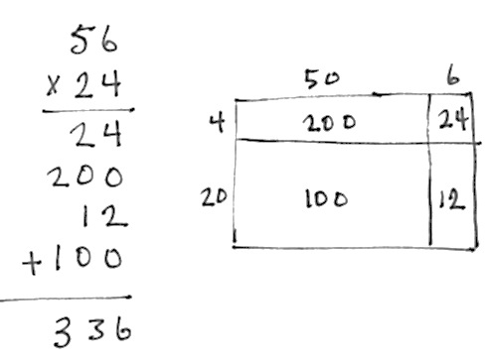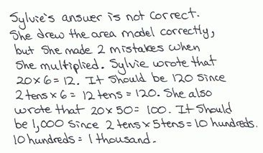

Sylvie’s teacher challenged the class to draw an area model to represent the expression 24 × 56 and then to solve using partial products. Sylvie solved the expression as seen to the right. Is her answer correct? Why or why not?

Note: This Application Problem builds on the content of Lessons 34, 35, and 36. Students now have a solid foundation upon which to build understanding of two-digit by two-digit multiplication. They move from pictorial representations to abstract representations. This Application Problem guides such movement and builds to the content of today’s lesson where students see how all of the work that they have done fits together and prepares them to solve using the standard algorithm (Lesson 38).

Concept Development (35 minutes)

Materials: (S) Paper, pencil

Problem 1: Solve 26 × 35 using four partial products and two partial products.

T: Work with a partner:

1. Draw an area model for 26 × 35.
2. Record the partial products within each of four smaller rectangles.
3. Write the expression 26 × 35 vertically.
4. Write the four partial products under the expression.
5. Find their sum.
6. Connect the rectangles in the area model to the partial products using arrows.

S: (Draw area model and solve.) 26 × 35 = 910.

T: Shade the top half of the area model with the side of your pencil. Shade the corresponding partial products as well.

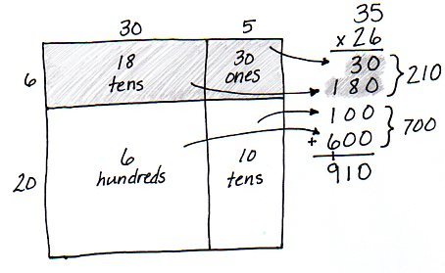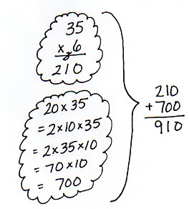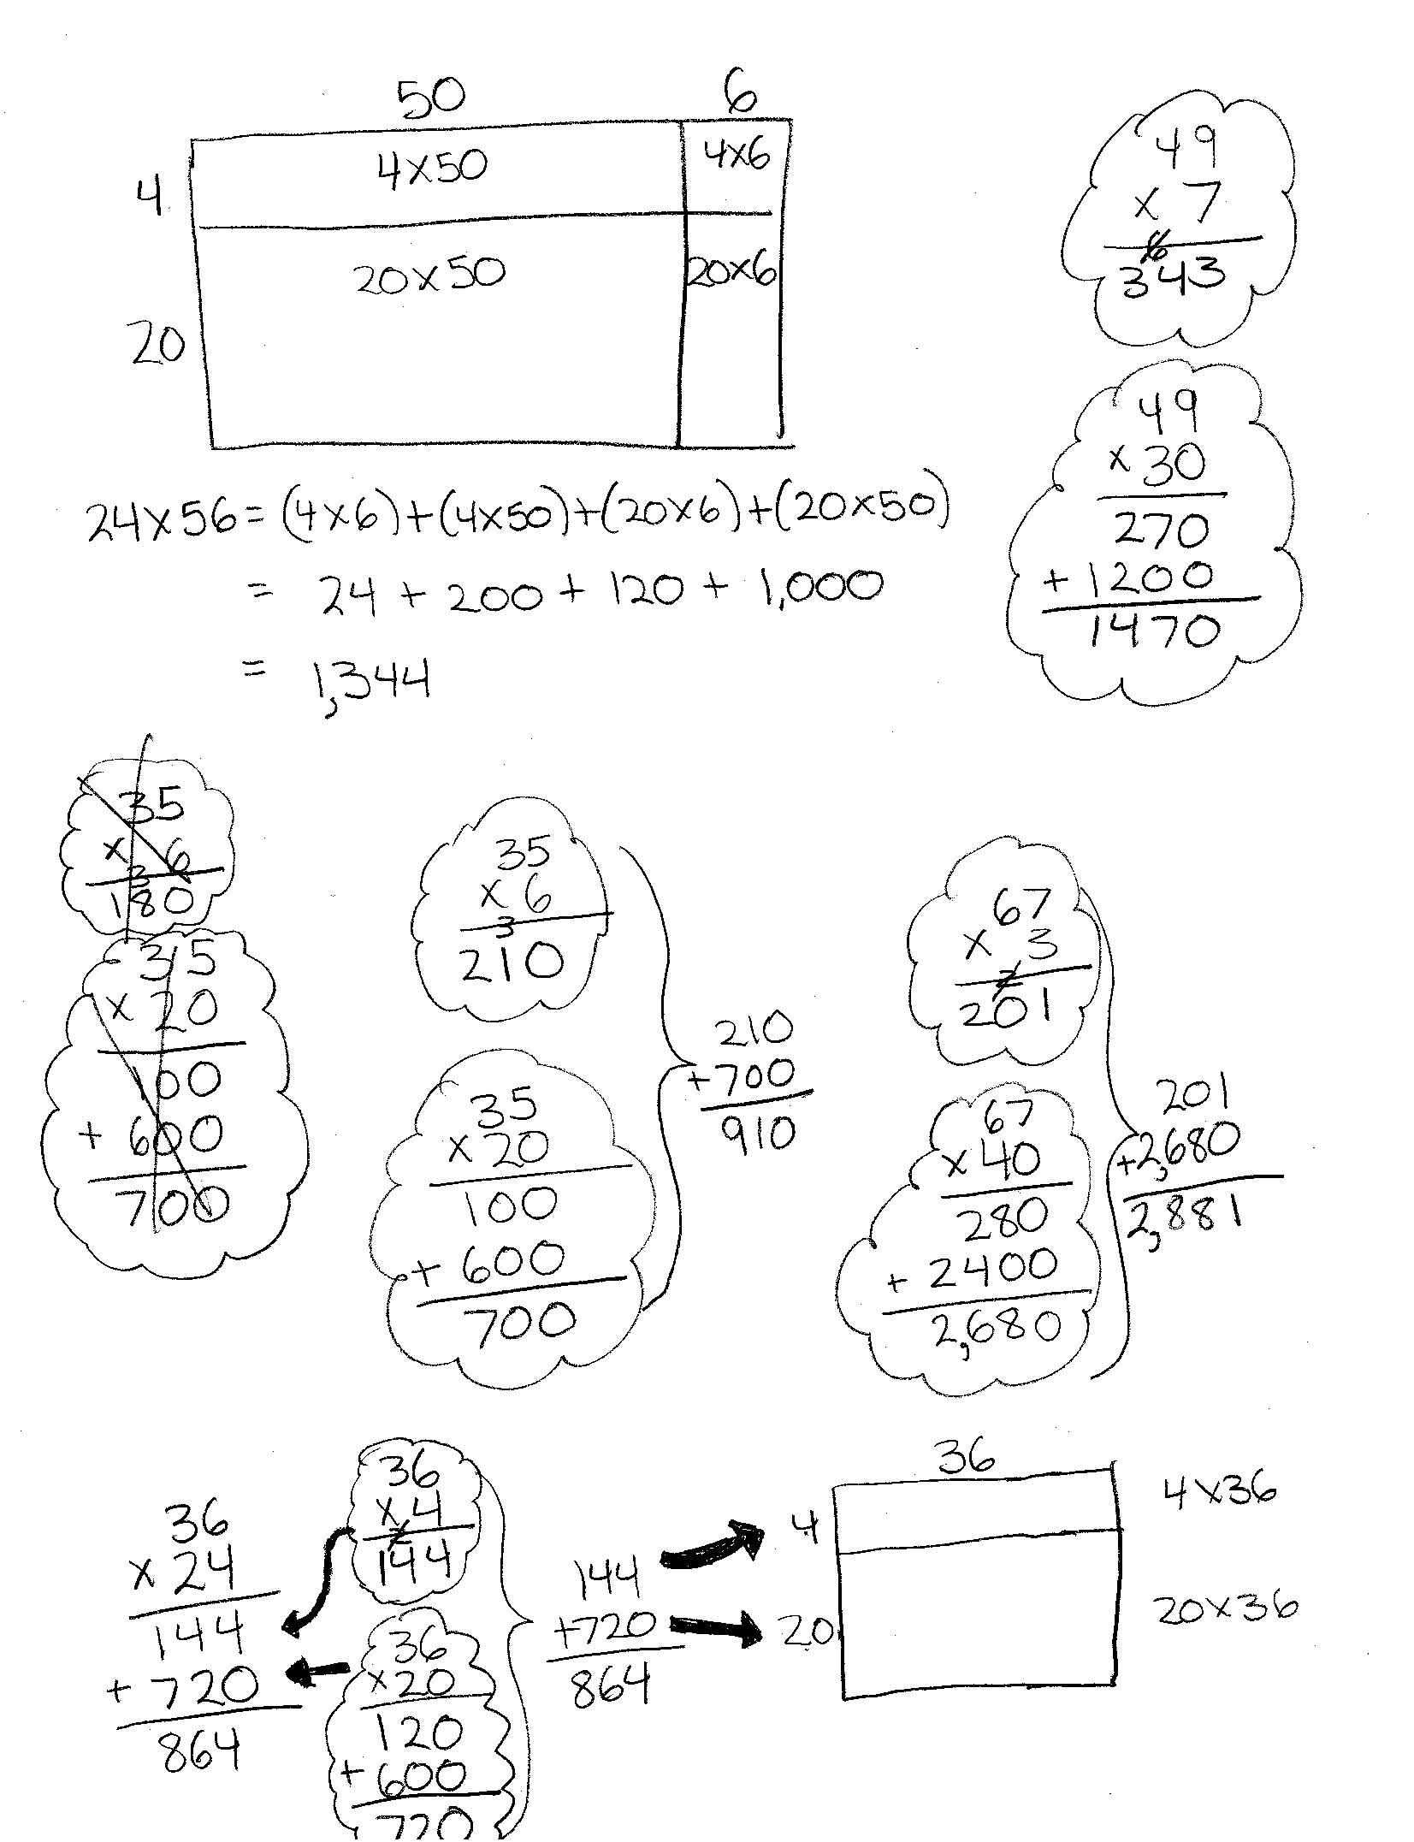

T: Use mental math to add the two partial products that you just shaded.

S: 30 + 180 = 210.

T: What multiplication expression can be used to represent the entire shaded area?

S: 6 × 35.

T: Find the total for 6 thirty-fives.

S: (Solve.)

S: 6 × 35 = 210. Hey, that’s the same as when we added the two partial products that are shaded.

T: Explain why they are the same.

S: The two smaller rectangles in the shaded portion take up the same amount of space as the larger rectangle in the shaded portion.

T: Use mental math to add the two partial products that are not shaded.

S: 100 + 600 = 700.

T: What expression can be used to represent the area of the larger rectangle that is not shaded?

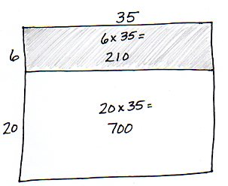S: 20 × 35.

T: Solve for 20 thirty-fives.

S: (Solve.)

S: 700. It’s the same!

T: (Draw an area model to show two partial products.) Say an addition sentence for the sum of the two parts.

S: 210 + 700 = 910. That’s the same answer as when we added the four partial products.

T: We can solve by finding two partial products instead of four!

Problem 2: Solve 43 × 67 using four partial products and two partial products.

**MP.4**

T: Work with a partner to draw and label an area model for 43 × 67 and solve.

T: Draw arrows to show how the parts of the area model relate to the partial products.

T: Draw and label another area model, as we did in Problem 1, which shows how we can combine the rectangles in the top portion and the rectangles in the bottom portion. (Guide students as they draw and label.) What expressions do the rectangles represent? Write the expressions in the rectangles. Solve for each expression.

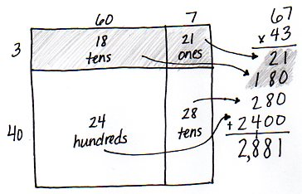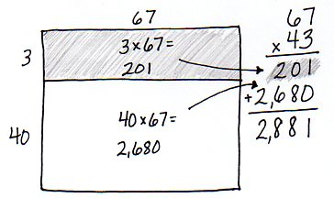

S: (3 × 67) and (40 × 67). 3 sixty-sevens is 201.   
40 sixty-sevens is 2,680.

|  |  |
| --- | --- |
|  | NOTES ON MULTIPLE MEANS OF REPRESENTATION: |

If students are not ready to complete the transition away from the area model, encourage them to quickly sketch an area model so that they can visually see the partial products.

T: Write the two partial products within their corresponding rectangles. Write 43 × 67 vertically, and then write the partial products. Draw arrows to show how the parts of the area model relate to the partial products. (Guide students as they make the connections.)

T: What is the sum of the two partial products?

S: 201 + 2,680 = 2,881. Again, it’s the same as when we solved using four partial products.

T: We found the value of 3 sixty-sevens and then added the value of 40 sixty-sevens.

Problem 3: Solve 24 × 36 using two partial products and an area model.

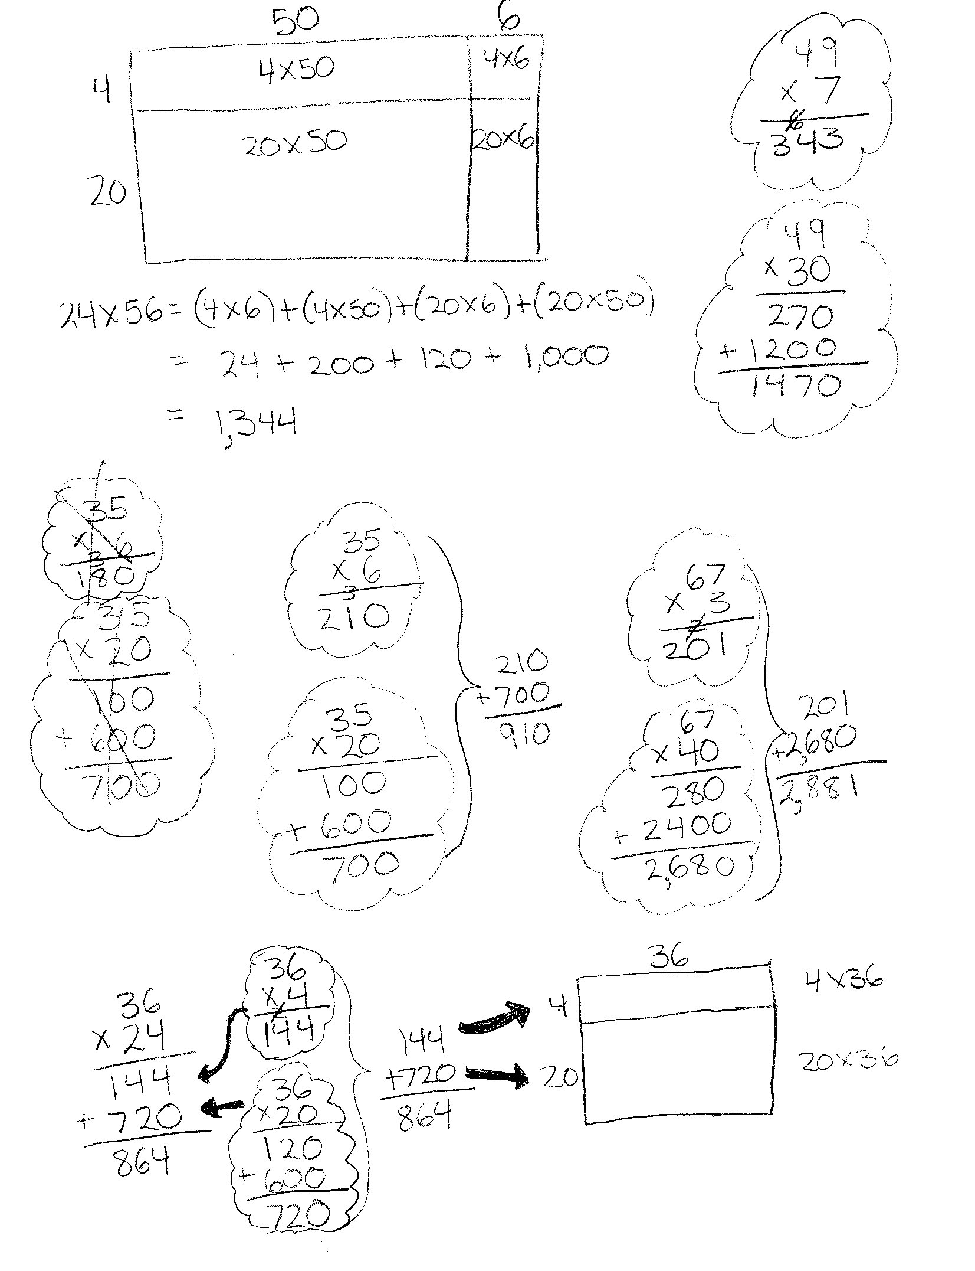

T: Write 24 × 36 vertically, and then represent it by drawing an area model. Discuss with a partner how to solve with two partial products.

S: One rectangle represents 4 thirty-sixes, and the other represents 20 thirty-sixes. We can find the area of each rectangle and then find their sum.

|  |  |
| --- | --- |
|  | NOTES ON MULTIPLE MEANS OF ACTION AND EXPRESSION: |

Lead students through steps that help them to create a picture in their mind of the area model. Ask questions such as the following to support the visualization.

* Can you see the rectangle?
* How many parts does it have?
* What are the two lengths of the vertical side?
* What is the length of the horizontal side?
* What expressions give us the area of each smaller rectangle?
* Look at the vertical expression that we have written. Do you see the expressions for the area of each smaller rectangle?

T: (Draw arrows next to where the partial products will be written.) Let’s write the expressions for each partial product. (Write expressions next to where the partial products will be written as students do the same.) Find each partial product, and then determine their sum.

S: 144 + 720 = 864.

T: Look at the area model that you drew. Connect the partial products in the area model to the partial products in the vertical expression. Close your eyes and create a picture in your mind of how the partial products relate to the area model.

Problem 4: Solve 37 × 49 using two partial products without an area model.

T: Write 37 × 49 vertically on your personal white board. How can we solve?

S: I can think about what the area model would look like. I know that the expressions for the partial products are 7 × 49 and 30 × 49.

T: Find each partial product. (Allow time for students to calculate answers.)

S: 7 forty-nines is 343; 30 forty-nines is 1,470.

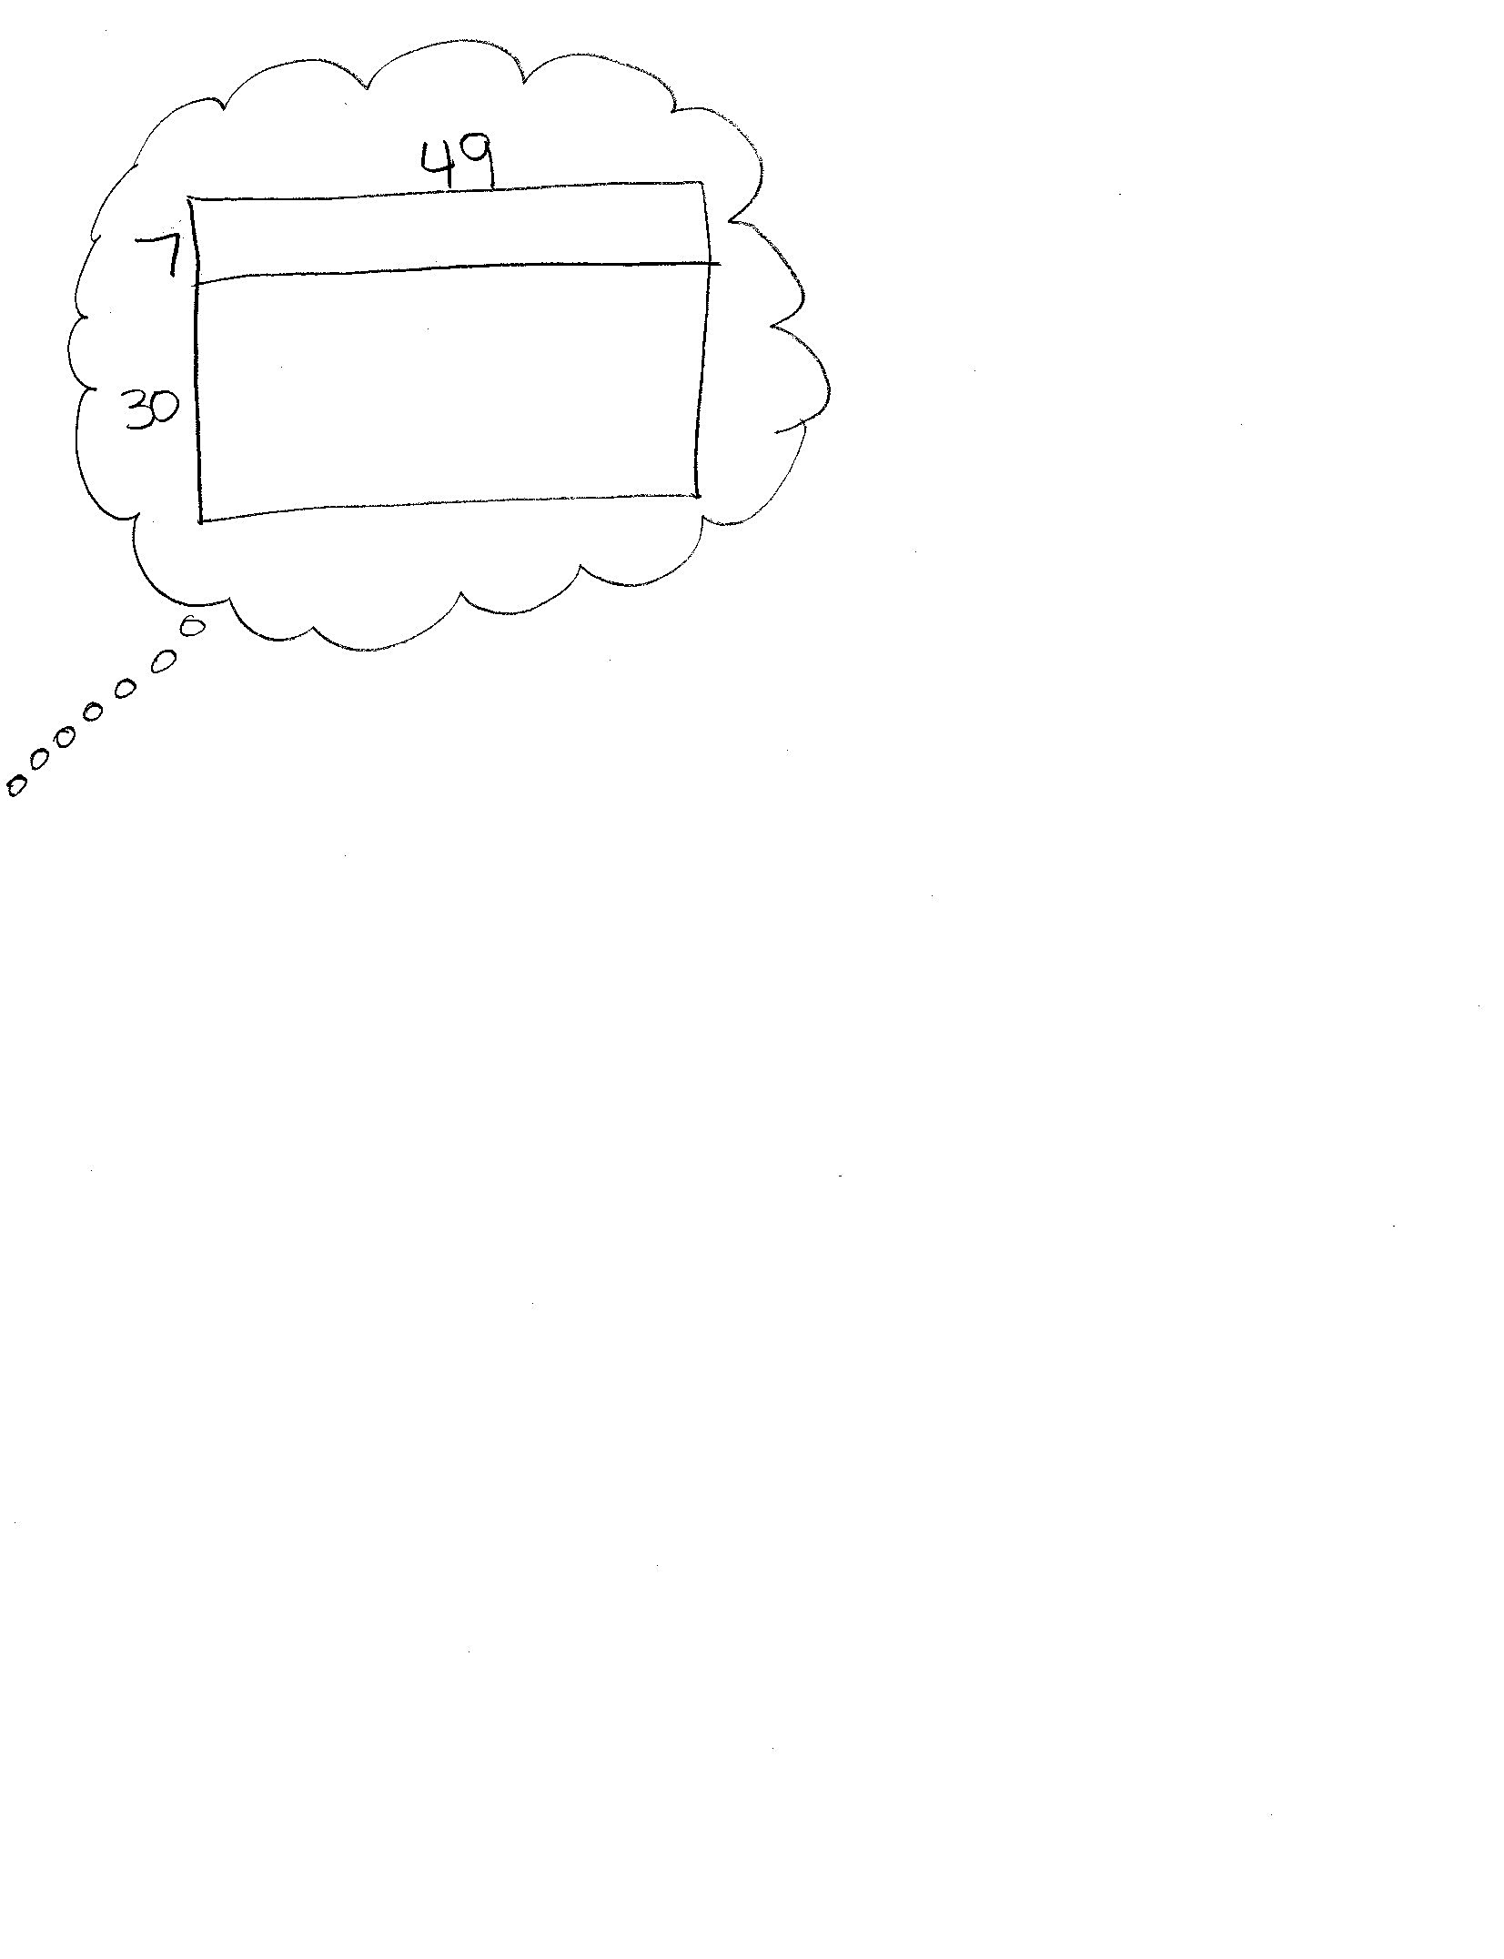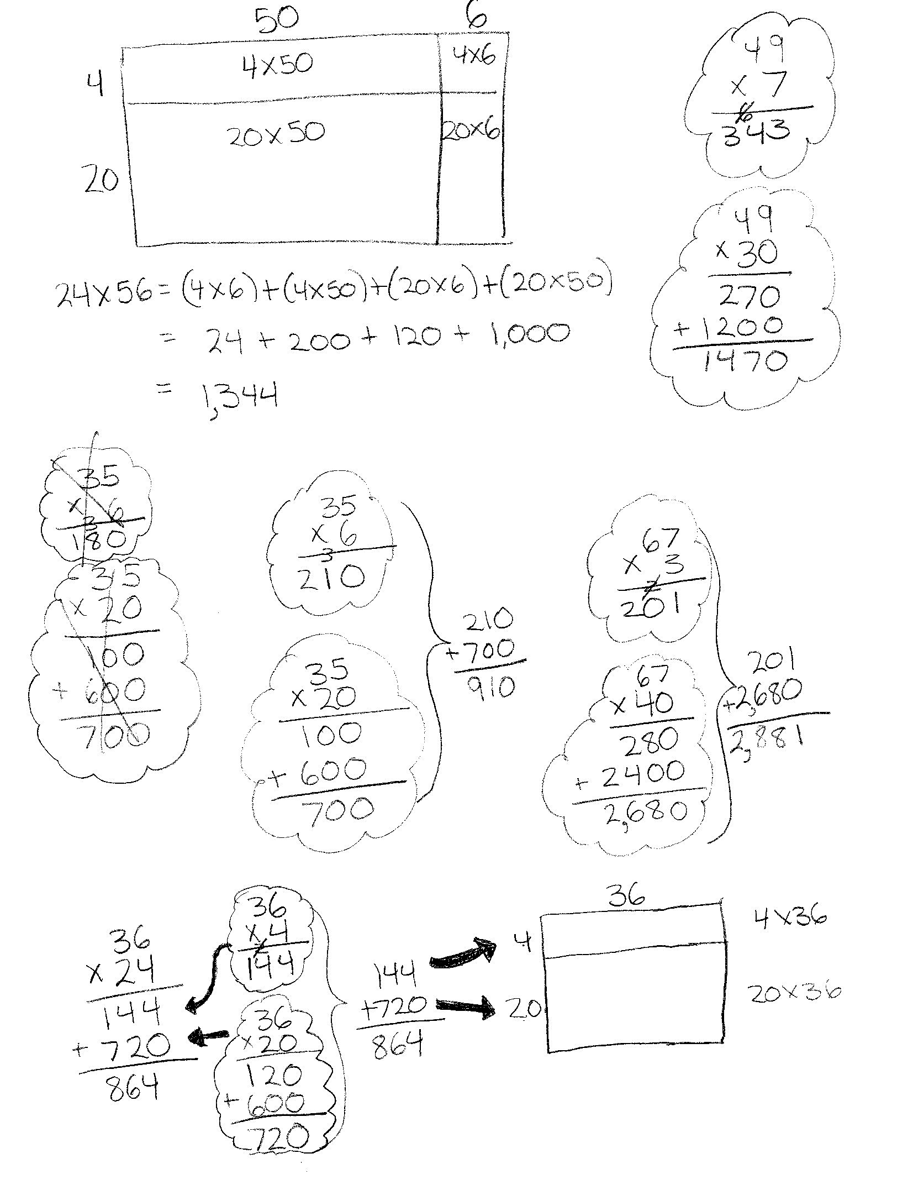

T: How did you solve for the partial products?

S: I multiplied the numbers off to the side because I know how to multiply one-digit numbers by two-digit numbers and multiples of 10 by two-digit numbers.

T: Write the partial products beneath the expression. What is their sum?

S: 343 + 1,470 = 1,813. 🡪 37 × 49 = 1,813.

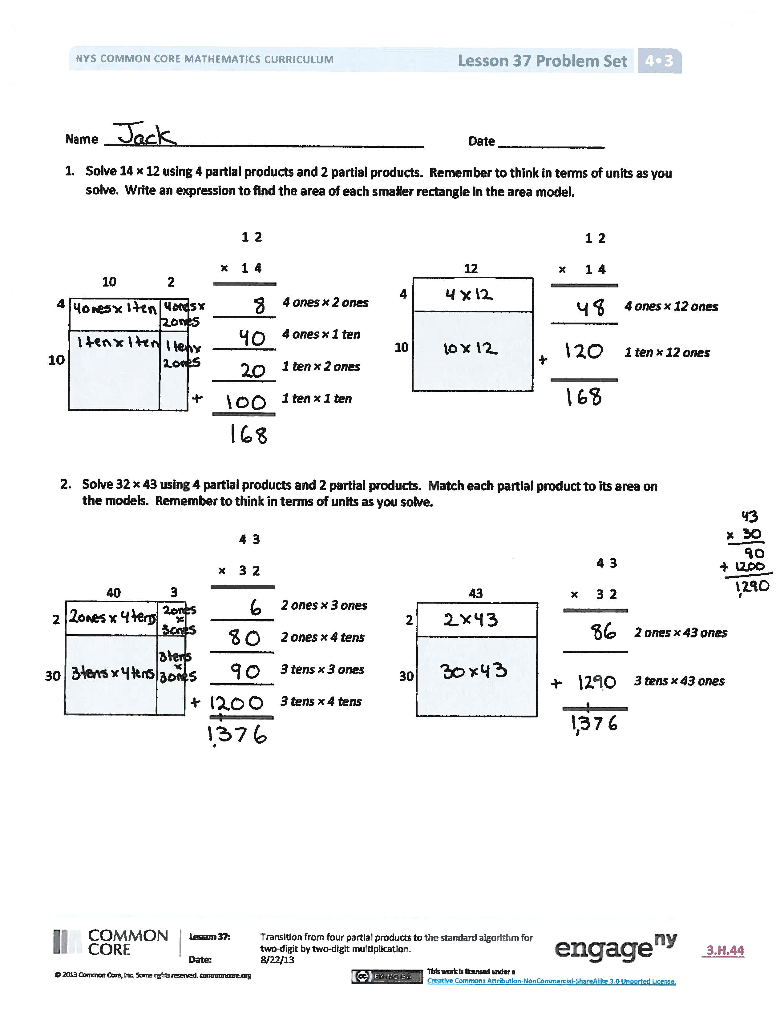Problem Set (10 minutes)

Students should do their personal best to complete the Problem Set within the allotted 10 minutes. For some classes, it may be appropriate to modify the assignment by specifying which problems they work on first. Some problems do not specify a method for solving. Students should solve these problems using the RDW approach used for Application Problems.

Student Debrief (10 minutes)

**Lesson Objective:** Transition from four partial products to the standard algorithm for two-digit by two-digit multiplication.

The Student Debrief is intended to invite reflection and active processing of the total lesson experience.

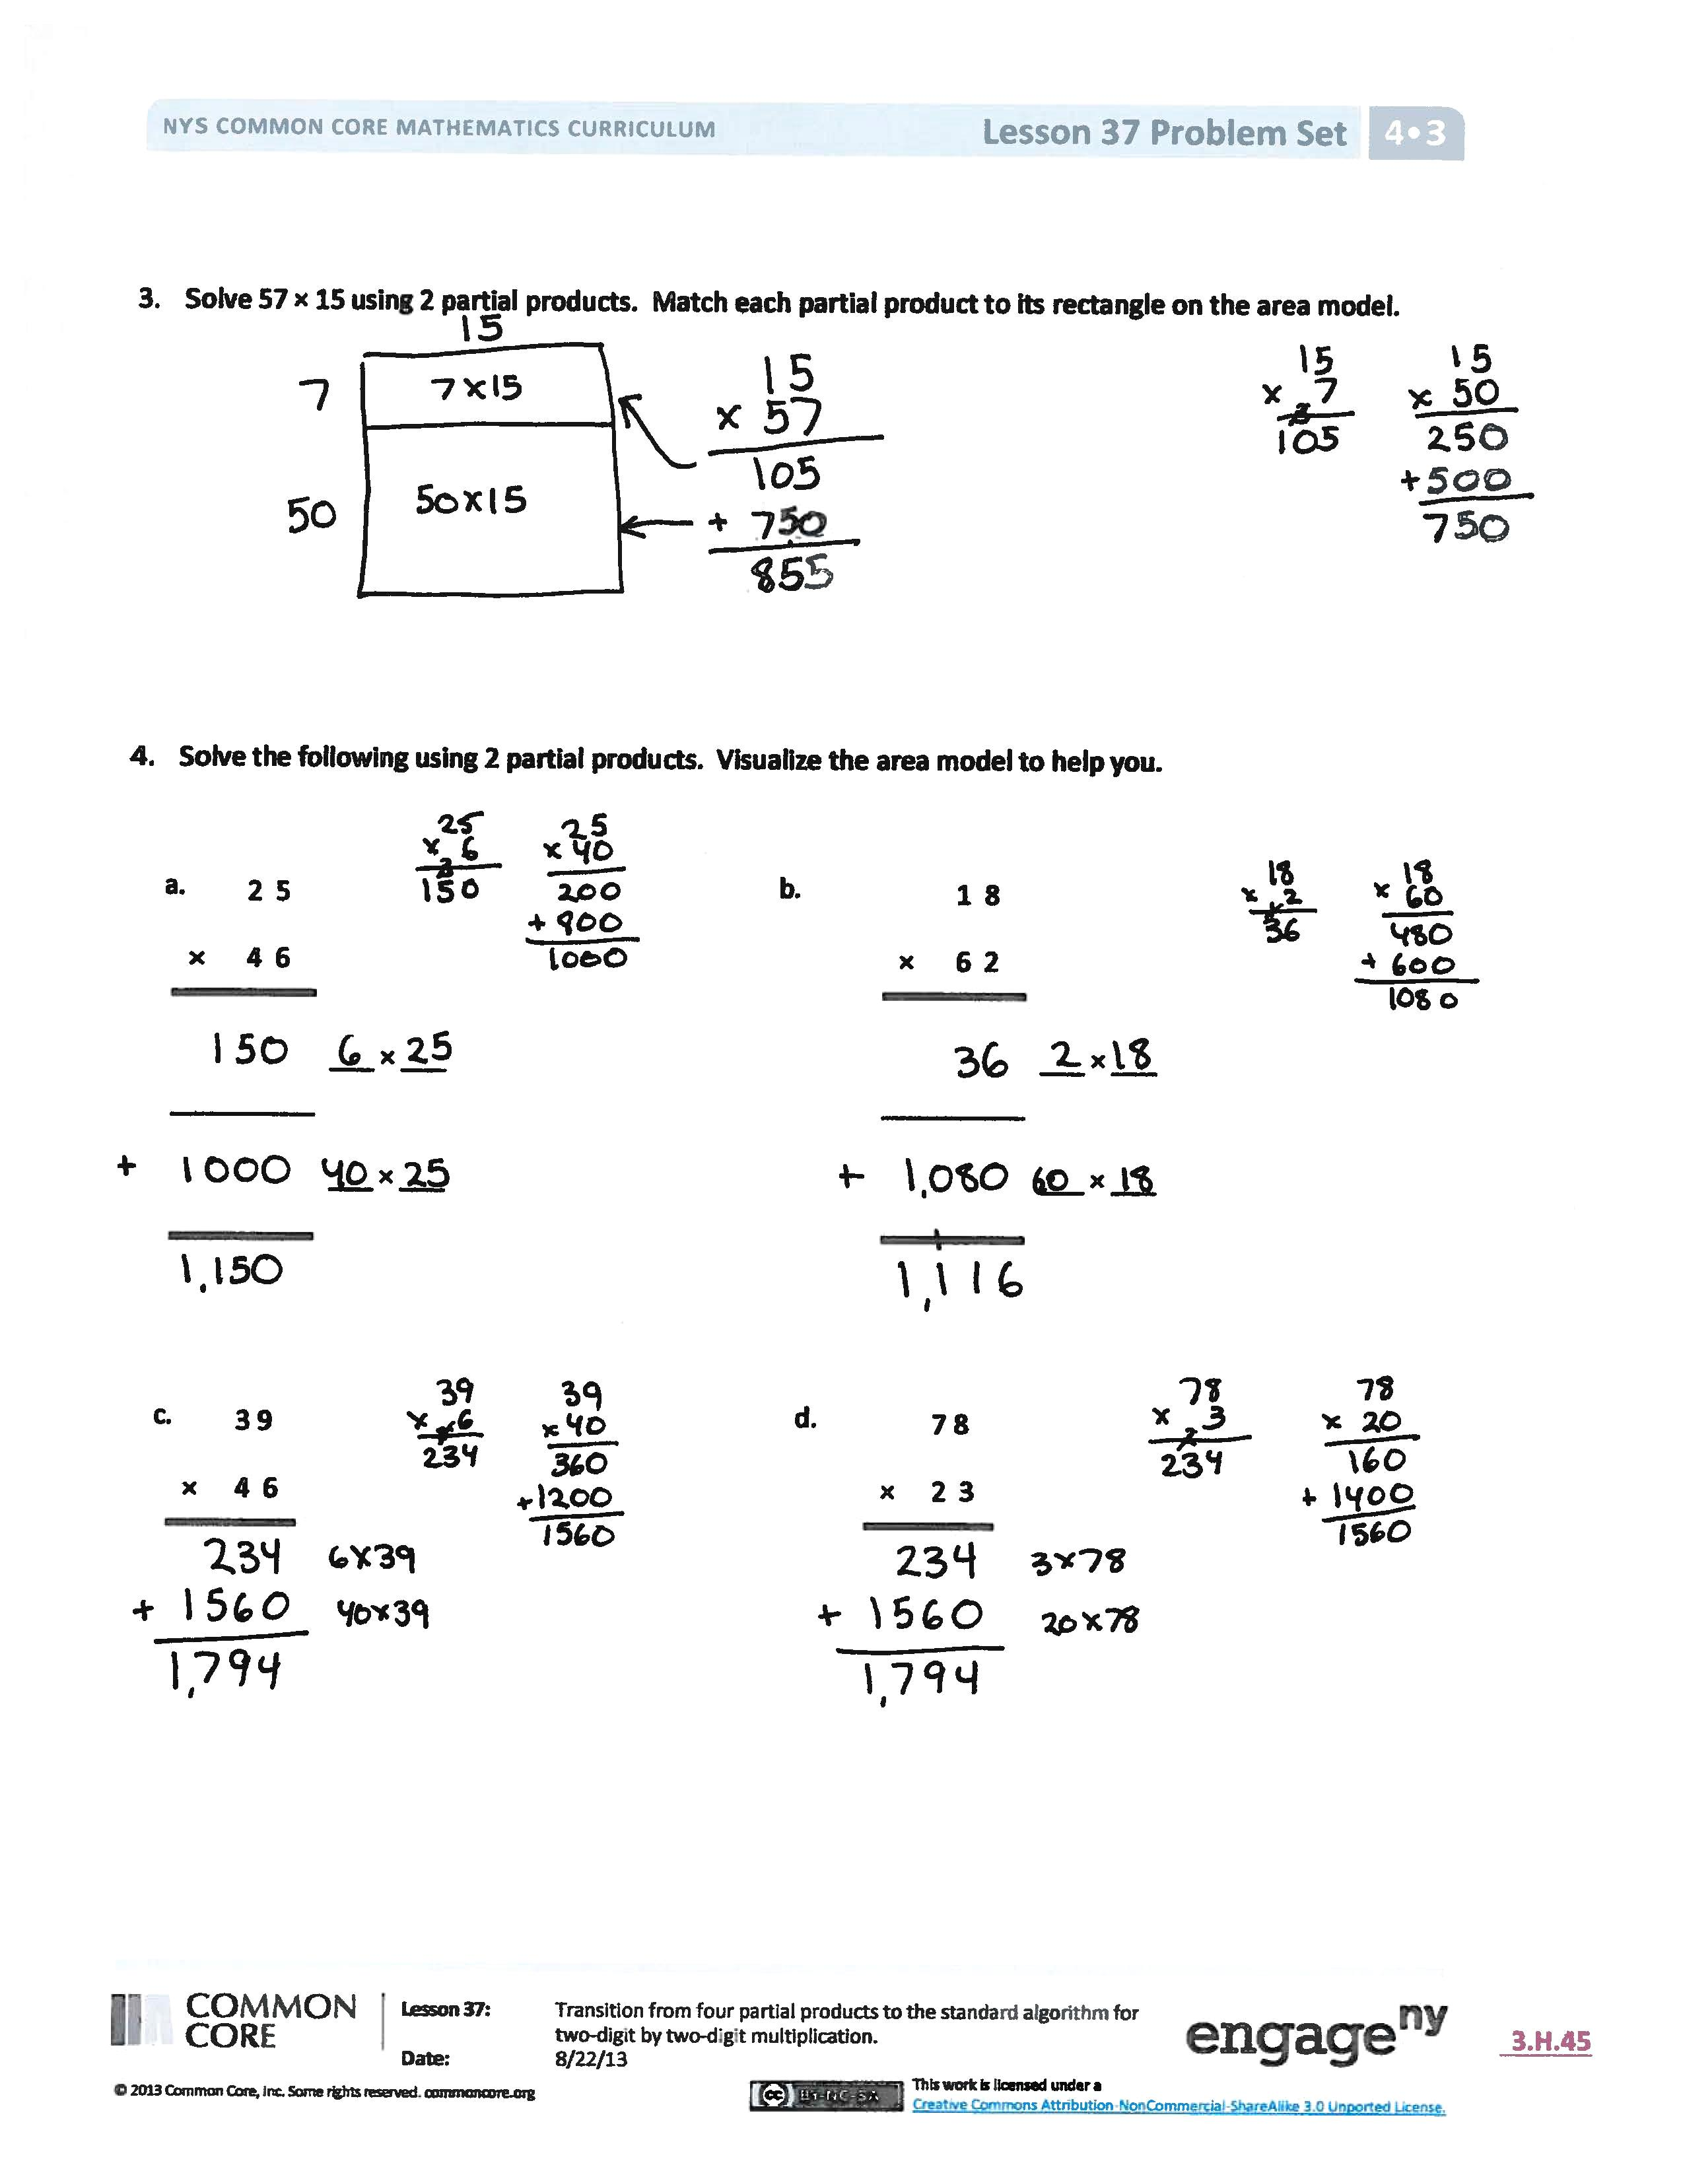Invite students to review their solutions for the Problem Set. They should check work by comparing answers with a partner before going over answers as a class. Look for misconceptions or misunderstandings that can be addressed in the Debrief. Guide students in a conversation to debrief the Problem Set and process the lesson.

Any combination of the questions below may be used to lead the discussion.

* Did you record the 15 or 57 as the width of the rectangle in Problem 3? Does it matter the order? Which number as the width is easiest for you to solve the rest of the problem? Explain.
* Imagine the area models for Problems 4(c) and (d). Notice how the rectangle in Problem 4(d) is half as wide and double the length of the rectangle in Problem 4(c). What might the areas look like? Why does that result in the same product?
* How does the shading on the area models help you understand the movement from four partial products to two partial products?
* Why would we want to represent the area model using two partial products instead of four?
* How did the Application Problem connect to today’s lesson?

Exit Ticket (3 minutes)

After the Student Debrief, instruct students to complete the Exit Ticket. A review of their work will help with assessing students’ understanding of the concepts that were presented in today’s lesson and planning more effectively for future lessons. The questions may be read aloud to the students.

Name Date

1. Solve 14 × 12 using 4 partial products and 2 partial products. Remember to think in terms of units as you solve. Write an expression to find the area of each smaller rectangle in the area model.

|  |  |  |
| --- | --- | --- |
|  | 1 2 |  |
| × | 1 4 | 10  4   |  |  | | --- | --- | |  |  | |  |  |   4  12  12 |
|  |  | *4 ones × 2 ones* |
|  |  | *4 ones × 1 ten* |
|  |  | *1 ten × 2 ones* |
|  |  | *1 ten × 1 ten* |
|  |  |  |

|  |  |  |
| --- | --- | --- |
|  | 1 2 |  |
| × | 1 4 |  |
|  | | *4 ones × 12 ones* |
|  | | *1 ten × 12 ones* |
|  |  |  |

10

10

4

4

10

10

2

2

|  |  |
| --- | --- |
|  |  |
|  |  |

|  |  |
| --- | --- |
|  |  |
|  |  |

1. Solve 32 × 43 using 4 partial products and 2 partial products. Match each partial product to its area on the models. Remember to think in terms of units as you solve.

|  |  |  |
| --- | --- | --- |
|  | 4 3 |  |
| × | 3 2 | 30  30  2  2  43  43 |
|  |  | *2 ones × 3 ones* |
|  |  | *2 ones × 4 tens* |
|  |  | *3 tens × 3 ones* |
|  |  | *3 tens × 4 tens* |
|  |  |  |

|  |  |
| --- | --- |
|  |  |
|  |  |

|  |  |
| --- | --- |
|  |  |
|  |  |

|  |  |  |
| --- | --- | --- |
|  | 4 3 |  |
| × | 3 2 |  |
|  | | *2 ones × 43 ones* |
|  | | *3 tens × 43 ones* |
|  |  |  |

30

30

2

2

40

40

3

3

30

30

2

2

43

43

1. Solve 57 × 15 using 2 partial products. Match each partial product to its rectangle on the area model.

___

___

___

___

1. Solve the following using 2 partial products. Visualize the area model to help you.

d.

d.

c.

c.

a.

a.

b.

b.

5

5

|  |  |  |
| --- | --- | --- |
|  | 1 8 |  |
| × | 6 2 |  |
|  | | _____ × _____ |
|  | | _____ × _____ |
|  |  |  |

|  |  |  |
| --- | --- | --- |
|  | 2 5 |  |
| × | 4 6 |  |
|  | | _____ × _____ |
|  | | _____ × _____ |
|  |  |  |

20

20

|  |  |  |
| --- | --- | --- |
|  | 3 9 |  |
| × | 4 6 |  |
|  | |  |

|  |  |  |
| --- | --- | --- |
|  | 7 8 |  |
| × | 2 3 |  |
|  | |  |

Name Date

1. Solve 43 × 22 using 4 partial products and 2 partial products. Remember to think in terms of units as you solve. Write an expression to find the area of each smaller rectangle in the area model.

|  |  |  |
| --- | --- | --- |
|  | 2 2 |  |
| × | 4 3 |  |
|  | | *3 ones × 22 ones* |
|  | | *4 tens × 22 ones* |
|  |  |  |

|  |  |  |
| --- | --- | --- |
|  | 2 2 |  |
| × | 4 3 | 40  40  3  3  22  22 |
|  |  | *3 ones × 2 ones* |
|  |  | *3 ones × 2 tens* |
|  |  | *4 tens × 2 ones* |
|  |  | *4 tens × 2 tens* |
|  |  |  |

|  |  |
| --- | --- |
|  |  |
|  |  |

40

40

3

3

20

20

2

2

|  |  |
| --- | --- |
|  |  |
|  |  |

1. Solve the following using 2 partial products.

|  |  |  |
| --- | --- | --- |
|  | 6 4 |  |
| × | 1 5 |  |
|  | | *5 ones × 64 ones* |
|  | | *1 ten × 64 ones* |
|  |  |  |

|  |  |
| --- | --- |
|  |  |
|  |  |

Name Date

1. Solve 26 × 34 using 4 partial products and 2 partial products. Remember to think in terms of units as you solve. Write an expression to find the area of each smaller rectangle in the area model.

|  |  |  |
| --- | --- | --- |
|  | 3 4 |  |
| × | 2 6 | 6  6  3 4  3 4  20  20 |
|  |  | *6 ones × 4 ones* |
|  |  | *6 ones × 3 tens* |
|  |  | *2 tens × 4 ones* |
|  |  | *2 tens × 3 tens* |
|  |  |  |

|  |  |  |
| --- | --- | --- |
|  | 3 4 |  |
| × | 2 6 |  |
|  | | *6 ones × 34 ones* |
|  | | *2 tens × 34 ones* |
|  |  |  |

20

20

6

6

30

30

4

4

|  |  |
| --- | --- |
|  |  |
|  |  |

|  |  |
| --- | --- |
|  |  |
|  |  |

|  |  |  |
| --- | --- | --- |
|  | 4 1 |  |
| × | 8 2 |  |
|  | | *2 ones × 41 ones* |
|  | | *8 tens × 41 ones* |
|  |  |  |

1. Solve using 4 partial products and 2 partial products. Remember to think in terms of units as you solve. Write an expression to find the area of each smaller rectangle in the area model.

|  |  |  |
| --- | --- | --- |
|  | 4 1 |  |
| × | 8 2 | 2  2  4 1  4 1  80  80 |
|  |  | *2 ones × 1 one* |
|  |  | *2 ones × 4 tens* |
|  |  | *8 tens × 1 one* |
|  |  | *8 tens × 4 tens* |
|  |  |  |

|  |  |
| --- | --- |
|  |  |
|  |  |

|  |  |
| --- | --- |
|  |  |
|  |  |

80

80

2

2

40

40

1

1

1. Solve 52 × 26 using 2 partial products and an area model. Match each partial product to its area on the model.

___

___

___

___

1. Solve the following using 2 partial products. Visualize the area model to help you.

|  |  |  |
| --- | --- | --- |
|  | 6 8 |  |
| × | 2 3 |  |
|  | | _____ × _____ |
|  | | _____ × _____ |
|  |  |  |

d.

d.

c.

c.

a.

a.

b.

b.

|  |  |  |
| --- | --- | --- |
|  | 4 9 |  |
| × | 3 3 |  |
|  | | _____ × _____ |
|  | | _____ × _____ |
|  |  |  |

5

5

20

20

|  |  |  |
| --- | --- | --- |
|  | 1 6 |  |
| × | 2 5 |  |
|  | |  |

|  |  |  |
| --- | --- | --- |
|  | 5 4 |  |
| × | 7 1 |  |
|  | |  |