Lesson 35
Objective: Multiply two-digit multiples of 10 by two-digit numbers using the area model.

Suggested Lesson Structure
 Fluency Practice (12 minutes)
 Application Problem (6 minutes)
 Concept Development (32 minutes)
 Student Debrief (10 minutes)
Total Time (60 minutes)
Fluency Practice (12 minutes)
- Draw and Label Unit Fractions 3.G.2 (4 minutes)
- Divide Three Different Ways 4.NBT.6 (4 minutes)
- Multiply by Multiples of 10 4.NBT.1 (4 minutes)
Draw and Label Unit Fractions (4 minutes)
Materials: (S) Personal white board
Notes: This fluency activity reviews Grade 3 geometry and fraction concepts in anticipation of Modules 4 and 5. Accept reasonable drawings. Using rulers and protractors is not necessary to review the concept and takes too long.
T: On your personal white boards, write the name for any four-sided figure.
S: (Write quadrilateral.)
T: Draw a quadrilateral that has 4 right angles but not 4 equal sides.
S: (Draw a rectangle that is not a square.)
T: Partition the rectangle into 3 equal parts.
S: (Partition.)
T: Label the whole rectangle as 1. Write the unit fraction in each part.
Continue partitioning and labeling with the following possible sequence: a square as 4 fourths, a rhombus as 2 halves, a square as 5 fifths, and a rectangle as 6 sixths.

Divide Three Different Ways (4 minutes)
Materials: (S) Personal white board
Note: This fluency activity reviews content from Lessons 32 and 33.
T: (Write 348 ÷ 6.) Find the quotient using place value disks.
S: (Solve.)
T: Find the quotient using the area model.
S: (Solve.)
T: Find the quotient using the standard algorithm.
S: (Solve.)
Continue for 2,816 ÷ 8.
Multiply by Multiples of 10 (4 minutes)
Materials: (S) Personal white board
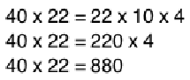
Note: This fluency activity reviews Lesson 34’s content.
T: (Write 40 × 22 = 22 × 10 × ___.) On your personal white boards, fill in the unknown factor to create a multiplication sentence.
S: (Write 40 × 22 = 22 × 10 × 4.)
T: What’s 22 × 10?
S: 22 × 10 = 220.
T: (Write 220 × 4 = ___.) On your boards, write the answer.
S: (Write 220 × 4 = 880.)
Continue with the following possible sequence: 30 × 21, 30 × 43, and 50 × 39.
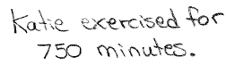
Application Problem (6 minutes)
Materials: (S) Thousands place value chart (Lesson 4 Template)
For 30 days out of one month, Katie exercised for 25 minutes a day. What is the total number of minutes that Katie exercised? Solve using a place value chart.
Note: This Application Problem builds on the content of Lesson 34 by using a place value chart to represent and then multiply a multiple of 10 by a two-digit number. Although some students may easily solve this problem using mental math, encourage them to see that the model verifies their mental math skills. Students can use their mental math and place value chart solution to verify their answer in Problem 1 of the Concept Development.
Concept Development (32 minutes)
Materials: (S) Personal white board
Problem 1: Find the product of 30 and 25 using an area model to solve.
T: Aside from the place value chart, what is another way that we have represented multiplication?

S: Arrays. Equal groups. The area model.
T: Let’s use an area model to show 30 × 25.
Since 30 × 25 = 10 × (3 × 25), let’s represent 3 × 25 first since we already know how to draw area models for one-digit by two-digit multiplication. (Draw an area model to represent 3 × 25.) We’ve decomposed 3 × 25 into what two products? Give me an expression for each in unit form.
S: 3 × 2 tens and 3 × 5 ones.
T: 3 × 2 tens is?
S: 6 tens.
T: And, 3 × 5 ones?
S: 15 ones.
T: So, 3 × 25 is?
S: 75.
T: What unit does this 3 have right now?
S: Ones.
T: Let’s change that unit. Let’s make it tens. (Draw the new area model.) What new multiplication problem is represented?
S: 30 × 25.
T: Let’s find the total area by finding partial products again. (Point to the 30 by 5 rectangle.) In unit form, give me a multiplication sentence to find the area of this portion.

NOTES ON
MULTIPLE MEANS
OF REPRESENTATION:
Help students understand that multiplying tens, unlike adding, results in a larger unit. Here, 3 tens times 2 tens is 6 hundreds, not 6 tens. To clarify, refer back to the magnifying arrows on the place value chart, the number form, or place value blocks (cubes, longs, and flats).

S: 3 tens × 5 = 15 tens.
T: Do we need to put a unit on the 5?
S: It would be ones. We don’t always have to say the unit when it’s just ones.
T: (Record as shown. Then, point to the 30 by 20 rectangle.) In unit form, give me a multiplication sentence to find the area of this rectangle.
S: 3 tens × 2 tens = 6 hundreds.
T: I noticed this time you gave me the units of both factors. Why?
S: They were both tens. This way, I can just think of 3 × 2, and all I have to do is figure out what the new unit will be. Tens times tens gives me hundreds.
T: Find the product for 30 × 25, and discuss with your partner how the two products, (3 × 25) and
(30 × 25), are related.
S: One was 75 and the other was 750. That’s 10 times as much. The first was 6 tens plus 15 ones. The other was 6 hundreds plus 15 tens. For the first one, we did 3 × 5 and 3 × 20. On the second, we just multiplied the 3 by 10 and got 30 × 5 and 30 × 20. That’s 150 + 600, or 750. The only difference was the unit on the 3. 3 ones were changed to 3 tens.
Problem 2: Find the product of 60 and 34 using an area model. Record the partial products to solve.
T: Draw an area model to represent 60 × 34, and then write the expressions that solve for the area of each rectangle.
S: (Draw area model and write expressions.)
T: Write 60 × 34 vertically next to the area model, and then record the partial products beginning with the area of the smaller rectangle.

NOTES ON
MULTIPLE MEANS
OF ACTION AND EXPRESSION:
Some learners may benefit from graph paper or lines outlining the place values to assist their accurate recording of the partial products.

S: (Record partial products as 240 and 1,800.)
T: What does the partial product of 240 represent?
S: The area of the small rectangle. 6 tens times 4.
T: What does the partial product of 1,800 represent?
S: The area of the larger part. 6 tens times 3 tens.
T: How do we find the product for 60 × 34?
S: We need to add the partial products.
240 + 1,800 = 2,040. 60 × 34 = 2,040.
Problem 3: Find the product of 90 and 34 without using an area model. Record the partial products to solve.
T: Write 90 × 34 vertically. If we were to create an area model to solve 90 × 34, what would it look like?
MP.8
S: It would be 90 units by 34 units. The 34 would be split into two parts: 30 and 4.
T: Imagine the area model, and use it to record the two partial products using the vertical written method. Then, use unit language to explain to your partner how you solved the problem.
Circulate and listen for phrases such as 9 tens times 4 and 9 tens × 3 tens. Ensure students are accurately lining up digits in the appropriate place value columns.
Repeat with 30 × 34.
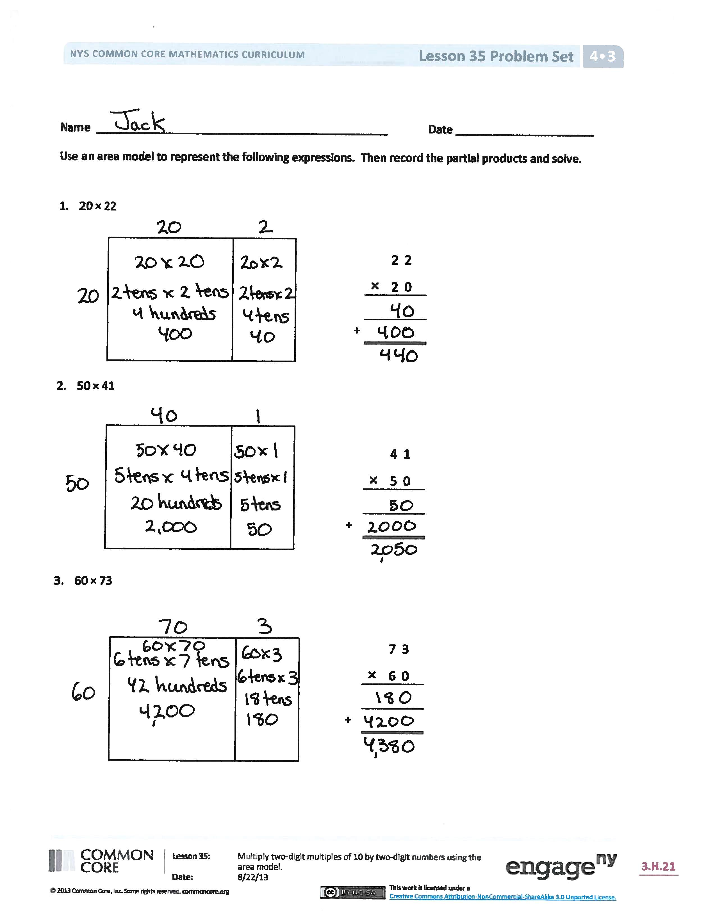
Problem Set (10 minutes)
Students should do their personal best to complete the Problem Set within the allotted 10 minutes. For some classes, it may be appropriate to modify the assignment by specifying which problems they work on first. Some problems do not specify a method for solving. Students should solve these problems using the RDW approach used for Application Problems.
Student Debrief (10 minutes)
Lesson Objective: Multiply two-digit multiples of 10 by two-digit numbers using the area model.
The Student Debrief is intended to invite reflection and active processing of the total lesson experience.
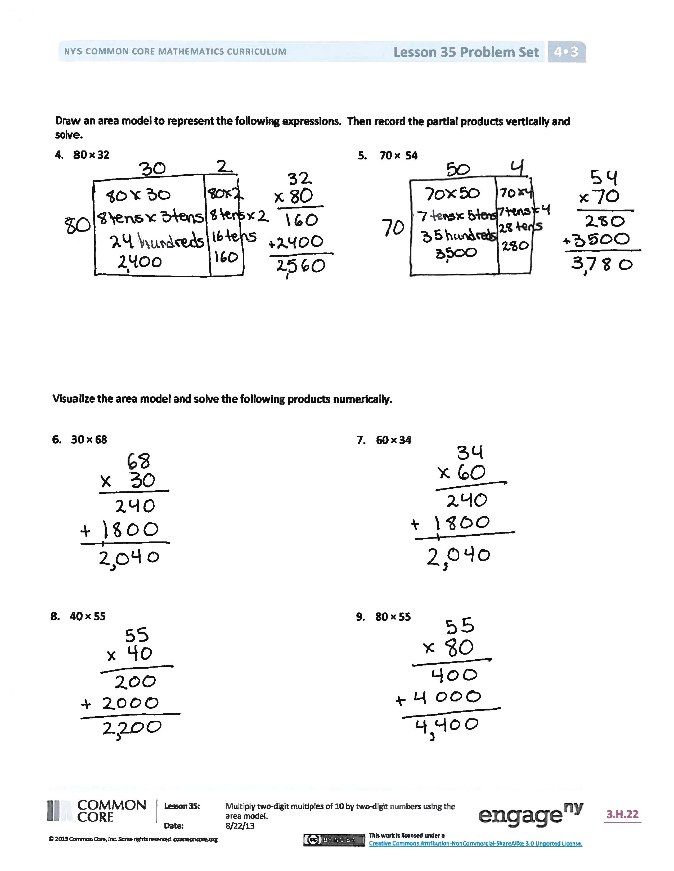
Invite students to review their solutions for the Problem Set. They should check work by comparing answers with a partner before going over answers as a class. Look for misconceptions or misunderstandings that can be addressed in the Debrief. Guide students in a conversation to debrief the Problem Set and process the lesson.
Any combination of the questions below may be used to lead the discussion.
- How is Problem 1 of the Problem Set less complex than the others?
- How do Problems 3–7 lend themselves to the use of the area model?
- Can you explain why Problems 6 and 7 have the same product?
- What can you say about area models for Problems 8 and 9?
- When we record partial products, do we have to start with the one with the smallest place value? Will we get a different result if we start with the tens?
- When we multiply by a multiple of 10, why is there always a 0 in the ones place?
- What significant math vocabulary did we use today to communicate precisely?
- How did the Application Problem connect to today’s lesson?
Exit Ticket (3 minutes)
After the Student Debrief, instruct students to complete the Exit Ticket. A review of their work will help with assessing students’ understanding of the concepts that were presented in today’s lesson and planning more effectively for future lessons. The questions may be read aloud to the students.

Name Date
Use an area model to represent the following expressions. Then, record the partial products and solve.
 | 2 2
× | 2 0
- 20 × 22

+

 | 4 1
× | 5 0
- 50 × 41

+

- 60 × 73
 | 7 3
× | 6 0

+

Draw an area model to represent the following expressions. Then, record the partial products vertically and solve.

- 80 × 32

- 70 × 54

Visualize the area model, and solve the following expressions numerically.

- 30 × 68

- 60 × 34

- 40 × 55
- 80 × 55

Name Date
Use an area model to represent the following expressions. Then, record the partial products and solve.
- 30 × 93
 | 9 3
× | 3 0

+

 | 7 6
× | 4 0
- 40 × 76

+

Name Date
Use an area model to represent the following expressions. Then, record the partial products and solve.
- 30 × 17
 | 1 7
× | 3 0

+

 | 5 8
× | 4 0
- 40 × 58

+

- 50 × 38
 | 3 8
× | 5 0

+

Draw an area model to represent the following expressions. Then, record the partial products vertically and solve.
- 60 × 19 5. 20 × 44

Visualize the area model, and solve the following expressions numerically.
- 20 × 88 7. 30 × 88

- 70 × 47 9. 80 × 65

