Lesson 33
Objective: Explain the connection of the area model of division to the long division algorithm for three- and four-digit dividends.

Suggested Lesson Structure
 Fluency Practice (12 minutes)
 Application Problem (5 minutes) 
 Concept Development (33 minutes)
 Student Debrief (10 minutes)
Total Time (60 minutes)
Fluency Practice (12 minutes)
- Quadrilaterals 3.G.1 (4 minutes)
- Group Counting 4.OA.1 (4 minutes)
- Multiply Units 4.NBT.1 (4 minutes)
Quadrilaterals (4 minutes)
Materials: (T) Shapes (Lesson 32 Fluency Template) (S) Personal white board
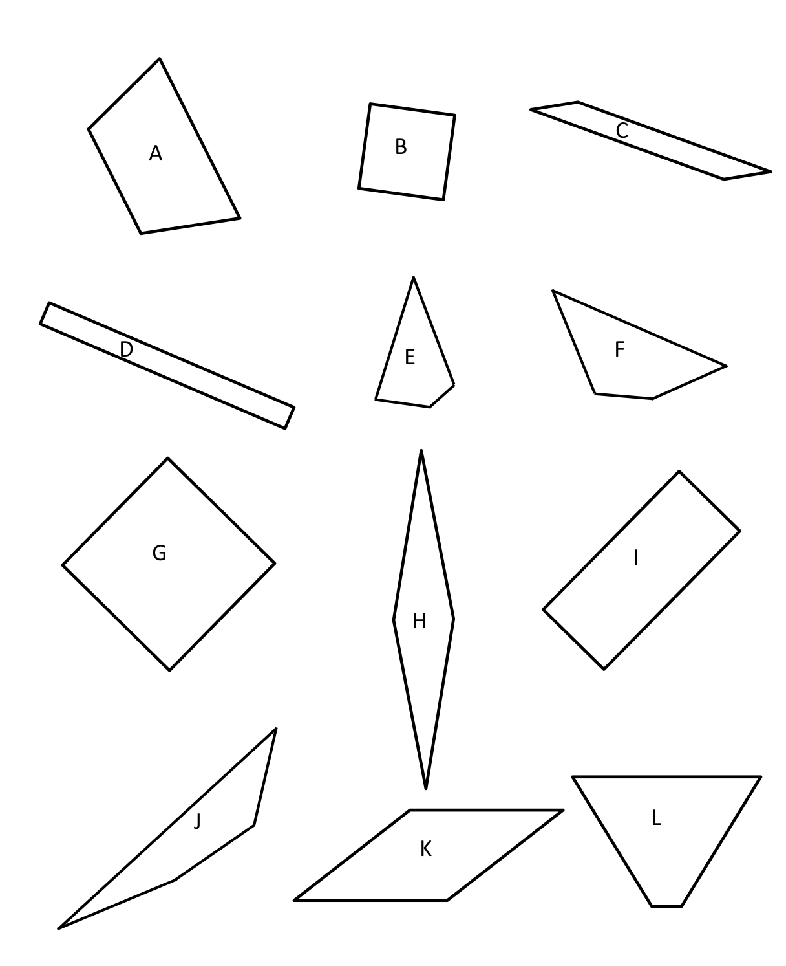
Note: This fluency activity reviews Grade 3 geometry concepts in anticipation of Module 4 content.
T: (Project the shapes template which includes the following: a square; a rhombus that is not a square; a rectangle that is not a square; and several quadrilaterals that are not squares, rhombuses, or rectangles.) How many sides does each polygon have?
S: 4.
T: On your personal white board, write the name for any four-sided polygon.
S: (Write quadrilateral.)
T: (Point to the square.) This quadrilateral has four equal sides and four right angles. On your board, write what type of quadrilateral it is.
S: (Write square.)
T: Rhombuses are quadrilaterals with four equal sides. Is this polygon a rhombus?
S: Yes.
T: Is it a rectangle?
S: Yes.
T: (Point to the rhombus that is not a square.) This polygon has four equal sides, but the angles are not the same. Write the name of this quadrilateral.
S: (Write rhombus.)
T: Is the square also a rhombus?
S: Yes!
T: (Point to the rectangle that is not a square.) This polygon has four equal angles, but the sides are not equal. Write the name of this quadrilateral.
S: (Write rectangle.)
T: Draw a quadrilateral that is not a square, rhombus, or rectangle.
Group Counting (4 minutes)
Note: This fluency activity prepares students to divide with remainders.

NOTES ON
MULTIPLE MEANS
OF REPRESENTATION:
Allow those students who consistently struggle with group counting at the pace of the majority of the class to count by the given multiple on a personal white board. Monitor their progress from one session to the next.

Direct students to count forward and backward, occasionally changing the direction of the count.
- Sixes to 60
- Sevens to 70
- Eights to 80
- Nines to 90
Multiply Units (4 minutes)
Materials: (S) Personal white board
Note: This fluency activity reviews Lesson 4’s content.
T: (Write 3 × 3 = .) Say the multiplication sentence in unit form.
S: 3 ones × 3 = 9 ones.
T: Write the answer in standard form.
S: (Write 9.)
T: (Write 30 × 3 = .) Say the multiplication sentence in unit form.
S: 3 tens × 3 = 9 tens.
T: Write the answer in standard form.
S: (Write 90.)
Continue with the following possible sequence: 3 hundreds × 3, 3 thousands × 3, 4 ones × 3, 4 tens × 3,
4 thousands × 3, 5 thousands × 2, 5 tens × 4, 5 hundreds × 8, and 8 tens × 6.
Application Problem (5 minutes)
Write an equation to find the unknown length of each rectangle. Then, find the sum of the two unknown lengths.
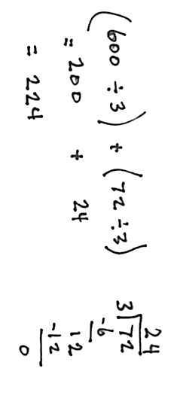

72 square
m
3 m
600 square m
3 m
The sum of the two unknown lengths is 224 meters.

Note: This Application Problem serves as an introduction to today’s Concept Development, in which students find the total unknown length of a rectangle with an area of 672 square meters.
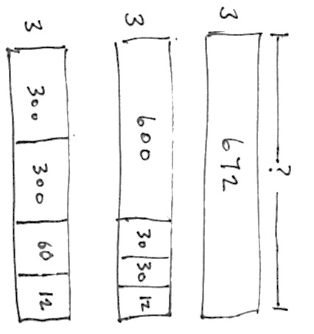
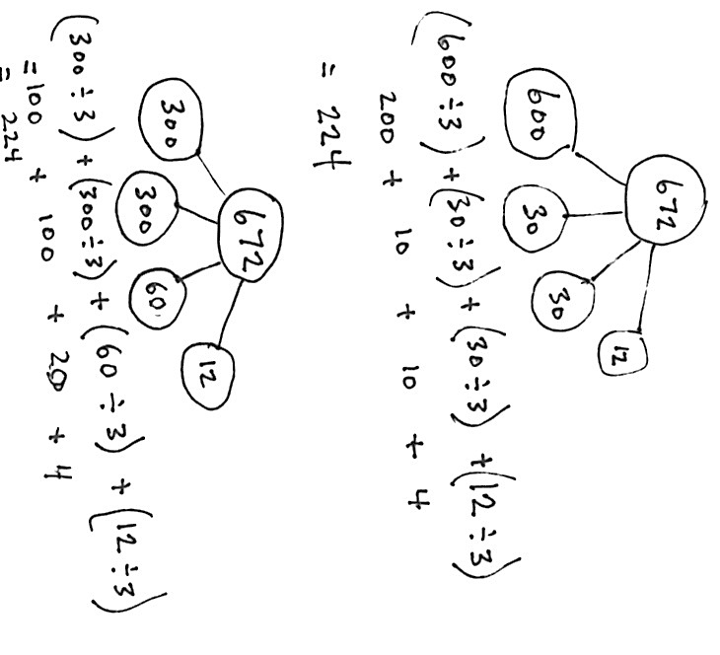
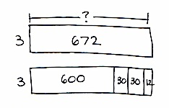
Concept Development (33 minutes)
Materials: (S) Personal white board
Problem 1
672 ÷ 3 and 1,344 ÷ 6
T: Draw a rectangle with an area of 672 square inches and a width of 3 inches.
S: (Draw.)
T: Draw a new rectangle with the same area directly below, but partitioned to make it easy for you to divide each part using mental math and your knowledge of place value. (Allow time for students to work.)
T: Share with a partner how you partitioned your new rectangle.
S: I made one part 6 hundred, two parts of 3 tens, and one part 12 ones. I made two parts of 3 hundreds, one part of 6 tens, and one part 12 ones. I made mine one part
6 hundred and two parts 36.
T: Draw a number bond to match the whole and parts of your rectangles.
S: (Draw bonds as pictured to the right.)
T: Find the unknown side lengths of the smaller rectangles, and add them to find the length of the largest rectangle.
T: Take a moment to record the number sentences, reviewing with your partner the connection to both the number bond and the area model.
Those who finish early can find other ways to decompose the rectangle or work with 1,344 ÷ 6.
T: (Allow students to work for about four minutes.)
T: What were some ways you found to partition 1,344 to divide it easily by 6?
S: We chopped it into 12 hundreds, 12 tens, and 24 ones. We decomposed it as 2 six hundreds,
2 sixties, and 24. I realized 1,344 is double 672. But, 6 is double 3 and that’s like the associative property 224 × 2 × 3, so 1,344 ÷ 6 equals 672 ÷ 3.
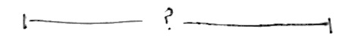

T: How can we see from our bonds that 1,344 is double 672?
S: When we chopped up the rectangles, I saw 600, 60, and 12 made 672, and the chopped up rectangle for 1,344 had two of all those!
T: Explain to your partner why different ways of partitioning give us the same correct side length.
S: You are starting with the same amount of area but just chopping it up differently. The sum of the lengths is the same as the whole length. You can take a total, break it into two or more parts, and divide each of them separately.

Problem 2
672 ÷ 3
T: (Write 672 ÷ 3.) This expression can describe a rectangle with an area of 672 square units. We are trying to find out the length of the unknown side.
T: What is the known side length?
S: 3.
T: (Draw a rectangle with a width of 3.) Three times how many hundreds gets us as close as possible to an area of 6 hundred square units? (Point to the 6 hundreds of the dividend.)
S: 2 hundreds.
T: Let’s give 2 hundreds to the length. (Label 2 lengths of hundreds.) Let’s record the 2 hundreds in the hundreds place.
T: What is 3 times 2 hundreds?
S: 6 hundreds. (Record 6 below the
6 hundreds.)
T: How many square units is that?
S: 600 square units. (Record 600 square units in the rectangle.)
T: How many hundreds remain?
S: Zero.
T: (Record 0 hundreds below the
6 hundreds.) 0 hundreds and 7 tens is…? (Record the 7 tens to the right of the
0 hundreds.)
S: 7 tens.
T: We have 70 square units left with a width of 3. (Point to the 7 tens in the algorithm.) Three times how many tens gets us as close as possible to 7 tens?
S: 2 tens.
T: Let’s give 2 tens to the length.
T: 3 times 2 tens is?
S: 6 tens.
T: How many square units?
S: 60 square units.
T: 7 tens minus 6 tens is?
S: 1 ten.
T: That is 10 square units of area to add to 2 square units. The remaining area is…?
S: 12 square units!
T: Three times how many ones gets us as close as possible to 12 ones?
S: 4 ones.
T: Let’s give 4 ones to the length.
T: Three times 4 ones is…?
S: 12 ones.
T: Do we have any remaining area?
S: No!
T: What is the length of the unknown side?
S: 224 length units.
T: Review our drawings and our process with your partner. Try to reconstruct what we did step by step before we try another one. (Allow students time to review.)
T: We solved 672 divided by 3 in two very different ways using the area model. First we started with the whole rectangle and partitioned it. The second way was to go one place value at a time and make the whole rectangle from parts.
Give students the chance to try the following problems in partners, in a small group with the teacher, or independently, as they are able.
539 ÷ 2
This first practice problem has an easy divisor and a remainder in the ones. Guide students to determine the greatest length possible first for the remaining area at each place value.
438 ÷ 5

NOTES ON
MULTIPLE MEANS
OF ACTION AND EXPRESSION:
Guide English language learners and students working below grade level who may not complete the Problem Set in the allotted 13 minutes to set specific goals for their work. After briefly considering their progress, strengths, and weaknesses, have students choose the problems they will solve strategically. For example, a learner who is perfecting sequencing his written explanations might choose Problem 2. Connect this short-term goal to long-term goals.
This next practice problem involves seeing the first area as
40 tens and having a remainder of 3 in the ones.
1,216 ÷ 4
The final practice problem involves a four-digit number.
Like the previous example, students must see the first area as 12 hundreds and the next area as 16 ones.
Problem Set (13 minutes)
Students should do their personal best to complete the Problem Set within the allotted 13 minutes. For some classes, it may be appropriate to modify the assignment by specifying which problems they work on first. Some problems do not specify a method for solving. Students should solve these problems using the RDW approach used for Application Problems.
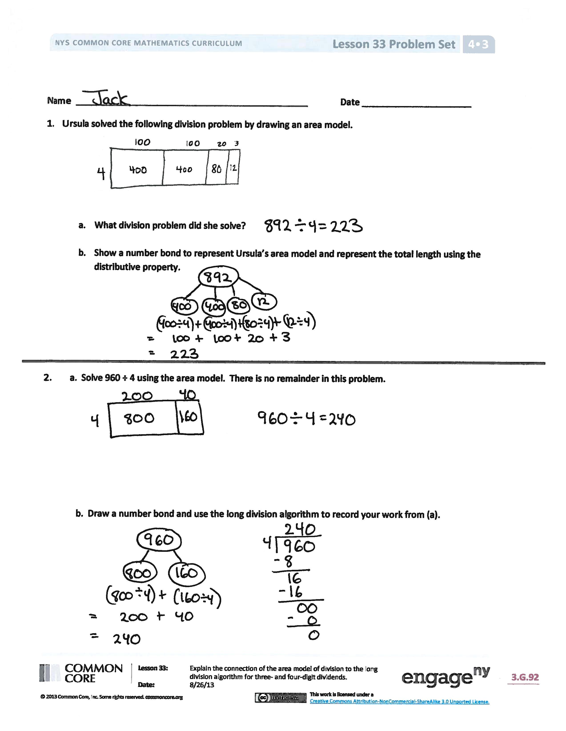
Student Debrief (10 minutes)
Lesson Objective: Explain the connection of the area model of division to the long division algorithm for
three- and four-digit dividends.
The Student Debrief is intended to invite reflection and active processing of the total lesson experience.
Invite students to review their solutions for the Problem Set. They should check work by comparing answers with a partner before going over answers as a class. Look for misconceptions or misunderstandings that can be addressed in the Debrief. Guide students in a conversation to debrief the Problem Set and process the lesson.
Any combination of the questions below may be used to lead the discussion.
- In Problem 1, is there another way Ursula could have represented the division problem with an area model? Would your number bond in 1(b) need revision if the area model changed?
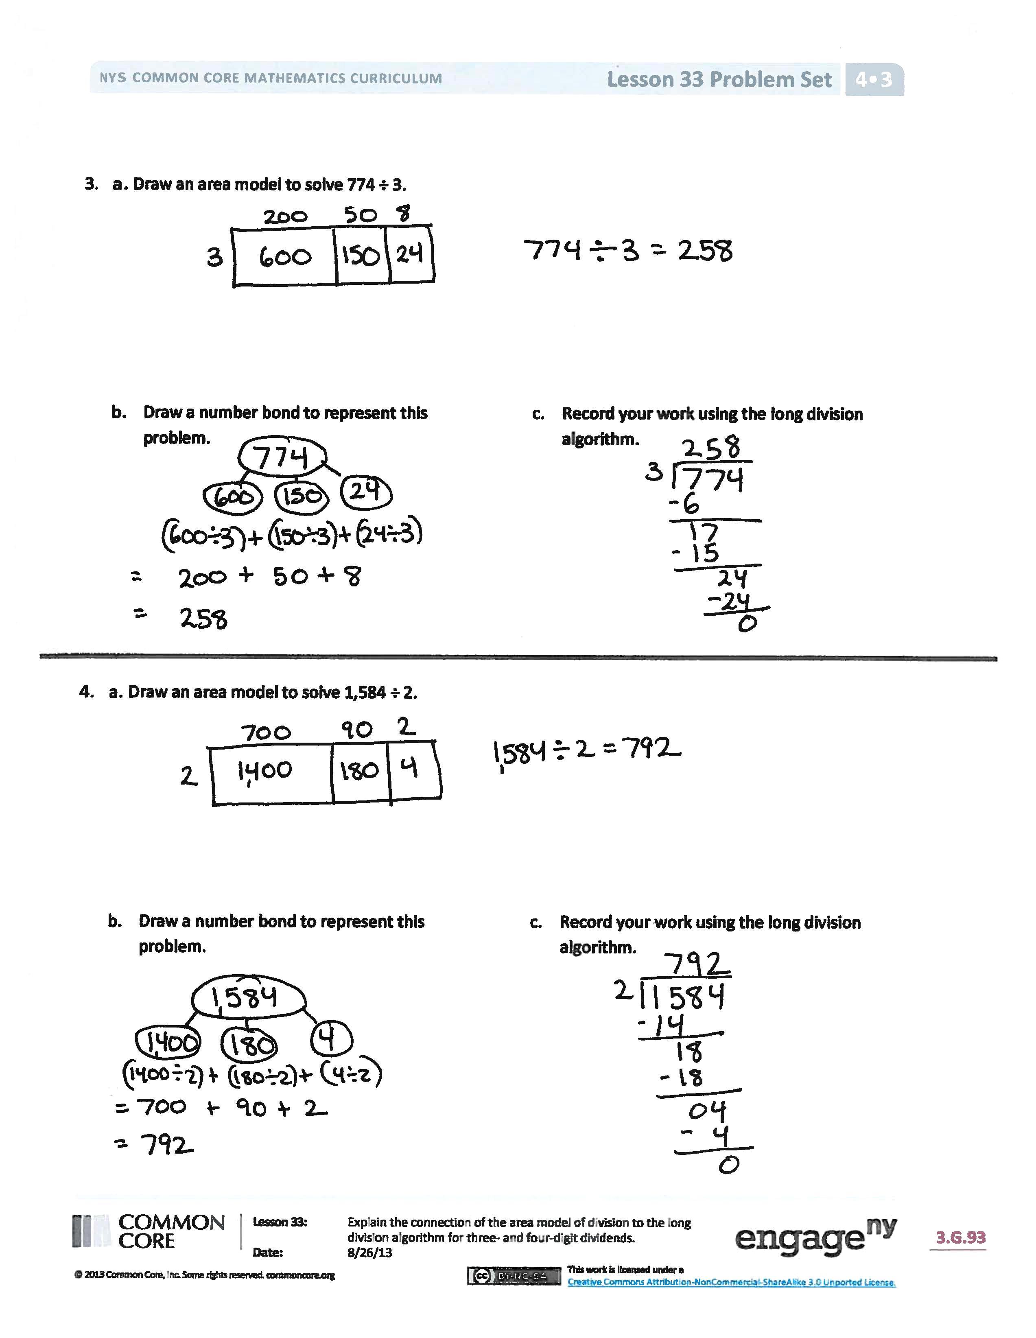
- Compare your area model in Problem 2(a) to your partner’s. Is it easier to solve the area model separating it into 2 parts, 3 parts, 4 parts, etc.?
- How do you decide how many parts are needed when building the area model for division?
- How are area models, number bonds, and the long division algorithm connected? Is there a correct order in which to use them to solve division problems?
Exit Ticket (3 minutes)
After the Student Debrief, instruct students to complete the Exit Ticket. A review of their work will help with assessing students’ understanding of the concepts that were presented in today’s lesson and planning more effectively for future lessons. The questions may be read aloud to the students.

Name Date
- Ursula solved the following division problem by drawing an area model.
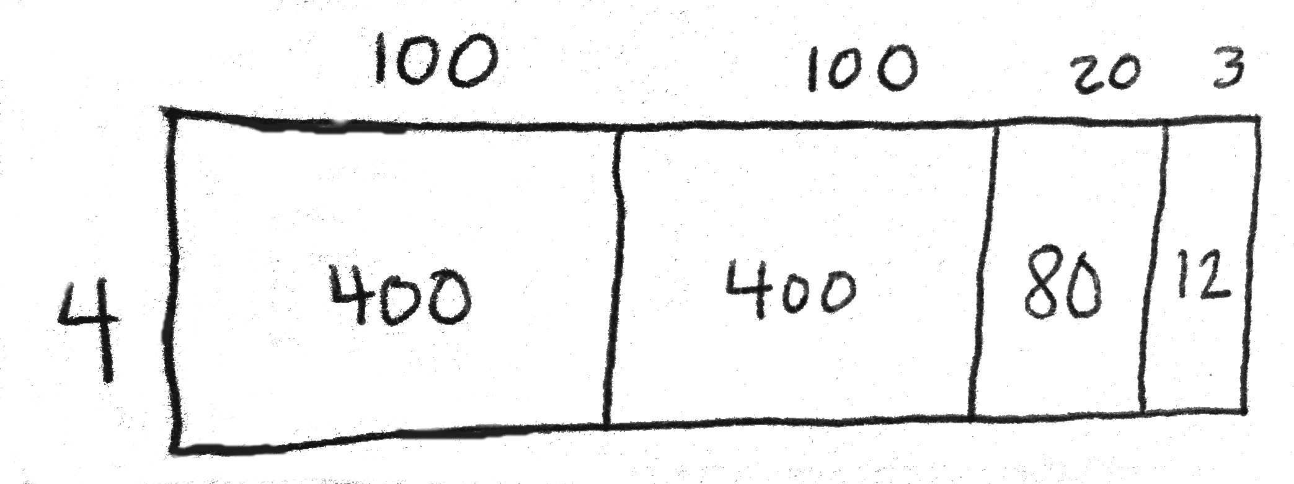

- What division problem did she solve?

- Show a number bond to represent Ursula’s area model, and represent the total length using the distributive property.

- a. Solve 960 ÷ 4 using the area model. There is no remainder in this problem.

b. Draw a number bond and use the long division algorithm to record your work from Part (a).

- a. Draw an area model to solve 774 ÷ 3.

- Draw a number bond to represent this problem.
- Record your work using the long division algorithm.

- a. Draw an area model to solve 1,584 ÷ 2.

- Draw a number bond to represent this problem.
- Record your work using the long division algorithm.

Name Date
- Anna solved the following division problem by drawing an area model.

- What division problem did she solve?

- Show a number bond to represent Anna’s area model, and represent the total length using the distributive property.

- a. Draw an area model to solve 1,368 ÷ 2.

- Draw a number bond to represent this problem.

- Record your work using the long division algorithm.

Name Date
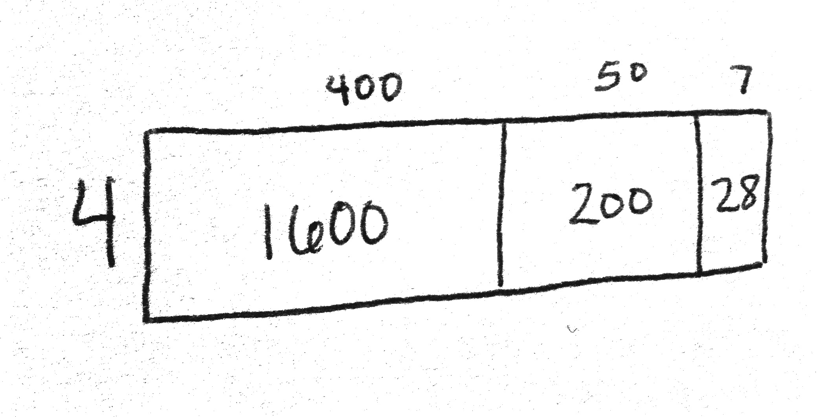
- Arabelle solved the following division problem by drawing an area model.

- What division problem did she solve?

- Show a number bond to represent Arabelle’s area model, and represent the total length using the distributive property.

- a. Solve 816 ÷ 4 using the area model. There is no remainder in this problem.

b. Draw a number bond and use a written method to record your work from Part (a).

- a. Draw an area model to solve 549 ÷ 3.

- Draw a number bond to represent this problem.

- Record your work using the long division algorithm.

- a. Draw an area model to solve 2,762 ÷ 2.

- Draw a number bond to represent this problem.
- Record your work using the long division algorithm.

