Lesson 29
Objective: Represent numerically four-digit dividend division with divisors of 2, 3, 4, and 5, decomposing a remainder up to three times.

Suggested Lesson Structure
 Fluency Practice (12 minutes)
 Application Problem (5 minutes)
 Concept Development (33 minutes)
 Student Debrief (10 minutes)
Total Time (60 minutes)
Fluency Practice (12 minutes)
- Multiply by Units 4.NBT.1 (4 minutes)
- Divide Different Units 4.NBT.1 (4 minutes)
- Divide to Find Half 4.NBT.6 (4 minutes)
Multiply by Units (4 minutes)
Materials: (S) Personal white board
Note: This fluency activity reviews Lesson 4.
T: (Write 2 × 4 = .) Say the multiplication sentence in unit form.
S: 2 ones × 4 = 8 ones.
T: Write the equation in standard form.
S: (Write 2 × 4 = 8.)
T: (Write 20 × 4 = .) Say the multiplication sentence in unit form.
S: 2 tens × 4 = 8 tens.
T: Write the equation in standard form.
S: (Write 20 × 4 = 80.)
T: (Write 2 tens × 4 tens = .) Say the multiplication sentence in unit form.
S: 2 tens × 4 tens = 8 hundreds.
T: Write the equation in standard form.
S: (Write 20 × 40 = 800.)
Continue with the following possible sequence: 3 × 3, 30 × 3, 30 × 30, 30 × 40, 5 × 3, 50 × 3, 50 × 30, 50 × 50, 5 × 8, 50 × 8, and 50 × 80.
Divide Different Units (4 minutes)
Materials: (S) Personal white board
Note: This fluency activity reviews Lesson 26’s Concept Development and strengthens students’ understanding of place value’s role in the long division algorithm.
Repeat the process from Lesson 28 using the following possible sequence: 9 ones ÷ 3, 9 tens ÷ 3,
9 hundreds ÷ 3, 9 thousands ÷ 3, 16 tens ÷ 4, 15 hundreds ÷ 5, 27 hundreds ÷ 3, 24 tens ÷ 3, 32 tens ÷ 4,
40 tens ÷ 5, and 20 hundreds ÷ 5.
Divide to Find Half (4 minutes)
Materials: (S) Personal white board
Note: This fluency activity reviews Lesson 28’s Concept Development.
T: Find half of 38 using long division.
S: 19.
T: Find half of 386.
S: 193.
Continue with the following possible sequence: half of 56, 562, 74, and 744.
Application Problem (5 minutes)

NOTES ON
MULTIPLE MEANS
OF REPRESENTATION:
Simplify and clarify the Application Problem for English language learners and others. Use images or illustrations to explain a roll of ribbon. Challenge students working above grade level to make predictions or estimates before solving and to determine and discuss which model and method is most efficient (for them) to solve 225 divided by 4.

Janet uses 4 feet of ribbon to decorate each pillow. The ribbon comes in 225-foot rolls. How many pillows will she be able to decorate with one roll of ribbon? Will there be any ribbon left over?
Note: This Application Problem reviews the skill of decomposing units in order to divide and interpreting a remainder within the context of a word problem so that those skills may be applied to today’s work with four-digit dividends.

Concept Development (33 minutes)
Materials: (S) Personal white board

NOTES ON
MULTIPLE MEANS
OF ENGAGEMENT:
In order to sustain the interest of some learners, it may be meaningful to couple the long division with premade modeling with place value disks or real objects that can be referred to throughout the vignette. Give students graph paper to ease the recording of numbers in their place value columns.

Problem 1: Divide using the standard algorithm and multiply to check the answer.
T: (Write 4,325 ÷ 3.) Write 4,325 ÷ 3 on your personal white board.
T: Divide 4 thousands by 3. What is the quotient?
S: 1 thousand.
T: Record 1 thousand. Say the multiplication sentence that tells how many of the thousands we distributed.
S: 1 thousand times three equals 3 thousands.
As students are reciting the multiplication sentence, point to the thousand, then to the divisor, and then record the 3 in the thousands column. Be sure students are also recording.
T: We began with 4 thousands and distributed 3 of them. How many thousands remain? What is the subtraction sentence that will show that?
S: 4 thousands minus 3 thousands equals 1 thousand.
As students are reciting the subtraction sentence, point to the 4 thousands and the 3 thousands, and then record the remaining 1.
T: What do you notice about what we subtracted?
S: We have 1 thousand left that we can decompose into 10 hundreds.
T: How many hundreds did we already have?
S: 3 hundreds. Now, our division sentence for the hundreds is 13 hundreds divided by 3. 13 hundreds divided by 3 is 4 hundreds.
T: Record 4 hundreds. Continue dividing with your partner.
Allow time for students to complete the long division.
T: Say the complete division sentence.
S: 4,325 divided by 3 is 1,441 with a remainder of 2.
T: Great! How can we use multiplication and addition to check if our quotient and remainder are correct?
S: We can multiply 1,441 by 3 and then add the remainder
of 2.
Repeat with 2,254 ÷ 3. Use the standard algorithm and multiply to check the answer. (Students see
22 hundreds ÷ 3 is the first step instead of 2 thousands ÷ 3.)
Problem 2
Ellie bought two packs of beads. Altogether, she has 1,254 beads. If the number of beads in each bag is the same, how many beads are in three packs?
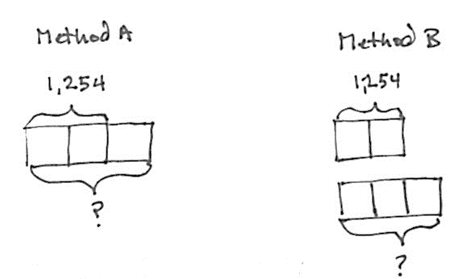
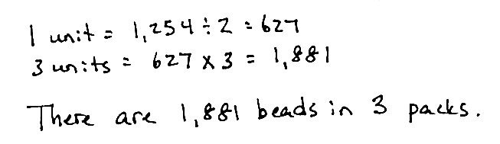
T: Draw something to help you solve this problem. (Pause.) What did you draw?
S: (Method A) I drew a tape diagram. I made
2 units and labeled the whole as 1,254, since we know that there are 1,254 beads in two packs. Then, I just drew a third unit. I labeled all 3 units with a question mark to represent how many beads are in three packs.
S: (Method B) Not me. After I drew two equal parts, I drew a second tape diagram below with three equal parts.
T: What conclusions did you make from your drawing?
S: We need to divide 1,254 by 2 to find out how many beads are in each bag. This helps because if we know how many beads are in one bag, we can multiply by 3 to find out how many beads are in three bags.
T: 1,254 divided by 2 is …?
S: 1,254 divided by 2 is 627.
T: Are we done?
S: No! We needed to multiply 627 by 3 to find the total number of beads in three packs.
S: 627 times 3 equals 1,881. There are 1,881 beads in three packs.
Note: Clearly this is scripted to reflect a classroom where students have confidence with the tape diagram.
If students need a more guided approach, it should be provided.
Problem Set (20 minutes)
Students should do their personal best to complete the Problem Set within the allotted 20 minutes.
For some classes, it may be appropriate to modify the assignment by specifying which problems they work on first. Some problems do not specify a method for solving. Students should solve these problems using the RDW approach used for Application Problems.

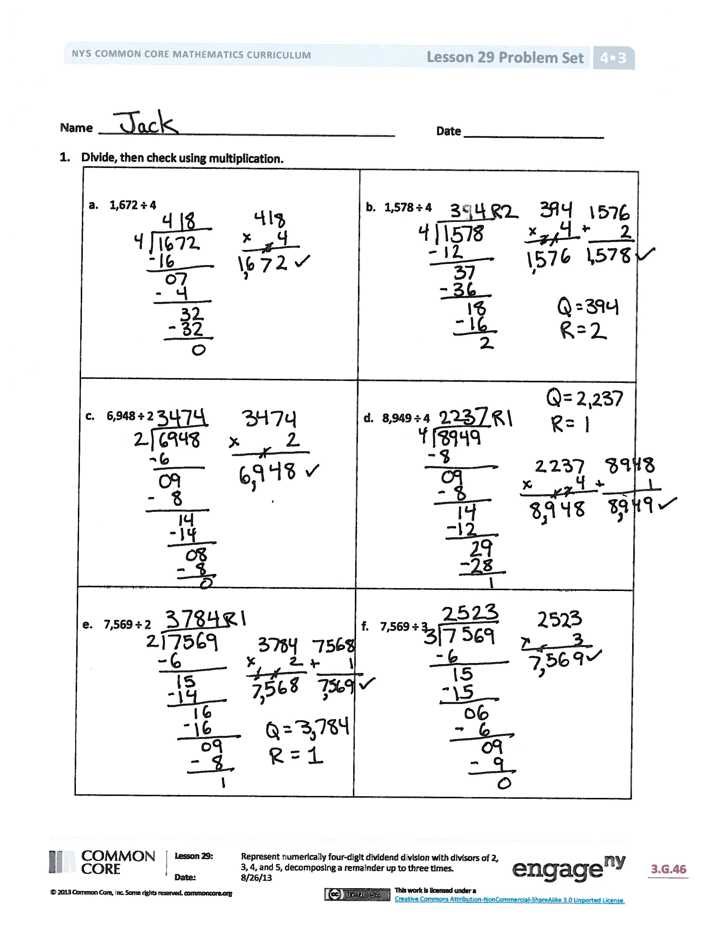
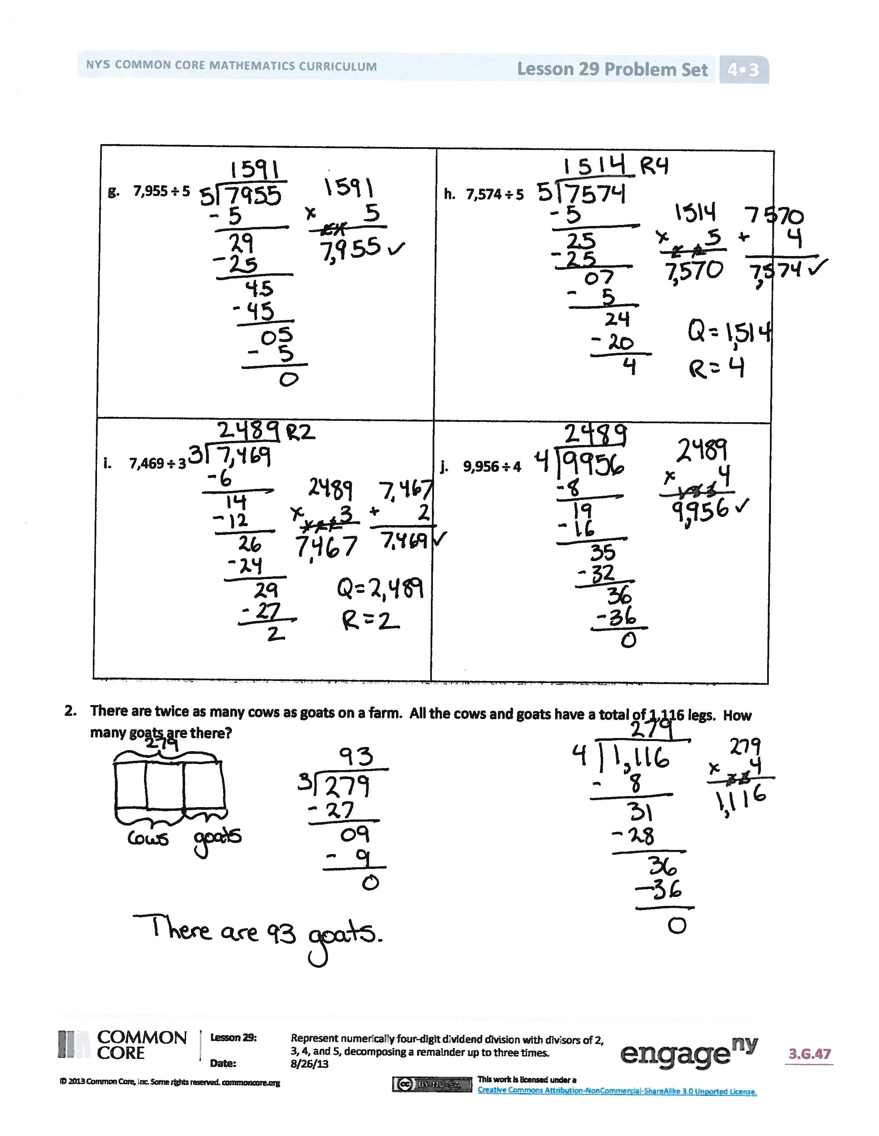
Student Debrief (10 minutes)
Lesson Objective: Represent numerically four-digit dividend division with divisors of 2, 3, 4, and 5, decomposing a remainder up to three times.
The Student Debrief is intended to invite reflection and active processing of the total lesson experience.
Invite students to review their solutions for the Problem Set. They should check work by comparing answers with a partner before going over answers as a class. Look for misconceptions or misunderstandings that can be addressed in the Debrief. Guide students in a conversation to debrief the Problem Set and process the lesson.
Any combination of the questions below may be used to lead the discussion.
- All of the problems in the Problem Set divided a four-digit number by a one-digit number.
Why do some of the quotients contain three digits while others have four?
- What did you notice about the size of the quotient in Problems 1(e) and 1(f) when the divisor increased from 2 to 3?
- Problems 1(i) and 1(j) resulted in the same quotient. Explain why that is possible.
- When is it possible for you to know, before dividing, whether or not a division problem will have a remainder?
- We have divided two-, three-, and now four-digit numbers. Explain to your partner how each time the whole became larger, another step was added. Discuss what you think would be true for dividing a number with a greater number of digits.
Exit Ticket (3 minutes)
After the Student Debrief, instruct students to complete the Exit Ticket. A review of their work will help with assessing students’ understanding of the concepts that were presented in today’s lesson and planning more effectively for future lessons. The questions may be read aloud to the students.
Name Date
- Divide, and then check using multiplication.
- 1,672 ÷ 4

- 1,578 ÷ 4

- 6,948 ÷ 2

- 8,949 ÷ 4

- 7,569 ÷ 2

- 7,569 ÷ 3

- 7,955 ÷ 5

- 7,574 ÷ 5

- 7,469 ÷ 3

- 9,956 ÷ 4

- There are twice as many cows as goats on a farm. All the cows and goats have a total of 1,116 legs.
How many goats are there?

Name Date
- Divide, and then check using multiplication.
- 1,773 ÷ 3 | - 8,472 ÷ 5

- The post office had an equal number of each of 4 types of stamps. There was a total of 1,784 stamps. How many of each type of stamp did the post office have?

Name Date
- Divide, and then check using multiplication.
- 2,464 ÷ 4

- 1,848 ÷ 3

- 9,426 ÷ 3

- 6,587 ÷ 2

- 5,445 ÷ 3

- 5,425 ÷ 2

- 8,467 ÷ 3

- 8,456 ÷ 3

- 4,937 ÷ 4

- 6,173 ÷ 5

- A truck has 4 crates of apples. Each crate has an equal number of apples. Altogether, the truck is carrying 1,728 apples. How many apples are in 3 crates?

