Lesson 28
Objective: Represent and solve three-digit dividend division with divisors of 2, 3, 4, and 5 numerically.

Suggested Lesson Structure
 Fluency Practice (15 minutes)
 Application Problem (6 minutes)
 Concept Development (30 minutes)
 Student Debrief (9 minutes)
Total Time (60 minutes)
Fluency Practice (15 minutes)
- Multiply by Units 4.NBT.1 (4 minutes)
- Divide Different Units 4.NBT.1 (4 minutes)
- Group Counting 4.NBT.1 (3 minutes)
- Divide Three-Digit Numbers by 2 4.NBT.6 (4 minutes)
Multiply by Units (4 minutes)
Materials: (S) Personal white board
Note: This fluency activity reviews Lesson 4.
T: (Project area model of 3 tens × 1. Beneath it, write 3 tens × 1.) Say the number sentence in unit form.
S: 3 tens × 1 = 3 tens.
T: (Write 3 tens × 1 = 3 tens.) Write the number sentence in standard form.
S: (Write 30 × 1 = 30.)
T: (Beneath 3 tens × 1 = 3 tens, write 30 × 1 = 30. Project area model of 3 tens × 1 ten. Beneath it, write 3 tens × 1 ten.) Say the number sentence in unit form.
S: (Write 3 tens × 1 ten.) 3 tens × 1 ten = 3 hundreds.
T: (Write 3 tens × 1 ten = 3 hundreds.) Write the number sentence in standard form.
S: (Write 30 × 10 = 300.)
T: (Beneath 3 tens × 1 ten = 3 hundreds, write 30 × 10 = 300. Project area model of 3 tens × 2 tens. Beneath it, write 3 tens × 2 tens.) Say the number sentence in unit form.
S: 3 tens × 2 tens = 6 hundreds.
T: (Write 3 tens × 2 tens = 6 hundreds.) Write the number sentence in standard form.
S: (Write 30 × 20 = 600.)
T: Beneath 3 tens × 2 tens = 6 hundreds, write 30 × 20 = 600.
Continue with the following possible sequence: 3 tens × 3 tens, 3 tens × 5 tens, 2 tens × 1, 2 tens × 1 ten,
2 tens × 2 tens, 2 tens × 4 tens, and 3 tens × 4 tens.
Divide Different Units (4 minutes)
Materials: (S) Personal white board
Note: This fluency activity reviews Lesson 26’s Concept Development.
8 ÷ 2 = 4 80 ÷ 2 = 40 800 ÷ 2 = 400 8,000 ÷ 2 = 4,000
T: (Write 8 ÷ 2 = .) Say the division sentence in unit form.
S: 8 ones ÷ 2 = 4 ones.
T: (Write 8 ÷ 2 = 4. To the right, write 80 ÷ 2 = .) Say the division sentence in unit form.
S: 8 tens ÷ 2 = 4 tens.
T: (Write 80 ÷ 2 = 40. To the right, write 800 ÷ 2 = .) Say the division sentence in unit form.
S: 8 hundreds ÷ 2 = 4 hundreds.
T (Write 800 ÷ 2 = 400. To the right, write 8,000 ÷ 2 = .) Say the division sentence in unit form.
S: 8 thousands ÷ 2 = 4 thousands.
T: (Write 8,000 ÷ 2 = 4,000.)
T: (Write 6 tens ÷ 2 = .) On your personal white board, write the division sentence in standard form.
S: (Write 60 ÷ 2 = 30.)
Continue with the following possible sequence: 15 tens ÷ 5, 12 hundreds ÷ 3, 28 hundreds ÷ 4, 21 tens ÷ 3,
36 tens ÷ 4, 20 tens ÷ 5, and 30 hundreds ÷ 5.
Group Counting (3 minutes)
Note: This fluency activity prepares students to divide with remainders during Lesson 30’s Concept Development.
Direct students to count forward and backward, occasionally changing the direction of the count.
- Sixes to 60
- Sevens to 70
- Eights to 80
- Nines to 90
Divide Three-Digit Numbers by 2 (4 minutes)
Materials: (S) Personal white board, thousands place value chart for dividing (Lesson 26 Template)
Note: This fluency activity reviews Lesson 27’s Concept Development.
T: (Write 546 ÷ 2.) Show 546 ÷ 2 by drawing place value disks in two different groups.
S: (Draw place value disks.)
T: Solve the same problem using the algorithm.
S: (Solve.)
Repeat the process using the following possible sequence: 368 ÷ 2 and 846 ÷ 2.
Application Problem (6 minutes)
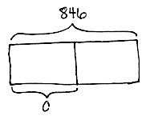
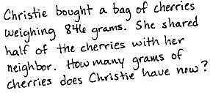
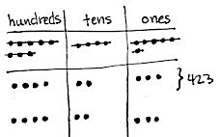
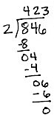
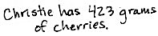
Use 846 ÷ 2 to write a word problem. Then, draw an accompanying tape diagram and solve.

Note: This Application Problem connects to Lesson 27’s halving discussion in the Student Debrief. It also reinforces the use of inverse operations to check calculations. It uses the division problem from the fluency activity Divide Three-Digit Numbers. Encourage students to revise their word problems to use the word half.
Concept Development (30 minutes)
Materials: (T) Thousands place value chart for dividing (Lesson 26 Template) (S) Personal white board, thousands place value chart for dividing (Lesson 26 Template)
Problem 1: 297 ÷ 4
T: (Write 297 ÷ 4.) Set up 297 ÷ 4 in your thousands place value chart, and write the problem to solve using long division.
T: Divide 2 hundreds by 4.
S: There aren’t enough hundreds to put them into 4 groups. I need to break them apart.
T: Correct. 2 hundreds is the same as how many tens?

NOTES ON
MULTIPLE MEANS
OF ENGAGEMENT:
This vignette supports students step by step when using it in combination with Lesson 27. Consider enhancing the experience for learners who have limited executive functioning by guiding students to set appropriate individual goals. Goals may include effort, efficiency, timing, organization, and persistence. In addition, consider adjusting the numbers to challenge students working above grade level or offer alternatives such as developing a game to practice the skill.

S: 20 tens.
T: 20 tens plus 9 tens is 29 tens. Divide 29 tens by 4. What is the quotient?
S: 7 tens.
T: Where do we record 7 tens?
S: Above the 9.
T: Why?
S: Because the 9 is in the tens place. It represents the number of tens.
T: Record 7 tens. When we distribute 29 tens into
4 groups, there are 7 tens in each group. Say the multiplication sentence that tells how many of the tens were distributed.
S: 7 tens times 4 equals 28 tens.
As students are reciting the multiplication sentence, point to the 7 tens, then to the divisor, and then record the 28. Be sure students are also recording.
T: We began with 29 tens, but we distributed 28 of them. How many tens are remaining? Say the subtraction sentence that will show that.
S: 29 tens minus 28 tens equals 1 ten.
T: Continue dividing with your partner.
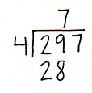
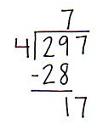
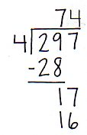
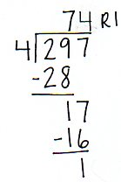
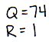
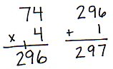
Allow time for students to divide.

T: What is the quotient and the remainder?
S: The quotient is 74 and the remainder is 1.
T: How can we use multiplication and addition to check if our quotient is correct?
S: We can multiply 74 by 4, and then add the remainder 1. If we get 297, then we are correct.
T: Check your quotient using multiplication.
T: What was the new complexity for this division problem?
S: We didn’t have enough hundreds to divide, so we decomposed them as tens and divided by tens first.

Problem 2
How many weeks are there in one year?
T: What do we need to know in order to solve this problem?
S: The number of days in one year.
T: How many days are in one year?
S: 365. Sometimes 366.
T: Good! Let’s use 365 days. What other information is necessary?
S: There are 7 days in a week.
T: Okay, use a tape diagram to represent this problem. Show your partner how you set up your tape diagram. Solve and then check your work.
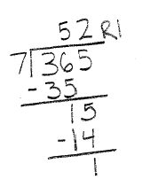
Allow students time to work independently. Circulate and offer assistance as necessary.
T: Did you find that 365 could be divided by 7 evenly?
S: No, there was a remainder of 1.
T: In this problem, what does the remainder mean?
S: It means that there is one extra day.
T: Talk to your partner. How did you know it was an extra day?
S: Our whole, or total, represented the number of days in a year, 365, so our remainder is days. 365 minus 52 groups of 7 leaves 1 day remaining. 1 one is one day. 365 ones, or days, is one year.
T: So, what would be a good sentence to write?
S: We can say, “There are 52 weeks and 1 day in one year.”
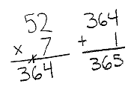
Problem Set (10 minutes)
Students should do their personal best to complete the Problem Set within the allotted 10 minutes. For some classes, it may be appropriate to modify the assignment by specifying which problems they work on first. Some problems do not specify a method for solving. Students should solve these problems using the RDW approach used for Application Problems.

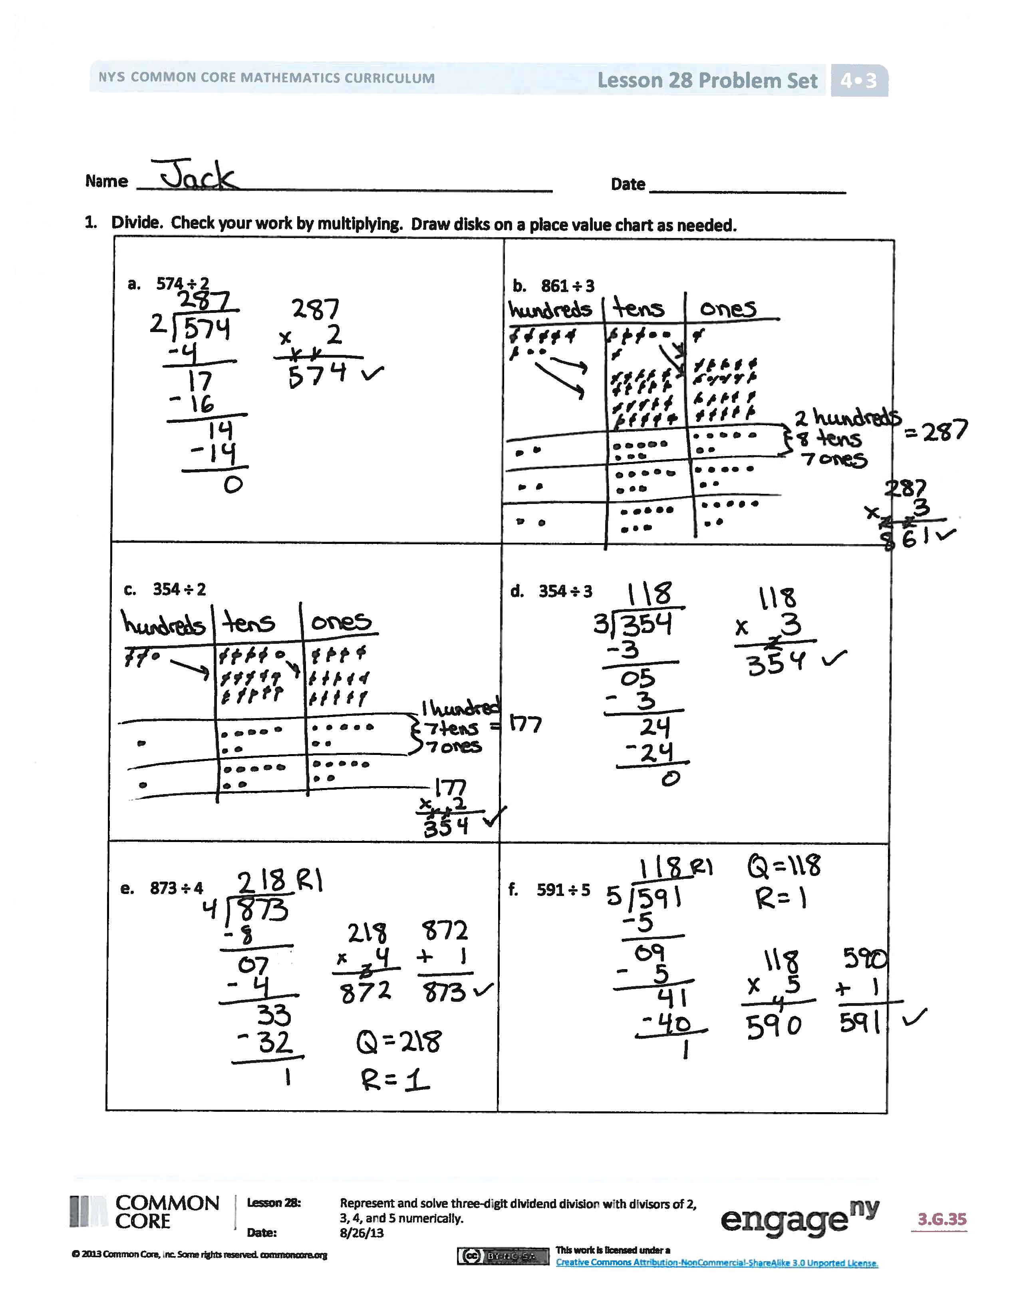
Student Debrief (9 minutes)
Lesson Objective: Represent and solve three-digit dividend division with divisors of 2, 3, 4, and 5 numerically.
The Student Debrief is intended to invite reflection and active processing of the total lesson experience.
Invite students to review their solutions for the Problem Set. They should check work by comparing answers with a partner before going over answers as a class. Look for misconceptions or misunderstandings that can be addressed in the Debrief. Guide students in a conversation to debrief the Problem Set and process the lesson.
Any combination of the questions below may be used to lead the discussion.
- Look at all of the problems with 4 as a divisor. They all have a remainder of 1, 2, or 3. If you were dividing by 4 and came up with a remainder of 4, 5, or 6, what would you know?
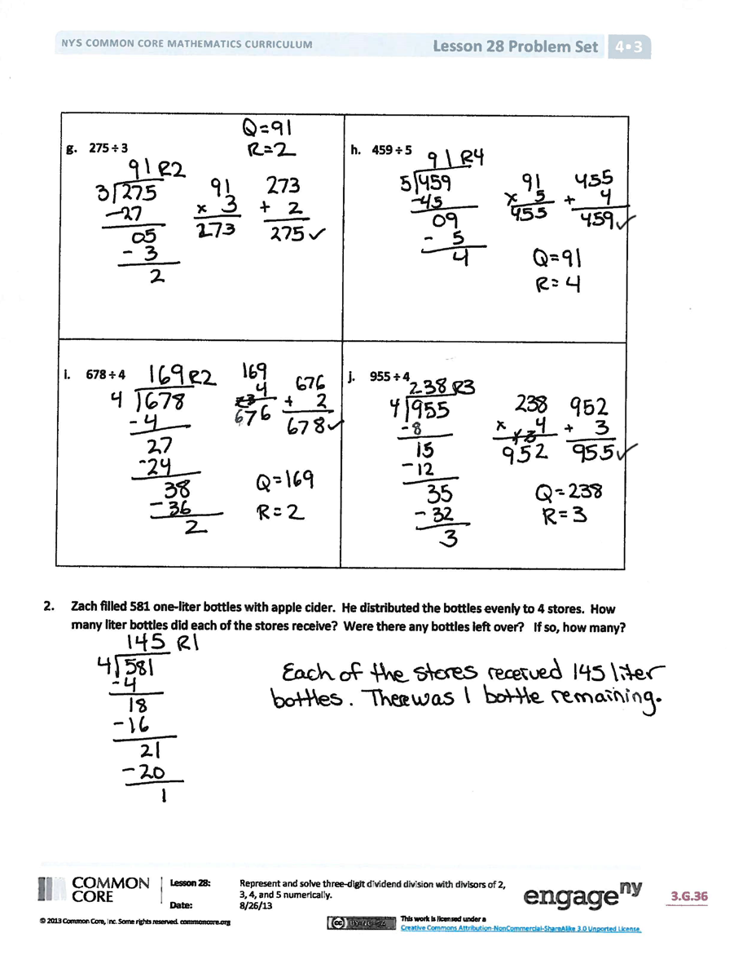
- Problems 1(a) and 1(b) have the same quotient. How can the same quotient come from two different whole amounts? Let’s draw a tape diagram for each to show how that could be true.
- Problems 1(c) and 1(d) have the same whole. Which quotient is larger? Why?
- How did the Application Problem connect to today’s lesson?
Exit Ticket (3 minutes)
After the Student Debrief, instruct students to complete the Exit Ticket. A review of their work will help with assessing students’ understanding of the concepts that were presented in today’s lesson and planning more effectively for future lessons. The questions may be read aloud to the students.

Name Date
- Divide. Check your work by multiplying. Draw disks on a place value chart as needed.
- 574 ÷ 2
- 861 ÷ 3
- 354 ÷ 2

- 354 ÷ 3

- 873 ÷ 4

- 591 ÷ 5

- 275 ÷ 3

- 459 ÷ 5
- 678 ÷ 4

- 955 ÷ 4

- Zach filled 581 one-liter bottles with apple cider. He distributed the bottles to 4 stores. Each store received the same number of bottles. How many liter bottles did each of the stores receive?
Were there any bottles left over? If so, how many?

Name Date
- Divide. Check your work by multiplying. Draw disks on a place value chart as needed.
- 776 ÷ 2 | - 596 ÷ 3

- A carton of milk contains 128 ounces. Sara’s son drinks 4 ounces of milk at each meal. How many
4-ounce servings will one carton of milk provide?

Name Date
- Divide. Check your work by multiplying. Draw disks on a place value chart as needed.
- 378 ÷ 2

- 795 ÷ 3

- 512 ÷ 4

- 492 ÷ 4

- 539 ÷ 3

- 862 ÷ 5

- 498 ÷ 3

- 783 ÷ 5
- 621 ÷ 4

- 531 ÷ 4

- Selena’s dog completed an obstacle course that was 932 meters long. There were 4 parts to the course, all equal in length. How long was 1 part of the course?

