Lesson 27

Objective: Represent and solve division problems with up to a three-digit dividend numerically and with place value disks requiring decomposing a remainder in the hundreds place.

Suggested Lesson Structure

 Fluency Practice (12 minutes)

 Application Problem (5 minutes)

 Concept Development (33 minutes)

 Student Debrief (10 minutes)

**Total Time (60 minutes)**

Fluency Practice (12 minutes)

* Sprint: Circle the Prime Number **4.OA.4** (8 minutes)
* Divide with Place Value Disks **4.NBT.1** (4 minutes)

Sprint: Circle the Prime Number (8 minutes)

Materials: (S) Circle the Prime Number Sprint

Note: This Sprint reviews content from Topic F.

Divide with Place Value Disks (4 minutes)

Materials: (S) Personal white board

Note: This fluency activity reviews Lesson 26’s Concept Development and strengthens students’ understanding of place value’s role in the long division algorithm.

T: (Display 6 ÷ 2.) On your personal white board, draw place value disks to represent the expression.

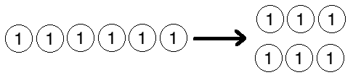S: (Draw 6 ones disks and divide them into 2 groups of 3.)

T: Say the division sentence in unit form.

S: 6 ones ÷ 2 = 3 ones.

Repeat the process using the following possible sequence: 60 ÷ 2; 600 ÷ 2; 6,000 ÷ 2; 80 ÷ 2; 1,200 ÷ 3, and 1,200 ÷ 4.

Application Problem (5 minutes)

Emma takes 57 stickers from her collection and divides them up equally between 4 of her friends. How many stickers will each friend receive? Emma puts the remaining stickers back in her collection. How many stickers will Emma return to her collection?

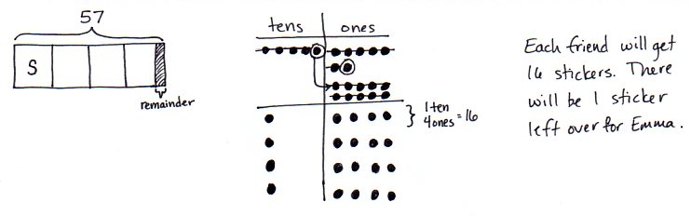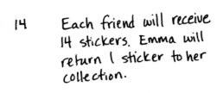

Note: This Application Problem reviews work with two-digit dividends from Lesson 17.

Concept Development (33 minutes)

Materials: (T) Thousands place value chart for dividing (Lesson 26 Template) (S) Personal white board, thousands place value chart for dividing (Lesson 26 Template)

**Problem 1: Divide a three-digit number by a one-digit number using place value disks, regrouping in the hundreds.**

Display 423 ÷ 3.

****T: Let’s find the quotient. Represent 423 on the place value chart. Tell your partner how many groups below will be needed.

S: (Draw disks on chart.) Three groups.

T: Four hundreds divided by 3. Distribute your disks and cross off what you’ve used. What is the quotient?

S: 1 hundred with a remainder of 1 hundred.

T: Tell me how to decompose the remaining 1 hundred.

S: Change 1 hundred for 10 tens.

T: Let’s decompose 1 hundred. Turn to your partner and decide together what to do next.

S: 10 tens and 2 tens makes 12 tens. Now, we have 12 tens to divide by 3.

T: Why didn’t we stop when we had a remainder of 1 hundred?

S: Because 1 hundred is just 10 tens, so you can keep dividing.

T: 12 tens divided by 3. What is the quotient? Distribute your disks and cross off what you’ve used.

|  |  |
| --- | --- |
|  | NOTES ON MULTIPLE MEANS OF ACTION AND EXPRESSION: |

Provide learners with learning and cognitive disabilities internal scaffolds to aid their memory and organization as they draw and distribute many place value disks. Guide students to refer back to the original expression frequently (e.g., 423 ÷ 3),whisper-count as they distribute, write down any numbers they may forget, and use self-talk, such as, “Now I’ll distribute   
12 tens.”

S: 4 tens. 🡪 4 tens distributed to each group with no remainder.

T: Does that mean we are finished?

S: No, we still have to divide the ones.

T: Do that now. Distribute and cross off your disks.   
3 ones divided by 3. What is the quotient?

S: 1 one.

T: Is there any more dividing we need to do?

S: No. We have distributed all of the units from the whole.

T: Great! So, what is the quotient of 423 divided by 3? Say the whole number sentence.

S: 423 divided by 3 equals 141.

Problem 2

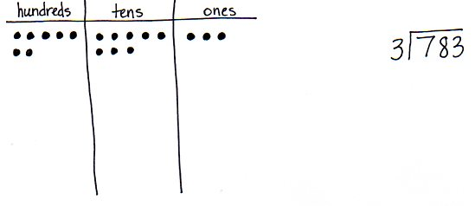Display 783 ÷ 3.

T: Let’s solve 783 ÷ 3 using a place value chart and long division side by side. Represent 783 in a place value chart and prepare for long division. (Allow time for students to draw disks and write the problem.) Starting with the largest unit, tell me what to divide.

S: We divide 7 hundreds by 3.

T: Do that on your chart. 7 hundreds divided by 3.   
What is the quotient?

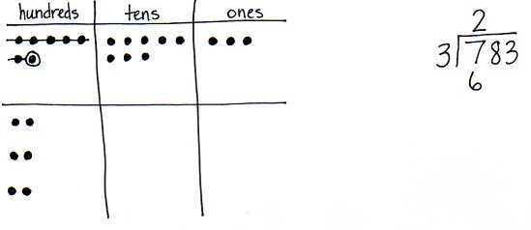S: 2 hundreds, with 1 hundred remaining.

T: (Record 2 hundreds. Point to the place value chart.) In your place value chart, you recorded   
2 hundreds three times. Say a multiplication sentence that tells that.

S: 2 hundreds times 3 equals 6 hundreds.

As students say the multiplication equation, refer to the algorithm, point to the 2 hundreds and the divisor, and finally, record 6 hundreds.

T: (Point to the place value chart.) We started with 7 hundreds, distributed 6 hundreds, and have   
1 hundred remaining. Tell me a subtraction sentence for that.

S: 7 hundreds minus 6 hundreds equals 1 hundred.

As students say the subtraction sentence, refer to the algorithm, point to the hundreds column, record a subtraction line and symbol, and record 1 hundred.

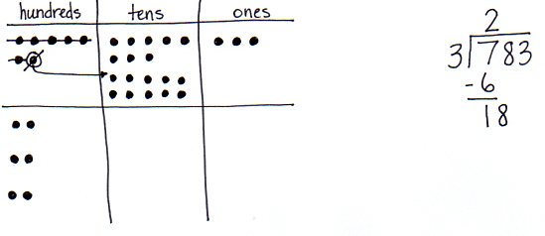T: (Point to the place value chart.) How many tens remain to be divided?

S: 8 tens.

T: (Record an 8 next to the 1 hundred remainder.)   
We decompose the remaining 1 hundred for 10 tens and add on the 8 tens. Decompose the 1 hundred.   
Say a division sentence for how we should distribute 18 tens.

S: 18 tens divided by 3 equals 6 tens.

As students say the division sentence, refer to the algorithm, point to the 18 tens and the divisor, and then record 6 tens in the quotient. Likewise, distribute the 18 tens in the place value chart.

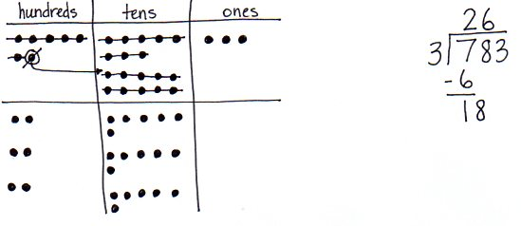

T: (Point to the place value chart.) You recorded 6 tens, three times. Say a multiplication sentence that tells that.

S: 6 tens times 3 equals 18 tens.

As students say the multiplication equation, refer to the algorithm, point to 6 tens, then the divisor, and finally, record 18 tens.

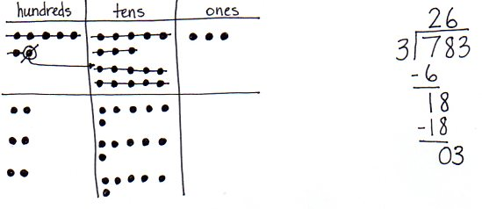T: (Point to the place value chart.) We renamed   
10 tens, distributed all 18 tens, and have no tens remaining. Say a subtraction sentence for that.

S: 18 tens minus 18 tens equals 0 tens.

As students say the subtraction equation, refer to the algorithm, record a subtraction line and symbol, and 0 tens.

T: What is left to distribute?

S: The ones.

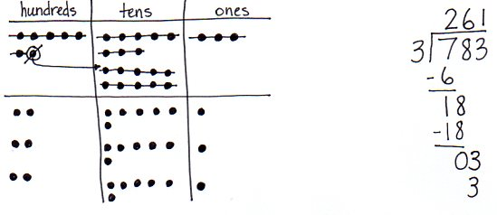T: (Point to the place value chart.) How many ones remain to be divided?

S: 3 ones.

T: (Record a 3 next to the 0 in the tens column.) Say a division sentence for how we should distribute   
3 ones.

S: 3 ones divided by 3 equals 1 one.

As students say the division sentence, refer to the algorithm, point to the 3 ones and the divisor, and then record 1 one in the quotient.

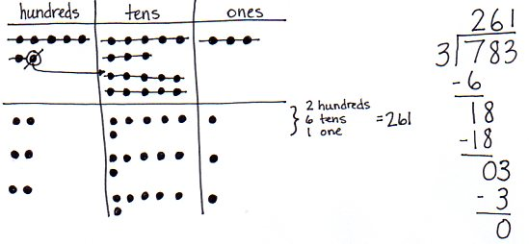T: (Point to the place value chart.) You recorded   
1 one, three times. Say a multiplication sentence that describes that.

S: 1 one times 3 equals 3 ones.

As students say the multiplication equation, refer to the algorithm, point to 1 one, then the divisor, and finally, record 3 ones.

T: (Point to the place value chart.) We have 3 ones, and we distributed 3 ones. Say a subtraction sentence for that.

S: 3 ones minus 3 ones equals 0 ones.

Have students share with a partner how the model matches the algorithm. Note that both show equal groups, as well as how both can be used to check their work using multiplication.

Problem 3

Display 546 ÷ 3.

T: Work together with a partner to solve 546 ÷ 3 using place value disks and long division. One partner solves the problem using a place value chart and disks, while the other partner uses long division. Work at the same pace, matching the action of the disks with the written method, and, of course, compare your quotients.

Circulate as students are working to offer assistance as needed.

T: How was this problem unlike the others we solved today?

S: There were more hundreds left after we distributed them. 🡪 We had to decompose 2 hundreds this time.



Problem Set (10 minutes)

|  |  |
| --- | --- |
|  | NOTES ON MULTIPLE MEANS OF ENGAGEMENT: |
| Challenge students working above grade level and others to approximate estimates before they solve in order to check the reasonableness of their answers. | |

Students should do their personal best to complete the Problem Set within the allotted 10 minutes. For some classes, it may be appropriate to modify the assignment by specifying which problems they work on first. Some problems do not specify a method for solving. Students should solve these problems using the RDW approach used for Application Problems.

Student Debrief (10 minutes)

**Lesson Objective:** Represent and solve division problems with up to a three-digit dividend numerically and with place value disks requiring decomposing a remainder in the hundreds place.

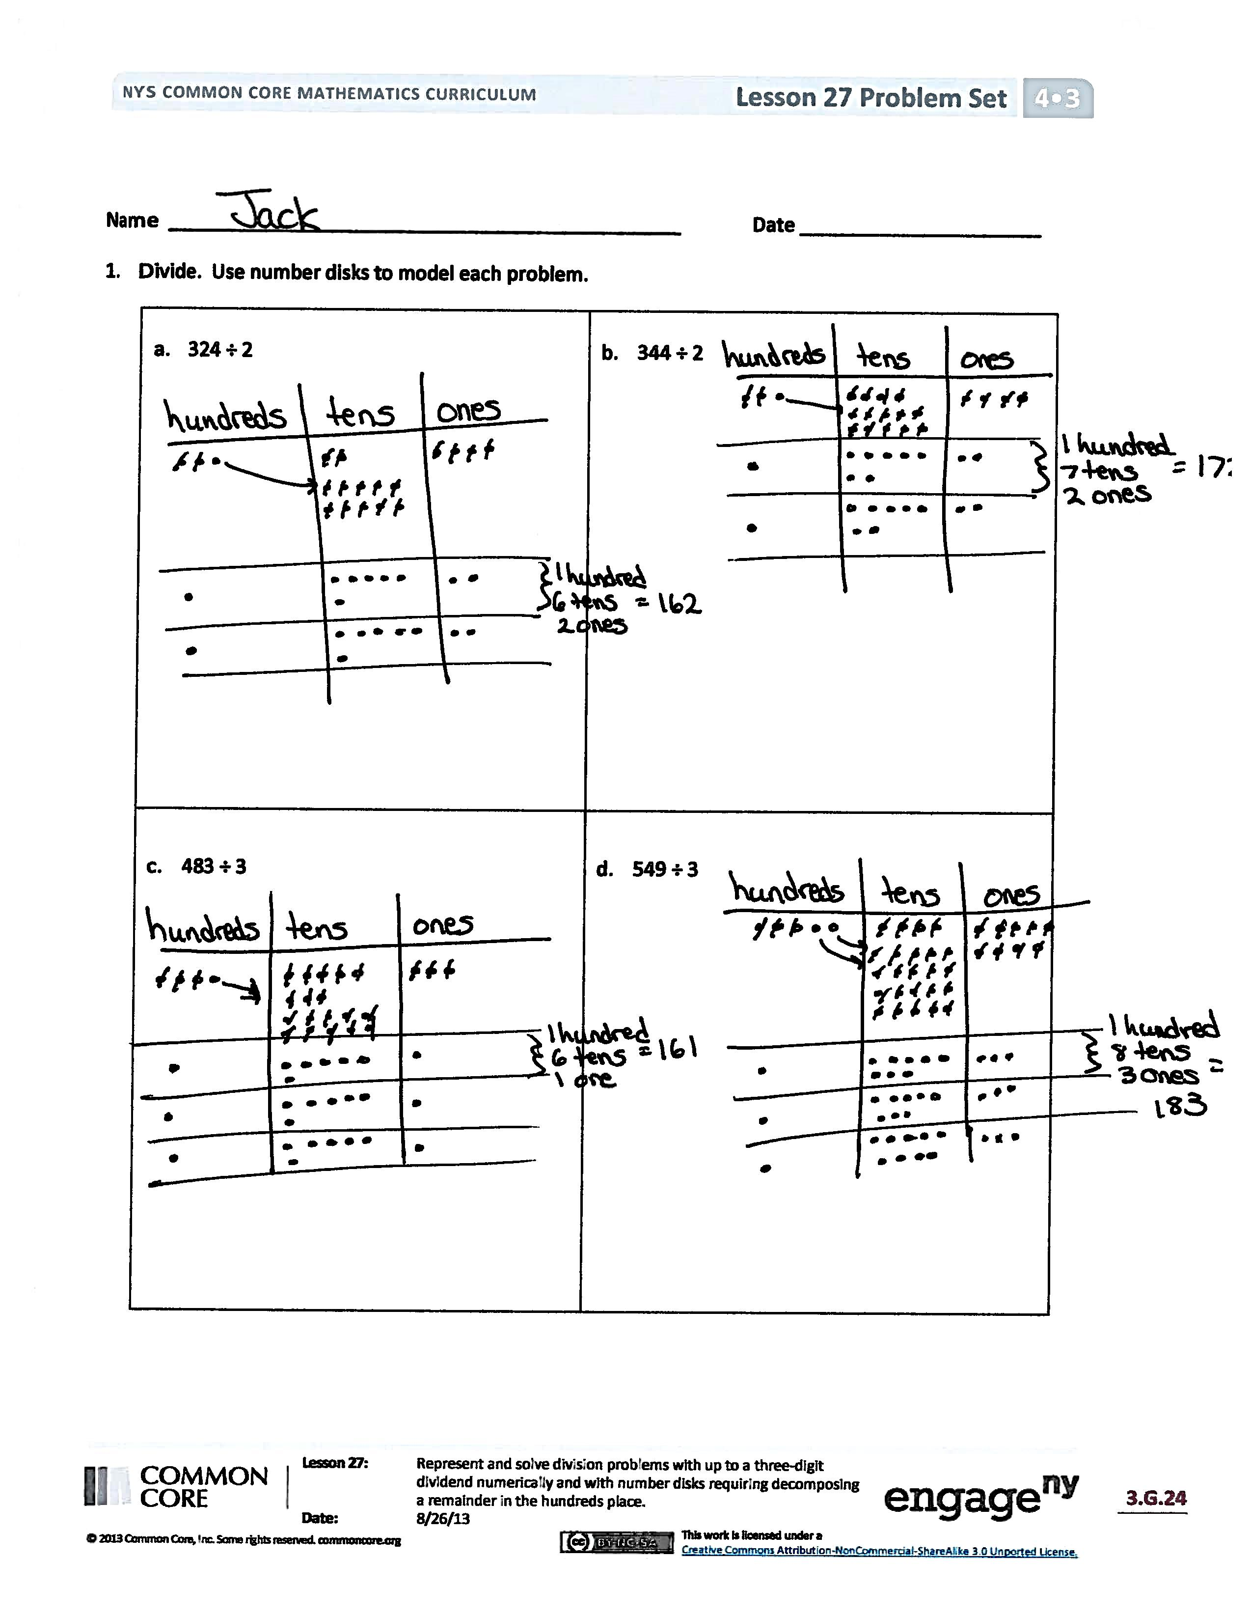

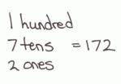The Student Debrief is intended to invite reflection and active processing of the total lesson experience.

Invite students to review their solutions for the Problem Set. They should check work by comparing answers with a partner before going over answers as a class. Look for misconceptions or misunderstandings that can be addressed in the Debrief. Guide students in a conversation to debrief the Problem Set and process the lesson.

Any combination of the questions below may be used to lead the discussion.

* Think about ways to connect the division Problems in 1(a) and 1(b) to word problems. What are some other ways to say *divided by two*? Try making a connection to fractions by using words like *half*.
* Problems 1(c) and 1(d) have the same divisor. Problem 1(d) has a larger whole. What conclusions can you make about quotients when the wholes are different, but the divisors are the same?
* The size of a remainder is closely connected with that of the divisor.
  + What conclusions can you make about remainders, whether they are in the hundreds, tens, or ones columns? Use Problems 2(a) and 2(b) to discuss your findings.
  + Imagine your partner found a remainder of 4 hundreds in Problem 2(b). How could you explain to him his mistake? Is there a connection with the remainder and the divisor that would help him to avoid this miscalculation in the future?
* In Problem 2(c), you had to decompose   
  2 hundreds into 20 tens. What did you find challenging about representing that using place value disks? Did it take a while to draw that many disks? Is there a model that would simplify that process? When is it more efficient to just imagine the disks and do the long division?

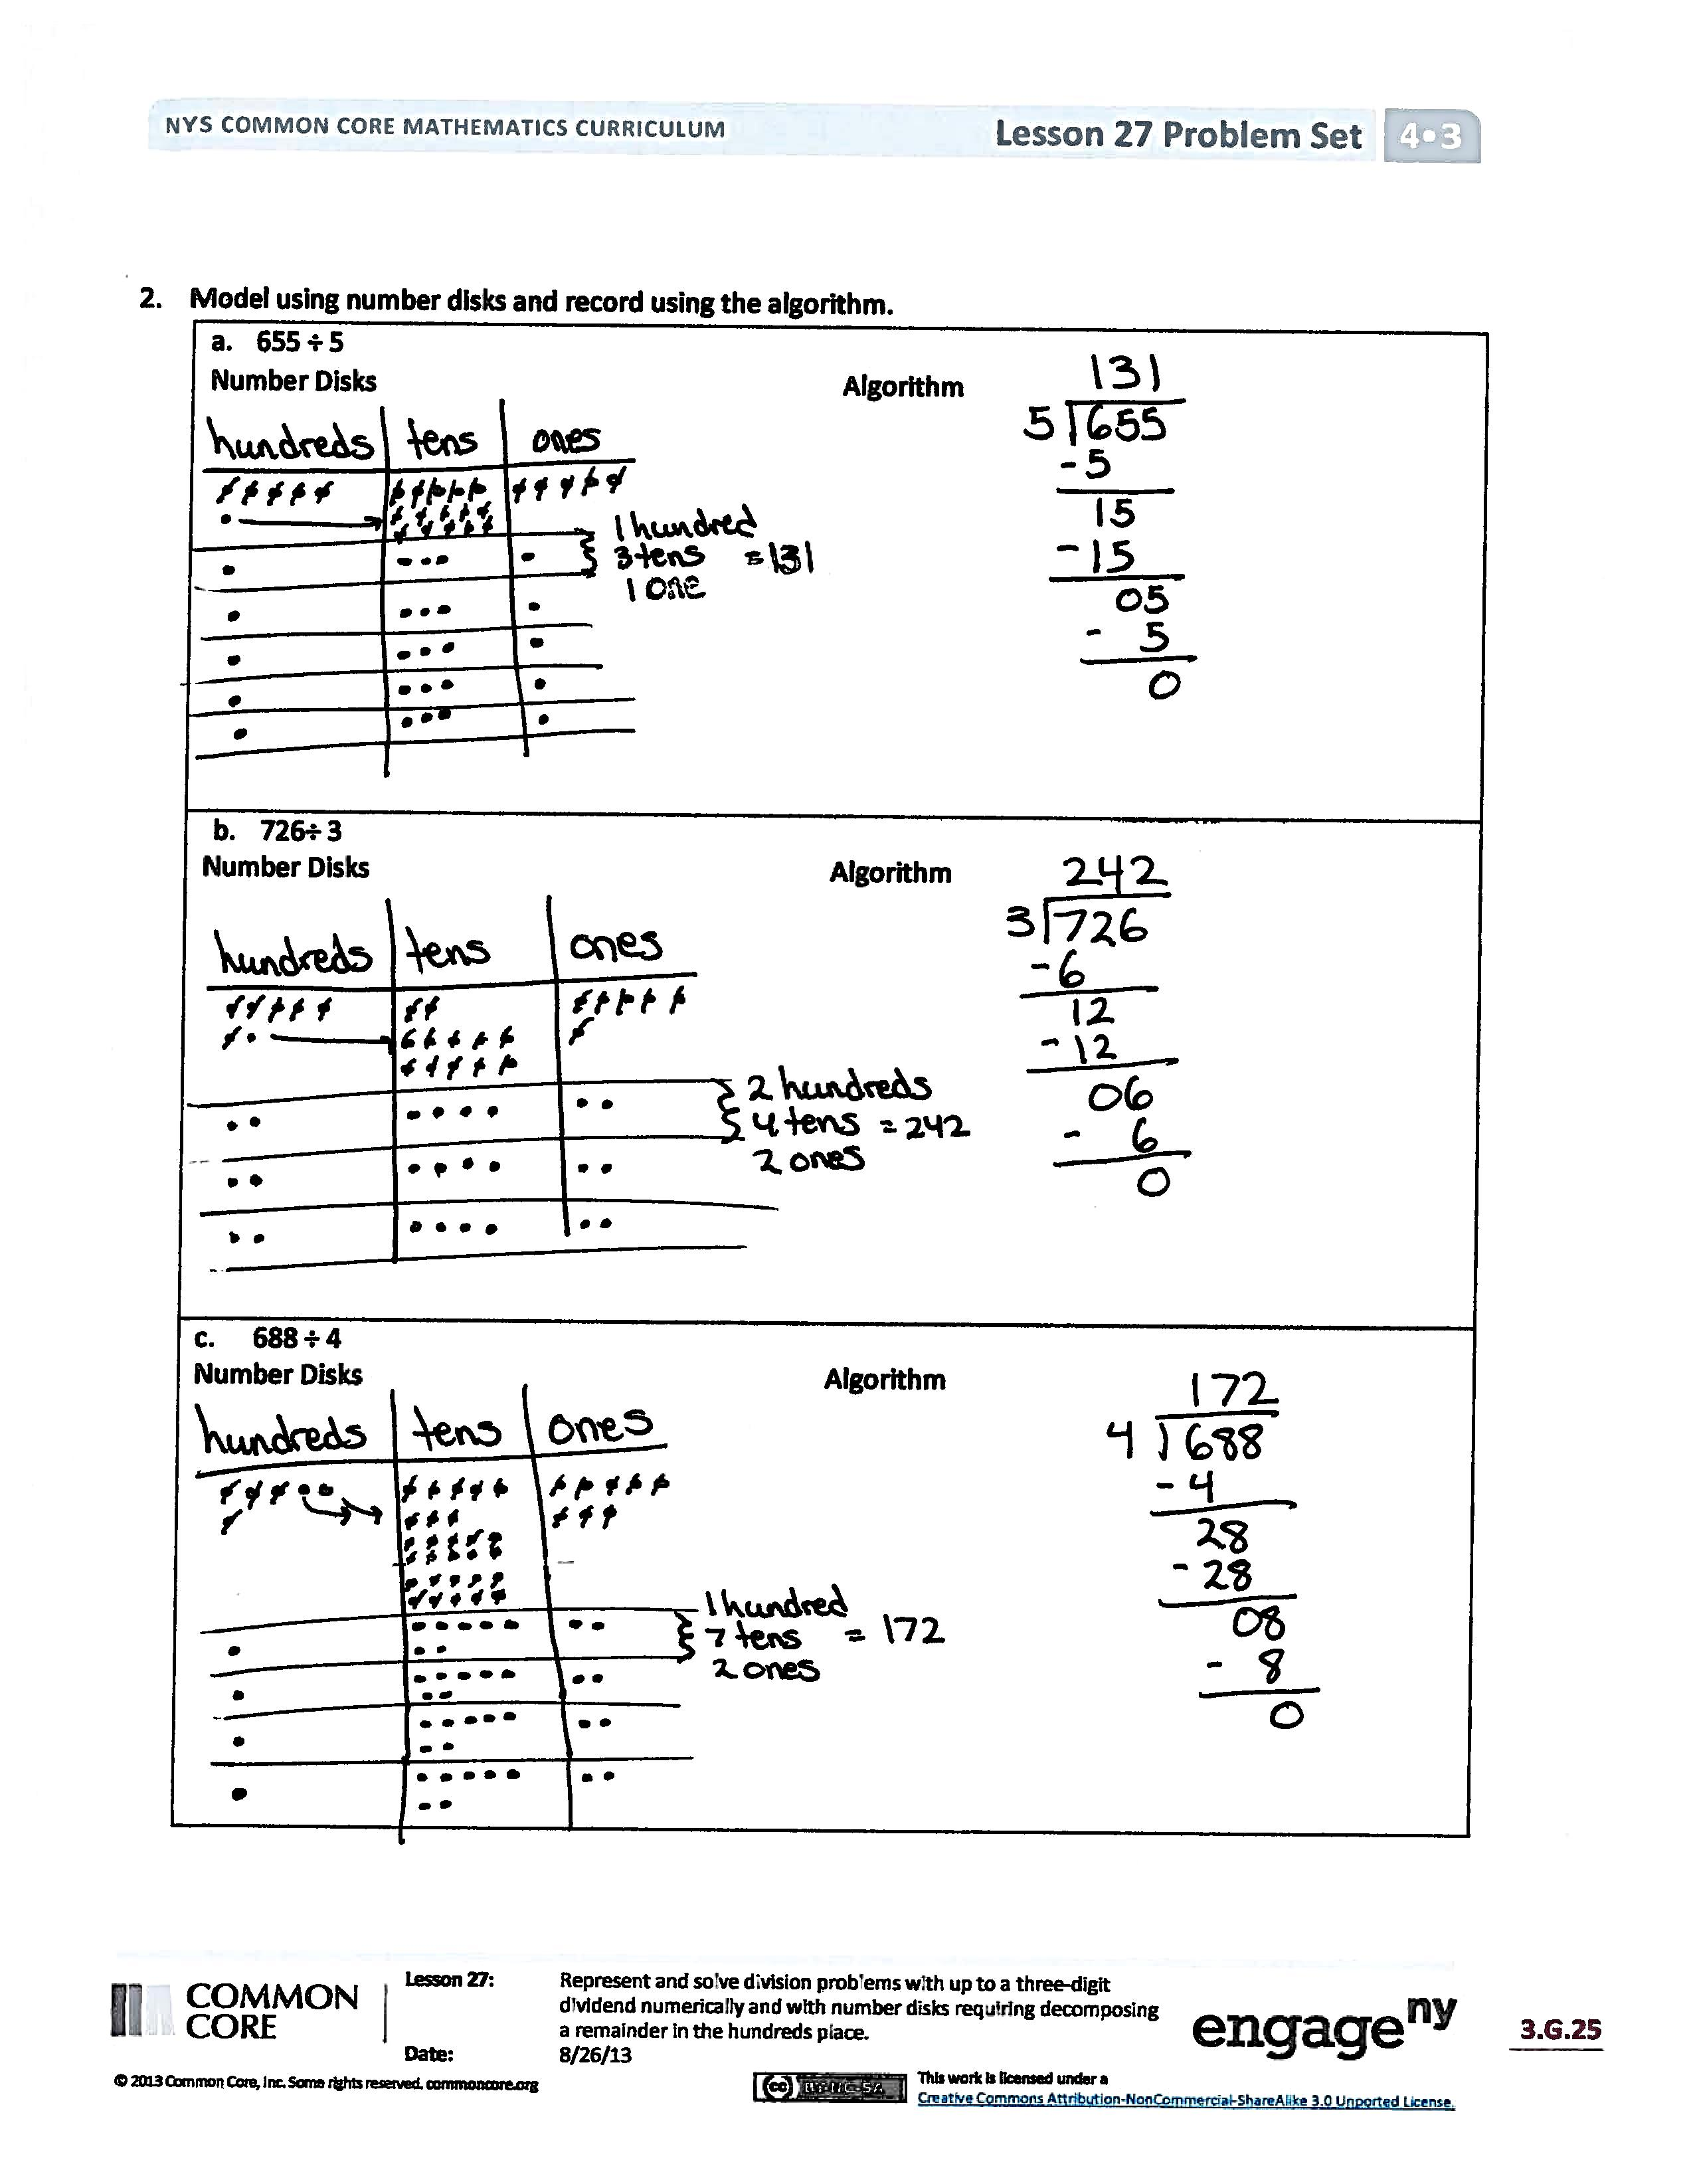

* What changed when we moved from dividing two-digit wholes to three-digit wholes? Would the same process we’re using for three-digit wholes work for four-digit wholes? Five digits? Six digits? A million digits?
* How did the Application Problem connect to today’s lesson?

Exit Ticket (3 minutes)

After the Student Debrief, instruct students to complete the Exit Ticket. A review of their work will help with assessing students’ understanding of the concepts that were presented in today’s lesson and planning more effectively for future lessons. The questions may be read aloud to the students.

**A**

**[KEY]**

Number Correct: _______

Circle the Prime Number

|  |  |  |  |  |  |  |  |
| --- | --- | --- | --- | --- | --- | --- | --- |
|  | 4 | 3 |  |  | 40 | 41 | 42 |
|  | 6 | 3 |  |  | 42 | 43 | 44 |
|  | 8 | 3 |  |  | 49 | 47 | 45 |
|  | 5 | 10 |  |  | 53 | 50 | 55 |
|  | 5 | 12 |  |  | 54 | 56 | 59 |
|  | 5 | 14 |  |  | 99 | 97 | 95 |
|  | 8 | 7 |  |  | 90 | 92 | 91 |
|  | 9 | 11 |  |  | 95 | 96 | 97 |
|  | 11 | 15 |  |  | 88 | 89 | 90 |
|  | 15 | 17 |  |  | 60 | 61 | 62 |
|  | 19 | 16 |  |  | 63 | 65 | 67 |
|  | 14 | 11 |  |  | 71 | 70 | 69 |
|  | 13 | 12 |  |  | 73 | 75 | 77 |
|  | 18 | 17 |  |  | 49 | 79 | 99 |
|  | 19 | 20 |  |  | 63 | 93 | 83 |
|  | 21 | 23 |  |  | 22 | 2 | 12 |
|  | 25 | 19 |  |  | 17 | 27 | 57 |
|  | 29 | 27 |  |  | 5 | 15 | 25 |
|  | 31 | 30 |  |  | 39 | 49 | 59 |
|  | 33 | 37 |  |  | 1 | 21 | 31 |
|  | 9 | 2 |  |  | 51 | 57 | 2 |
|  | 51 | 2 |  |  | 84 | 95 | 43 |

**B**

**[KEY]**

Number Correct: _______

Improvement: _______

Circle the Prime Number

|  |  |  |  |  |  |  |  |
| --- | --- | --- | --- | --- | --- | --- | --- |
|  | 4 | 5 |  |  | 42 | 41 | 40 |
|  | 6 | 5 |  |  | 44 | 43 | 42 |
|  | 8 | 5 |  |  | 45 | 47 | 49 |
|  | 7 | 10 |  |  | 53 | 55 | 50 |
|  | 7 | 12 |  |  | 56 | 54 | 59 |
|  | 7 | 14 |  |  | 95 | 97 | 99 |
|  | 4 | 3 |  |  | 90 | 91 | 92 |
|  | 11 | 10 |  |  | 99 | 98 | 97 |
|  | 15 | 11 |  |  | 90 | 89 | 88 |
|  | 17 | 15 |  |  | 67 | 65 | 63 |
|  | 19 | 20 |  |  | 62 | 61 | 60 |
|  | 14 | 13 |  |  | 72 | 71 | 70 |
|  | 11 | 12 |  |  | 77 | 75 | 73 |
|  | 16 | 17 |  |  | 27 | 67 | 77 |
|  | 19 | 18 |  |  | 39 | 49 | 59 |
|  | 22 | 23 |  |  | 32 | 2 | 22 |
|  | 21 | 19 |  |  | 19 | 49 | 69 |
|  | 29 | 28 |  |  | 5 | 15 | 55 |
|  | 31 | 33 |  |  | 99 | 49 | 59 |
|  | 35 | 37 |  |  | 1 | 21 | 41 |
|  | 2 | 9 |  |  | 45 | 51 | 2 |
|  | 57 | 2 |  |  | 48 | 85 | 67 |

Name Date

1. Divide. Use place value disks to model each problem.

|  |
| --- |
| 1. 324 ÷ 2 |
| 1. 344 ÷ 2 |
| 1. 483 ÷ 3 |
| 1. 549 ÷ 3 |

1. Model using place value disks and record using the algorithm.

|  |  |
| --- | --- |
| 1. 655 ÷ 5 | |
| Disks | Algorithm |
| 1. 726÷ 3 | |
| Disks | Algorithm |
| 1. 688 ÷ 4 | |
| Disks | Algorithm |

Name Date

Divide. Use place value disks to model each problem. Then, solve using the algorithm.

|  |  |
| --- | --- |
| 1. 423 ÷ 3 | |
| Disks | Algorithm |
| 1. 564 ÷ 4 | |
| Disks | Algorithm |

Name Date

1. Divide. Use place value disks to model each problem.

|  |
| --- |
| 1. 346 ÷ 2 |
| 1. 528 ÷ 2 |
| 1. 516 ÷ 3 |
| 1. 729 ÷ 3 |

1. Model using place value disks, and record using the algorithm.

|  |  |
| --- | --- |
| 1. 648 ÷ 4 | |
| Disks | Algorithm |
| 1. 755 ÷ 5 | |
| Disks | Algorithm |
| 1. 964 ÷ 4 | |
| Disks | Algorithm |