Lesson 26
Objective: Divide multiples of 10, 100, and 1,000 by single-digit numbers.

Suggested Lesson Structure
 Fluency Practice (12 minutes)
 Application Problem (5 minutes)
 Concept Development (30 minutes)
 Student Debrief (13 minutes)
Total Time (60 minutes)
Fluency Practice (12 minutes)
- Show Values with Place Value Disks 4.NBT.1 (4 minutes)
- Group Counting 4.OA.1 (2 minutes)
- List Multiples and Factors 4.OA.4 (2 minutes)
- List Prime Numbers 4.OA.4 (4 minutes)
Show Values with Place Value Disks (4 minutes)
Materials: (T) Thousands place value chart (Lesson 4 Template) (S) Personal white board, thousands place value chart (Lesson 4 Template)
Note: This fluency activity prepares students for this lesson’s Concept Development.
Repeat the process from Lesson 15 with the following possible sequence (projected or drawn).
- 1 hundreds disk, 2 tens disks, and 3 ones disks
- 4 hundreds disks, 1 tens disk, and 3 ones disks
- 3 hundreds disks, 15 tens disks, and 2 ones disks
- 2 hundreds disks, 15 tens disks, and 3 ones disks
Follow by having students draw disks for 524, 231, and 513.

Group Counting (2 minutes)
Note: Group counting reviews factors and multiples.
Direct students to count forward and backward, occasionally changing the direction of the count.
- Threes to 30
- Fours to 40
- Sixes to 60
- Eights to 80
List Multiples and Factors (2 minutes)
Materials: (S) Personal white board
Note: This fluency activity reviews Topic F’s content and gives students practice in remembering the difference between factors and multiples.
Repeat the process from Lesson 25 with the following possible sequence: 4 multiples of 6 starting from 60, the 4 factors of 6, the 4 factors of 8, 4 multiples of 8 starting at 80, the 3 factors of 9, and 4 multiples of 9 starting at 90.
List Prime Numbers (4 minutes)
Materials: (S) Paper
Note: This fluency activity reviews Lesson 25’s Concept Development.
T: What’s the smallest prime number?
S: 2.
T: On your paper, write 2.
T: Are there any other even prime numbers?
S: No.
T: On your paper, list the prime numbers in order from least to greatest, beginning with 2. You have one minute.
S: (List the prime numbers.)
T: Compare your list with your partner’s. Look for differences in your lists and decide who is correct. Make changes to your lists as needed. You have two minutes.

Application Problem (5 minutes)
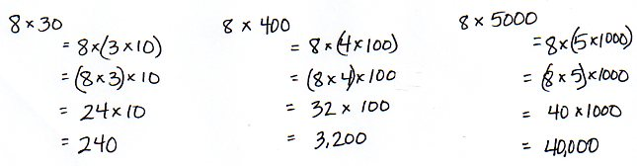
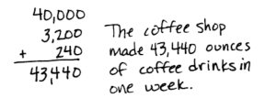
A coffee shop uses 8-ounce mugs to make all of its coffee drinks. In one week, they served 30 mugs of espresso, 400 lattes, and 5,000 mugs of coffee. How many ounces of coffee drinks did they make in that one week?

Note: By reviewing multiplication of 10, 100, and 1,000, this Application Problem leads up to today’s Concept Development, which will explore division of multiples of 10, 100, and 1,000.
Concept Development (30 minutes)

NOTES ON
MULTIPLE MEANS
OF ENGAGEMENT:
Students who still need visual support to divide may be allowed to draw place value disks or to use concrete place value disks.

Materials: (T) Thousands place value chart for dividing (Template) (S) Personal white board, thousands place value chart for dividing (Template)
Problem 1
9 ÷ 3 and 90 ÷ 3
900 ÷ 3 and 9,000 ÷ 3
Display 9 ÷ 3 and 90 ÷ 3.
T: Let’s draw place value disks to represent these expressions. Solve. Compare your models to your partner’s.
T: Give me a number sentence for each in unit form.
S: 9 ones ÷ 3 = 3 ones. 9 tens ÷ 3 = 3 tens.
Display 900 ÷ 3 and 9,000 ÷ 3.
T: Tell your partner how you might model these two expressions.
S: It’s just like we did for the last problems.
We represented 9 disks and divided them into 3 groups. Our disks will be in the hundreds or in the thousands. We won’t have a remainder because 3 is a factor of 9.
T: Model these expressions, using place value disks, with your partner.
S: (Draw disks and divide.)
T: What do you notice?
S: All 9 disks were split into 3 groups of 3, but they are groups of different units.
T: Write these number sentences in unit form. Turn and talk with your partner about what you notice.
S: They all look similar. They are the same with different units. They are all solved with 9 divided by 3; they just have different units.
Problem 2
500 ÷ 5
350 ÷ 5
3,000 ÷ 5
Display 500 ÷ 5.
T: On your personal white board, rewrite the expression
500 ÷ 5 in unit form.
S: (Write 5 hundreds ÷ 5.)
T: Why don’t you need a pencil and paper to solve this problem?
S: Because 5 divided by 5 is 1, and the unit is hundreds.
The answer is 1 hundred. Five of anything divided by 5 is 1. Yeah, 5 bananas divided by 5 is 1 banana.
Display 350 ÷ 5.
T: Now, let’s look at 350 divided by 5. Rewrite this expression in unit form. Talk to your partner about how representing this expression is different from the last one.
S: This time we have two units, hundreds and tens. I can rename 3 hundreds and 5 tens as 35 tens. 35 tens divided by 5. We didn’t have to decompose 5 hundreds, but now we do have to change 3 hundreds for tens since we can’t divide
3 hundreds by 5.
T: Let’s use 35 tens. Say the number sentence you will use to solve in unit form.
S: 35 tens ÷ 5 = 7 tens.
T: What is the quotient of 350 divided by 5?
S: 70.
T: Let’s model this on the place value chart just to be sure you really understand. Draw 3 hundreds and 5 tens and change the hundreds into smaller units.
S: It’s true. When I decomposed each hundred, I got 10 more tens.
5 tens + 10 tens + 10 tens + 10 tens is 35 tens. Each 10 tens is 1 hundred.
Display 3,000 ÷ 5.

NOTES ON
MULTIPLE MEANS
OF ACTION AND EXPRESSION:
Support English language learners and others as they transcribe number form to unit form. If helpful, guide students to whisper-say the number before writing. Depending on students’ proficiency, provide the spelling of hundreds and thousands.
Help students understand how to determine the appropriate unit form. Say, “If the divisor is greater than the first digit, try a smaller unit form.” Give multiple examples.
T: Discuss with your partner a way to solve this problem.
T: (Allow one minute for students to discuss.) Solve. Compare your solution with a pair near you. Discuss the strategy you used.
T: (Allow time for sharing.) Is there a pair that would like to share their solution?
S: We had to decompose 3,000 into 30 hundreds because there weren’t enough thousands to divide. 30 hundreds divided by 5 is easy because we know 30 divided by 5 is 6. Then, we just had to divide
30 hundreds by 5 and got a quotient of 6 hundreds, or 600.
T How is this problem related to 350 ÷ 5?
S: 3 hundreds got changed for 30 tens, and 3 thousands got changed for 30 hundreds. In both problems, we had to change 3 larger units for 30 of the next smaller units. It’s like when we are subtracting and we don’t have enough units—we have to change a larger unit for smaller units, too.
T: Good connections. Turn and restate the ideas of your peers to your partner in your own words.
T: (Allow time for talk.) Let me fire some quick problems at you. Tell me the first expression you would solve.
For example, if I say 250 ÷ 2, you say 2 hundreds divided by 2. If I say 250 ÷ 5, you say 25 tens divided by 5. Ready?
Give students a sequence of problems such as the following:
120 ÷ 2; 400 ÷ 2; 6,200 ÷ 2; 1,800 ÷ 2; 210 ÷ 3; 360 ÷ 3; 1,200 ÷ 3; and 4,200 ÷ 3.
Problem 3
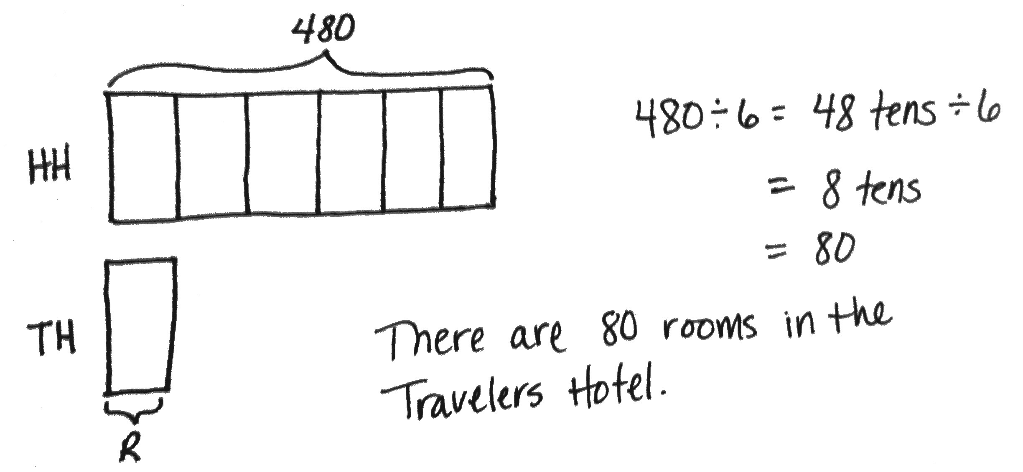
Display: The Hometown Hotel has a total of
480 guest rooms. That is 6 times as many rooms as the Travelers Hotel down the street. How many rooms are there in the Travelers Hotel?
T: Let’s read this problem together. Draw a tape diagram to model this problem. When you have drawn and labeled your diagram, compare it with your partner’s.
T: How can we determine the value of 1 unit? (Point to the unit representing the number of rooms at the Travelers Hotel.)
S: We need to divide 480 by 6.
MP.2
T: Yes, 480 divided by 6 units will give us the value of
1 unit. What strategy can you use to solve?

NOTES ON
MULTIPLE MEANS
OF ENGAGEMENT:
Instead of moving forward into the last word problem of the Problem Set, offer students working below grade level more opportunities to determine whether or not decomposition is necessary. Have students model, on a place value chart, the suggested sequence found at the end of Problem 2. Have them do the division using the models. Finally, have them state the full number sentence using the correct unit language.

S: We can rename 4 hundreds 8 tens as 48 tens.
T: Okay, how does that help?
S: 48 divided by 6 is 8, so 48 tens divided by 6 is 8 tens.
T: One unit is equal to …?
S: One unit equals 80.
T: So, how many rooms are there in the Travelers Hotel?
S: There are 80 rooms.
Problem Set (10 minutes)
Students should do their personal best to complete the Problem Set within the allotted 10 minutes. For some classes, it may be appropriate to modify the assignment by specifying which problems they work on first. Some problems do not specify a method for solving. Students should solve these problems using the RDW approach used for Application Problems.
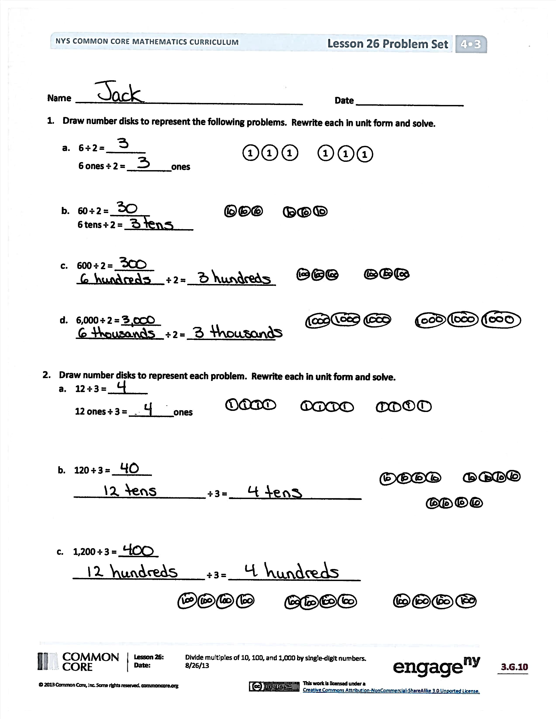
Student Debrief (13 minutes)
Lesson Objective: Divide multiples of 10, 100, and 1,000 by single-digit numbers.
The Student Debrief is intended to invite reflection and active processing of the total lesson experience.
Invite students to review their solutions for the Problem Set. They should check work by comparing answers with a partner before going over answers as a class. Look for misconceptions or misunderstandings that can be addressed in the Debrief. Guide students in a conversation to debrief the Problem Set and process the lesson.
Any combination of the questions below may be used to lead the discussion.
- How is writing the number sentence in unit form helpful for solving problems like Problem 1?
- How did you rename the numbers in Problems 2(b) and 2(c) to divide?
- How are Problems 3(a) and 3(e) alike? How are they different?

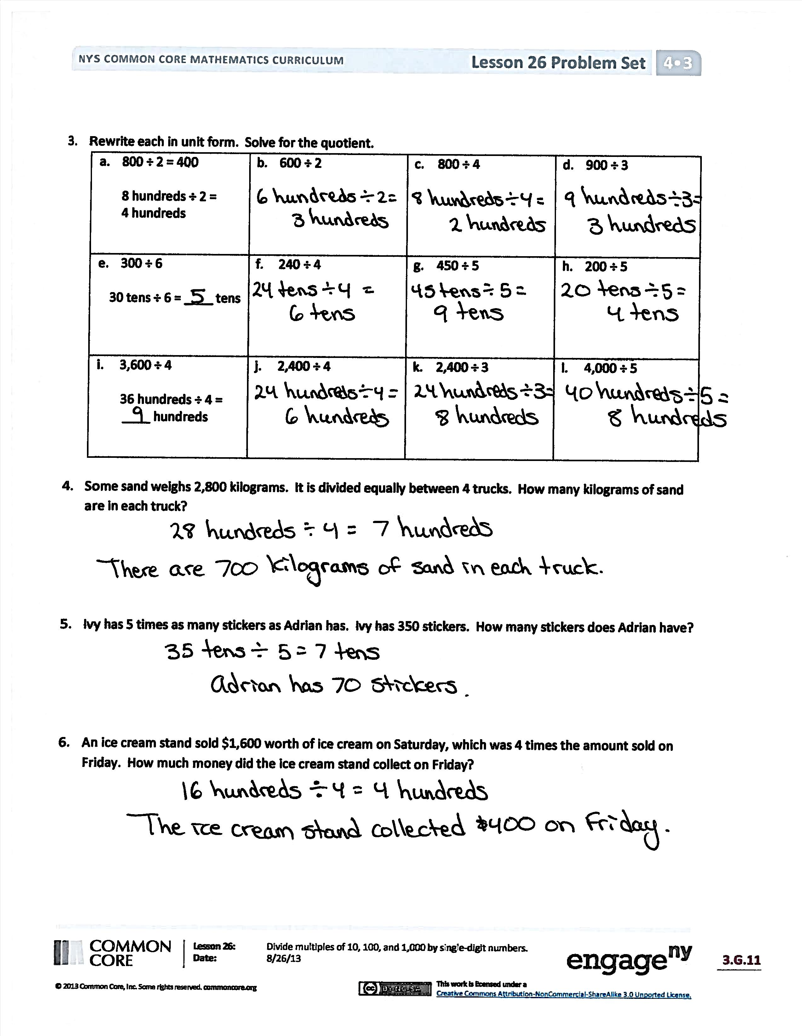
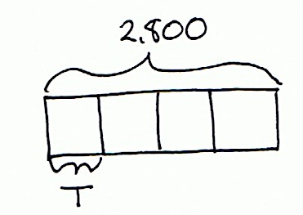
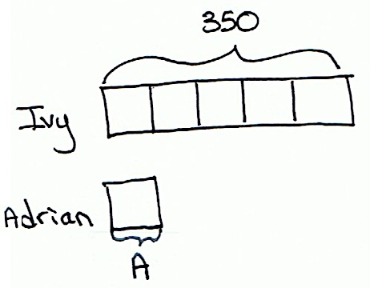
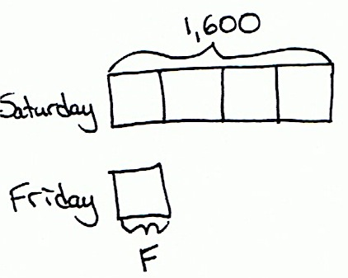
- Explain to your partner how to solve Problem 3(g). How can you start dividing in the hundreds when there aren’t enough hundreds to divide?
- How are the tape diagrams different for Problem 4 and Problem 5? How could multiplication be used to solve these problems?
- How did the Application Problem connect to today’s lesson?
Exit Ticket (3 minutes)
After the Student Debrief, instruct students to complete the Exit Ticket. A review of their work will help with assessing students’ understanding of the concepts that were presented in today’s lesson and planning more effectively for future lessons. The questions may be read aloud to the students.

Name Date
- Draw place value disks to represent the following problems. Rewrite each in unit form and solve.
- 6 ÷ 2 = ________
11
1
1
1
1
1
1
6 ones ÷ 2 = _________ ones

- 60 ÷ 2 = ________
6 tens ÷ 2 = ______________

- 600 ÷ 2 = ________
___________________________ ÷ 2 = ___________________________

- 6,000 ÷ 2 = ________
___________________________ ÷ 2 = ___________________________

- Draw place value disks to represent each problem. Rewrite each in unit form and solve.
- 12 ÷ 3 = ________
12 ones ÷ 3 = _________ ones

- 120 ÷ 3 = ________
___________________________ ÷ 3 = ___________________________

- 1,200 ÷ 3 = ________
___________________________ ÷ 3 = ___________________________

- Solve for the quotient. Rewrite each in unit form.
- 800 ÷ 2 = 400  8 hundreds ÷ 2 =  4 hundreds | - 600 ÷ 2 = ________ | - 800 ÷ 4 = ________ | - 900 ÷ 3 = _______
- 300 ÷ 6 = _________  30 tens ÷ 6 = ____ tens | - 240 ÷ 4 = ________ | - 450 ÷ 5 = ________ | - 200 ÷ 5 = _______
- 3,600 ÷ 4 = ________  36 hundreds ÷ 4 =  ____ hundreds | - 2,400 ÷ 4 = ________ | - 2,400 ÷ 3 = _______ | - 4,000 ÷ 5 = ______

- Some sand weighs 2,800 kilograms. It is divided equally among 4 trucks. How many kilograms of sand are in each truck?

- Ivy has 5 times as many stickers as Adrian has. Ivy has 350 stickers. How many stickers does Adrian have?

- An ice cream stand sold $1,600 worth of ice cream on Saturday, which was 4 times the amount sold on Friday. How much money did the ice cream stand collect on Friday?

Name Date
- Solve for the quotient. Rewrite each in unit form.
- 600 ÷ 3 = 200  6 hundreds ÷ 3 =  ____ hundreds | - 1,200 ÷ 6 = _______ | - 2,100 ÷ 7 = _______ | - 3,200 ÷ 8 = _____

- Hudson and 7 of his friends found a bag of pennies. There were 320 pennies, which they shared equally. How many pennies did each person get?

Name Date
- Draw place value disks to represent the following problems. Rewrite each in unit form and solve.
- 6 ÷ 3 = ________
1
1
1
1
1
1
6 ones ÷ 3 = _________ones

- 60 ÷ 3 = ________
6 tens ÷ 3 = ______________

- 600 ÷ 3 = ________
___________________________ ÷ 3 =___________________________

- 6,000 ÷ 3 = ________
___________________________ ÷ 3 = ___________________________

- Draw place value disks to represent each problem. Rewrite each in unit form and solve.
- 12 ÷ 4 = ________
12 ones ÷ 4 = _________ones

- 120 ÷ 4 = ________
___________________________ ÷ 4 = ___________________________

- 1,200 ÷ 4 = ________
___________________________ ÷ 4 = ___________________________
- Solve for the quotient. Rewrite each in unit form.
- 800 ÷ 4 = 200  8 hundreds ÷ 4 =  2 hundreds | - 900 ÷ 3 = _________ | - 400 ÷ 2 = ________ | - 300 ÷ 3 = ________
- 200 ÷ 4 = _________  20 tens ÷ 4 = ____ tens | - 160 ÷ 2 = _________ | - 400 ÷ 5 = ________ | - 300 ÷ 5 = ________
- 1,200 ÷ 3 = _________  12 hundreds ÷ 3 =  ____ hundreds | - 1,600 ÷ 4 = ________ | - 2,400 ÷ 4 = _______ | - 3,000 ÷ 5 = ______

- A fleet of 5 fire engines carries a total of 20,000 liters of water. If each truck holds the same amount of water, how many liters of water does each truck carry?

- Jamie drank 4 times as much juice as Brodie. Jamie drank 280 milliliters of juice. How much juice did Brodie drink?

- A diner sold $2,400 worth of French fries in June, which was 4 times as much as was sold in May.
How many dollars’ worth of French fries were sold at the diner in May?

ones
tens
hundreds
thousands
0F0F

thousands place value chart for dividing

