Lesson 25
Objective: Explore properties of prime and composite numbers to 100 by using multiples.

Suggested Lesson Structure
 Fluency Practice (12 minutes)
 Concept Development (30 minutes)
 Student Debrief (18 minutes)
Total Time (60 minutes)
Fluency Practice (12 minutes)
- Test for Factors 4.OA.5 (5 minutes)
- Multiples Are Infinite 4.NBT.1 (5 minutes)
- List Multiples and Factors 4.OA.4 (2 minutes)
Test for Factors (5 minutes)
Materials: (S) Personal white board
Note: This fluency activity reviews Lesson 23’s content.
T: (Project 40, 64, 54, and 42.) On your personal white board, write the number that has 10 as a factor.
S: (Write 40.)
T: Use division to prove both 4 and 2 are factors of 40.
T: Write the numbers that have 6 as a factor.
S: (Write 54 and 42.)
T: Prove that both 3 and 2 are factors of 54 and 42, using the associative property.
T: Write the numbers that have 8 as a factor.
S: (Write 40 and 64.)
T: Prove that both 4 and 2 are factors of 40 and 64, using the associative property.

Multiples Are Infinite (5 minutes)
Have students make groups of four. Assign each foursome a different number to count by starting at 0. Allow students two minutes to count round robin in their groups.
T: Let’s share our results. (Call on each group to share.)
T: Could you have kept counting by (assigned number) after I told you to stop?
S: Yes, because we just kept adding on (assigned number) more. Yes, because you can keep counting forever.
T: (Allow all groups to share.) We now know the multiples for any number are infinite—they go on forever. How is that different from the factors of a number? Turn and talk to your partner about this question.
S: Every number has only a certain amount of factors but an unlimited number of multiples. The number of factors any number has is finite, but the number of multiples is infinite.
List Multiples and Factors (2 minutes)
Materials: (S) Personal white board
Note: This fluency activity gives students practice in remembering the difference between factors and multiples.
T: (Write 3.) List as many multiples of 3 as you can in the next 20 seconds. Take your mark. Get set. Go.
S: (Write 3, 6, 9, 12, 15, 18, 21, 24, ….)
T: List the factors of 3.
S: (Write 1, 3.)
Continue with the following possible sequence: multiples of 4, factors of 4; multiples of 5, factors of 5.
Concept Development (30 minutes)
Materials: (T) Sieve (for the Student Debrief) (S) Problem Set, orange crayon, red crayon
Note: Use the Problem Set to guide this lesson’s content.
T: Let’s take a look at the number chart in front of you. What is the smallest prime number you see on the chart?
S: Two.
T: What is the greatest composite number you see? How do you know?
S: One hundred, because it is even. One hundred, because all even numbers greater than 2 have 2 as a factor, so they have to be composite numbers.
T: Excellent! Now, working with your partner, read and follow all of the directions at the top of the first page of the Problem Set. Be sure to follow the directions in order, and check with each other to see that you complete each activity the same way. If you find that you have different responses at times, talk about it to see what the correct thing to do is.
As students are charged with determining multiples that are greater than those in the times tables, some will choose to continue adding on, while others will choose to divide, and some will begin to rely on number patterns they have noticed. Encourage partners to compare strategies.
Note: At a certain point, the majority of students will have finished marking off multiples of 7. A few may have begun to notice that the multiples of the remaining numbers have already been crossed off. Interrupt the class at this point. Below is the suggested midpoint dialogue.
T: After you marked off multiples of 7, what was the next number that you circled?
S: 11.
T: Were there any multiples of 11 that hadn’t been crossed out already?
S: No.
T: What about 13? Are there any multiples of 13 that still need to be crossed off?
S: No, they’re already crossed off from before.
T: I wonder if that’s true of the rest? Go back to 11. Let’s see if we can figure out what happened. Count by elevens within 100 using the chart.
S: 11, 22, 33, 44, 55, …, 99.
T: Ninety-nine is how many elevens?
S: 9 elevens.
T: So, by the time we circled 11, is it true that we’d already marked all of the multiples of 2, 3, all the way up to 10?
S: Well, yeah, we circled 2, 3, 5, and 7, and crossed off their multiples. We didn’t have to do fours, because the fours got crossed out when we crossed out multiples of 2. The same thing happened with the sixes, eights, nines, and tens.
T: Interesting, so we had already crossed out 2 × 11, 3 × 11, all the way up to 9 × 11. I wonder if the same thing happens with 13. Discuss with a partner: Will there be more or fewer groups of 13 than groups of 11 within a hundred?
S: More, because it is a bigger number. Fewer, because it is a larger number so fewer will fit in 100. Fewer because 9 × 11 is 99, so maybe 7 or 8 times 13 will be less than 100. 9 × 13 is more than 100, so fewer groups.
T: Take a moment to figure out how many multiples of 13 are within 100.
S: (Might count by 13 or multiply.)
T: How many multiples of 13 are less than 100?
S: 7.
T: 7 times 13 is…?
S: 91.
T: We already marked off 91 because it is a multiple of 7. The same is true for 6 × 13, 5 × 13, and so on. Do we need to mark off multiples of 17?
S: No, because there will be even fewer groups, and we already marked off those factors.
T: Exactly. The highest multiple of 17 on the hundreds chart is 85. 5 seventeens is 85. We already marked 2 × 17 up to 5 × 17.
Following this dialogue, have students return to work. Once students have correctly completed page 1, have them continue to page 2. Allow students time to thoroughly discuss and answer each question. Circulate and offer assistance as needed. Be ready to initiate or prompt discussions when students seem unsure.
Answer questions with questions to keep students thinking and analyzing.
Regroup, as the class completes page 2, to share responses to the Student Debrief questions.
Problem Set
Please note that the Problem Set comprises only questions used in the Concept Development. No additional time is allotted here since all problems are completed during the lesson. The Student Debrief has additional time allotted for the purpose of whole-class discussion of questions raised and discoveries made by the students during the Concept Development.
Student Debrief (18 minutes)
Lesson Objective: Explore properties of prime and composite numbers to 100 by using multiples.
The Student Debrief is intended to invite reflection and active processing of the total lesson experience.
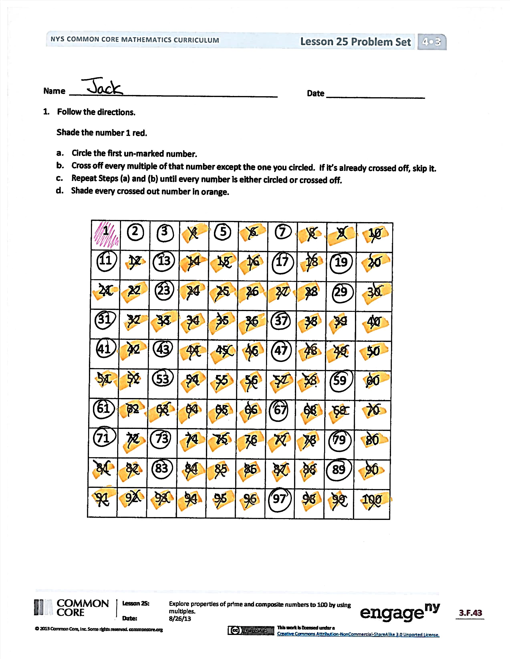
Invite students to review their solutions for the Problem Set. They should check work by comparing answers with a partner before going over answers as a class. Look for misconceptions or misunderstandings that can be addressed in the Debrief. Guide students in a conversation to debrief the Problem Set and process the lesson.
Any combination of the questions below may be used to lead the discussion .
- Which numbers are circled? Which numbers are crossed out?
- We started this Problem Set by coloring number 1 red and beginning our work with the multiples of 2. Why didn’t we cross out the multiples of 1?
- Are any prime numbers even? Are all odd numbers prime?
- We crossed off multiples of 2, 3, 5, and 7. Why didn’t we have to cross off multiples of 4 or 6?
- How did you know some of the larger numbers, like 53 and 79, were prime?
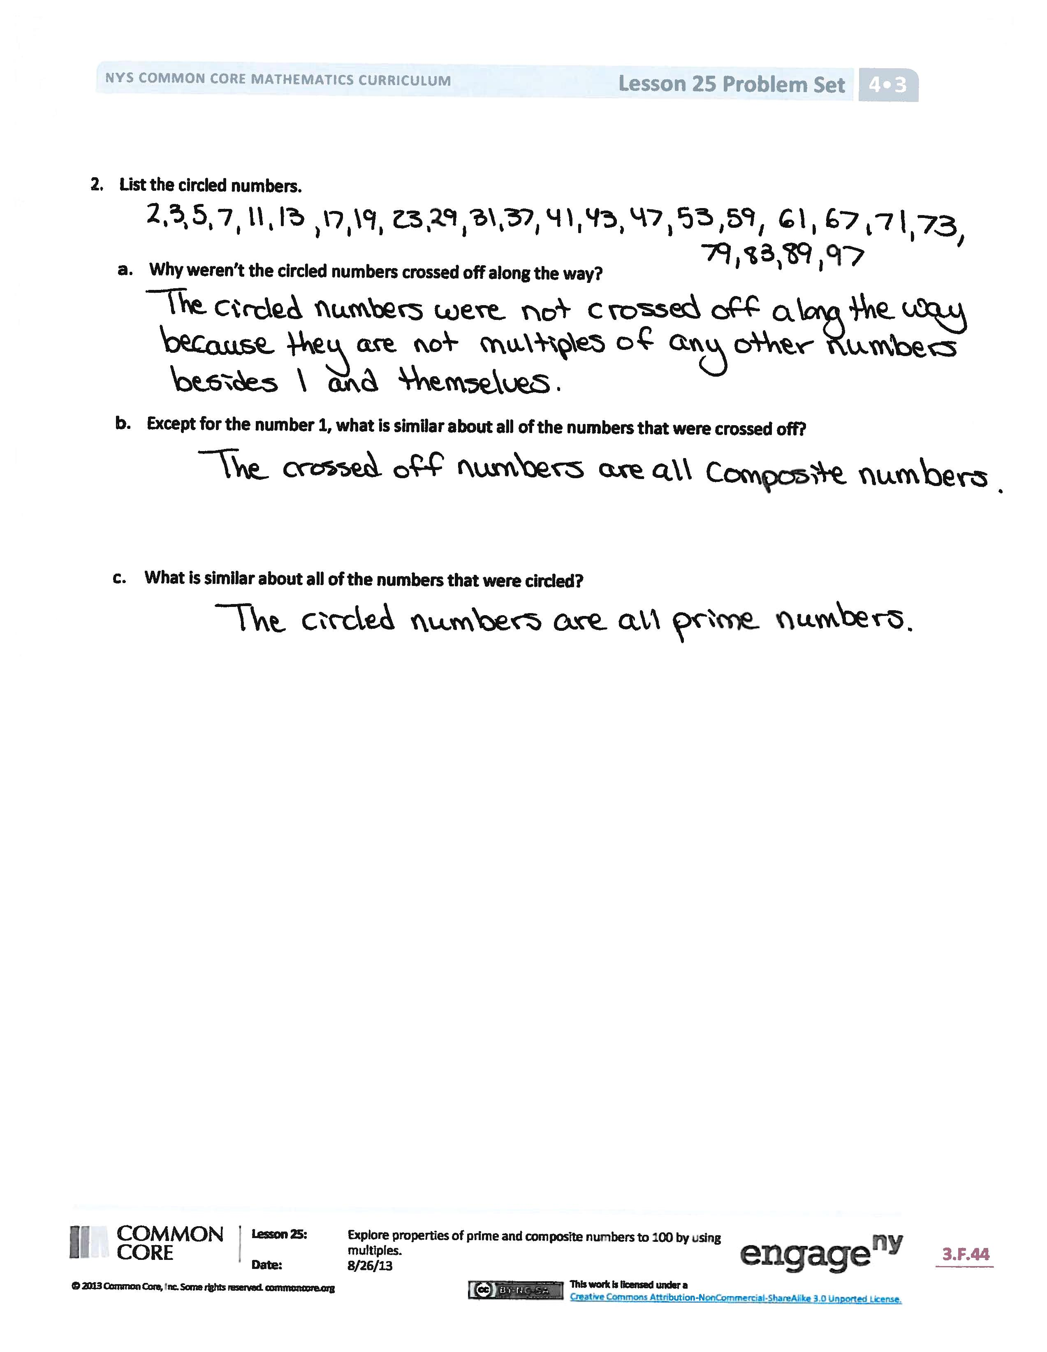
- How can we find the prime numbers between
1 and 200?
- The process of crossing out multiples to find primes is called the sieve of Eratosthenes. Eratosthenes was an ancient Greek mathematician. Why do you think this is called a sieve (show a sieve to the students)?
Exit Ticket (3 minutes)
After the Student Debrief, instruct students to complete the Exit Ticket. A review of their work will help with assessing students’ understanding of the concepts that were presented in today’s lesson and planning more effectively for future lessons. The questions may be read aloud to the students.

Name Date
- Follow the directions.
Shade the number 1 red.
- Circle the first unmarked number.
- Cross off every multiple of that number except the one you circled. If it’s already crossed off, skip it.
- Repeat Steps (a) and (b) until every number is either circled or crossed off.
- Shade every crossed out number in orange.
1 | 2 | 3 | 4 | 5 | 6 | 7 | 8 | 9 | 10
11 | 12 | 13 | 14 | 15 | 16 | 17 | 18 | 19 | 20
21 | 22 | 23 | 24 | 25 | 26 | 27 | 28 | 29 | 30
31 | 32 | 33 | 34 | 35 | 36 | 37 | 38 | 39 | 40
41 | 42 | 43 | 44 | 45 | 46 | 47 | 48 | 49 | 50
51 | 52 | 53 | 54 | 55 | 56 | 57 | 58 | 59 | 60
61 | 62 | 63 | 64 | 65 | 66 | 67 | 68 | 69 | 70
71 | 72 | 73 | 74 | 75 | 76 | 77 | 78 | 79 | 80
81 | 82 | 83 | 84 | 85 | 86 | 87 | 88 | 89 | 90
91 | 92 | 93 | 94 | 95 | 96 | 97 | 98 | 99 | 100

- a. List the circled numbers.

- Why were the circled numbers not crossed off along the way?

- Except for the number 1, what is similar about all of the numbers that were crossed off?

- What is similar about all of the numbers that were circled?

Name Date
Use the calendar below to complete the following:
- Cross off all composite numbers.
- Circle all of the prime numbers.
- List any remaining numbers.

Sunday Monday Tuesday Wednesday Thursday Friday Saturday
 |  |  |  |  | 1 | 2
3 | 4 | 5 | 6 | 7 | 8 | 9
10 | 11 | 12 | 13 | 14 | 15 | 16
17 | 18 | 19 | 20 | 21 | 22 | 23
24 | 25 | 26 | 27 | 28 | 29 | 30
31

Name Date
- A student used the sieve of Eratosthenes to find all prime numbers less than 100. Create a step-by-step set of directions to show how it was completed. Use the word bank to help guide your thinking as you write the directions. Some words may be used just once, more than once, or not at all.
Word Bank

circle
composite
prime
cross out
shade
X
multiple
number

Directions for completing the sieve of Eratosthenes activity:

- What do all of the numbers that are crossed out have in common?

- What do all of the circled numbers have in common?

- There is one number that is neither crossed out nor circled. Why is it treated differently?

