Lesson 21
Objective: Solve division problems with remainders using the area model.

Suggested Lesson Structure
 Fluency Practice (12 minutes)
 Application Problem (8 minutes)
 Concept Development (30 minutes)
 Student Debrief (10 minutes)
Total Time (60 minutes)
Fluency Practice (12 minutes)
- Sprint: Division with Remainders 4.NBT.6 (8 minutes)
- Find the Unknown Factor 4.OA.4 (4 minutes)
Sprint: Division with Remainders (8 minutes)
Materials: (S) Division with Remainders Sprint
Note: This Sprint reviews content from Topic E, including division with and without remainders.
Find the Unknown Factor (4 minutes)
Materials: (S) Personal white board
Note: This fluency activity prepares students for Lesson 22’s Concept Development
T: (Write 6 × ___ = 18.) Say the unknown factor.
S: 3.
T: (Write 18 ÷ 6.) On your personal white board, complete the division sentence.
S: (Write 18 ÷ 6 = 3.)
Continue with the following possible sequence: 3 × ___ = 21, 4 × ___ = 20, 5 × ___ = 25, 6 × ___ = 42,
7 × ___ = 56, 9 × ___ = 72, 6 × ___ = 54, 7 × ___ = 63, and 9 × ___ = 63.

Application Problem (8 minutes)
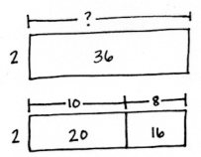
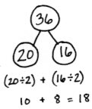
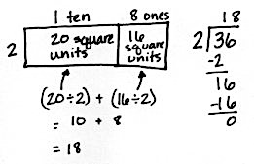
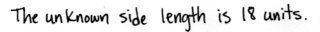
A rectangle has an area of 36 square units and a width of 2 units. What is the unknown side length?
Method 1:
Method 2:

Note: This Application Problem serves as an introduction to Problem 1 in the Concept Development, in which students find the total unknown length of a rectangle with an area of 37 and a width of 2. In today’s Concept Development, students move on to the complexity of using the area model when there is a remainder.
Concept Development (30 minutes)
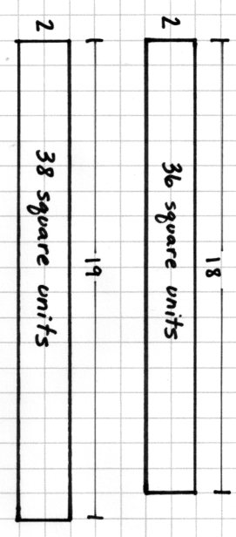
Materials: (T) Square grid paper (S) Problem Set
Note: Use the Problem Set for Lesson 21 to record work for Problems 1 and 2 of this Concept Development. Use the remaining problems on the Problem Set for class instruction or independent practice.
Problem 1: 37 ÷ 2
T: (Display the Application Problem with an area of 36 square units on grid paper.) This rectangle has a side length of 18. What would be the area of a rectangle with a width of 2 units and a length of 19 units? (Draw on grid paper.)
S: 38 square units.
T: So, we cannot represent a rectangle with a width of 2 and an area of 37 square units. Let’s get as close as we can to 37 square units by building a rectangle part to whole as we did yesterday.

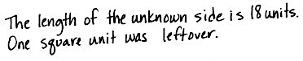
T: Draw a rectangle. Label the width as 2 units. Two times how many tens gets us as close as possible to an area of 3 tens?
S: 1 ten.
T: Label this rectangle with a length of 1 ten. Record 1 ten in the tens place. What is
1 ten times 2?
S: 2 tens.
T: How many square units of area is that?
S: 20 square units.
T: (Record 20 square units in the rectangle.) How many tens remain?
S: 1 ten. (Record 1 ten below 2 tens. Record
7 ones next to the 1 ten.)
T: 17 ones remain. Two times how many ones gives us an area close to 17 square units?
S: 8 ones.
T: Extend the rectangle, and label its length as
8 ones. 8 ones times 2 is…?
S: 16 ones.
T: 16 ones represents the area of this rectangle. (Label as 16 square units.) How many ones remain?
S: 1 one.
T: To make a new length unit, we must have
2 square units. We only have 1. Let’s draw the remaining 1 square unit.
T: Let’s validate our drawing and algorithm using the distributive property. 20 square units divided by 2 is…?
S: 10.
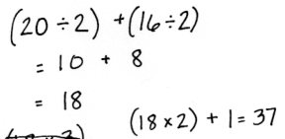
T: 10 length units. 16 square units divided by 2 is…?
S: 8 length units.
T: 10 length units plus 8 length units is…?
S: 18 length units.
T: Let’s solve for the area. 18 length units times 2 length units equals?
S: 36 square units.
T: We see that in our area model. Add 1 square unit, our remainder.
S: 37 square units.
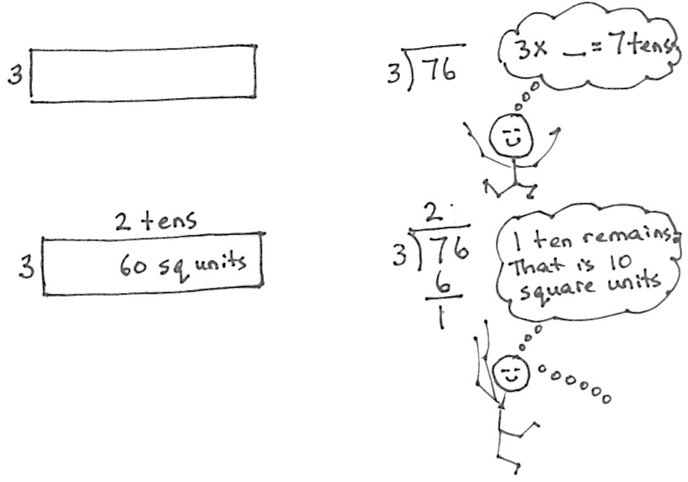
Problem 2: 76 ÷ 3
T: (Write 76 ÷ 3.) I’m going to represent this with an area model moving from part to whole by place value, just as we did with
37 ÷ 2. What should the total area be?
S: 76 square units.
T: (Draw a rectangle.) What is the width or the known side length?
S: 3 length units.
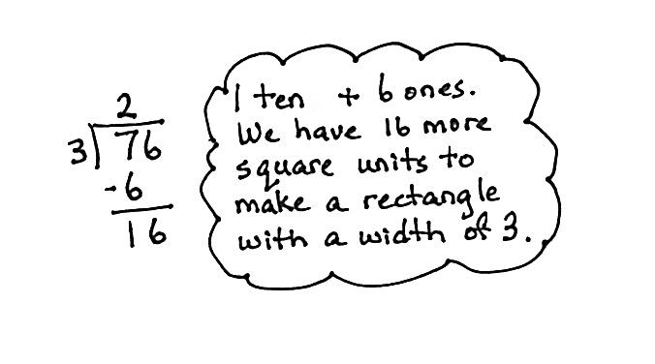
T: (Label a width of 3.) Three times how many tens gets us as close as possible to an area of 7 tens? (Point to the 7 tens of the dividend.)
S: 2 tens.
T: Let’s give 2 tens to the length. (Write the length on the area model.) Let’s record 2 tens in the tens place.
T: What is 2 tens times 3?
S: 6 tens. (Record 6 tens below the 7 tens.)
T: How many square units of area is that?
S: 60 square units. (Record in the rectangle.)
T: How many tens remain?
S: 1 ten. (Record 1 ten below the
6 tens.)
T: Let’s add the remaining ten to the
6 ones. What is 1 ten + 6 ones? (Record the 6 ones to the right of the 1 ten.)
S: 16 ones.
T: We have an area of 16 square units remaining with a width of 3. (Point to the 16 in the algorithm.) Three times how many ones gets us as close as possible to an area of 16?
S: 5 ones.
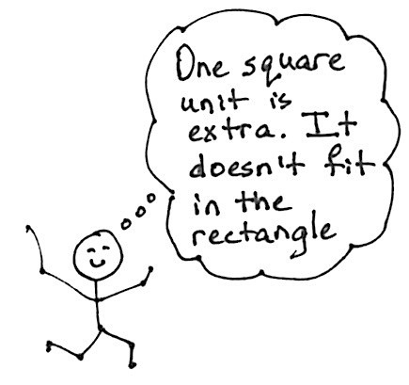
T: Let’s give 5 ones to the length. (Label the length.)
T: This rectangle has an area of…?
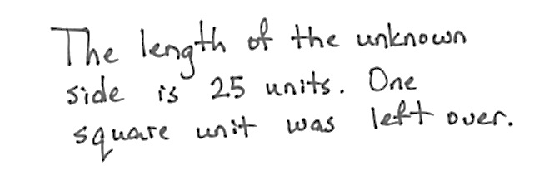
S: 15 square units.
T: How many square units remain?
S: 1 square unit.
T: What is the unknown length, and how many square units remain?
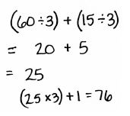
S: The unknown length is 25 with a remainder of 1 square unit.
T: 60 square units divided by a side length of 3 (record with the distributive property as shown to the right) gave us a side length of…?
S: 20.
T: Let’s say “length units.”
S: 20 length units.

NOTES ON
MULTIPLE MEANS
OF REPRESENTATION:
To draw the area models, consider giving students the option of using graph paper, which gives the concreteness of the squares that make up the area.

T: 15 square units divided by a side length of 3 (record) gave us a side length of…?
S: 5 length units.
T: The total length was…?
S: 25 length units.
T: With 1 square unit, we did not add on to the length.
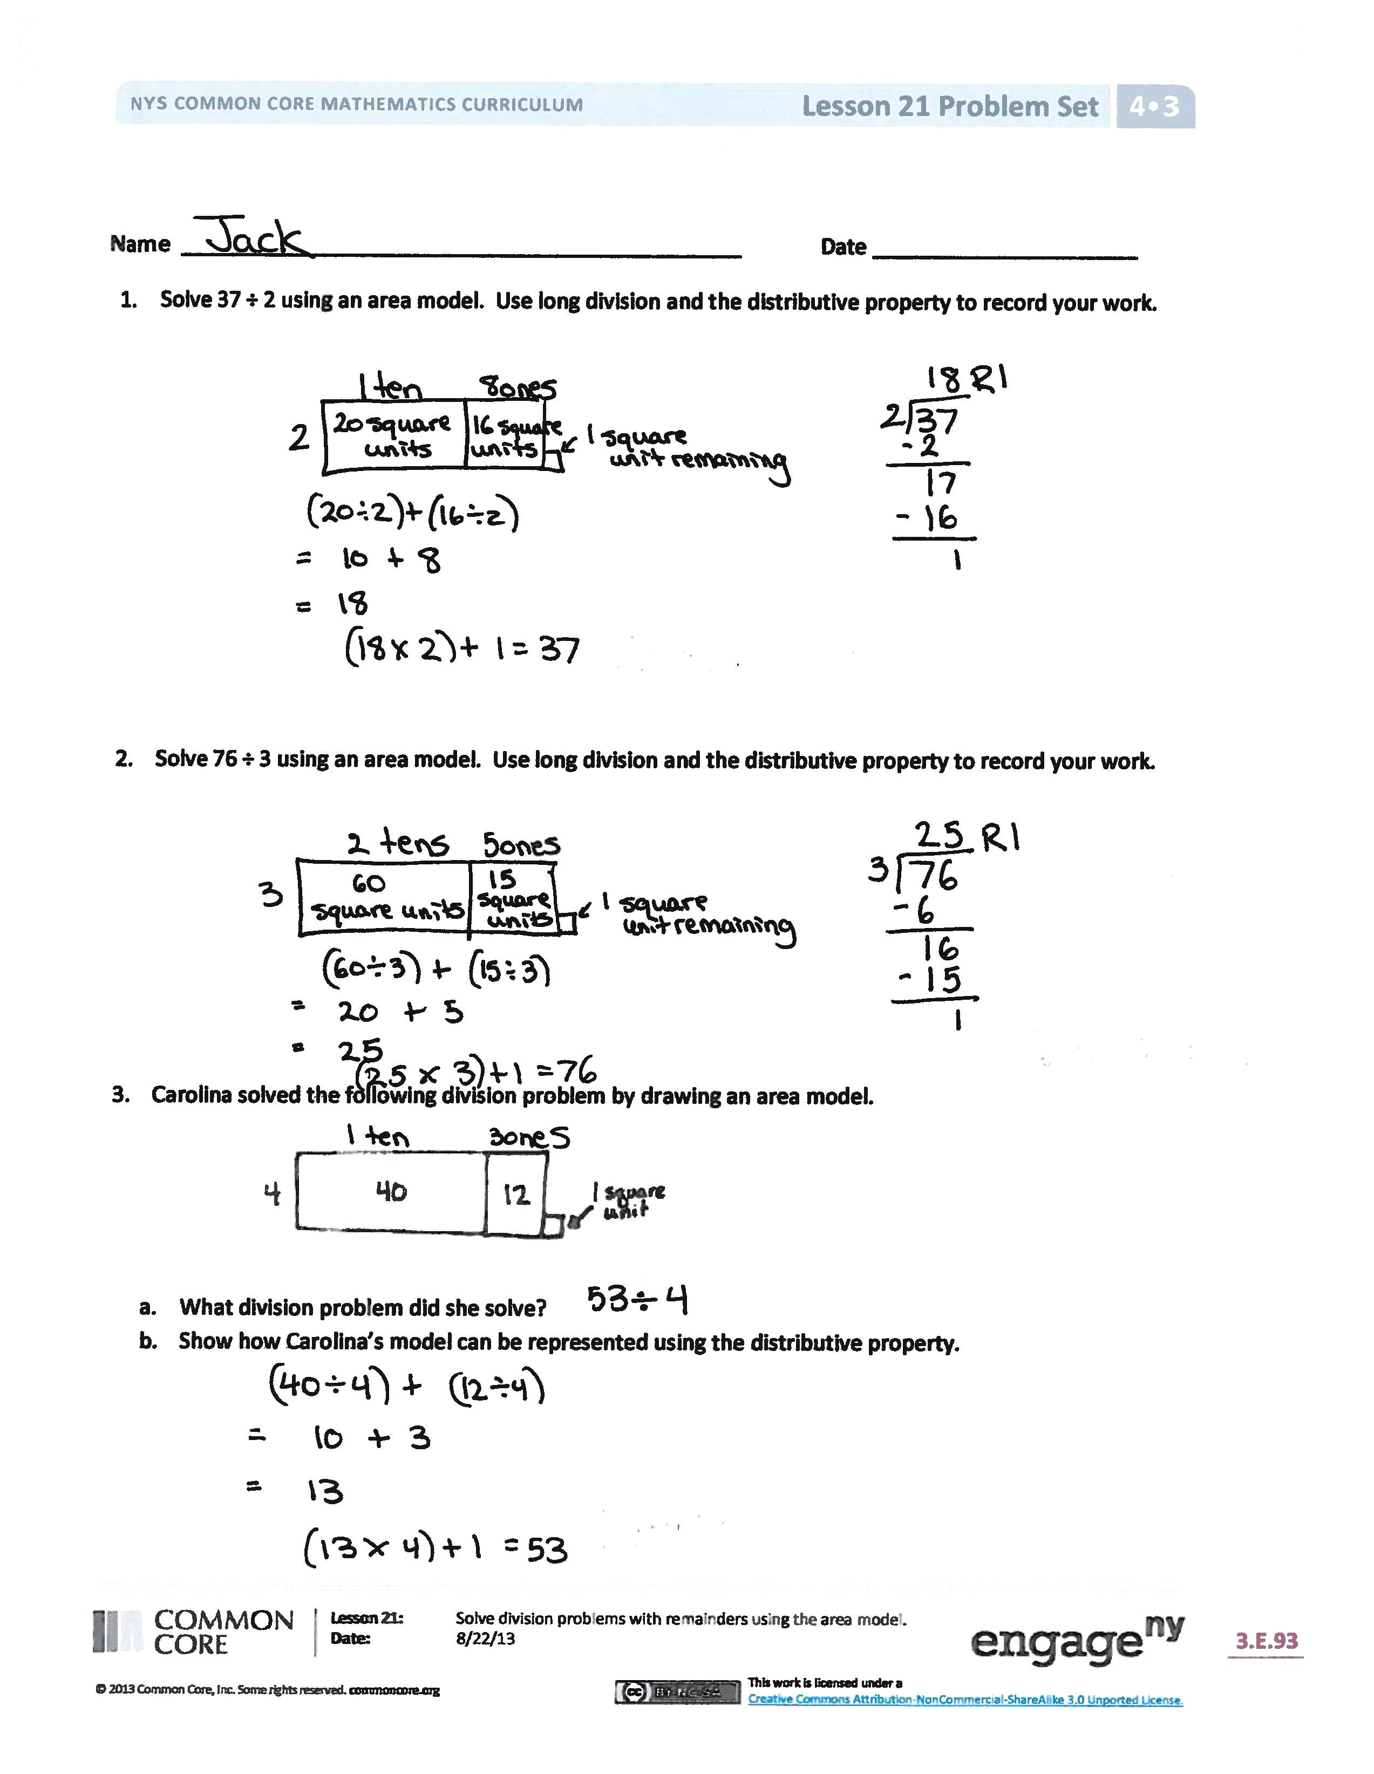
T: We built the area one rectangle at a time by place value. Each time after we divide, we have some area remaining. After dividing the tens, we had 16 square units remaining. (Point to the model and long division.) After dividing the ones, we had 1 square unit remaining. (Point to the model and long division.) Later, when we study fractions more, we will be able to make a little more length from that area, but for now, we are just going to leave it as 1 square unit of area remaining. (Optional: See the Student Debrief for a way of understanding the remainder as length.)
T: Review with your partner how we solved this problem step by step.
Have students proceed through the balance of the Problem Set, supported as necessary.
Problem Set (10 minutes)
Students should do their personal best to complete the remainder of the Problem Set within the allotted 10 minutes. For some classes, it may be appropriate to modify the assignment by specifying which problems they work on first. Some problems do not specify a method for solving. Students should solve these problems using the RDW approach used for Application Problems.

Student Debrief (10 minutes)
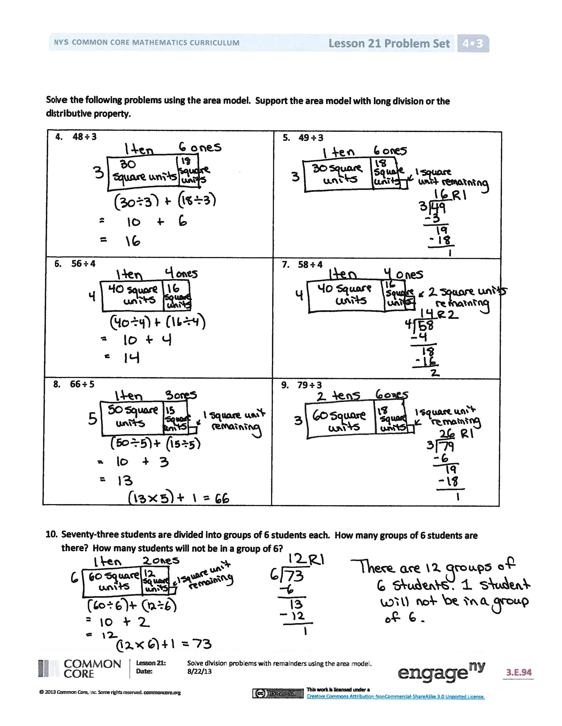
Lesson Objective: Solve division problems with remainders using the area model.
The Student Debrief is intended to invite reflection and active processing of the total lesson experience.
Invite students to review their solutions for the Problem Set. They should check work by comparing answers with a partner before going over answers as a class. Look for misconceptions or misunderstandings that can be addressed in the Debrief. Guide students in a conversation to debrief the Problem Set and process the lesson.
Any combination of the questions below may be used to lead the discussion.
- Explain to your partner the connection between the distributive property and the area model in Problem 3.
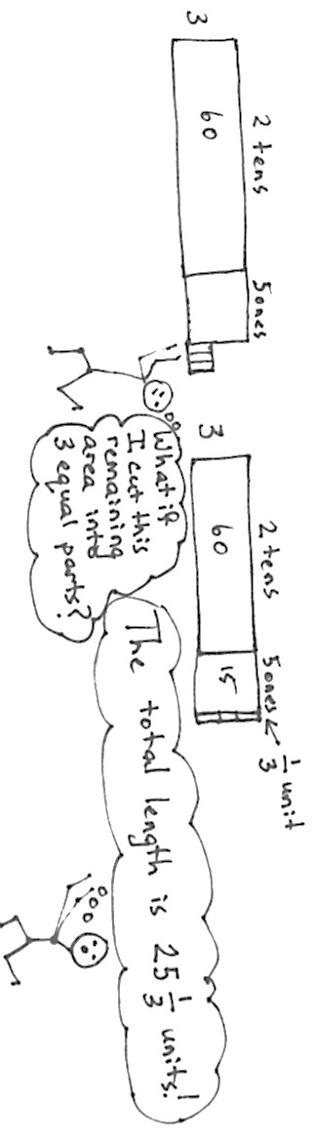
- Because we often have remainders when we divide, we have to use the area model by building up from part to whole. What did the first rectangle you drew in Problem 1 represent? The next chunk of the rectangle?
- Each time we divide, what happens to the amount of area we still have left to divide?
- Why don’t we have this complication of leftovers or remainders with multiplication?
- In Problem 4, we didn’t know if we were going to have a remainder in the ones place, so instead we built up to the area working with one place value unit at a time. How might the problems with remainders have been challenging if you started with the whole area, like in Lesson 20?
- (Optional.) Let’s look back at Problem 2, 76 ÷ 3. What if we cut this remaining square unit into 3 equal parts with vertical lines? What is the length of one of these units? What if we stack them to add more area? What is the total length of the new rectangle, including this tiny piece?
Exit Ticket (3 minutes)
After the Student Debrief, instruct students to complete the Exit Ticket. A review of their work will help with assessing students’ understanding of the concepts that were presented in today’s lesson and planning more effectively for future lessons. The questions may be read aloud to the students.
A
Number Correct: _______
Division with Remainders
 | 8 ÷ 2 | Q = ______ | R = ______ |  |  | 6 ÷ 2 | Q = ______ | R = ______
 | 9 ÷ 2 | Q = ______ | R = ______ |  |  | 7 ÷ 2 | Q = ______ | R = ______
 | 4 ÷ 4 | Q = ______ | R = ______ |  |  | 3 ÷ 3 | Q = ______ | R = ______
 | 5 ÷ 4 | Q = ______ | R = ______ |  |  | 4 ÷ 3 | Q = ______ | R = ______
 | 7 ÷ 5 | Q = ______ | R = ______ |  |  | 6 ÷ 4 | Q = ______ | R = ______
 | 8 ÷ 5 | Q = ______ | R = ______ |  |  | 7 ÷ 4 | Q = ______ | R = ______
 | 5 ÷ 3 | Q = ______ | R = ______ |  |  | 6 ÷ 6 | Q = ______ | R = ______
 | 6 ÷ 3 | Q = ______ | R = ______ |  |  | 7 ÷ 6 | Q = ______ | R = ______
 | 8 ÷ 4 | Q = ______ | R = ______ |  |  | 4 ÷ 2 | Q = ______ | R = ______
 | 9 ÷ 4 | Q = ______ | R = ______ |  |  | 5 ÷ 2 | Q = ______ | R = ______
 | 2 ÷ 2 | Q = ______ | R = ______ |  |  | 9 ÷ 3 | Q = ______ | R = ______
 | 3 ÷ 2 | Q = ______ | R = ______ |  |  | 9 ÷ 5 | Q = ______ | R = ______
 | 7 ÷ 3 | Q = ______ | R = ______ |  |  | 7 ÷ 7 | Q = ______ | R = ______
 | 8 ÷ 3 | Q = ______ | R = ______ |  |  | 9 ÷ 9 | Q = ______ | R = ______
 | 9 ÷ 3 | Q = ______ | R = ______ |  |  | 13 ÷ 4 | Q = ______ | R = ______
 | 8 ÷ 6 | Q = ______ | R = ______ |  |  | 18 ÷ 5 | Q = ______ | R = ______
 | 9 ÷ 6 | Q = ______ | R = ______ |  |  | 21 ÷ 6 | Q = ______ | R = ______
 | 5 ÷ 5 | Q = ______ | R = ______ |  |  | 24 ÷ 7 | Q = ______ | R = ______
 | 6 ÷ 5 | Q = ______ | R = ______ |  |  | 29 ÷ 8 | Q = ______ | R = ______
 | 8 ÷ 8 | Q = ______ | R = ______ |  |  | 43 ÷ 6 | Q = ______ | R = ______
 | 9 ÷ 8 | Q = ______ | R = ______ |  |  | 53 ÷ 6 | Q = ______ | R = ______
 | 9 ÷ 9 | Q = ______ | R = ______ |  |  | 82 ÷ 9 | Q = ______ | R = ______
B
[KEY]

Number Correct: _______
Improvement: _______
Division with Remainders
 | 9 ÷ 8 | Q = ______ | R = ______ |  |  | 4 ÷ 2 | Q = ______ | R = ______
 | 8 ÷ 8 | Q = ______ | R = ______ |  |  | 5 ÷ 2 | Q = ______ | R = ______
 | 9 ÷ 6 | Q = ______ | R = ______ |  |  | 8 ÷ 4 | Q = ______ | R = ______
 | 8 ÷ 6 | Q = ______ | R = ______ |  |  | 9 ÷ 4 | Q = ______ | R = ______
 | 5 ÷ 5 | Q = ______ | R = ______ |  |  | 9 ÷ 3 | Q = ______ | R = ______
 | 6 ÷ 5 | Q = ______ | R = ______ |  |  | 8 ÷ 3 | Q = ______ | R = ______
 | 7 ÷ 4 | Q = ______ | R = ______ |  |  | 9 ÷ 5 | Q = ______ | R = ______
 | 6 ÷ 4 | Q = ______ | R = ______ |  |  | 6 ÷ 6 | Q = ______ | R = ______
 | 5 ÷ 3 | Q = ______ | R = ______ |  |  | 7 ÷ 6 | Q = ______ | R = ______
 | 6 ÷ 3 | Q = ______ | R = ______ |  |  | 9 ÷ 9 | Q = ______ | R = ______
 | 2 ÷ 2 | Q = ______ | R = ______ |  |  | 7 ÷ 7 | Q = ______ | R = ______
 | 3 ÷ 2 | Q = ______ | R = ______ |  |  | 9 ÷ 2 | Q = ______ | R = ______
 | 3 ÷ 3 | Q = ______ | R = ______ |  |  | 8 ÷ 2 | Q = ______ | R = ______
 | 4 ÷ 3 | Q = ______ | R = ______ |  |  | 37 ÷ 8 | Q = ______ | R = ______
 | 8 ÷ 7 | Q = ______ | R = ______ |  |  | 50 ÷ 9 | Q = ______ | R = ______
 | 9 ÷ 7 | Q = ______ | R = ______ |  |  | 17 ÷ 6 | Q = ______ | R = ______
 | 4 ÷ 4 | Q = ______ | R = ______ |  |  | 48 ÷ 7 | Q = ______ | R = ______
 | 5 ÷ 4 | Q = ______ | R = ______ |  |  | 51 ÷ 8 | Q = ______ | R = ______
 | 6 ÷ 2 | Q = ______ | R = ______ |  |  | 68 ÷ 9 | Q = ______ | R = ______
 | 7 ÷ 2 | Q = ______ | R = ______ |  |  | 53 ÷ 6 | Q = ______ | R = ______
 | 8 ÷ 5 | Q = ______ | R = ______ |  |  | 61 ÷ 8 | Q = ______ | R = ______
 | 7 ÷ 5 | Q = ______ | R = ______ |  |  | 70 ÷ 9 | Q = ______ | R = ______

Name Date
- Solve 37 ÷ 2 using an area model. Use long division and the distributive property to record your work.

- Solve 76 ÷ 3 using an area model. Use long division and the distributive property to record your work.

- Carolina solved the following division problem by drawing an area model.

- What division problem did she solve?
- Show how Carolina’s model can be represented using the distributive property.

Solve the following problems using the area model. Support the area model with long division or the distributive property.
- 48 ÷ 3 | - 49 ÷ 3
- 56 ÷ 4 | - 58 ÷ 4
- 66 ÷ 5 | - 79 ÷ 3
- Seventy-three students are divided into groups of 6 students each. How many groups of 6 students are there? How many students will not be in a group of 6?

Name Date
- Kyle drew the following area model to find an unknown length. What division equation did he model?
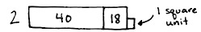

2. Solve 93 ÷ 4 using the area model, long division, and the distributive property.

Name Date
- Solve 35 ÷ 2 using an area model. Use long division and the distributive property to record your work.

- Solve 79 ÷ 3 using an area model. Use long division and the distributive property to record your work.

- Paulina solved the following division problem by drawing an area model.
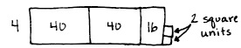

- What division problem did she solve?
- Show how Paulina’s model can be represented using the distributive property.

Solve the following problems using the area model. Support the area model with long division or the distributive property.
- 42 ÷ 3 | - 43 ÷ 3
- 52 ÷ 4 | - 54 ÷ 4
- 61 ÷ 5 | - 73 ÷ 3
- Ninety-seven lunch trays were placed equally in 4 stacks. How many lunch trays were in each stack? How many lunch trays will be left over?

