Lesson 19
Objective: Explain remainders by using place value understanding and models.

Suggested Lesson Structure
 Fluency Practice (12 minutes)
 Application Problem (8 minutes)
 Concept Development (25 minutes)
 Student Debrief (15 minutes)
Total Time (60 minutes)
Fluency Practice (12 minutes)
- Sprint: Mental Division 4.NBT.6 (8 minutes)
- Divide Using the Standard Algorithm 4.NBT.6 (4 minutes)
Sprint: Mental Division (8 minutes)
Materials: (S) Mental Division Sprint
Note: This Sprint reviews content from previous lessons and reinforces place value used in the division algorithm.
Divide Using the Standard Algorithm (4 minutes)
Materials: (S) Personal white board
Note: This fluency activity reviews Lesson 17’s content.
Repeat the process from Lesson 17 using the following possible sequence: 37 ÷ 2, 45 ÷ 3, 26 ÷ 4, and 58 ÷ 3.
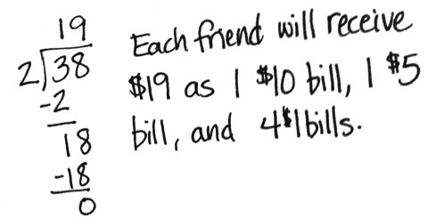
Application Problem (8 minutes)
Two friends start a business writing and selling comic books. After 1 month, they have earned $38. Show how they can share their earnings fairly, using $1, $5, $10, and $20 bills.
Note: Students practice decomposing a ten using long division from Lesson 17 and with a money model. Other acceptable answers are 1 ten 9 ones, 19 ones, 3 fives 4 ones, or 2 fives 9 ones.
Concept Development (25 minutes)
Materials: (T) Tens place value chart (Lesson 16 Template) (S) Personal white board, tens place value chart (Lesson 16 Template)
Problem 1: Model division with remainders in the tens and ones places using place value disks.
41 ÷ 3
T: (Write 41 ÷ 3.) What disks will you draw to represent 41?
S: 4 tens 1 one.
T: How many equal groups will we divide 41 into?
S: 3.
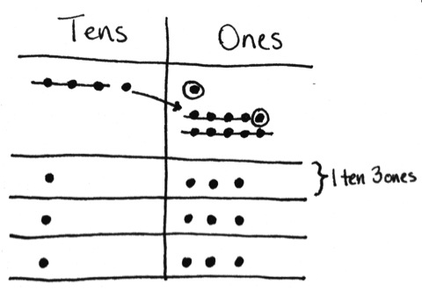
T: Draw 3 groups, and let’s share 4 tens equally. How many tens in each group? Draw place value disks as you distribute 4 tens into 3 groups like you’re dealing cards to 3 players.
S: 1 ten in each group, with 1 ten remaining.
T: How can we divide the remaining ten?
S: Unbundle 1 ten as 10 ones.
T: Let’s see you draw that. (Allow students time to draw.) What did you do?
S: I drew an arrow from the remaining tens disk in the tens place and drew 10 ones in the ones place.
T: How many ones do you have now?

NOTES ON
MULTIPLE MEANS
OF ACTION AND EXPRESSION:
Some learners may need less guidance to model 41 ÷ 3 and, after solving quickly and independently, may benefit more from writing a step-by-step script for solving 41 ÷ 3 in preparation for Problem 5 of the Problem Set. This script might be used in a video of the student supporting his peers as they learn long division.
S: 11 ones.
T: Let’s divide those 11 ones equally into 3 groups. Divide 11 ones into 3 groups by distributing 1 to each group. How many ones are remaining?
S: 8.
T: Are there enough to distribute again?
S: Yes. We can distribute another one to each group.
T: How many are left now?
S: Five. We can distribute again. We will have 2 remaining.
T: Explain what happened.
S: 2 ones are left after distributing the rest equally. We had to keep distributing until we didn’t have enough to distribute evenly again.
T: Now, your place value disks clearly show the solution for 41 ÷ 3. Tell me the quotient. Tell me the remainder.
S: 41 divided by 3 is 13 with a remainder of 2.
T: With your partner, write an equation we can use to check your division.
S: (13 × 3) + 2 = 41.
T: With your partner, find where 13, 3, 2, and 41 are represented in the place value chart.
S: Thirteen is the 1 ten and 3 ones in each group. Three is the number of groups we made. Two is the remaining 2 ones from the whole. Forty-one is the whole.
Problem 2: Share $64 as 6 tens and 4 ones equally among 4 friends.
T: Tell your partner what happens when we have an extra ten we can’t distribute.
MP.8
S: We break the ten apart into 10 ones. Then, we add the 10 ones to the ones that are already there. Then, we can distribute the ones into 4 equal groups.
T: Can you think of a real-life situation in which you might change a ten for 10 ones?
S: Yeah! When you’re getting change for 10 dollars! If the soda machine doesn’t take tens, you need to change out for ones.
T: Let’s say I give 4 students $64 to share equally—6 ten-dollar bills and 4 one-dollar bills. Write an equation and draw place value disks to show how to divide the money.
T: What happens when you try to share 6 ten-dollar bills equally with 4 people?
S: Each person gets 1 ten-dollar bill, but then you have 2 ten-dollar bills left.
T: What do you do?
S: Make change! Cash in those 2 ten-dollar bills for 20 ones. Then, we can share the money fairly. Or, they could change the 2 tens for 4 fives. That would work, too.
T: You’re both correct. Either approach would work. Since we’re using a place value chart to show division, let’s pretend they changed the 2 tens for 20 ones and model that. Since we have so many ones, model with quick dots as you distribute like a fast card dealer. How will you distribute the ones?
S: I will keep distributing them until I can’t distribute them equally anymore. This time, I was able to distribute evenly.
T: Why do you have to keep distributing?
S: If I don’t keep distributing, there will be too many remaining. That means that you would be able to distribute again but didn’t.
T: How much money does each student receive?
S: $16.
T: Check your quotient with your partner using multiplication.
S: 16 × 4 = 64. I see 4 groups of 1 ten 6 ones, which is 64.

Problem Set (15 minutes)

NOTES ON
MULTIPLE MEANS
OF ACTION AND EXPRESSION:
Support English language learners as they write a script to explain how to solve 45 ÷ 3. Provide a word bank with corresponding pictures. The following are possible words to include in the word bank:
cross out distribute share draw
tens ones four five
three unbundle divide equal
fairly next then last

Students should do their personal best to complete the Problem Set within the allotted 15 minutes. For some classes, it may be appropriate to modify the assignment by specifying which problems they work on first. Some problems do not specify a method for solving. Students should solve these problems using the RDW approach used for Application Problems.
Student Debrief (15 minutes)
Lesson Objective: Explain remainders by using place value understanding and models.
The Student Debrief is intended to invite reflection and active processing of the total lesson experience.
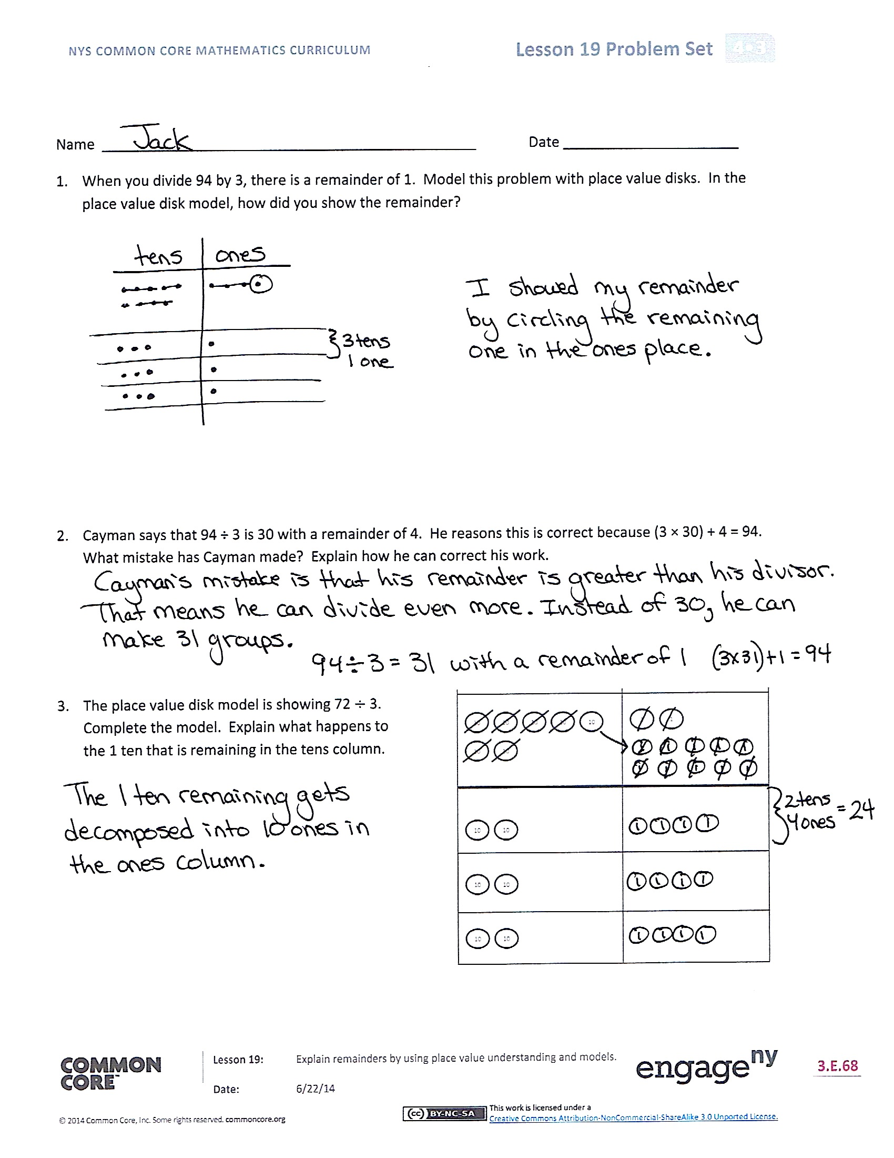
Invite students to review their solutions for the Problem Set. They should check work by comparing answers with a partner before going over answers as a class. Look for misconceptions or misunderstandings that can be addressed in the Debrief. Guide students in a conversation to debrief the Problem Set and process the lesson.
Any combination of the questions below may be used to lead the discussion.
- In Problem 2, Cayman’s remainder is larger than the divisor. What rule can you suggest to Cayman so he doesn’t make this mistake again? Was his answer completely wrong? Why not?
- In Problem 4, the friends have to make change for the 1 ten-dollar bill. Why can’t they tear the bill in half? How does that relate to the place value disks?
- In Problem 5, how did your script describe the remainder in the tens and ones?
- Select a few students to share and compare their scripts for solving 45 ÷ 3.
- Compare using place value disks and other methods to divide. Which do you prefer? Why?
- We related a remainder in the tens place to making change with money. What other real-life situations can you relate it to? Is this similar to mixed metric units, such as having 5 liters of water to share among 4 people?
- With money, sometimes we might use units other than ones and tens, such as fives or twenties. Why do you think we use only ones and tens to model division on the place value chart?
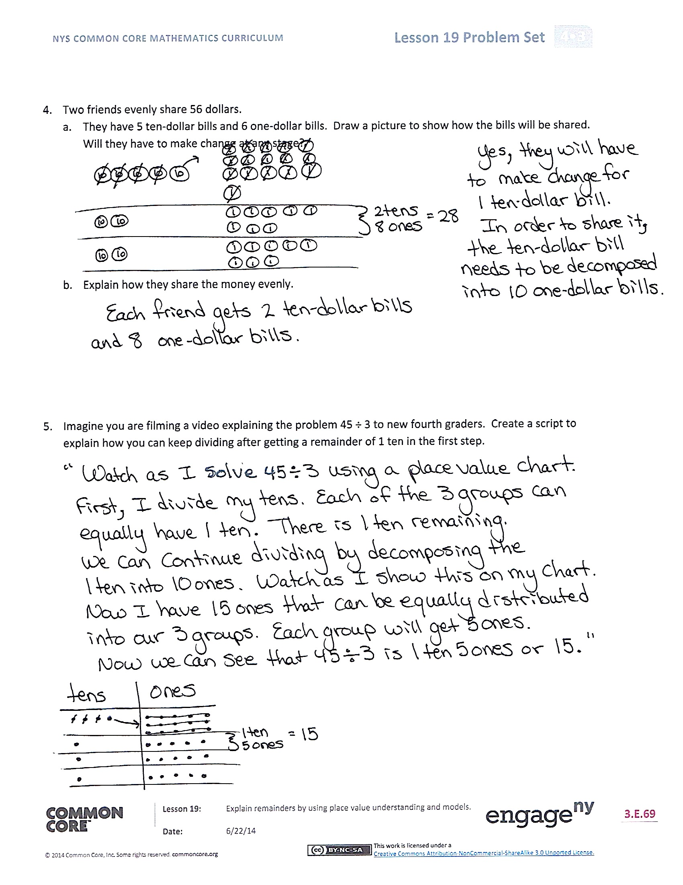
Exit Ticket (3 minutes)
After the Student Debrief, instruct students to complete the Exit Ticket. A review of their work will help with assessing students’ understanding of the concepts that were presented in today’s lesson and planning more effectively for future lessons. The questions may be read aloud to the students.

Number Correct: _______
A
Mental Division
 | 20 ÷ 2 = |  |  |  | 68 ÷ 2 =
 | 4 ÷ 2 = |  |  |  | 96 ÷ 3 =
 | 24 ÷ 2 = |  |  |  | 86 ÷ 2 =
 | 30 ÷ 3 = |  |  |  | 93 ÷ 3 =
 | 6 ÷ 3 = |  |  |  | 88 ÷ 4 =
 | 36 ÷ 3 = |  |  |  | 99 ÷ 3 =
 | 40 ÷ 4 = |  |  |  | 66 ÷ 3 =
 | 8 ÷ 4 = |  |  |  | 66 ÷ 2 =
 | 48 ÷ 4 = |  |  |  | 40 ÷ 4 =
 | 2 ÷ 2 = |  |  |  | 80 ÷ 4 =
 | 40 ÷ 2 = |  |  |  | 60 ÷ 4 =
 | 42 ÷ 2 = |  |  |  | 68 ÷ 4 =
 | 3 ÷ 3 = |  |  |  | 20 ÷ 2 =
 | 60 ÷ 3 = |  |  |  | 40 ÷ 2 =
 | 63 ÷ 3 = |  |  |  | 30 ÷ 2 =
 | 4 ÷ 4 = |  |  |  | 36 ÷ 2 =
 | 80 ÷ 4 = |  |  |  | 30 ÷ 3 =
 | 84 ÷ 4 = |  |  |  | 39 ÷ 3 =
 | 40 ÷ 5 = |  |  |  | 45 ÷ 3 =
 | 50 ÷ 5 = |  |  |  | 60 ÷ 3 =
 | 60 ÷ 5 = |  |  |  | 57 ÷ 3 =
 | 70 ÷ 5 = |  |  |  | 51 ÷ 3 =
B
[KEY]

Number Correct: _______
Improvement: _______
Mental Division
 | 30 ÷ 3 = |  |  |  | 86 ÷ 2 =
 | 9 ÷ 3 = |  |  |  | 69 ÷ 3 =
 | 39 ÷ 3 = |  |  |  | 68 ÷ 2 =
 | 20 ÷ 2 = |  |  |  | 96 ÷ 3 =
 | 6 ÷ 2 = |  |  |  | 66 ÷ 3 =
 | 26 ÷ 2 = |  |  |  | 99 ÷ 3 =
 | 80 ÷ 4 = |  |  |  | 88 ÷ 4 =
 | 4 ÷ 4 = |  |  |  | 88 ÷ 2 =
 | 84 ÷ 4 = |  |  |  | 40 ÷ 4 =
 | 2 ÷ 2 = |  |  |  | 80 ÷ 4 =
 | 60 ÷ 2 = |  |  |  | 60 ÷ 4 =
 | 62 ÷ 2 = |  |  |  | 64 ÷ 4 =
 | 3 ÷ 3 = |  |  |  | 20 ÷ 2 =
 | 90 ÷ 3 = |  |  |  | 40 ÷ 2 =
 | 93 ÷ 3 = |  |  |  | 30 ÷ 2 =
 | 8 ÷ 4 = |  |  |  | 38 ÷ 2 =
 | 40 ÷ 4 = |  |  |  | 30 ÷ 3 =
 | 48 ÷ 4 = |  |  |  | 36 ÷ 3 =
 | 50 ÷ 5 = |  |  |  | 42 ÷ 3 =
 | 60 ÷ 5 = |  |  |  | 60 ÷ 3 =
 | 70 ÷ 5 = |  |  |  | 54 ÷ 3 =
 | 80 ÷ 5 = |  |  |  | 48 ÷ 3 =

Name Date
- When you divide 94 by 3, there is a remainder of 1. Model this problem with place value disks. In the place value disk model, how did you show the remainder?

- Cayman says that 94 ÷ 3 is 30 with a remainder of 4. He reasons this is correct because (3 × 30) + 4 = 94. What mistake has Cayman made? Explain how he can correct his work.

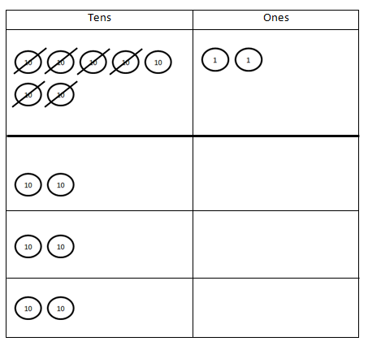
- The place value disk model is showing 72 $÷$ 3. Complete the model. Explain what happens to the
1 ten that is remaining in the tens column.

- Two friends evenly share 56 dollars.
  - They have 5 ten-dollar bills and 6 one-dollar bills. Draw a picture to show how the bills will be shared. Will they have to make change at any stage?

  - Explain how they share the money evenly.

- Imagine you are filming a video explaining the problem 45 ÷ 3 to new fourth graders. Create a script to explain how you can keep dividing after getting a remainder of 1 ten in the first step.

Name Date
- Molly’s photo album has a total of 97 pictures. Each page of the album holds 6 pictures. How many pages can Molly fill? Will there be any pictures left? If so, how many? Use place value disks to solve.

- Marti’s photo album has a total of 45 pictures. Each page holds 4 pictures. She said she can only fill
10 pages completely. Do you agree? Explain why or why not.

Name Date
- When you divide 86 by 4, there is a remainder of 2. Model this problem with place value disks. In the place value disk model, how can you see that there is a remainder?

- Francine says that 86 ÷ 4 is 20 with a remainder of 6. She reasons this is correct because
(4 × 20) + 6 = 86. What mistake has Francine made? Explain how she can correct her work.

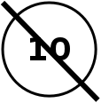
- The place value disk model is showing 67 $÷$ 4. Complete the model. Explain what happens to the 2 tens that are remaining in the tens column.

- Two friends share 76 blueberries.
- To count the blueberries, they put them into small bowls of 10 blueberries. Draw a picture to show how the blueberries can be shared equally. Will they have to split apart any of the bowls
of 10 blueberries when they share them?

- Explain how the friends can share the blueberries fairly.

- Imagine you are drawing a comic strip showing how to solve the problem 72 ÷ 4 to new fourth graders. Create a script to explain how you can keep dividing after getting a remainder of 3 tens in the first step.

