Lesson 15
Objective: Understand and solve division problems with a remainder using the array and area models.

Suggested Lesson Structure
 Fluency Practice (12 minutes)
 Application Problem (5 minutes)
 Concept Development (33 minutes)
 Student Debrief (10 minutes)
Total Time (60 minutes)
Fluency Practice (12 minutes)
- Show Values with Place Value Disks 4.NBT.1 (4 minutes)
- Divide with Remainders 4.NBT.6 (4 minutes)
- Number Sentences in an Array 4.NBT. (4 minutes)
Show Values with Place Value Disks (4 minutes)
Materials: (T) Thousands place value chart (Lesson 4 Template) (S) Personal white board, thousands place value chart (Lesson 4 Template)
Note: This fluency activity prepares students for Lesson 16’s Concept Development.
T: (Project the place value chart with 2 tens disks and 4 ones disks.) On your personal white board, write the number in standard form.
S: (Write 24.)
Repeat process for 5 tens and 3 ones, 4 tens and 1 one, 3 tens and 11 ones, and 3 tens and 17 ones.
T: (Write 32.) Say the number.
S: 32.
T: Show 32 using place value disks.
S: (Draw disks for 3 tens and 2 ones.)
Continue with the following possible sequence: 21 and 43.
Divide with Remainders (4 minutes)
Note: This fluency activity provides maintenance of the fluency introduced in Lesson 14.
Repeat the process from Lesson 14 for the following possible sequence: 6 ÷ 2 and 7 ÷ 2; 24 ÷ 3 and 25 ÷ 3,
12 ÷ 4 and 15 ÷ 4, 18 ÷ 6 and 21 ÷ 6, and 45 ÷ 5 and 49 ÷ 5.
Number Sentences in an Array (4 minutes)
Materials: (S) Personal white board
Note: This fluency activity prepares students for this lesson’s Concept Development.
T: (Project a 5 × 3 + 1 array.) How many boxes do you see altogether?
S: 16.
T: Let’s count by fives to check. (Point at columns as students count.)
S: 5, 10, 15.
T: Plus 1? (Point to the extra square outside of the rectangle.)
S: 16.
T: Count by threes to check.
S: 3, 6, 9, 12, 15.
T: Plus 1? (Point to the extra square outside of the rectangle.)
S: 16.
T: On your personal white board, write two multiplication number sentences to show how many boxes are in this array.
S: (Write (5 × 3) + 1 = 16 and (3 × 5) + 1 = 16.)
T: Write two division sentences for this array.
S: (Write 16 ÷ 3 = 5 with a remainder of 1 and 16 ÷ 5 = 3 with a remainder of 1.)
Repeat using the following possible sequence: (3 × 6) + 1 and (3 × 4) + 2.
Application Problem (5 minutes)

NOTES ON
MULTIPLE MEANS
OF REPRESENTATION:
Modeling the array (rather than the tape diagram) may give students a clearer picture of the solution to the Application Problem. Encourage students to use the labels photo and page, if beneficial. Discuss how the equation informs the solution, yet the picture reveals the solution.

Chandra printed 38 photos to put into her scrapbook. If she can fit 4 photos on each page, how many pages will she use for her photos?
Note: This Application Problem relates to the objective of Lesson 14 in that students solve a division word problem with a remainder. Here, students interpret the remainder to determine the total number of scrapbook pages needed. This anticipates the last problem in this lesson.
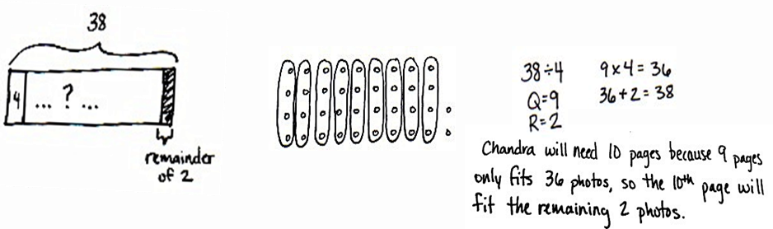

Concept Development (33 minutes)
Materials: (T/S) Square grid paper
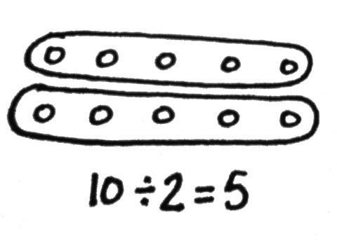
Problem 1: Solve a division problem with and without a remainder using the area model.
Display 10 ÷ 2.
T: Draw an array to represent 10 ÷ 2. Explain to your partner how you solved.
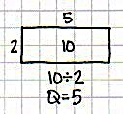
S: (Draw.) I drew 2 circles and placed 10 dots evenly among the circles. I drew 10 dots as 2 rows of 5 dots.
T: Let’s use grid paper to draw a rectangle with an area of 10 square centimeters and one side length of 2 centimeters. Tell your partner how we can find the unknown side length.
S: The area is 10, so we know it is 5. If the width is 2 centimeters, that means the length is 5 centimeters, and 2 centimeters times
5 centimeters gives an area of 10 square centimeters. We can count and mark off by twos until we get to 10.
T: Discuss with your partner how the length of 5 centimeters is represented in the area model.
S: The length is 5, and the quotient is 5. The length of the area model represents the quotient of this division problem.
Display 11 ÷ 2.
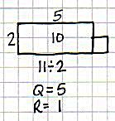
T: With your partner, discuss how you would draw an area model
for 11 ÷ 2.
S: Two can be the length or the width. I can’t just draw 2 rows of square units because of the remainder. If I mark off 2 squares at a time, I count 2, 4, 6, 8, 10. I can’t do another group of 2 because it would be 12. There aren’t enough.
T: Eleven square centimeters is the total area. Let’s draw a rectangle starting with a width of 2 centimeters. We’ll continue lengthening it until we get as close to 11 square centimeters as we can.
S: A length of 5 centimeters and width of 2 centimeters is as close as we can get to 11 square centimeters. We can’t do 2 × 6 because that’s 12 square centimeters, and the total area is 11 square centimeters.
T: We can show a total area of 11 square centimeters by modeling 1 more square centimeter. The remainder of 1 represents 1 more square centimeter.
Repeat for 16 ÷ 3 and 23 ÷ 4.

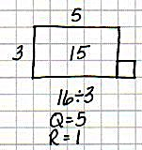
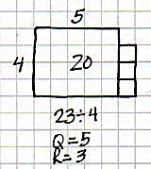
Problem 2: Solve a division problem using an array and the area model.
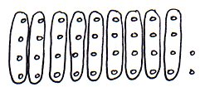
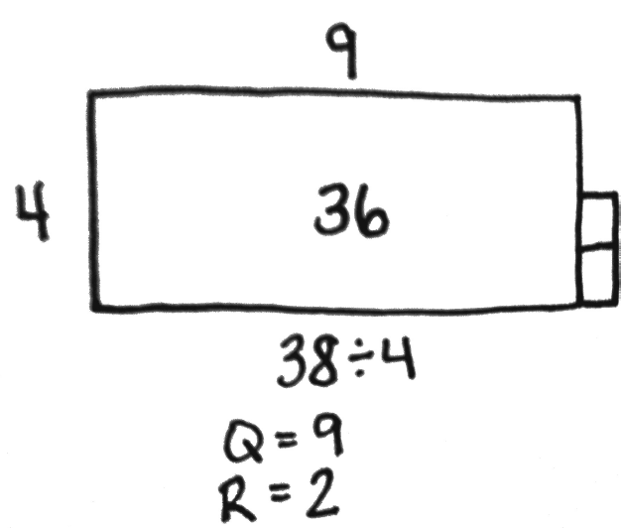
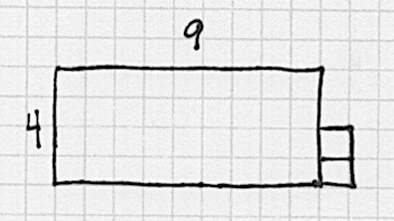
Display 38 ÷ 4.
MP.4
T: In the Application Problem, you drew an array (pictured to the right) to solve. Represent the same problem using the area model on grid paper. (Allow two minutes to work.)
T: What do you notice about the array compared to the area model on graph paper?
S: The area model is faster to draw. Thirty-eight dots is a lot to draw. There are the same number of dots and squares when I used graph paper. Both get us the same answer of a quotient 9 with a remainder of 2.
T: Let’s represent 38 ÷ 4 even more efficiently without grid paper since it’s hard to come by grid paper every time you want to solve a problem.
T: (Give students one minute to draw.) Talk to your partner about how the array model and grid paper model supported you in drawing the rectangle with a given structure.
S: I knew the length was a little more than twice the width. I knew that the remainder was half a column. I knew that there was a remainder. It was really obvious with the array and grid paper.
Problem Set (10 minutes)

NOTES ON
MULTIPLE MEANS
OF REPRESENTATION:
Help English language learners distinguish between terms used for division: division, divisor, quotient, and whole. Label a division equation, and post for future reference. Make a word web of synonyms for division that students can interchange, if desired. Encourage students to speak these words as they participate in the Student Debrief.

Students should do their personal best to complete the Problem Set within the allotted 10 minutes. For some classes, it may be appropriate to modify the assignment by specifying which problems they work on first. Some problems do not specify a method for solving. Students should solve these problems using the RDW approach used for Application Problems.
Student Debrief (10 minutes)
Lesson Objective: Understand and solve division problems with a remainder using the array and area models.
The Student Debrief is intended to invite reflection and active processing of the total lesson experience.
Invite students to review their solutions for the Problem Set. They should check work by comparing answers with a partner before going over answers as a class. Look for misconceptions or misunderstandings that can be addressed in the Debrief. Guide students in a conversation to debrief the Problem Set and process the lesson.
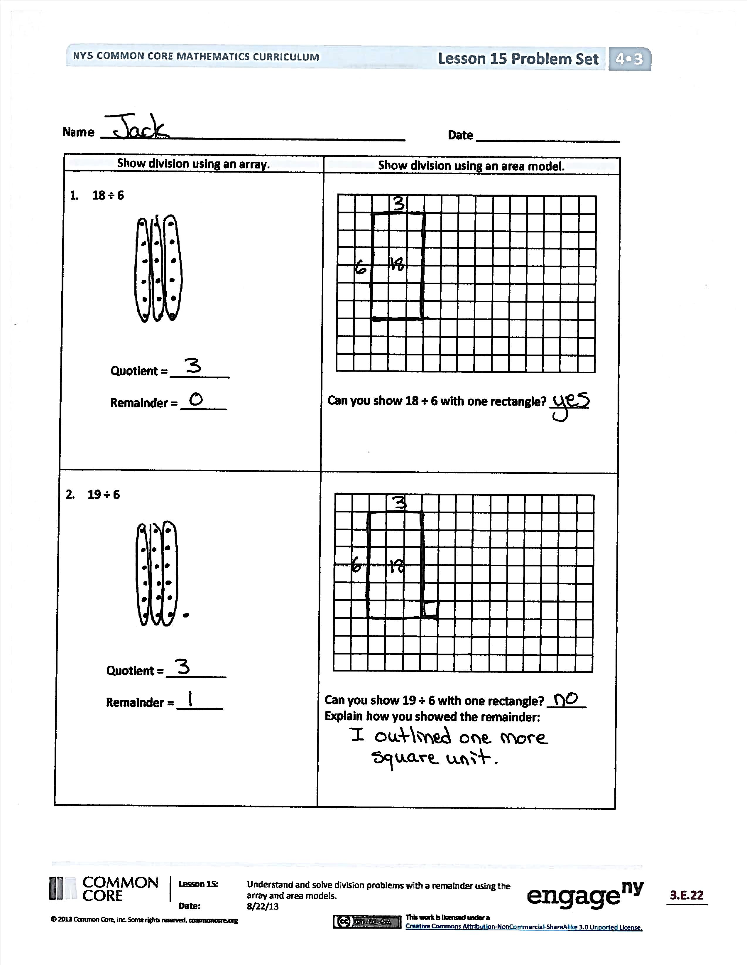
Any combination of the questions below may be used to lead the discussion.
- What does the quotient represent in the area model?
- When does the area model present a challenge in representing division problems?
- How can Problem 3 and Problem 4 have the same remainder?
- How could you change the 43 in Problem 5 so that there would be the same quotient but with no remainder?
- The quotient represents a side length. The remainder consists of square units. Why?
- How is the whole represented in an area model?
- What new math vocabulary did we use today to communicate precisely?
- How did the Application Problem connect to today’s lesson?
Exit Ticket (3 minutes)
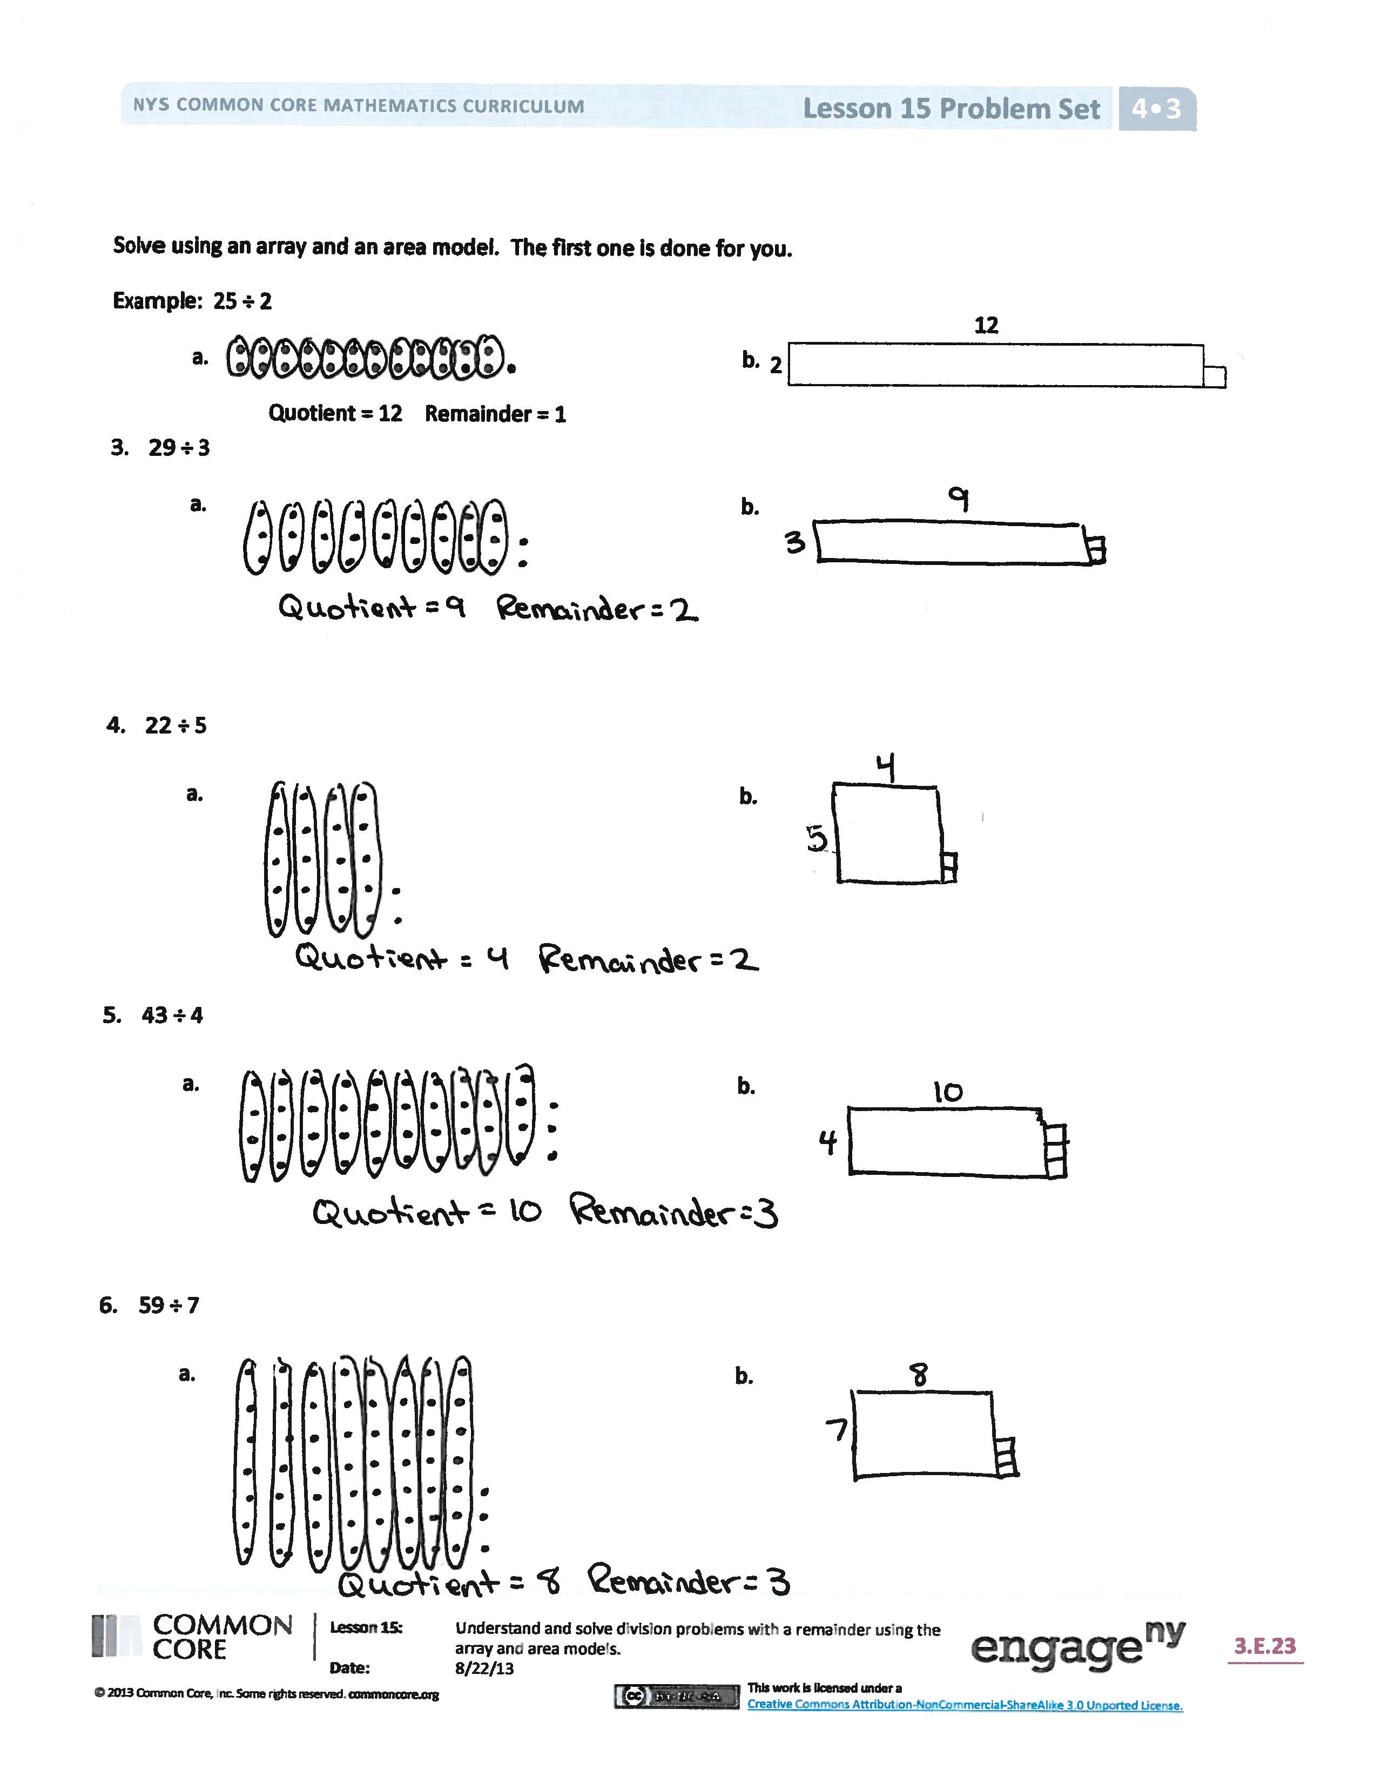
After the Student Debrief, instruct students to complete the Exit Ticket. A review of their work will help with assessing students’ understanding of the concepts that were presented in today’s lesson and planning more effectively for future lessons. The questions may be read aloud to the students.
Name Date
Show division using an array. | Show division using an area model.
- 18 ÷ 6  Quotient = _________  Remainder = _______ | Can you show 18 ÷ 6 with one rectangle? ______
- 19 ÷ 6  Quotient = _________  Remainder = _______ | Can you show 19 ÷ 6 with one rectangle? ______  Explain how you showed the remainder:

Solve using an array and an area model. The first one is done for you.
Example: 25 ÷ 2
2
12
a. b.
Quotient = 12 Remainder = 1
- 29 ÷ 3
a. b.

- 22 ÷ 5
a. b.

- 43 ÷ 4
a. b.

- 59 ÷ 7
a. b.

Name Date
Solve using an array and area model.
- 27 ÷ 5
- b.

- 32 ÷ 6
- b.

Name Date
Show division using an array. | Show division using an area model.
- 24 ÷ 4  Quotient = _________  Remainder = _______ | Can you show 24 ÷ 4 with one rectangle? ______
- 25 ÷ 4  Quotient = _________  Remainder = _______ | Can you show 25 ÷ 4 with one rectangle? ______  Explain how you showed the remainder:

Solve using an array and area model. The first one is done for you.
Example: 25 ÷ 3
8
a. b.
3
Quotient = 8 Remainder = 1

- 44 ÷ 7
a. b.

- 34 ÷ 6
a. b.

- 37 ÷ 6
a. b.

- 46 ÷ 8
a. b.

