Lesson 12
Objective: Solve two-step word problems, including multiplicative comparison.

Suggested Lesson Structure
 Fluency Practice (12 minutes)
 Concept Development (35 minutes)
 Student Debrief (13 minutes)
Total Time (60 minutes)

Fluency Practice (12 minutes)
- Multiply Mentally 4.NBT.5 (4 minutes)
- Multiply in Three Different Ways 4.NBT.5 (8 minutes)

Multiply Mentally (4 minutes)
Note: Reviewing these mental multiplication strategies provides a foundation for students to succeed during the Concept Development.
Repeat the process from Lesson 7 with the following possible sequence: 3,421 × 2, 2,302 × 3, 2,112 × 4,
and 2,023 × 4.

Multiply in Three Different Ways (8 minutes)
Materials: (S) Place value disks
Note: This fluency activity reviews the concepts learned in Topic C.
Repeat the fluency activity from Lesson 11, expanding to three- and four-digit numbers for the following possible sequence: 245 × 2, 301 × 5, and 5,241 × 2.

Concept Development (35 minutes)
Materials: (S) Problem Set

NOTES ON
MULTIPLE MEANS
OF ENGAGEMENT:
Give everyone a fair chance to be successful by providing appropriate scaffolds. Demonstrating students may use translators, interpreters, or sentence frames to present and respond to feedback. Models shared may include concrete manipulatives.
If the pace of the lesson is a consideration, prepare presenters beforehand. The first problem may be most approachable for students working below grade level.

Note: For this lesson, the Problem Set comprises word problems from the Concept Development and is therefore to be used during the lesson itself.
Students may work in pairs to solve Problems 1─4 below using the RDW approach to problem solving.
1. Model the problem.
Have two pairs of students who can be successful with modeling the problem work at the board while the others work independently or in pairs at their seats. Review the following questions before beginning the first problem.
- Can you draw something?
- What can you draw?
- What conclusions can you make from your drawing?
As students work, circulate. Reiterate the questions above.
After two minutes, have the two pairs of students share only their labeled diagrams.
For about one minute, have the demonstrating students receive and respond to feedback and questions from their peers.
2. Calculate to solve and write a statement.
Give everyone two minutes to finish work on that question, sharing the work and thinking with a peer. All should then write their equations and statements of the answer.
3. Assess the solution.
Give students one to two minutes to assess the solutions presented by their peers on the board, comparing the solutions to their own work. Highlight alternative methods to reach the correct solution.
Problem 1
The table shows the cost of party favors. Each party guest receives a bag with 1 balloon, 1 lollipop, and
1 bracelet. What is the total cost for 9 guests?
Item | Cost
1 balloon | 26¢
1 lollipop | 14¢
1 bracelet | 33¢

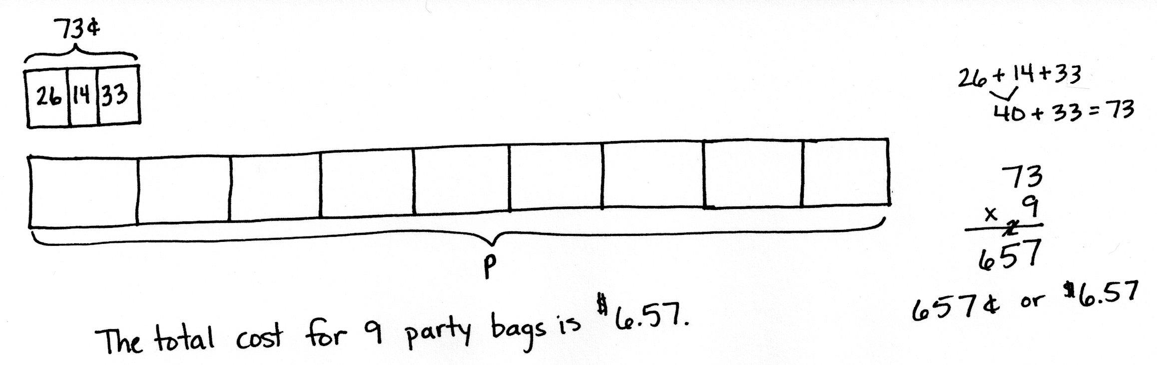
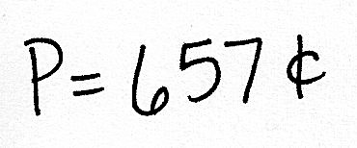
This two-step problem requires students to determine the cost of party favors for one guest and then use that information to determine the total cost of party favors for 9 guests. Although RDW is reviewed prior to beginning work on this problem, because of its simplicity, many students might elect to begin solving immediately. Some students may choose to multiply each item by 9 before adding those amounts. Based on their prior experience with money, some students may represent the total amount of 657 cents as $6.57, but they are not required to do so.
Problem 2
The Turner family uses 548 liters of water per day. The Hill family uses 3 times as much water per day. How much water does the Hill family use per week?
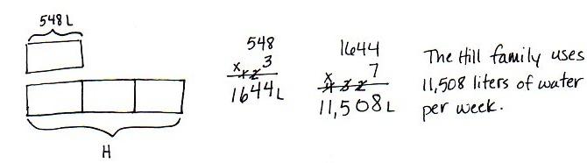
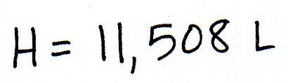
In solving this problem, students use information from the problem and their knowledge of language denoting multiplicative comparison to determine their answer. They must also remember that there are 7 days in a week in order to complete the computation necessary to finish the problem. Models chosen for this problem may include tape diagrams as shown.
Problem 3
Jayden has 347 marbles. Elvis has 4 times as many as Jayden. Presley has 799 fewer than Elvis. How many marbles does Presley have?
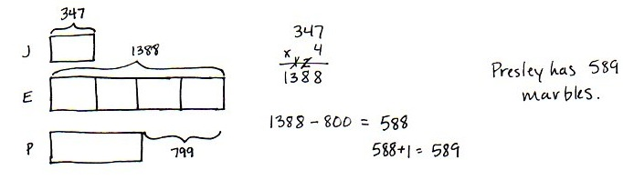
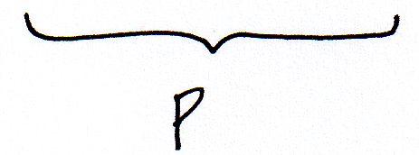
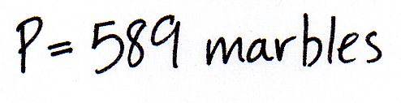

This two-step problem affords students another opportunity to model with tape diagrams. They are required to apply what they have learned about multiplying multi-digit numbers by single digits, as well as practice their subtraction with multiple regrouping skills from Module 1. Encourage students to also practice mental math, such as when subtracting 799 from 1,388. As illustrated above, note that the diagram may or may not accurately show the relationship between 799 and the unit size, 347. Nevertheless, discuss how one might use mental math to estimate how long Presley’s bar should be.

Problem 4

NOTES ON
MULTIPLE MEANS
OF ACTION AND EXPRESSION:
Support English language learners as they write their own word problems. Provide sentence starters and a word bank.
Sentence starters may include:
“I had (units),”
“How many in all?”
Possible words for the word bank may include:
times as many fewer than
more than total difference

  - Write an equation that would allow someone to find the value of R.
239
1,167
1,167
1,167
R

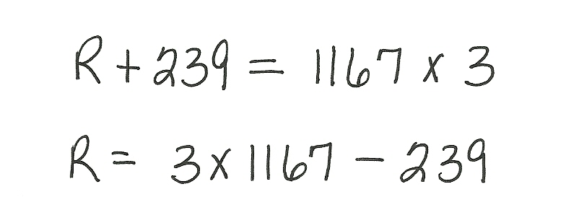

Student equations may include one or both of the equations above. They must include the use of the R for the unknown quantity and show that R is equal to 239 less than three times 1,167.

- Write your own word problem to correspond to the tape diagram, and then solve.
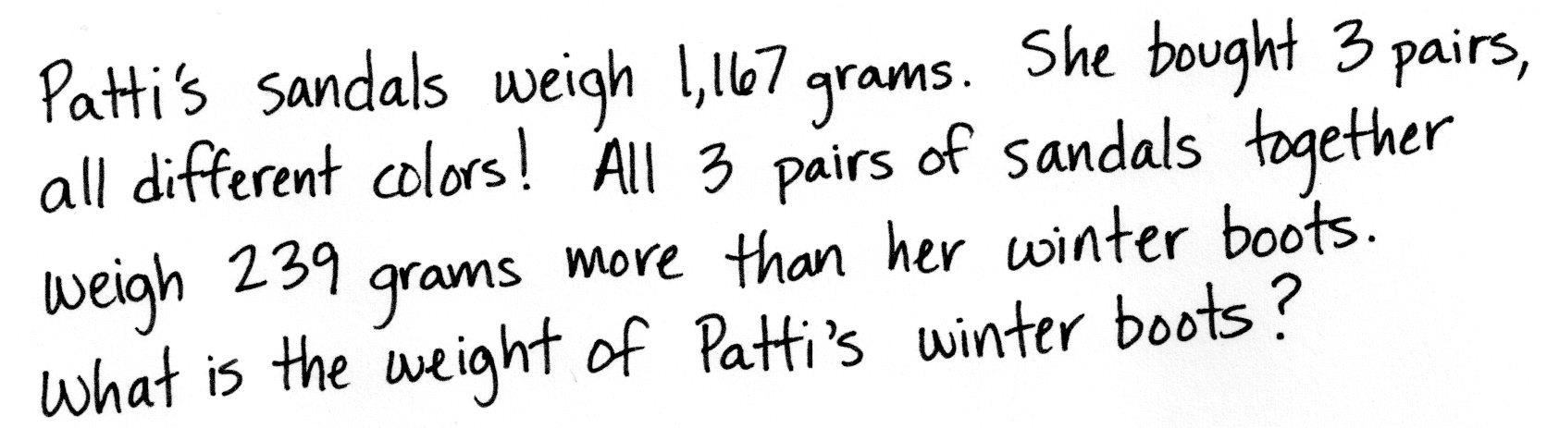
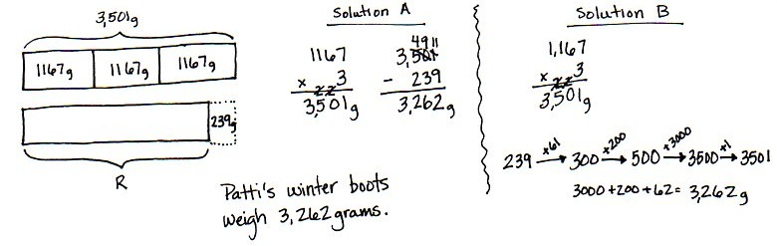
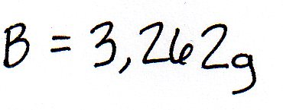

Responses will vary. Guide students with a context for creating a problem, such as the number of students who attend two schools or the weights of objects.

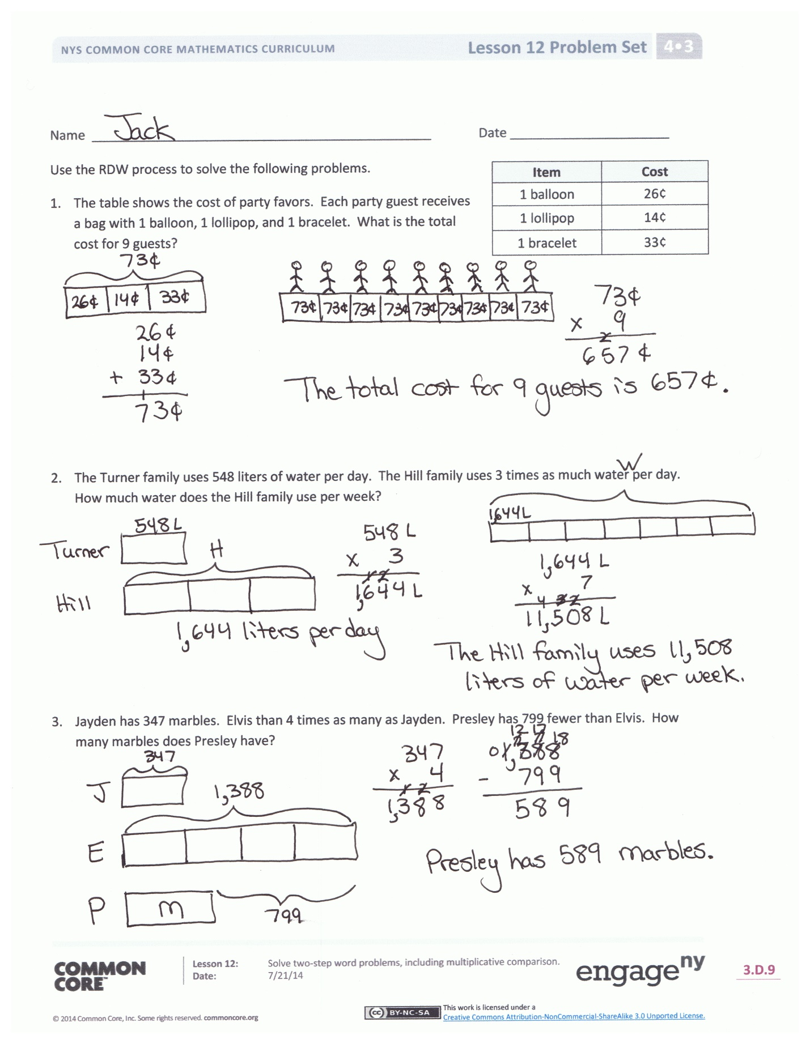
Problem Set
Please note that the Problem Set for Lesson 12 comprises the problems from the Concept Development, as stated in the introduction of the lesson.

Student Debrief (13 minutes)
Lesson Objective: Solve two-step word problems, including multiplicative comparison.
The Student Debrief is intended to invite reflection and active processing of the total lesson experience.
Invite students to review their solutions for the Problem Set. They should check work by comparing answers with a partner before going over answers as a class. Look for misconceptions or misunderstandings that can be addressed in the Debrief. Guide students in a conversation to debrief the problems and process the lesson.

Any combination of the questions below may be used to lead the discussion.
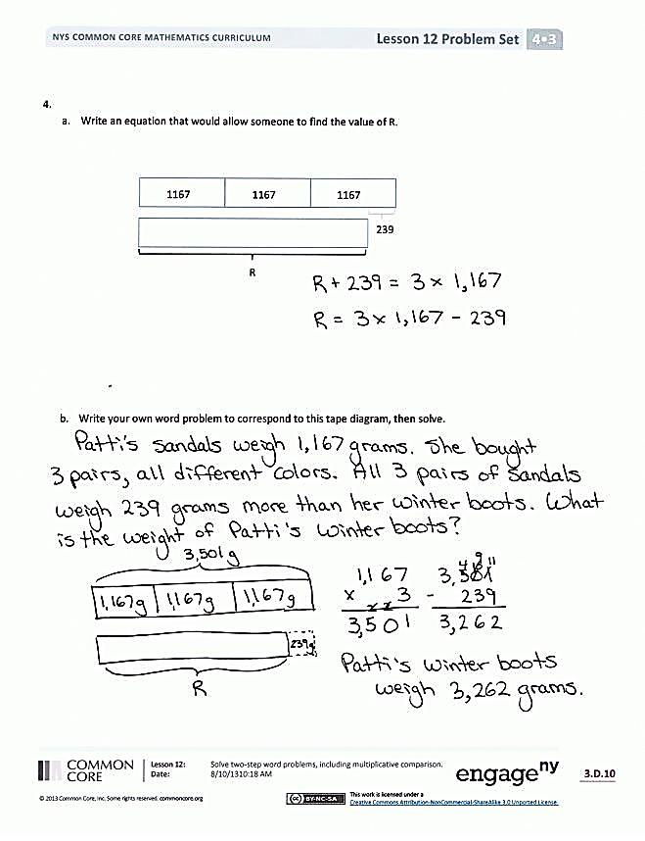
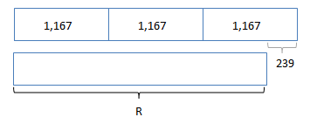
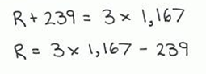
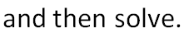
- How was Problem 1 similar to the other problems we did today? How was it different?
- How was setting up Problem 2 similar to setting up Problem 3? At what point did the two problems become quite different?
- What piece of information did you need to know to solve Problem 2 that was not given to you in the problem?
- Share the word problem you created for Problem 4(b) with your partner. Solve your partner’s problem. Explain the strategy you used to solve it.

Exit Ticket (3 minutes)
After the Student Debrief, instruct students to complete the Exit Ticket. A review of their work will help with assessing students’ understanding of the concepts that were presented in today’s lesson and planning more effectively for future lessons. The questions may be read aloud to the students.

Name Date
Item | Cost
1 balloon | 26¢
1 lollipop | 14¢
1 bracelet | 33¢
Use the RDW process to solve the following problems.
- The table shows the cost of party favors. Each party guest receives a bag with 1 balloon, 1 lollipop, and 1 bracelet.
What is the total cost for 9 guests?

- The Turner family uses 548 liters of water per day. The Hill family uses 3 times as much water per day. How much water does the Hill family use per week?

- Jayden has 347 marbles. Elvis has 4 times as many as Jayden. Presley has 799 fewer than Elvis. How many marbles does Presley have?

- a. Write an equation that would allow someone to find the value of R.

239
1,167
1,167
1,167

R

- Write your own word problem to correspond to the tape diagram, and then solve.

Name Date
Use the RDW process to solve the following problem.
Jennifer has 256 beads. Stella has 3 times as many beads as Jennifer. Tiah has 104 more beads than Stella. How many beads does Tiah have?

Name Date
Use the RDW process to solve the following problems.
Type of Sticker | Number of Stickers
flowers | 32
smiley faces | 21
hearts | 39
- The table shows the number of stickers of various types in Chrissy’s new sticker book. Chrissy’s six friends each own the same sticker book. How many stickers do Chrissy and her six friends have altogether?

- The small copier makes 437 copies each day. The large copier makes 4 times as many copies each day. How many copies does the large copier make each week?

- Jared sold 194 Boy Scout chocolate bars. Matthew sold three times as many as Jared. Gary sold 297 fewer than Matthew. How many bars did Gary sell?

- a. Write an equation that would allow someone to find the value of M.
723 meters
M
973 meters
723 meters
723 meters

b. Write your own word problem to correspond to the tape diagram, and then solve.

