Lesson 7
Objective: Use place value disks to represent two-digit by one-digit multiplication.

Suggested Lesson Structure
 Fluency Practice (12 minutes)
 Application Problem (10 minutes)
 Concept Development (28 minutes)
 Student Debrief (10 minutes)
Total Time (60 minutes)

Fluency Practice (12 minutes)
- Sprint: Multiply Multiples of 10, 100, and 1,000 4.NBT.1 (9 minutes)
- Multiply Mentally 4.NBT.4 (3 minutes)

Sprint: Multiply Multiples of 10, 100, and 1,000 (9 minutes)
Materials: (S) Multiply Multiples of 10, 100, and 1,000 Sprint
Note: This Sprint reinforces concepts taught and reviewed in Lessons 1─6.

Multiply Mentally (3 minutes)
Note: Reviewing these mental multiplication strategies provides a foundation for students to succeed during the Concept Development.
T: (Write 3 × 2 = .) Say the multiplication sentence.
S: 3 × 2 = 6.
T: (Write 3 × 2 = 6. Below it, write 40 × 2 = .) Say the multiplication sentence.
S: 40 × 2 = 80.
T: (Write 40 × 2 = 80. Below it, write 43 × 2 = .) Say the multiplication sentence.
S: 43 × 2 = 86.
Repeat process for the following possible sequence: 32 × 3, 21 × 4, and 24 × 4, directing students to follow the format demonstrated for them.

Application Problem (10 minutes)
The basketball team is selling T-shirts for $9 each. On Monday, they sold 4 T-shirts. On Tuesday, they sold 5 times as many T-shirts as on Monday. How much money did the team earn altogether on Monday and Tuesday?

NOTES ON
MULTIPLE MEANS
OF ENGAGEMENT:
Extend the Application Problem for students above grade level with open-ended questions, such as the following:
- What might be an explanation for the large difference in T-shirt sales between Monday and Tuesday?
- Based on your thoughts, what might be a strategy for generating the most money from T-shirt sales?
- Given the increase in T-shirts sold, should the team increase or decrease the price of the shirt? Explain your reasoning.

Note: This is a multi-step word problem reviewing multiplying by multiples of 10 from Lesson 5, including multiplicative comparison.

Concept Development (28 minutes)
Materials: (T) Ten thousands place value chart (Template)
(S) Personal white board, ten thousands place value chart (Template)
Problem 1: Represent 2 × 23 with disks. Write a matching equation, and record the partial products vertically.
T: Use your place value chart and draw disks to represent 23.
T: Draw disks on your place value chart to show 1 more group of 23. What is the total value in the ones?
S: 2 × 3 ones = 6 ones = 6.
T: Write 2 × 3 ones under the ones column. Let’s record 2 × 23 vertically.
T: We record the total number for the ones below, just like in addition. (Record the 6 ones as shown above.)
T: Let’s look at the tens. What is the total value in the tens?
S: 2 × 2 tens = 4 tens = 40.
T: Write 2 × 2 tens under the tens column. Let’s represent our answer in the problem. We write 40 to represent the value of the tens.
T: What is the total value represented by the disks?
S: The total value is 46 because 4 tens + 6 ones = 46.
T: Notice that when we add the values we wrote below the line that they add to 46, the product!
Repeat with 3 × 23.

Problem 2: Model and solve 4 × 54.

NOTES ON
MULTIPLE MEANS
OF ACTION AND EXPRESSION:
Some learners may have difficulty drawing, tracking, and organizing place value disks to represent 4 × 54. A similar demonstration of renaming in the tens and ones place can be shown through 3 × 34. Alternatively, students can model numerals (i.e., writing 4 instead of 4 ones disks).

T: Draw disks to represent 54 on your place value chart. What is 54 in unit form?
S: 5 tens 4 ones.
T: Draw three more groups of 54 on your chart, and then write the expression 4 × 54 vertically on your personal white board.
T: What is the value of the ones now?
S: 4 × 4 ones = 16 ones.
T: Record the value of the ones. What is the value of the tens?
S: 4 × 5 tens = 20 tens.
T: Record the value of the tens.
MP.4
T: Add up the partial products you recorded. What is the sum?
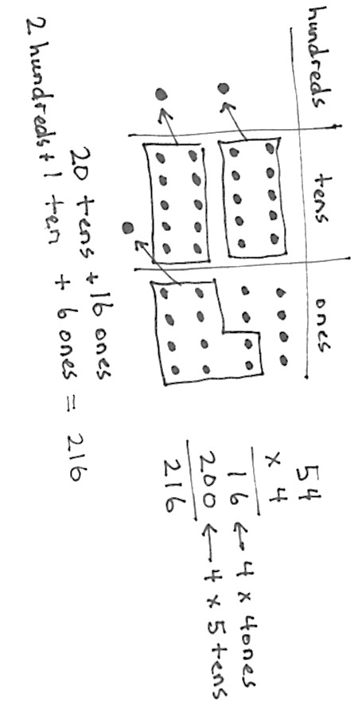
S: 216.
T: Let’s look at our place value chart to confirm.
T: Can we change to make larger units?
S: Yes, we can change 10 ones for 1 ten and
10 tens for 1 hundred twice.
T: Show me.
S: (Change 10 smaller units for 1 larger.)
T: What value is represented on the place value chart?
S: 2 hundreds, 1 ten, and 6 ones. That’s 216.
Repeat with 5 × 42.

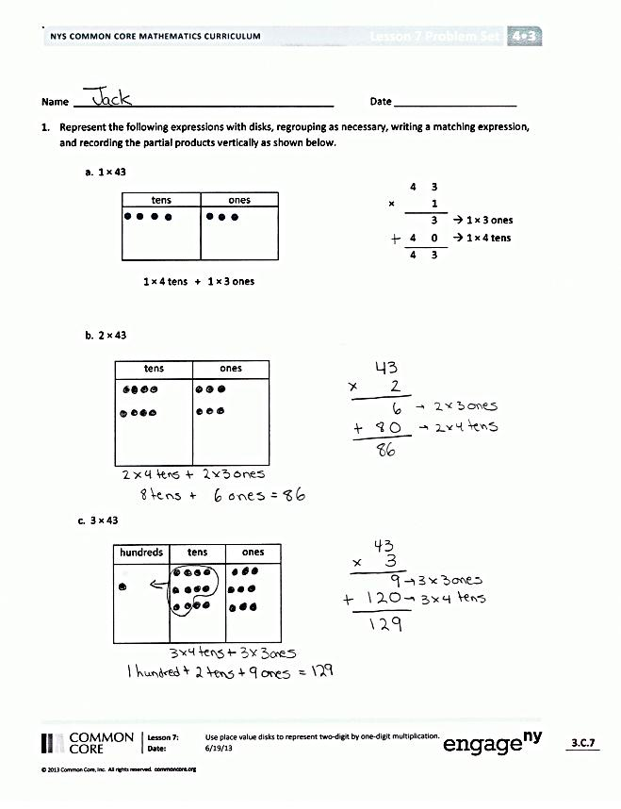
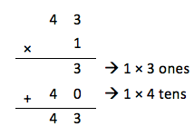
Problem Set (10 minutes)
Students should do their personal best to complete the Problem Set within the allotted 10 minutes. For some classes, it may be appropriate to modify the assignment by specifying which problems they work on first. Some problems do not specify a method for solving. Students should solve these problems using the RDW approach used for Application Problems.
Student Debrief (10 minutes)
Lesson Objective: Use place value disks to represent two-digit by one-digit multiplication.
The Student Debrief is intended to invite reflection and active processing of the total lesson experience.
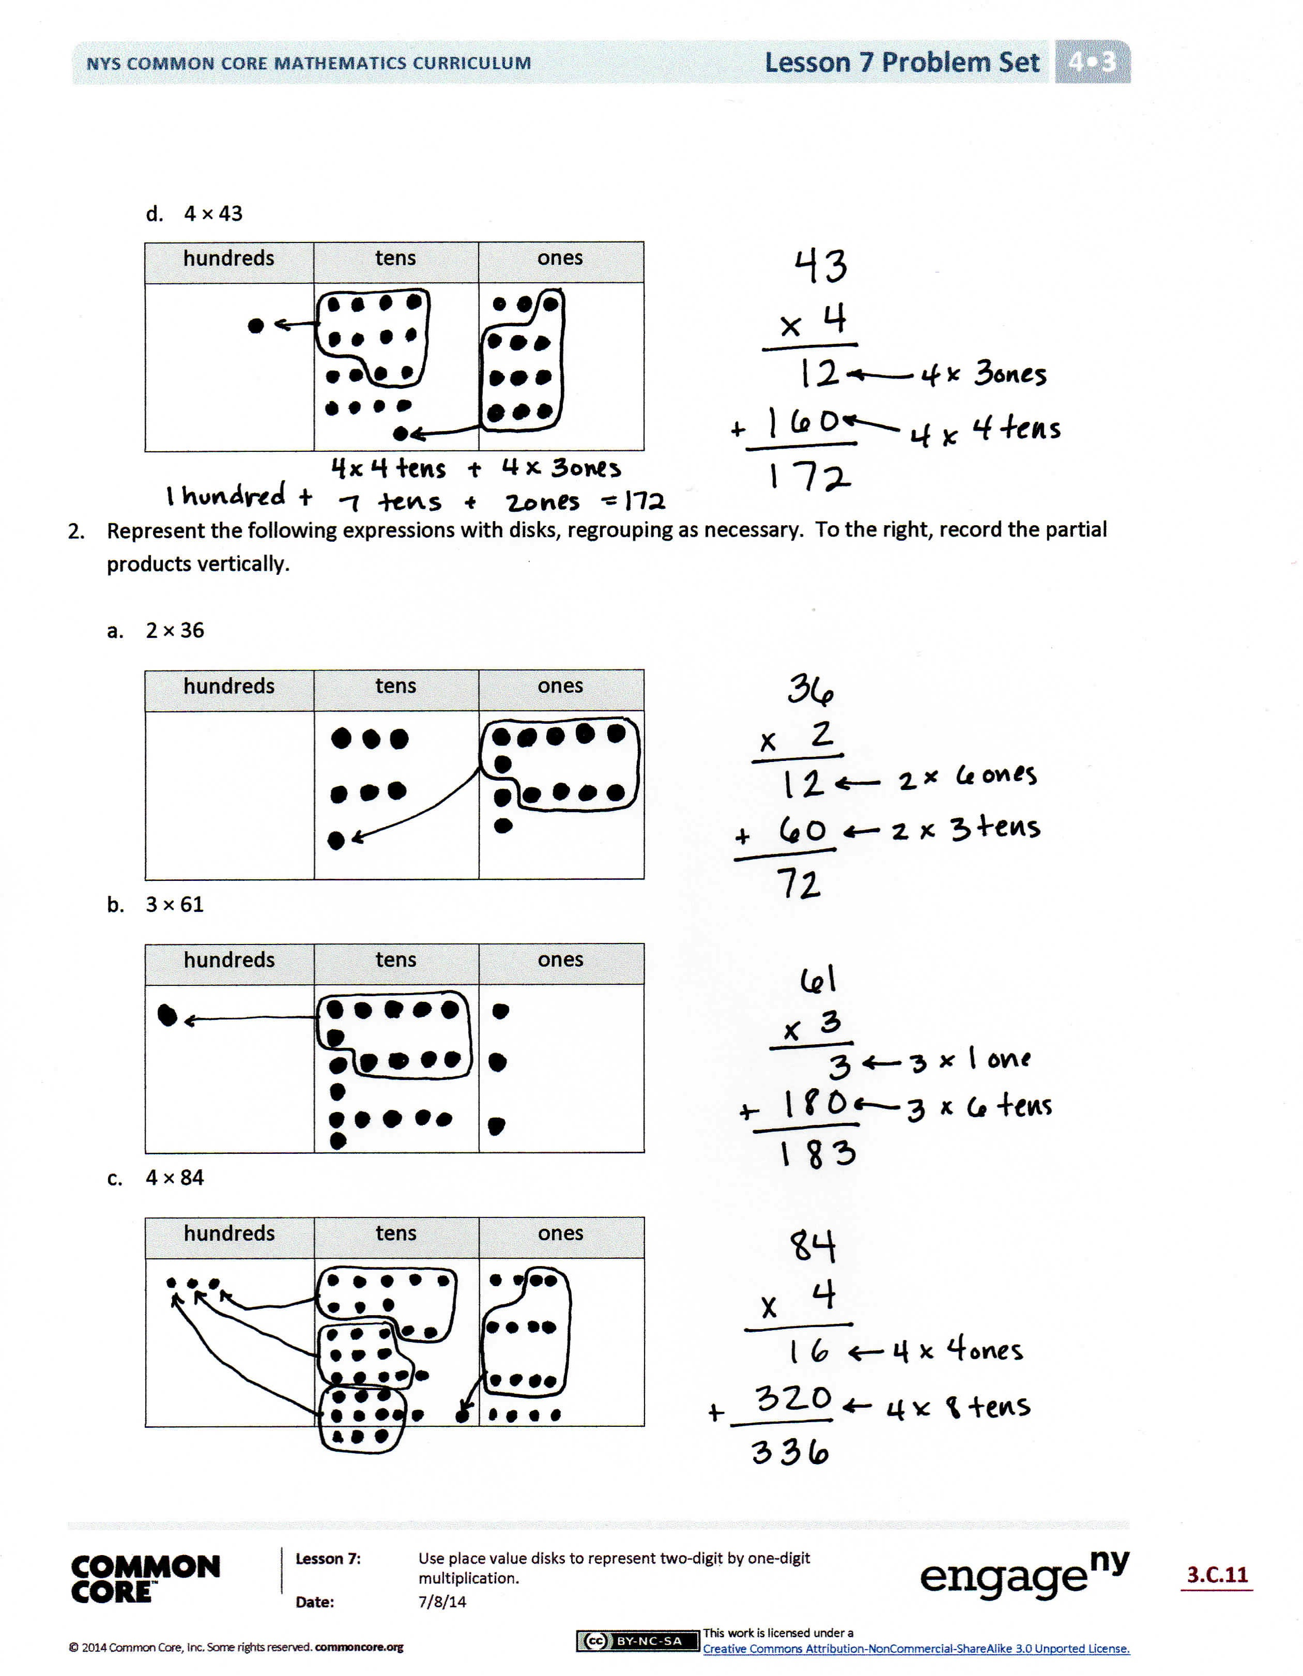
Invite students to review their solutions for the Problem Set. They should check work by comparing answers with a partner before going over answers as a class. Look for misconceptions or misunderstandings that can be addressed in the Debrief. Guide students in a conversation to debrief the Problem Set and process the lesson.
Any combination of the questions below may be used to lead the discussion.
- What pattern do you notice in the answers to Problems 1(a), 1(b), 1(c), and 1(d)?
- Describe the renaming you had to do when solving Problem 2(a). How is it different from the renaming you had to do when solving Problem 2(b)?
- Why did some of the problems require you to use a hundreds column in the place value chart, but others did not?
- When you start solving one of these problems, is there a way to tell if you are going to need to change 10 tens to 1 hundred or 10 ones to 1 ten?
- How did the Application Problem connect to today’s lesson?
  - If we found the total number of T-shirts sold first (24) and then multiplied to find the total amount of money, what would our multiplication problem have been? (24 × 9.)
  - What do the partial products for 24 × 9 represent in the context of the word problem?
- Talk to your partner about which method you prefer. Do you prefer writing the partial products or using a place value chart with disks? Is one of these methods easier for you to understand? Does one of them help you solve the problem faster?
Exit Ticket (3 minutes)
After the Student Debrief, instruct students to complete the Exit Ticket. A review of their work will help with assessing students’ understanding of the concepts that were presented in today’s lesson and planning more effectively for future lessons. The questions may be read aloud to the students.

A
Number Correct: _______
Multiply Multiples of 10, 100, and 1,000
 | 3 × 2 = |  |  |  | 7 × 5 =
 | 30 × 2 = |  |  |  | 700 × 5 =
 | 300 × 2 = |  |  |  | 8 × 3 =
 | 3,000 × 2 = |  |  |  | 80 × 3 =
 | 2 × 3,000 = |  |  |  | 9 × 4 =
 | 2 × 4 = |  |  |  | 9,000 × 4 =
 | 2 × 40 = |  |  |  | 7 × 6 =
 | 2 × 400 = |  |  |  | 7 × 600 =
 | 2 × 4,000 = |  |  |  | 8 × 9 =
 | 3 × 3 = |  |  |  | 8 × 90 =
 | 30 × 3 = |  |  |  | 6 × 9 =
 | 300 × 3 = |  |  |  | 6 × 9,000 =
 | 3,000 × 3 = |  |  |  | 900 × 9 =
 | 4,000 × 3 = |  |  |  | 8,000 × 8 =
 | 400 × 3 = |  |  |  | 7 × 70 =
 | 40 × 3 = |  |  |  | 6 × 600 =
 | 5 × 3 = |  |  |  | 800 × 7 =
 | 500 × 3 = |  |  |  | 7 × 9,000 =
 | 7 × 2 = |  |  |  | 200 × 5 =
 | 70 × 2 = |  |  |  | 5 × 60 =
 | 4 × 4 = |  |  |  | 4,000 × 5 =
 | 4,000 × 4 = |  |  |  | 800 × 5 =
B
[KEY]

Number Correct: _______
Improvement: _______
Multiply Multiples of 10, 100, and 1,000
 | 4 × 2 = |  |  |  | 9 × 5 =
 | 40 × 2 = |  |  |  | 900 × 5 =
 | 400 × 2 = |  |  |  | 8 × 4 =
 | 4,000 × 2 = |  |  |  | 80 × 4 =
 | 2 × 4,000 = |  |  |  | 9 × 3 =
 | 3 × 3 = |  |  |  | 9,000 × 3 =
 | 3 × 30 = |  |  |  | 6 × 7 =
 | 3 × 300 = |  |  |  | 6 × 700 =
 | 3 × 3,000 = |  |  |  | 8 × 7 =
 | 2 × 3 = |  |  |  | 8 × 70 =
 | 20 × 3 = |  |  |  | 9 × 6 =
 | 200 × 3 = |  |  |  | 9 × 6,000 =
 | 2,000 × 3 = |  |  |  | 800 × 8 =
 | 3,000 × 4 = |  |  |  | 9,000 × 9 =
 | 300 × 4 = |  |  |  | 7 × 700 =
 | 30 × 4 = |  |  |  | 6 × 60 =
 | 3 × 5 = |  |  |  | 700 × 8 =
 | 30 × 5 = |  |  |  | 9 × 7,000 =
 | 6 × 2 = |  |  |  | 20 × 5 =
 | 60 × 2 = |  |  |  | 5 × 600 =
 | 4 × 4 = |  |  |  | 400 × 5 =
 | 400 × 4 = |  |  |  | 8,000 × 5 =

Name Date
- Represent the following expressions with disks, regrouping as necessary, writing a matching expression, and recording the partial products vertically as shown below.
 | 4 | 3
× |  | 1
 |  | 3 | 1 × 3 ones
+ | 4 | 0 | 1 × 4 tens
 | 4 | 3
- 1 × 43
tens | ones

1 × 4 tens + 1 × 3 ones

- 2 × 43
tens | ones

- 3 × 43

hundreds | tens | ones

- 4 × 43

hundreds | tens | ones

- Represent the following expressions with disks, regrouping as necessary. To the right, record the partial products vertically.

  - 2 × 36
hundreds | tens | ones

  - 3 × 61
hundreds | tens | ones

  - 4 × 84
hundreds | tens | ones

Name Date
Represent the following expressions with disks, regrouping as necessary. To the right, record the partial products vertically.
- 6 × 41
hundreds | tens | ones

- 7 × 31
hundreds | tens | ones

Name Date
1. Represent the following expressions with disks, regrouping as necessary, writing a matching expression, and recording the partial products vertically.

tens | ones
- 3 × 24

- 3 × 42
hundreds | tens | ones

- 4 × 34
hundreds | tens | ones

- Represent the following expressions with disks, regrouping as necessary. To the right, record the partial products vertically.

- 4 × 27
hundreds | tens | ones

- 5 × 42
hundreds | tens | ones

3. Cindy says she found a shortcut for doing multiplication problems. When she multiplies 3 × 24, she says, “3 × 4 is 12 ones, or 1 ten and 2 ones. Then, there’s just 2 tens left in 24, so add it up, and you get 3 tens and 2 ones.” Do you think Cindy’s shortcut works? Explain your thinking in words, and justify your response using a model or partial products.

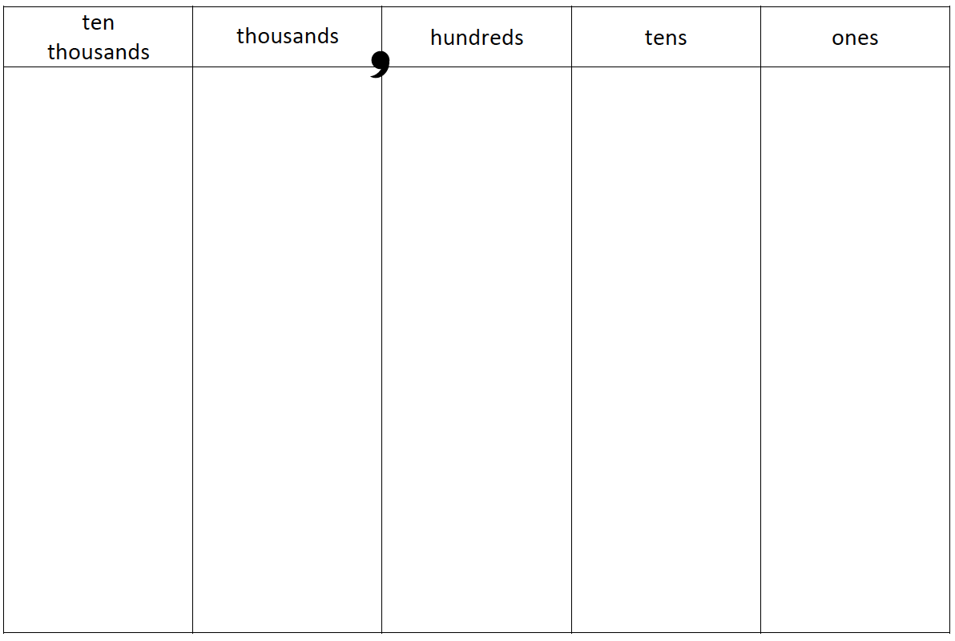

ten thousands place value chart

