Lesson 11
Objective: Connect the area model and the partial products method to the standard algorithm.

Suggested Lesson Structure
 Fluency Practice (12 minutes)
 Application Problem (7 minutes)
 Concept Development (31 minutes)
 Student Debrief (10 minutes)
Total Time (60 minutes)

Fluency Practice (12 minutes)
- Multiply Mentally 4.NBT.4 (4 minutes)
- Multiply in Three Different Ways 4.NBT.4 (8 minutes)
Multiply Mentally (4 minutes)
Note: Reviewing these mental multiplication strategies provides a foundation for students to succeed during the Concept Development.
Repeat the process from Lesson 7, expanding to four-digits for the following possible sequence: 4,312 × 2, 2,032 × 3, 2,212 × 4, and 3,203 × 4.
Multiply in Three Different Ways (8 minutes)

Materials: (S) Place value disks
Note: This fluency activity reviews the Concept Development in Lessons 7─10.
T: (Write 43 × 2.) Say the multiplication expression in unit form.
S: 4 tens 3 ones × 2.
T: Show the multiplication expression using partial products.
S: (Write (40 × 2) + (3 × 2).)
T: Show the multiplication expression using place value disks.
S: (Show multiplication expression using place value disks.)
T: Write the multiplication expression using the standard algorithm.
T: (Students do so.)
Repeat the process using the following possible sequence: 54 × 2 and 63 × 3.

Application Problem (7 minutes)

4
8
30

Write an equation for the area of each rectangle. Then, find the sum of the two areas.
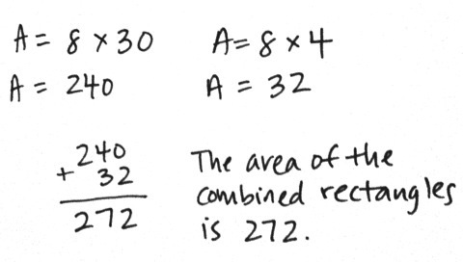
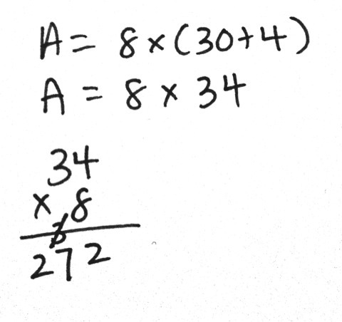
Extension: Find a faster method for finding the area of the combined rectangles.

NOTES ON
MULTIPLE MEANS
OF ACTION AND EXPRESSION:
Scaffold student use of the area model to solve with the following options:
- Provide a blank area model template for students to slip into their personal white boards.
- Review expanded form with place value cards or place value disks.
- Simplify the multiplication. For example, use 4 as a factor rather than 8.

Note: This problem is designed to bridge learning from Topic A, in which students solved for the area, to this lesson, where they learn to model multiplication problems using the area model. The placement of the small rectangle to the right of the larger rectangle is intentional for showing the tens and ones of the area model. It is recommended that this problem be presented immediately prior to the Concept Development.

Concept Development (31 minutes)

Materials: (S) Personal white board
Problem 1: Multiply a three-digit number by a one-digit number using the area model.
T: Draw a rectangle with a width of 8 and a length of 200.
S: (Draw.)
T: Tell your neighbor how to find the area.
S: Multiply 8 times 200. That equals 1,600.
T: Write the area inside your rectangle.
T: Think back to the Application Problem (above). We had two rectangles also with the width of 8. Let’s combine all three rectangles: this one and the two from the Application Problem. (Draw them.) With
your partner, discuss how to find the area of all three rectangles put together.
S: In the Application Problem, I multiplied 8 times 4 and 8 times 30. So, then I can also multiply 8 times 200 and add all the sums together.
T: Record that as one continuous addition problem with your partner.
Guide students to record (8 × 200) + (8 × 30) + (8 × 4).
T: You are saying to multiply each section of the lengths by 8? (Record 8 (200 + 30 + 4) on the board.)
S: Yes.
T: Solve to find the area of the entire rectangle. Let’s begin with the largest rectangle.
T: 8 times 200?
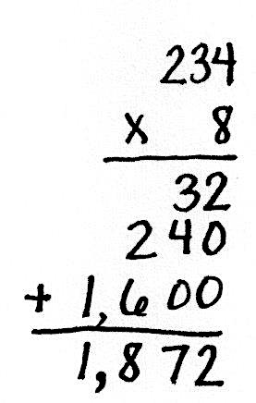
S: 1,600. (Record 1,600 as a partial product in the area model and in the written method.)
T: 8 times 30?
S: 240. (Record 240 as a partial product in the area model and in the written method.)
T: Show your partner where to record 8 times 4. Tell your partner the multiplication sentence represented by the area model.
S: 8 times 234 equals 1,872.
T: Compare the partial products to the rectangular area model.
S: The area inside each smaller rectangle is the same as each of the partial products.

NOTES ON
MULTIPLE MEANS
OF ACTION AND EXPRESSION:
One advantage of the area model is its flexibility for learners. Students can represent their partial products as arrays of place value disks, in unit form, or standard form. Though not as efficient as the standard algorithm, it may be an effective scaffold for students working below grade level.

T: We recorded the partial products starting with the largest unit, the hundreds. Does the order of partial products change the final product? Work with your partner to solve 8 times 234 using partial products, beginning with the smallest unit, the ones.
S: The answer is the same. I can multiply in any order using partial products. The order of addends does not matter. That’s the commutative property of addition. I can record partial products using the smallest or largest unit first.
T: Yes, the rectangle, or area model, is another way to represent the partial products in multiplication.
Problem 2: Multiply a three-digit number by a one-digit number, connecting the area model to the standard algorithm.
Display 316 × 4.
T: How many hundreds, tens, and ones are in 316?
S: 3 hundreds 1 ten 6 ones.
T: Draw an area model with a length of 3 hundreds 1 ten 6 ones and a width of 4.
T: Tell your partner how to solve using the area model.
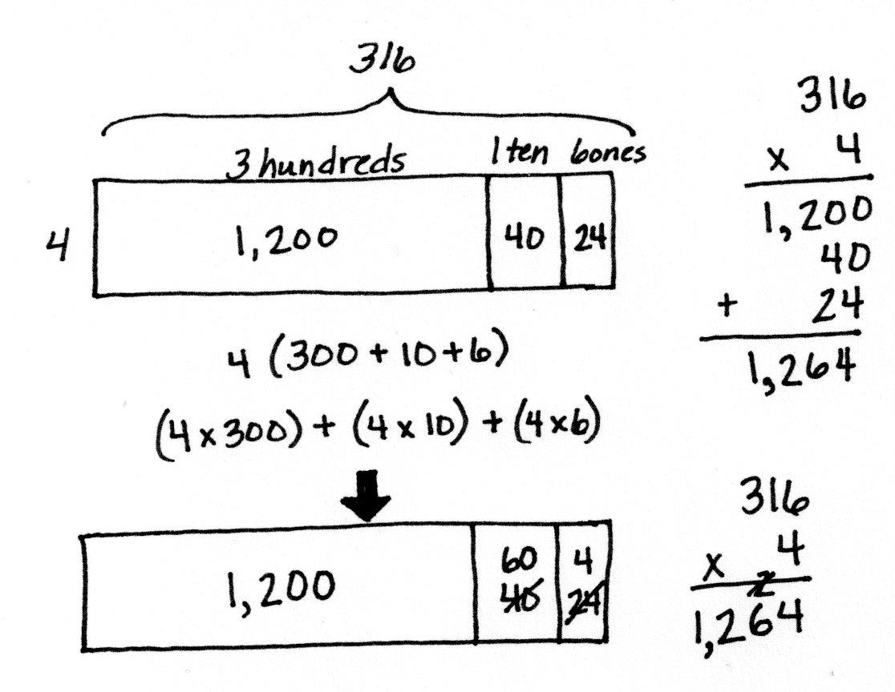
S: The rectangle is partitioned into hundreds, tens, and ones. I’ll multiply 4 times
3 hundreds, 4 times 1 ten, and 4 times
6 ones and add the three products together for the answer. That’s like the break apart and distribute property we learned last year.
T: Yes, the distributive property allows us to break apart the large multiplication problem into three smaller ones.
T: Work with your partner to multiply.
Circulate, providing assistance, while students work.
T: 4 times 3 hundreds is…?
S: 12 hundreds.
T: 4 times 1 ten is…?
S: 4 tens.
T: 4 times 6 ones is…?
S: 24 ones.
MP.5
T: Solve 316 times 4 using the standard algorithm, and compare your answer to the area model.
S: 316 times 4 is 1,264. I got that answer using both methods. The area model doesn’t let me show how to regroup 24 ones for 2 tens 4 ones, but the algorithm does. I can regroup in the area model. I can draw an arrow to regroup 20 ones as 2 tens. Now, my area model looks like a place value chart because I regrouped to show 6 tens. The area model aligns better to the partial products method, but the algorithm is still the quickest way for me to solve!
Repeat with 5,463 × 5, drawing the area model and comparing it to the algorithm or the partial products method.
Problem 3: Solve a word problem using the standard algorithm, area model, or partial products strategy.
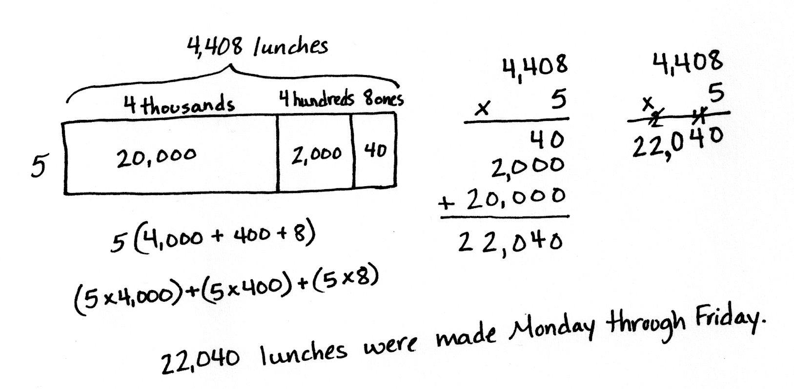
A cafeteria makes 4,408 lunches each day. How many lunches are made Monday through Friday?
T: Discuss with your partner how to solve this problem.
T: What are some methods you could use to solve this?
S: An area model could help. I like using the partial products method. I think I can just use the algorithm.
T: You could also use the distributive property to help break apart and solve. Choose your method and solve.
S: 4,408 × 5 is 22,040. The cafeteria makes 22,040 lunches Monday through Friday.
When debriefing the solution, make note of how to draw an area model without a digit in the tens column.

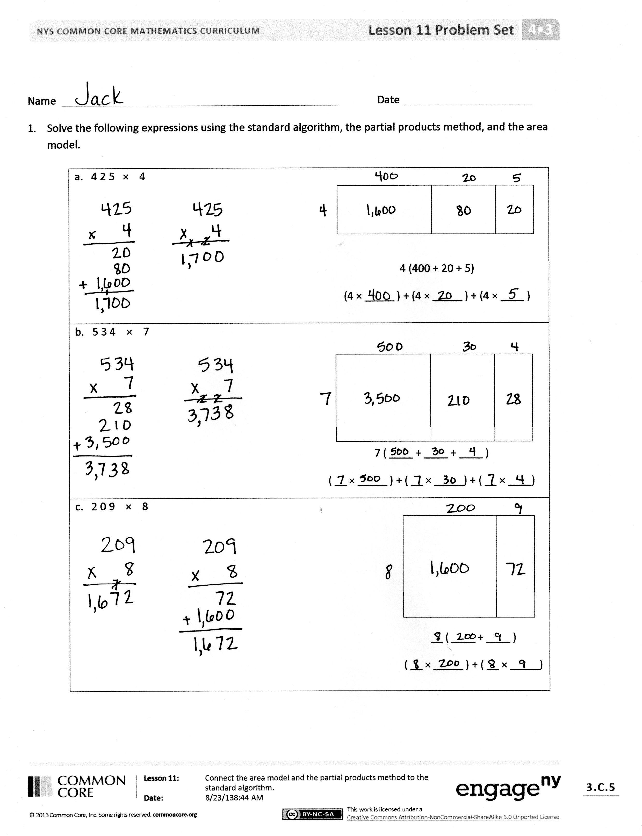
Problem Set (10 minutes)
Students should do their personal best to complete the Problem Set within the allotted 10 minutes. For some classes, it may be appropriate to modify the assignment by specifying which problems they work on first. Some problems do not specify a method for solving. Students should solve these problems using the RDW approach used for Application Problems.

Student Debrief (10 minutes)
Lesson Objective: Connect the area model and the partial products method to the standard algorithm.
The Student Debrief is intended to invite reflection and active processing of the total lesson experience.
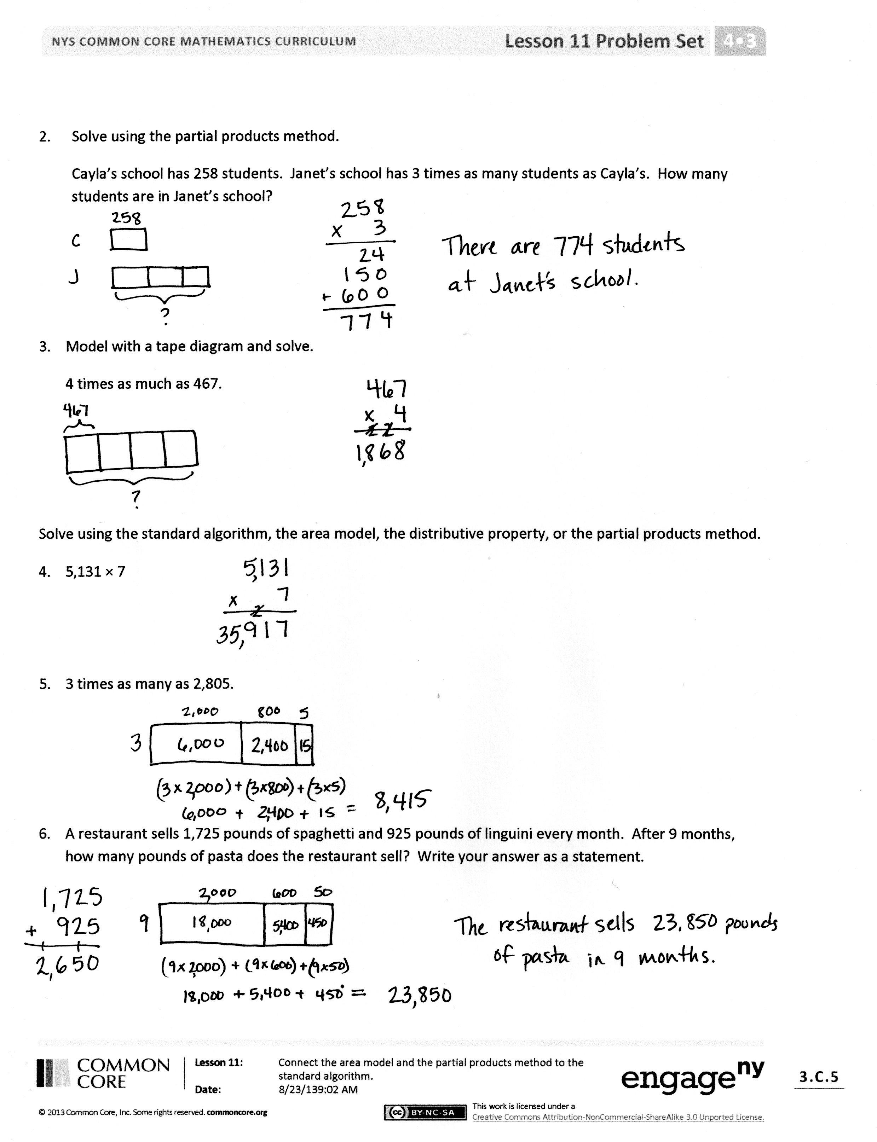
Invite students to review their solutions for the Problem Set. They should check work by comparing answers with a partner before going over answers as a class. Look for misconceptions or misunderstandings that can be addressed in the Debrief. Guide students in a conversation to debrief the Problem Set and process the lesson.
Any combination of the questions below may be used to lead the discussion.
- Can you solve any of the expressions in Problem 1 using a different method or strategy?
- In Problem 1, how does the area model connect to the expressions written below the area model? How could the distributive property be used to solve problems without drawing the area model?
- For Problems 4─6, which method(s) did you choose and why?
- How did the Application Problem introduce today’s lesson?
- How is finding the area of a rectangle similar to finding the product using the area model?

Exit Ticket (3 minutes)
After the Student Debrief, instruct students to complete the Exit Ticket. A review of their work will help with assessing students’ understanding of the concepts that were presented in today’s lesson and planning more effectively for future lessons. The questions may be read aloud to the students.
.
Name Date
1. Solve the following expressions using the standard algorithm, the partial products method, and the area model.
a. 4 2 5 × 4

4 (400 + 20 + 5)
(4 × _____ ) + (4 × _____ ) + (4 × _____ )
b. 5 3 4 × 7

7 ( ____ + ____ + ____ )
( __ × _____ ) + ( __ × _____ ) + ( __ × ____ )
c. 2 0 9 × 8
__ ( ____ + ____ )
( __ × _____ ) + ( __ × _____ )

2. Solve using the partial products method.
Cayla’s school has 258 students. Janet’s school has 3 times as many students as Cayla’s. How many students are in Janet’s school?

3. Model with a tape diagram and solve.
4 times as much as 467

Solve using the standard algorithm, the area model, the distributive property, or the partial products method.
- $\text{5}\text{,}\text{131 × 7 }$

- 3 times as many as 2,805

- A restaurant sells 1,725 pounds of spaghetti and 925 pounds of linguini every month. After 9 months, how many pounds of pasta does the restaurant sell?

Name Date
- Solve using the standard algorithm, the area model, the distributive property, or the partial products method.

2,809 × 4

- The monthly school newspaper is 9 pages long. Mrs. Smith needs to print 675 copies. What will be the total number of pages printed?

Name Date
1. Solve the following expressions using the standard algorithm, the partial products method, and the area model.
a. 3 0 2 × 8

8 (300 + 2)
(8 × _____ ) + (8 × _____ )
b. 2 1 6 × 5

5 ( ____ + ____ + ____ )
( __ × _____ ) + ( __ × _____ ) + ( __ × ____ )
c. 5 9 3 × 9
__ ( ____ + ____ + ____ )
( __ × _____ ) + ( __ × _____ ) + ( __ × ____ )

2. Solve using the partial products method.
On Monday, 475 people visited the museum. On Saturday, there were 4 times as many visitors as there were on Monday. How many people visited the museum on Saturday?

- Model with a tape diagram and solve.
6 times as much as 384

Solve using the standard algorithm, the area model, the distributive property, or the partial products method.
- $\text{6}\text{,}\text{253 × 3 }$

- 7 times as many as 3,073

- A cafeteria makes 2,516 pounds of white rice and 608 pounds of brown rice every month. After
6 months, how many pounds of rice does the cafeteria make?

