Lesson 10
Objective: Multiply three- and four-digit numbers by one-digit numbers applying the standard algorithm.

Suggested Lesson Structure
 Fluency Practice (12 minutes)
 Application Problem (5 minutes)
 Concept Development (33 minutes)
 Student Debrief (10 minutes)
Total Time (60 minutes)
Fluency Practice (12 minutes)
- Represent Expanded Form 2.NBT.3 (3 minutes)
- Multiply Mentally 4.NBT.4 (3 minutes)
- Multiply Using Partial Products 4.NBT.4 (6 minutes)
Represent Expanded Form (3 minutes)

NOTES ON
MULTIPLE MEANS
OF ENGAGEMENT:
Extend Represent Expanded Form by challenging students above grade level to do one of the following:
- Use your disks to show 1,000/100/10 less/more than 3,241.
- Use your disks to show another number that would be rounded to the same ten/hundred as 2,053.

Materials: (S) Place value disks
Note: This activity incorporates expanded form fluency from Lessons 8 and 9 while reviewing how to use place value disks.
T: (Write 532.) Say the number in expanded form.
S: 532 equals 500 plus 30 plus 2.
T: Say it in unit form.
S: 532 equals 5 hundreds 3 tens 2 ones.
T: Use your disks to show 5 hundreds 3 tens 2 ones.
Repeat the process for the following possible sequence: 415, 204, 3,241, and 2,053.
Multiply Mentally (3 minutes)
Note: Reviewing these mental multiplication strategies provides a foundation for students to succeed during the Concept Development.
Repeat the process from Lesson 7 for the following possible sequence: 342 × 2, 132 × 3, 221 × 4, and 213 × 4.
Multiply Using Partial Products (6 minutes)
Materials: (S) Personal white board
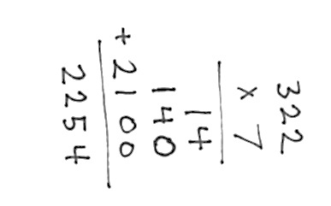
Note: This activity serves as a review of the Concept Development in Lessons 7 and 8.
T: (Write 322 × 7.) Say the multiplication expression.
S: 322 × 7.
T: Say it as a three-product addition expression in unit form.
S: (3 hundreds × 7) + (2 tens x 7) + (2 ones × 7).
T: Write 322 × 7 vertically, and solve using the partial product strategy.
Repeat the process for the following possible sequence: 7 thousands 1 hundred 3 tens 5 ones × 5 and
3 × 7,413.
Application Problem (5 minutes)
The principal wants to buy 8 pencils for every student at her school. If there are 859 students, how many pencils does the principal need to buy?
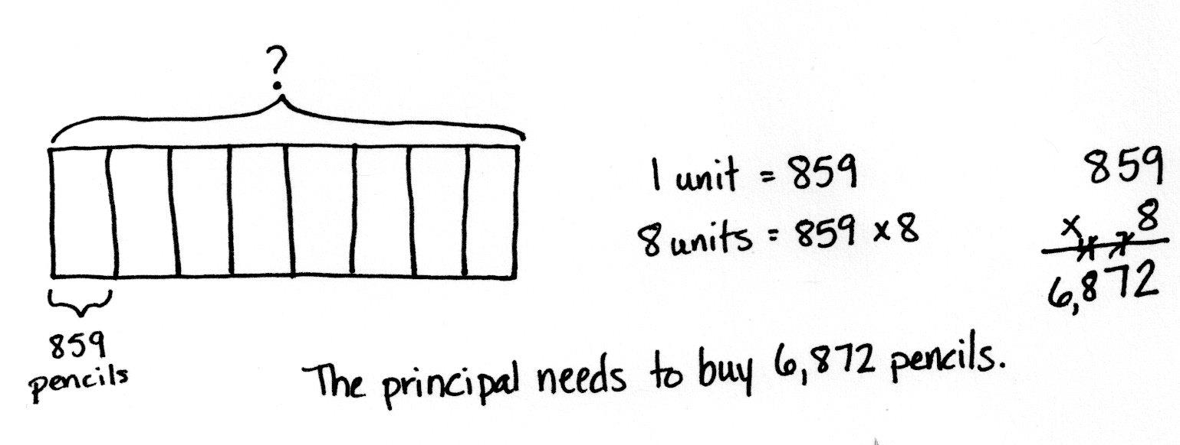

Note: This problem is a review of Lesson 9. Students may solve using the algorithm or partial products. Both are place value strategies.

Concept Development (33 minutes)
Materials: (S) Personal white board
Problem 1: Solve 5 × 2,374 using partial products, and then connect to the algorithm.
Display 5 × 2,374 vertically on the board.
T: With your partner, solve 5 × 2,374 using the partial products method.
Allow two minutes to solve.

T: Now, let’s solve using the algorithm. Say a multiplication sentence for the ones column.
S: 4 ones times 5 is 20 ones or 2 tens.
T: Tell your partner how to record 20 ones or 2 tens.
S: I am going to record 2 tens on the line in the tens column and the 0 in the ones column.
T: Do you have 20 ones recorded in your answer from the partial products?
S: Yes!
T: What is multiplied in the tens column?
S: 7 tens times 5 is 35 tens. I notice when I look back at the partial products, I also have 35 tens or
3 hundreds 5 tens.
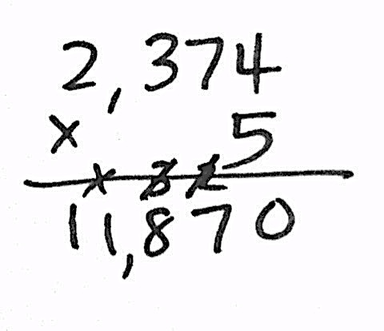
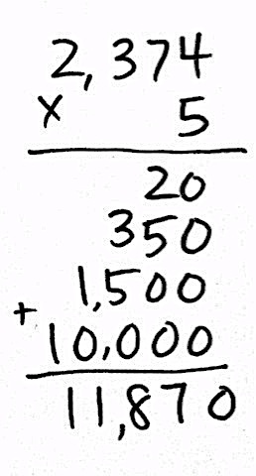
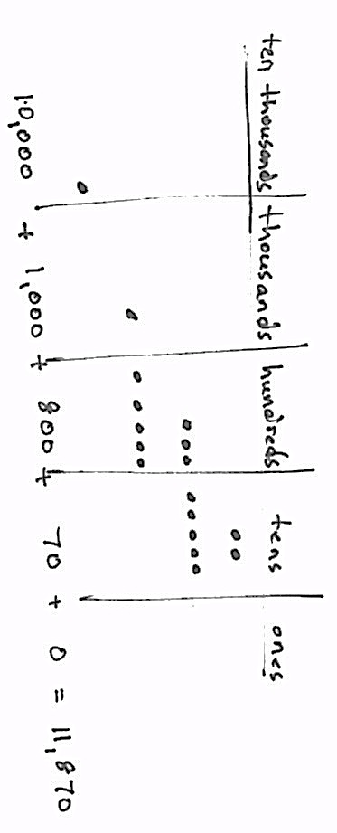

NOTES ON
MULTIPLE MEANS
OF REPRESENTATION:
Learners and mathematicians differ in the strategies they use to solve a problem. Whether we use the standard algorithm or partial products strategy, our product is the same. Cultivate a classroom culture of acceptance of multiple methods to solve. Encourage students to share and innovate efficient strategies for this and other math topics.

T: Tell your partner what to do with 3 hundreds 5 tens and the 2 tens we recorded on the line.
S: We have to add the 2 tens to get 37 tens or 3 hundreds 7 tens. Why do the partial products only show 350 though?
MP.4
T: Discuss with your partner why the algorithm shows
37 tens, but the partial product shows 35 tens.
S: In the partial products method, we add the 2 tens to
35 tens later after multiplying each place value separately. In the algorithm, you add as you go.
T: Let’s record 3 hundreds 7 tens or 37 tens. Cross off the
2 tens on the line because they’ve been added in.
T: What is our multiplication sentence for the hundreds column?
S: 3 hundreds times 5 is 15 hundreds or 1 thousand 5 hundreds. I noticed the 1,500 in the partial products strategy came next. The algorithm is multiplying in the same order starting with the ones column and moving left. We add the 3 hundreds that were changed from tens. Now we have
18 hundreds. I cross out the 3 on the line because I’ve added it.
T: Right. Last, we have the thousands column.
S: 2 thousands times 5 plus 1 thousand is 11 thousands.
T: Notice that our answer is the same when we used the algorithm and the partial products strategy.
Repeat using 9 × 3,082.

Problem 2: Solve 6 × 3,817 using the algorithm.
Display 6 × 3,817 vertically on the board.
T: With your partner, solve 6 × 3,817 using the algorithm.
Allow students two minutes to solve. Listen for use of unit language to multiply, such as 6 times 7 ones is 42 ones.
Repeat with 3 × 7,109.
Problem 3: Solve a word problem that requires four-digit by one-digit multiplication using the algorithm.
There are 5,280 feet in a mile. If Bryan ran 4 miles, how many feet did he run?
T: Discuss with your partner how you would solve this problem.
T: On your own, use the algorithm to solve for how many feet Bryan ran.
S: 5,280 × 4 is 21,120. Bryan ran 21,120 feet.
Problem Set (10 minutes)
Students should do their personal best to complete the Problem Set within the allotted 10 minutes. For some classes, it may be appropriate to modify the assignment by specifying which problems they work on first. Some problems do not specify a method for solving. Students should solve these problems using the RDW approach used for Application Problems.
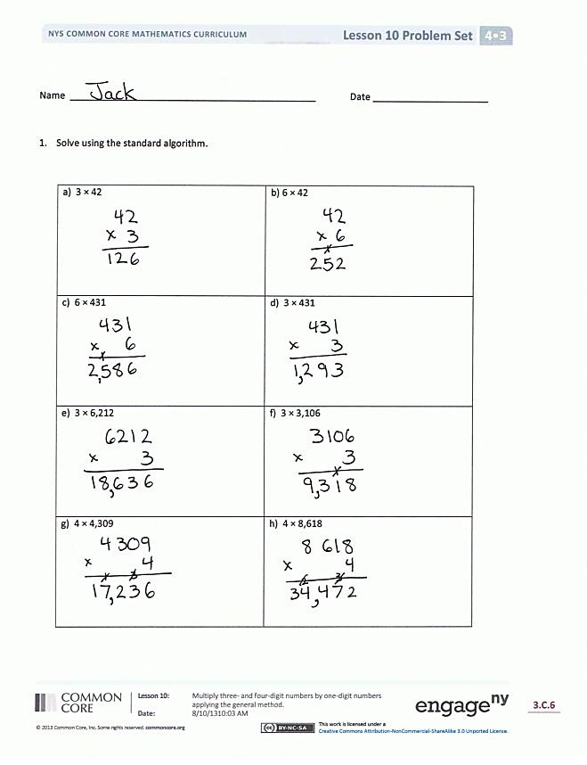
Student Debrief (10 minutes)
Lesson Objective: Multiply three- and four-digit numbers by one-digit numbers applying the standard algorithm.
The Student Debrief is intended to invite reflection and active processing of the total lesson experience.
Invite students to review their solutions for the Problem Set. They should check work by comparing answers with a partner before going over answers as a class. Look for misconceptions or misunderstandings that can be addressed in the Debrief. Guide students in a conversation to debrief the Problem Set and process the lesson.
Any combination of the questions below may be used to lead the discussion.
- What pattern did you notice while solving Problems 1(a) and (b)?
- What happens to the product if one factor is doubled? Halved?
- What other patterns did you notice while working on Problem 1?
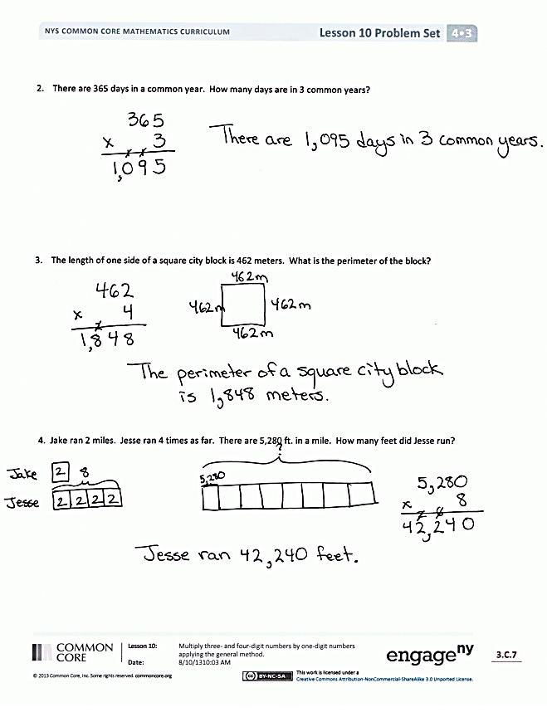
- Problem 3 only gave one factor. How did you find the other factor?
- If one of your classmates was absent for the past week, how would you explain how you solved Problem 4? Describe any visuals you could use to help you with your explanation.
- How did Lesson 9 help you to understand today’s lesson?
Exit Ticket (3 minutes)
After the Student Debrief, instruct students to complete the Exit Ticket. A review of their work will help you assess the students’ understanding of the concepts that were presented in the lesson today and plan more effectively for future lessons. The questions may be read aloud to the students

Name Date
- 3 × 42 | - 6 × 42
- 6 × 431 | - 3 × 431
- 3 × 6,212 | - 3 × 3,106
- 4 × 4,309 | - 4 × 8,618
- Solve using the standard algorithm.
- There are 365 days in a common year. How many days are in 3 common years?

- The length of one side of a square city block is 462 meters. What is the perimeter of the block?

- Jake ran 2 miles. Jesse ran 4 times as far. There are 5,280 feet in a mile. How many feet did Jesse run?

Name Date
- Solve using the standard algorithm.
- 2,348 × 6 | - 1,679 × 7

- A farmer planted 4 rows of sunflowers. There were 1,205 plants in each row. How many sunflowers did he plant?

Name Date
- Solve using the standard algorithm.
- 3 × 41 | - 9 × 41
- 7 × 143 | - 7 × 286
- 4 × 2,048 | - 4 × 4,096
- 8 × 4,096 | - 4 × 8,192
- Robert’s family brings six gallons of water for the players on the football team. If one gallon of water contains 128 fluid ounces, how many fluid ounces are in six gallons?

- It takes 687 Earth days for the planet Mars to revolve around the sun once. How many Earth days does it take Mars to revolve around the sun four times?

- Tammy buys a 4-gigabyte memory card for her camera. Dijonea buys a memory card with twice as much storage as Tammy’s. One gigabyte is 1,024 megabytes. How many megabytes of storage does Dijonea have on her memory card?

