Lesson 4
Objective: Interpret and represent patterns when multiplying by 10, 100, and 1,000 in arrays and numerically.

Suggested Lesson Structure
 Fluency Practice (12 minutes)
 Application Problem (4 minutes)
 Concept Development (34 minutes)
 Student Debrief (10 minutes)
Total Time (60 minutes)

Fluency Practice (12 minutes)
- Rename the Unit 4.NBT.1 (3 minutes)
- Group Count by Multiples of 10 and 100 4.NBT.1 (5 minutes)
- Find the Area and Perimeter 4.MD.3 (4 minutes)

Rename the Unit (3 minutes)
Materials: (S) Personal white board
Note: Renaming units helps prepare students for the next fluency activity and for this lesson’s content.
Repeat the process from Lesson 2 using the following suggested sequence: 8 tens, 9 tens, 11 tens,
14 tens, 14 hundreds, 14 thousands, 18 tens, 28 tens, 28 hundreds, and 28 thousands.

Group Count by Multiples of 10 and 100 (5 minutes)
Note: Changing units helps prepare students to recognize patterns of place value in multiplication.
T: Count by threes to 30.
S: 3, 6, 9, 12, 15, 18, 21, 24, 27, 30.
T: Now, count by 3 tens. When I raise my hand, stop counting.
S: 3 tens, 6 tens, 9 tens.
T: (Raise hand.) Say the number.
S: 90.

T: Continue.
S: 12 tens, 15 tens.
T: (Raise hand.) Say the number.
S: 150.
Repeat the process for 21 tens, 27 tens, and 30 tens.
Repeat the process, counting by 4 hundreds, stopping to convert at 12 hundreds, 20 hundreds, 32 hundreds, and 40 hundreds.
Repeat the process, counting by 6 hundreds, stopping to convert at 18 hundreds, 30 hundreds, 48 hundreds, and 60 hundreds.

Find the Area and Perimeter (4 minutes)
Materials: (S) Personal white board
Note: This activity reviews content from Lessons 1 and 2.
Repeat the process from Lesson 2 for the following possible suggestions:
- Rectangles with dimensions of 9 cm × 2 cm, 7 cm × 5 cm, and 3 cm × 8 cm.
- Squares with lengths of 7 cm and 8 m.
- Rectangles with the following properties: area of 10 square cm, length 2 cm, and width x; area of
35 square cm, length 5 cm, and width x; and area of 54 square m, width of 6 m, and length x.

Application Problem (4 minutes)
Samantha received an allowance of $3 every week. By babysitting, she earned an additional $30 every week. How much money did Samantha have in four weeks, combining her allowance and her babysitting?
Note: The multiplication of two-digit multiples of 10 by
single-digit numbers is a Grade 3 standard (3.NBT.3). The second step of this problem relates to today’s Concept Development. Students may solve it one way here and may find a simplifying strategy to solve after the lesson has been completed.

Concept Development (34 minutes)

NOTES ON
MULTIPLE MEANS
OF REPRESENTATION:
Noting patterns of ten in the place value chart is familiar to students after Modules 1 and 2. However, there may be a need to adjust the display of information by using base ten blocks to convey the magnification of the size or amount, by writing numerals instead of disks, or by writing 10 inside of each ten disk.

Materials: (T) Thousands place value chart (Template)
(S) Personal white board, thousands place value chart (Template)
Problem 1: Draw place value disks to represent products when multiplying by a one-digit number.
T: (Draw 3 ones on the place value chart.) How many do you see?
S: 3 ones.
T: How many groups of 3 ones do you see?
S: Just 1.
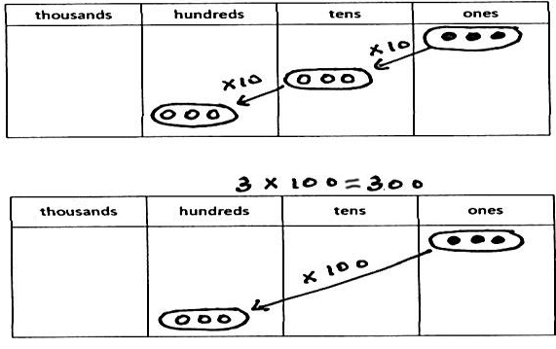
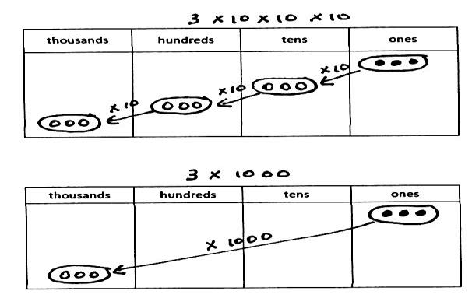
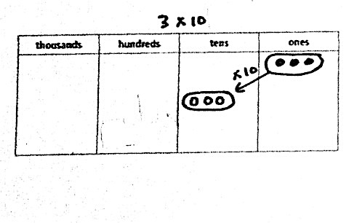
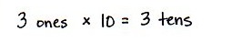
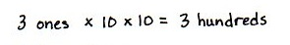
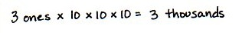
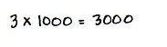
T: (Write 3 ones × 1.) Suppose I wanted to multiply 3 ones by ten instead. (Underneath, write 3 ones × 10.) How would I do that?
S: We can just move each disk over to the tens place and get 3 tens.
T: (Draw an arrow indicating that the disks shift one place to the left, label it × 10 and write 3 ones × 10 = 3 tens.) What if I wanted to multiply that by 10?
S: Do the same thing. Move them one more place into the hundreds and get 3 hundreds.
T: (Repeat the procedure on the place value chart, but now write 3 ones × 10 × 10 = 3 hundreds.) Look at my equation. I started with 3 ones. What did I multiply 3 ones by to get 3 hundreds? Turn and talk.
S: We multiplied by 10 and then multiplied by 10 again.
We multiplied by 10 × 10, but that's really 100. I can group the 10 × 10, so this is really 3 × (10 × 10). That's just
3 × 100.
T: Work with your partner. How can you solve 3 × 1,000?
S: I showed 3 times 1,000 by showing 3 ones × 10 to get 3 tens. Then, I did times 10 again to get 3 hundreds and times 10 again to show 3 thousands. I drew an arrow representing times 1,000 from 3 ones to the thousands column.
T: What is 3 × 10 × 10 × 10 or 3 × 1,000?
S: 3,000.
Repeat with 4 × 10, 4 × 100, and 4 × 1,000.

Problem 2: Draw place value disks to represent products when multiplying by a two-digit number.
Display 15 × 10 on the board.
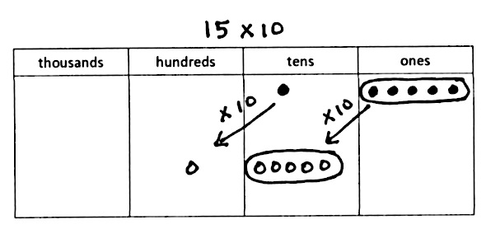
T: Draw place value disks to represent 15, and then show 15 × 10. Explain what you did.
S: I drew an arrow to the next column. I drew an arrow to show times 10 for the 1 ten and also for the 5 ones.
T: Right. We need to show times 10 for each of our units.
T: What is 1 ten × 10?
S: 1 hundred.
T: What is 5 ones × 10?
S: 5 tens.
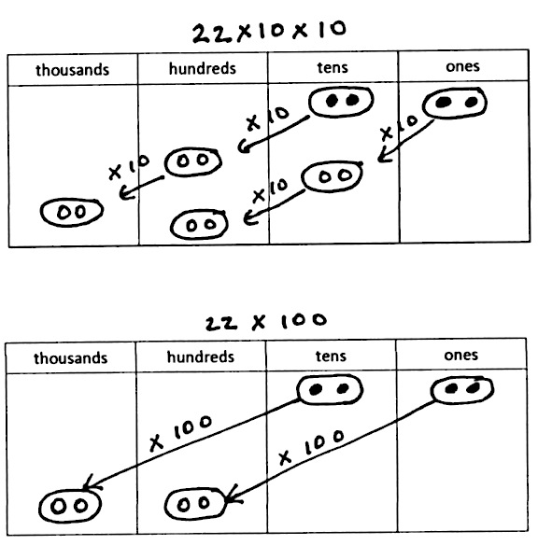
T: 15 × 10 equals?
S: 150.
Display 22 × 100 on the board.
T: With your partner, represent 22 × 100 using place value disks. What did you draw?
MP.4
S: I drew 2 tens and 2 ones and showed times 10. Then, I did times 10 again. I drew 2 tens and 2 ones and showed times 100 by moving two place values to the left.
T: How can we express your solution strategies as multiplication sentences?
S: 22 × 10 × 10. 22 × 100.
T: What is 22 × 100?
S: 2,200.

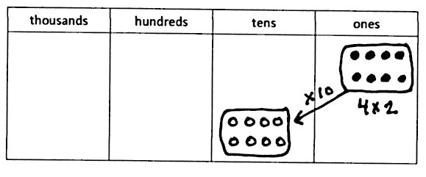
Problem 3: Decomposing multiples of 10 before multiplying.
Display 4 × 20 on the board.
T: Just like 3 × 100 can be expressed as 3 × 10 × 10, there are different ways to show 4 × 20 to help us multiply. What is another way that I could express 4 × 20?
S: 4 × 2 tens. 4 × 2 × 10. 8 × 10.
T: Discuss with your partner which of these methods would be most helpful to you to solve 4 × 20.
Allow one minute to discuss.
S: 4 × 2 tens is the most helpful for me, because I know 4 × 2. 4 × 2 × 10 is the most helpful because it is similar to 4 × 2 tens. I can do 4 × 2 first, which I know is 8. Then, I can do 8 times 10, which I know is 80.
T: When multiplying with multiples of 10, you can decompose a factor to help you solve. In this example, we expressed 4 × 20 as (4 × 2) × 10.
Display 6 × 400 on the board.
T: With your partner, solve 6 × 400. Use a simplifying strategy so that you are multiplying by 10, 100, or 1,000.

NOTES ON
MULTIPLE MEANS
OF ENGAGEMENT:
Invite students to compose a chart listing all basic facts whose products are multiples of 10 (such as 4 × 5). Encourage students to search for patterns and relationships as they decompose these facts.
For example:
4 × 500 = (2 × 10) × 100
6 × 500 = (3 × 10) × 100
8 × 500 = (4 × 10) × 100

Allow one minute to work. Have students share their decomposition and simplifying strategies.
S: 6 × 4 hundreds. (6 × 4) × 100. 24 × 100.
T: Using the expression of your choice, solve for 6 × 400.
S: 6 × 400 is 24 hundreds or 2,400.
Display 4 × 500 on the board.
T: Use a simplifying strategy to solve 4 × 500.
Allow one minute to work. Have students share their decomposition and simplifying strategies.
S: 4 × 5 hundreds. (4 × 5) × 100. 20 × 100. (2 × 10) × 100. 2 × 10 × 100. 2 × 1,000.
T: Using the expression of your choice, solve for 4 × 500.
S: 4 × 500 is 2 thousands or 20 hundreds or 2,000.

Problem Set (10 minutes)
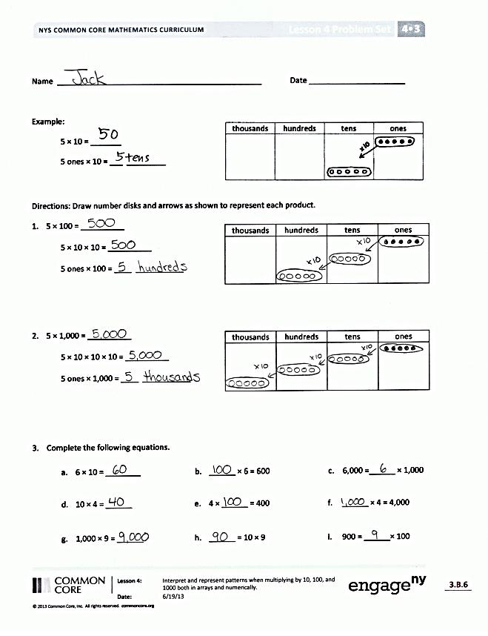
Students should do their personal best to complete the Problem Set within the allotted 10 minutes. For some classes, it may be appropriate to modify the assignment by specifying which problems they work on first. Some problems do not specify a method for solving. Students should solve these problems using the RDW approach used for Application Problems.

Student Debrief (10 minutes)
Objective: Interpret and represent patterns when multiplying by 10, 100, and 1,000 both in arrays and numerically.
The Student Debrief is intended to invite reflection and active processing of the total lesson experience.
Invite students to review their solutions for the Problem Set. They should check work by comparing answers with a partner before going over answers as a class. Look for misconceptions or misunderstandings that can be addressed in the Debrief. Guide students in a conversation to debrief the Problem Set and process the lesson.

Any combination of the questions below may be used to lead the discussion.
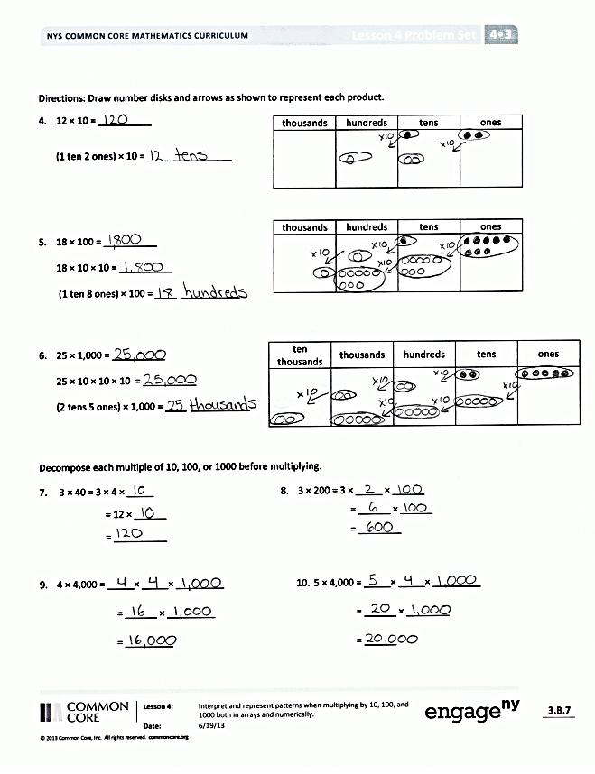
- What is the difference between saying 10 more and 10 times as many?
- What is another expression that has the same value as 10 × 800 and 1,000 × 8?
- Think about the problems we solved during the lesson and the problems you solved in the Problem Set. When does the number of zeros in
the factors not equal the number of zeros in the product?
- For Problem 4, 12 × 10 = 120, discuss with your partner whether or not this equation is true:
12 × 10 = 3 × 40. (Problem 7 features 3 × 40.)
- How did the Application Problem connect to today’s lesson?

Exit Ticket (3 minutes)
After the Student Debrief, instruct students to complete the Exit Ticket. A review of their work will help with assessing students’ understanding of the concepts that were presented in today’s lesson and planning more effectively for future lessons. The questions may be read aloud to the students.

Name Date
thousands | hundreds | tens | ones
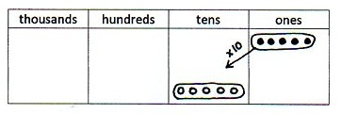
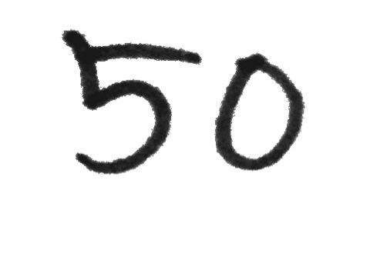
Example:
5 × 10 = _______
5 ones × 10 = ___ __________

Draw place value disks and arrows as shown
to represent each product.
thousands | hundreds | tens | ones
- 5 × 100 = __________
5 × 10 × 10 = __________
5 ones × 100 = ____ ___________

thousands | hundreds | tens | ones
- 5 × 1,000 = __________
5 × 10 × 10 × 10 = __________
5 ones × 1,000 = ____ ___________

- Fill in the blanks in the following equations.

- 6 × 10 = ________
- ______ × 6 = 600
- 6,000 = ______ × 1,000
- 10 × 4 = ______
- 4 × ______ = 400
- ______ × 4 = 4,000

- 1,000 × 9 = ______
- ______ = 10 × 9
- 900 = ______ × 100

Draw place value disks and arrows to represent each product.
thousands | hundreds | tens | ones
- 12 × 10 = __________
(1 ten 2 ones) × 10 = _______________

thousands | hundreds | tens | ones

- 18 × 100 = __________
18 × 10 × 10 = __________
(1 ten 8 ones) × 100 = ____________

ten thousands | thousands | hundreds | tens | ones
- 25 × 1,000 = __________
25 × 10 × 10 × 10 = __________
(2 tens 5 ones) × 1,000 = ________________
Decompose each multiple of 10, 100, or 1,000 before multiplying.

- 3 × 40 = 3 × 4 × _____
= 12 × ______
= __________
- 3 × 200 = 3 × _____ × ______
= ______ × ______
= ________

- 4 × 4,000 = _____ × _____× _________
= ______ × _________
= _________
- 5 × 4,000 = _____ × _____ × _________
= ______ × ________
= _________
Name Date
Fill in the blanks in the following equations.

- 5 × 10 = ________
- ______ × 5 = 500
- 5,000 = ______ × 1000

- 10 × 2 = ______
- ______ × 20 = 2,000
- 2,000 = 10 × ______

- 100 × 18 = ______
- ______ = 10 × 32
- 4,800 = ______ × 100

- 60 × 4 = ______
- 5 × 600 = ______
- 8,000 × 5 = ______

Name Date
Example:

5 × 10 = _______
5 ones × 10 = ___ ____________

Draw place value disks and arrows as shown to represent each product.
thousands | hundreds | tens | ones
- 7 × 100 = __________
7 × 10 × 10 = __________
7 ones × 100 = ___________

thousands | hundreds | tens | ones
- 7 × 1,000 = __________
7 × 10 × 10 × 10 = __________
7 ones × 1,000 = ____ ___________________

- Fill in the blanks in the following equations.

- 8 × 10 = ________
- ______ × 8 = 800
- 8,000 = ______ × 1,000
- 10 × 3 = ______
- 3 × ______ = 3,000
- ______ × 3 = 300

g. 1,000 × 4 = ______
h. ______ = 10 × 4
i. 400 = ______ × 100

Draw place value disks and arrows to represent each product.
thousands | hundreds | tens | ones
- 15 × 10 = __________
(1 ten 5 ones) × 10 = _____________
thousands | hundreds | tens | ones

- 17 × 100 = __________
17 × 10 × 10 = __________
(1 ten 7 ones) × 100 = __________________

ten thousands | thousands | hundreds | tens | ones
- 36 × 1,000 = __________
36 × 10 × 10 × 10 = __________
(3 tens 6 ones) × 1,000 = ____________

Decompose each multiple of 10, 100, or 1000 before multiplying.

- 2 × 80 = 2 × 8 × _____
= 16 × ______
= __________
- 2 × 400 = 2 × _____ × ______
= ______ × ______
= ________

- 5 × 5,000 = _____ × _____ × _________
= ______ × _________
= _________

10. 7 × 6,000 = _____ × _____ × _________
= ________ × ________
= ________
thousands | hundreds | tens | ones

thousands place value chart

