Lesson 3
Objective: Demonstrate understanding of area and perimeter formulas by solving multi-step real-world problems.

Suggested Lesson Structure
 Fluency Practice (12 minutes)
 Concept Development (38 minutes)
 Student Debrief (10 minutes)
Total Time (60 minutes)
Fluency Practice (12 minutes)
- Sprint: Squares and Unknown Factors 4.OA.4 (8 minutes)
- Find the Area and Perimeter 4.MD.3 (4 minutes)
Sprint: Squares and Unknown Factors (8 minutes)
Materials: (S) Squares and Unknown Factors Sprint
Note: This Sprint reviews skills that help students as they solve area problems.
Find the Area and Perimeter (4 minutes)
Materials: (S) Personal white board
Note: This activity reviews content from Lessons 1 and 2.
Repeat the process from Lesson 2 for the following possible sequence:
- Rectangles with dimensions of 5 cm × 2 cm, 7 cm × 2 cm, and 4 cm × 7 cm.
- Squares with lengths of 4 cm and 6 m.
- Rectangles with the following properties: area of 8 square cm, length 2 cm, width x; area of
15 square cm, length 5 cm, width x; and area of 42 square cm, width 6 cm, length x.

Concept Development (38 minutes)
Materials: (S) Problem Set

NOTES ON
MULTIPLE MEANS
OF ENGAGEMENT:
To maximize productivity, choose to make team goals for sustained effort, perseverance, and cooperation. Motivate improvement by providing specific feedback after each problem. Resist feedback that is comparative or competitive. Showcase students who incorporated feedback into their subsequent work.

Note: For this lesson, the Problem Set comprises word problems from the Concept Development and should therefore be used during the lesson itself.
Students may work in pairs to solve Problems 1─4 below using the RDW approach to problem solving.
1. Model the problem.
Have two pairs of students who can be successful with modeling the problem work at the board while the others work independently or in pairs at their seats. Review the following questions before beginning the first problem.
- Can you draw something?
- What can you draw?
- What conclusions can you make from your drawing?
As students work, circulate. Reiterate the questions above.
After two minutes, have the two pairs of students share only their labeled diagrams.
For about one minute, have the demonstrating students receive and respond to feedback and questions from their peers. Depending on the problem and student work seen while circulating, supplement this component of the process as necessary with direct instruction or clarification.
2. Calculate to solve and write a statement.

NOTES ON
MULTIPLE MEANS
OF ENGAGEMENT:
After the discussion of relationships of perimeter in Lesson 2, challenge students to quickly predict the perimeter of the screen in the auditorium. Have students offer several examples of the multiplicative pattern.

Give everyone two minutes to finish work on that question, sharing his work and thinking with a peer. Students should then write their equations and statements of the answer.
3. Assess the solution.
Give students one or two minutes to assess the solutions presented by their peers on the board, comparing the solutions to their own work. Highlight alternative methods to reach the correct solution.

Problem 1
The rectangular projection screen in the school auditorium is 5 times as long and 5 times as wide as the rectangular screen in the library. The screen in the library is 4 feet long with a perimeter of 14 feet. What is the perimeter of the screen in the auditorium?

The structure of this problem and what it demands of students is similar to that found within the first and second lessons of this module. Elicit from students why both the length and the width were multiplied by 5 to find the dimensions of the larger screen. Students use the dimensions to find the perimeter of the larger screen. Look for students to use formulas for perimeter other than 2 × (l + w) for this problem, such as the formula 2l + 2w.
Problem 2
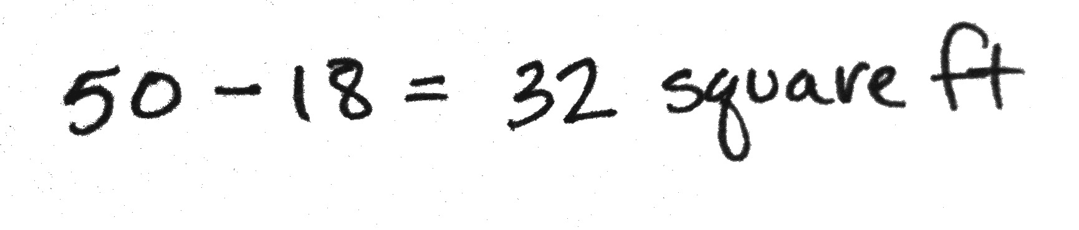
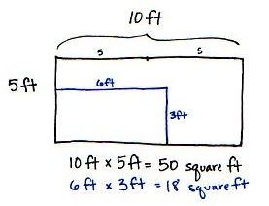
The width of David’s rectangular tent is 5 feet. The length is twice the width. David’s rectangular air mattress measures 3 feet by 6 feet. If David puts the air mattress in the tent, how many square feet of floor space will be available for the rest of his things?

The new complexity here is that students are finding an area within an area and determining the difference between the two. Have students draw and label the larger area first and then draw and label the area of the air mattress inside as shown above. Elicit from students how the remaining area can be found using subtraction.
Problem 3
Jackson’s rectangular bedroom has an area of 90 square feet. The area of his bedroom is 9 times that of his rectangular closet. If the closet is 2 feet wide, what is its length?
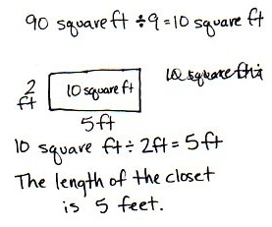

This multi-step problem requires students to work backwards, taking the area of Jackson’s room and dividing by 9 to find the area of his closet. Students use their learning from the first and second lessons of this module to help solve this problem.
Problem 4
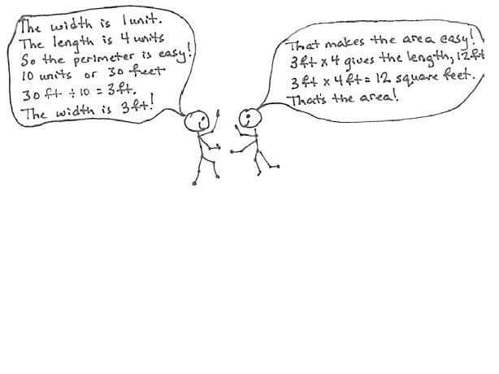
The length of a rectangular deck is 4 times its width. If the deck’s perimeter is 30 feet, what is the deck’s area?

Students need to use what they know about multiplicative comparison and perimeter to find the dimensions of the deck. Students find this rectangle has 10 equal-size lengths around its perimeter. Teachers can support students who are struggling by using square tiles to model the rectangular deck. Emphasize finding the number of units around the perimeter of the rectangle. Once the width is determined, students are able to solve for the area of the deck. If students have solved using square tiles, encourage them to follow up by drawing a picture of the square tile representation. This allows students to bridge the gap between the concrete and pictorial stages.
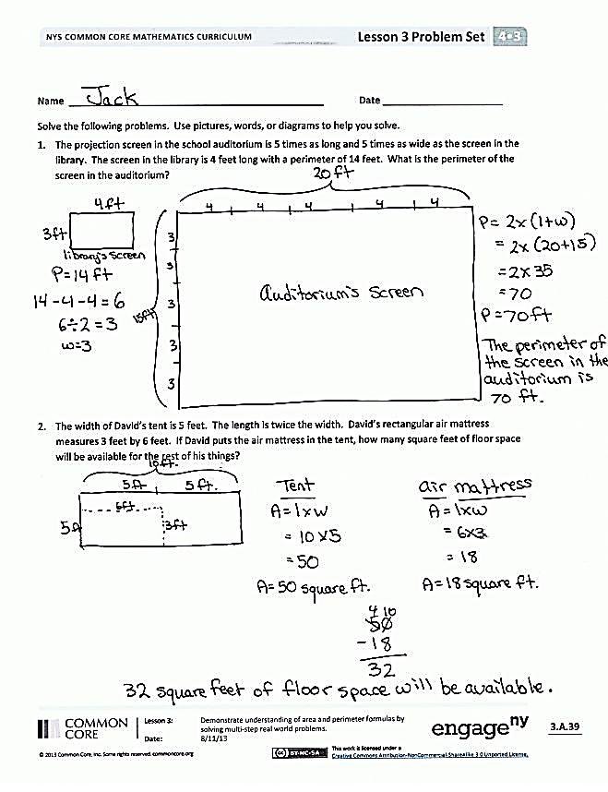
Problem Set
Please note that the Problem Set for Lesson 3 comprises this lesson’s problems, as stated in the introduction of the lesson.
Student Debrief (10 minutes)
Lesson Objective: Demonstrate understanding of area and perimeter formulas by solving multi-step real-world problems.
The Student Debrief is intended to invite reflection and active processing of the total lesson experience.
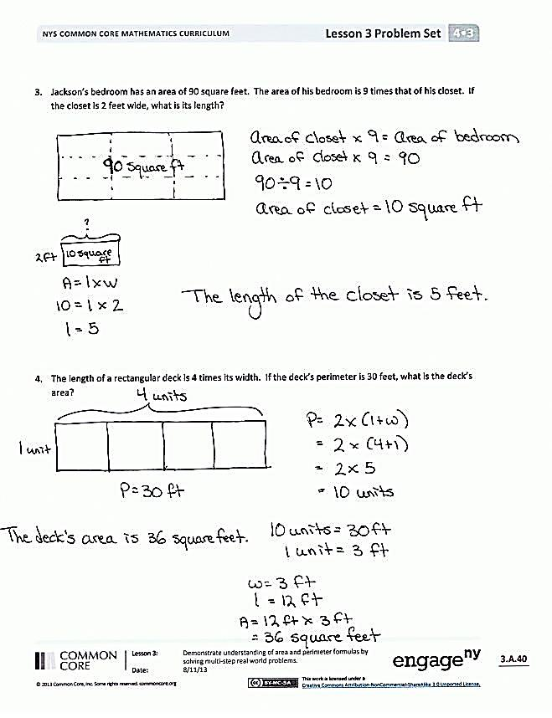
Invite students to review their solutions for the Problem Set. They should check work by comparing answers with a partner before going over answers as a class. Look for misconceptions or misunderstandings that can be addressed in the Debrief. Guide students in a conversation to debrief the Problem Set and process the lesson.
Any combination of the questions below may be used to lead the discussion.
- What simplifying strategies did you use to multiply to find the perimeter in Problem 1?
- Can David fit another air mattress of the same size in his tent? (Guide students to see that while there is sufficient area remaining, the dimensions of the air mattress and remaining area of the tent would prevent it from fitting.)
- How was solving Problem 3 different from other problems we have solved using multiplicative comparison?
- Explain how you used the figure you drew for Problem 4 to find a solution.
- When do we use twice as much, 2 times as many, or 3 times as many? When have you heard that language being used?

Exit Ticket (3 minutes)
After the Student Debrief, instruct students to complete the Exit Ticket. A review of their work will help with assessing students’ understanding of the concepts that were presented in today’s lesson and planning more effectively for future lessons. The questions may be read aloud to the students.

A
Number Correct: _______
Squares and Unknown Factors
 | 2 × 2 = |  |  |  | 3 × _____ = 21
 | 2 × _____ = 4 |  |  |  | 3 × 3 =
 | 3 × 3 = |  |  |  | 4 × _____ = 20
 | 3 × _____ = 9 |  |  |  | 4 × _____ = 32
 | 5 × 5 = |  |  |  | 4 × 4 =
 | 5 × _____ = 25 |  |  |  | 5 × _____ = 20
 | 1 × _____ = 1 |  |  |  | 5 × _____ = 40
 | 1 × 1 = |  |  |  | 5 × 5 =
 | 4 × _____ = 16 |  |  |  | 6 × _____ = 18
 | 4 × 4 = |  |  |  | 6 × _____ = 54
 | 7 × _____ = 49 |  |  |  | 6 × 6 =
 | 7 × 7 = |  |  |  | 7 × _____ = 28
 | 8 × 8 = |  |  |  | 7 × _____ = 56
 | 8 × _____ = 64 |  |  |  | 7 × 7 =
 | 10 × 10 = |  |  |  | 8 × _____ = 24
 | 10 × _____ = 100 |  |  |  | 8 × _____ = 72
 | 9 × _____ = 81 |  |  |  | 8 × 8 =
 | 9 × 9 = |  |  |  | 9 × _____ = 36
 | 2 × _____ = 10 |  |  |  | 9 × _____ = 63
 | 2 × _____ = 18 |  |  |  | 9 × 9 =
 | 2 × 2 = |  |  |  | 9 × _____ = 54
 | 3 × _____ = 12 |  |  |  | 10 × 10 =
B
[KEY]

Number Correct: _______
Improvement: _______
Squares and Unknown Factors
 | 5 × 5 = |  |  |  | 3 × _____ = 24
 | 5 × _____ = 25 |  |  |  | 3 × 3 =
 | 2 × 2 = |  |  |  | 4 × _____ = 12
 | 2 × _____ = 4 |  |  |  | 4 × _____ = 28
 | 3 × 3 = |  |  |  | 4 × 4 =
 | 3 × _____ = 9 |  |  |  | 5 × _____ = 10
 | 1 × 1 = |  |  |  | 5 × _____ = 35
 | 1 × _____ = 1 |  |  |  | 5 × 5 =
 | 4 × _____ = 16 |  |  |  | 6 × _____ = 24
 | 4 × 4 = |  |  |  | 6 × _____ = 48
 | 6 × _____ = 36 |  |  |  | 6 × 6 =
 | 6 × 6 = |  |  |  | 7 × _____ = 21
 | 9 × 9 = |  |  |  | 7 × _____ = 63
 | 9 × _____ = 81 |  |  |  | 7 × 7 =
 | 10 × 10 = |  |  |  | 8 × _____ = 32
 | 10 × _____ = 100 |  |  |  | 8 × _____ = 56
 | 7 × _____ = 49 |  |  |  | 8 × 8 =
 | 7 × 7 = |  |  |  | 9 × _____ = 27
 | 2 × _____ = 8 |  |  |  | 9 × _____ = 72
 | 2 × _____ = 16 |  |  |  | 9 × 9 =
 | 2 × 2 = |  |  |  | 9 × _____ = 63
 | 3 × _____ = 15 |  |  |  | 10 × 10 =

Name Date
Solve the following problems. Use pictures, numbers, or words to show your work.
- The rectangular projection screen in the school auditorium is 5 times as long and 5 times as wide as the rectangular screen in the library. The screen in the library is 4 feet long with a perimeter of 14 feet. What is the perimeter of the screen in the auditorium?

- The width of David’s rectangular tent is 5 feet. The length is twice the width. David’s rectangular air mattress measures 3 feet by 6 feet. If David puts the air mattress in the tent, how many square feet of floor space will be available for the rest of his things?

- Jackson’s rectangular bedroom has an area of 90 square feet. The area of his bedroom is 9 times that of his rectangular closet. If the closet is 2 feet wide, what is its length?

- The length of a rectangular deck is 4 times its width. If the deck’s perimeter is 30 feet, what is the deck’s area?
Name Date
Solve the following problem. Use pictures, numbers, or words to show your work.
A rectangular poster is 3 times as long as it is wide. A rectangular banner is 5 times as long as it is wide. Both the banner and the poster have perimeters of 24 inches. What are the lengths and widths of the poster and the banner?

Name Date
Solve the following problems. Use pictures, numbers, or words to show your work.
- Katie cut out a rectangular piece of wrapping paper that was 2 times as long and 3 times as wide as the box that she was wrapping. The box was 5 inches long and 4 inches wide. What is the perimeter of the wrapping paper that Katie cut?

- Alexis has a rectangular piece of red paper that is 4 centimeters wide. Its length is twice its width. She glues a rectangular piece of blue paper on top of the red piece measuring 3 centimeters by 7 centimeters. How many square centimeters of red paper will be visible on top?

- Brinn’s rectangular kitchen has an area of 81 square feet. The kitchen is 9 times as many square feet as Brinn’s pantry. If the rectangular pantry is 3 feet wide, what is the length of the pantry?

- The length of Marshall’s rectangular poster is 2 times its width. If the perimeter is 24 inches, what is the area of the poster?

