Lesson 2
Objective: Solve multiplicative comparison word problems by applying the area and perimeter formulas.

Suggested Lesson Structure
 Fluency Practice (12 minutes)
 Application Problem (6 minutes)
 Concept Development (32 minutes)
 Student Debrief (10 minutes)
Total Time (60 minutes)
Fluency Practice (12 minutes)
- Multiply a Number by Itself 4.MD.3 (2 minutes)
- Rename the Unit 4.NBT.1 (4 minutes)
- Find the Area and Perimeter 4.MD.3 (6 minutes)
Multiply a Number by Itself (2 minutes)
Materials: (S) Personal white board
Note: Multiplying a number by itself helps students quickly compute the areas of squares.
Repeat the process from Lesson 1, using more choral response.
Rename the Unit (4 minutes)
Materials: (S) Personal white board
Note: Renaming units helps prepare students for Topic B.
T: (Project 7 tens = .) Fill in the blank to make a true number sentence using standard form.
S: 7 tens = 70.
Repeat the process for 9 tens, 10 tens, 11 tens, and 12 tens.
T: (Project 17 tens = .) Fill in the blank to make a true number sentence using standard form.
S: (Show 17 tens = 170.)
Repeat with the following possible sequence: 17 hundreds, 17 thousands, 13 tens, 13 hundreds, and
13 thousands.
Find the Area and Perimeter (6 minutes)
Materials: (S) Personal white board
Note: This fluency activity reviews Lesson 1.
T: (Project a rectangle with a length of 4 cm and a width of 3 cm.) On your personal white boards, write a multiplication sentence to find the area.
S: (Write 4 cm × 3 cm = 12 square cm.)
T: Use the formula for perimeter to solve.
S: (Write 2 × (4 cm + 3 cm) = 14 cm.)
Repeat the process for a rectangle with dimensions of 6 cm × 4 cm.
T: (Project a square with a length of 2 m.) This is a square. Say the length of each side.
S: 2 meters.
T: On your boards, write a multiplication sentence to find the area.
S: (Write 2 m × 2 m = 4 square m.)
T: Write the perimeter.
S: 2 × (2 m + 2 m) = 8 m.
Repeat the process for squares with lengths of 3 cm and 9 cm.
T: (Project a rectangle with an area of 12 square cm, length of 2 cm, and x for the width.) On your boards, write a division sentence to find the width.
S: (Write 12 square cm ÷ 2 cm = 6 cm.)
Repeat the process for 12 square cm ÷ 4 cm, 18 square cm ÷ 3 cm, and 25 square cm ÷ 5 cm.
Application Problem (6 minutes)
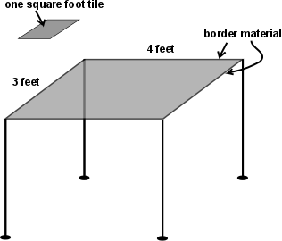
Tommy’s dad is teaching him how to make tables out of tiles. Tommy makes a small table that is 3 feet wide and 4 feet long. How many square-foot tiles does he need to cover the top of the table? How many feet of decorative border material will his dad need to cover the edges of the table?

Extension: Tommy’s dad is making a table 6 feet wide and 8 feet long. When both tables are placed together, what will their combined area be?
Note: This Application Problem builds from 3.MD.5, 3.MD.6, and 3.MD.8 and bridges back to the Concept Development of Lesson 1, during which students investigated and used the formulas for the area and perimeter of rectangles.

Concept Development (32 minutes)
Materials: (T) Chart of formulas for perimeter and area from Lesson 1 (S) Personal white board, square-inch tiles
Problem 1: A rectangle is 1 inch wide. It is 3 times as long as it is wide. Use square tiles to find its length.
T: Place 3 square-inch tiles on your personal white board. Talk to your partner about what the width and length of this rectangle are.
S: (Discuss.)
T: I heard Alyssa say that the width is 1 inch and the length is 3 inches. Now, make it 2 times as long. (Add 3 more square tiles.) It’s now 6 inches long. Three times as long (add 3 more tiles) would be 9 inches. Using the original length of 3 inches, tell your partner how to determine the current length that is three times as many.
S: I multiply the original length times 3. Three times as long as 3 inches is the same as 3 times 3 inches.
Repeat using tiles to find a rectangle that is 3 inches wide and 3 times as long as it is wide.
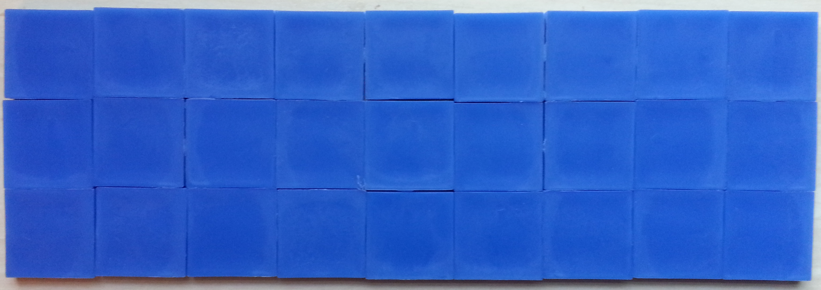
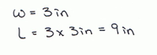

Problem 2: A rectangle is 2 meters wide. It is 3 times as long as it is wide. Draw to find its length.
T: The rectangle is 2 meters wide. (Draw a vertical line and label it as 2 meters.)
T: It is 3 times as long as it is wide. That means the length can be thought of as three segments, or short lines, each 2 meters long. (Draw the horizontal lines to create a square 2 meters by 2 meters.)
T: Here is the same length, 2 times as long, 3 times as long. (Extend the rectangle as shown.) What is the length when there are 3 segments, each 2 meters long?
S: 6 meters.

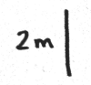
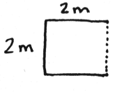
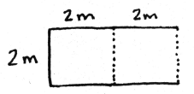
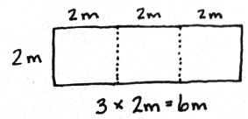

T: With your partner, draw this rectangle and label the length and width. What is the length? What is the width?

NOTES ON
MULTIPLE MEANS
OF ACTION AND EXPRESSION:
Ease the task of drawing by offering students the choice of tracing the concrete tiles. Alternatively, reduce the small motor demands by providing a template, grid paper, or computer software for drawing.

S: The length is 6 meters, and the width is 2 meters.
T: What is the perimeter? Use the chart of formulas for perimeters from Lesson 1 for reference.
S: Doubling the sum of 6 meters and 2 meters gives us
16 meters.
T: What is the area?
S: 6 meters times 2 meters is 12 square meters.
Repeat with a rectangle that is 3 meters long and 4 times as wide as it is long.
Problem 3: Solve a multiplicative comparison word problem using the area and perimeter formulas.
Christine painted a mural with an area of 18 square meters and a length of 6 meters. What is the width of her mural? Her next mural will be the same length as the first but 4 times as wide. What is the perimeter of her next mural?
Display the first two statements of the problem.
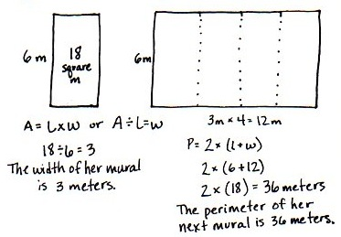
T: With your partner, determine the width of the first mural.
S: The area is 18 square meters. 18 square meters divided by 6 meters is 3 meters. The width is
3 meters.
T: True. (Display the last two statements of the problem.) Using those dimensions, draw and label Christine’s next mural. Begin with the side length you know, 6 meters. How many copies of Christine’s first mural will we see in her next mural? Draw them.
S: Four copies. (Draw.)
T: Tell me a multiplication sentence to find how wide her next mural will be.

NOTES ON
MULTIPLE MEANS
OF ENGAGEMENT:
English language learners may benefit from frequent checks for understanding as the word problem is read aloud. Explain how the term square meters denotes the garden’s area. Instead of twice, say two times. Use gestures and illustrations to clarify the meaning. In addition, after students discover the relationship between area and perimeter, challenge them to explore further. Ask, “If you draw another rectangle with a different length, will a similar doubling of the perimeter and quadrupling of the area result?”

S: 3 meters times 4 equals 12 meters.
T: Finish labeling the diagram.
T: Find the perimeter of Christine’s next mural. For help, use the chart of formulas for perimeter that we created during Lesson 1.
S: 12 meters plus 6 meters is 18 meters. 18 meters doubled is 36 meters. The perimeter is 36 meters.
Problem 4: Observe the relationship of area and perimeter while solving a multiplicative comparison word problem using the area and perimeter formulas.
Sherrie’s rectangular garden is 8 square meters. The longer side of the garden is 4 meters. Nancy’s garden is twice as long and twice as wide as Sherrie’s rectangular garden.
Display the first two statements.
T: With your partner, draw and label a diagram of Sherrie’s garden.
S: (Draw and label Sherrie’s garden.)
T: What is the width of Sherrie’s garden?
S: Two meters because 8 square meters divided by 4 meters is 2 meters.
T: (Display the next statement.) Help me draw Nancy’s garden. Twice as long as 4 meters is how many meters?
S: 8 meters.
T: Twice as wide as 2 meters is how many meters?
S: 4 meters.
T: Draw Nancy’s garden and find the perimeters of both gardens.
S: (Draw and solve to find the perimeters.)
T: Tell your partner the relationship between the two perimeters.
S: Sherrie’s garden has a perimeter of 12 meters. Nancy’s garden has a perimeter of 24 meters. The length doubled, and the width doubled, so the perimeter doubled! 12 meters times 2 is 24 meters.
T: If Sherrie’s neighbor had a garden 3 times as long and 3 times as wide as her garden, what would be the relationship of the perimeter between those gardens?
S: The perimeter would triple!
T: Solve for the area of Nancy’s garden and the neighbor’s garden. What do you notice about the relationship among the perimeters and areas of the three gardens?
S: Nancy’s garden has an area of 32 square meters. The neighbor’s garden has an area of 72 square meters. The length and width of Nancy’s garden is double that of Sherrie’s garden, but the area did not double. The length is doubled and the width is doubled. 2 times 2 is 4, so the area will be 4 times as large. Right, the area quadrupled! I can put the area of Sherrie’s garden inside Nancy’s garden 4 times. The length and width of the neighbor’s garden tripled, and 3 times 3 is 9. The area of the neighbor’s garden is 9 times that of Sherrie’s.
Create a table to show the relationship among the areas and perimeters of the three gardens.
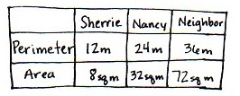

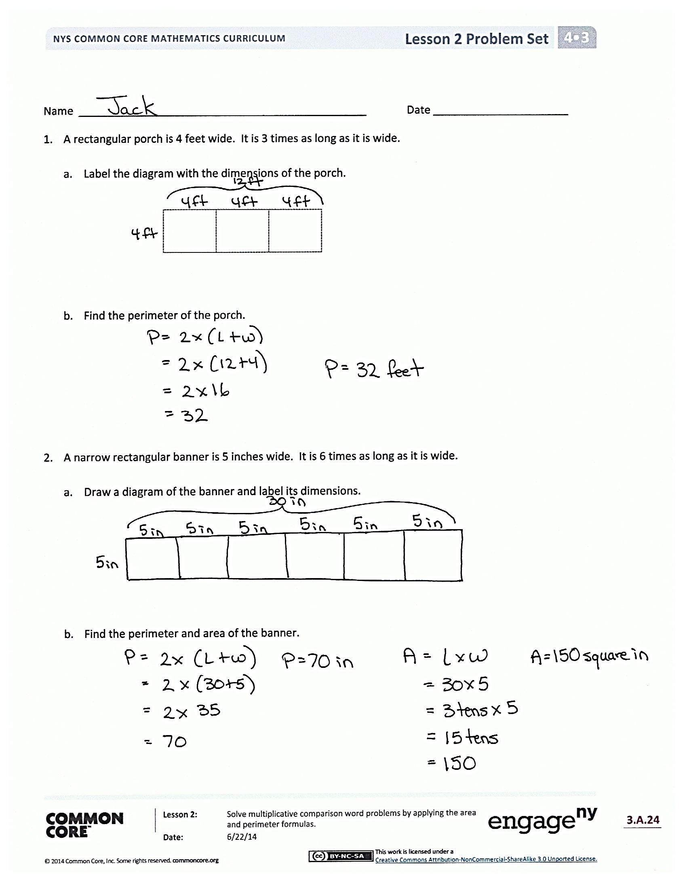
Problem Set (10 minutes)
Students should do their personal best to complete the Problem Set within the allotted 10 minutes. For some classes, it may be appropriate to modify the assignment by specifying which problems they work on first. Some problems do not specify a method for solving. Students should solve these problems using the RDW approach used for Application Problems.
Student Debrief (10 minutes)
Lesson Objective: Solve multiplicative comparison word problems by applying the area and perimeter formulas.
The Student Debrief is intended to invite reflection and active processing of the total lesson experience.
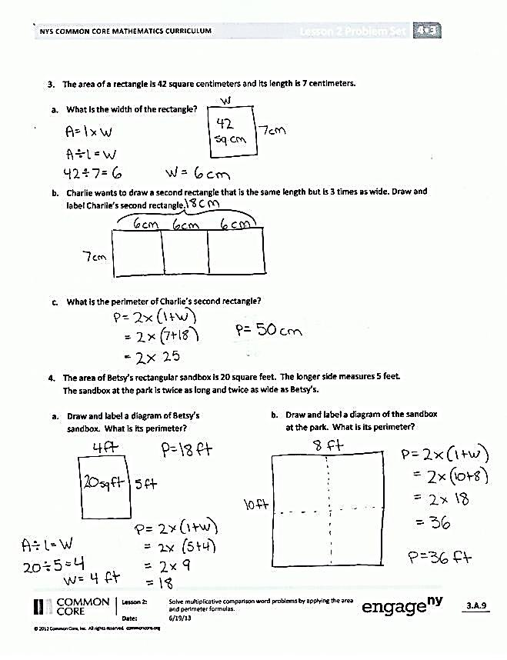
Invite students to review their solutions for the Problem Set. They should check work by comparing answers with a partner before going over answers as a class. Look for misconceptions or misunderstandings that can be addressed in the Debrief. Guide students in a conversation to debrief the Problem Set and process the lesson.
Any combination of the questions below may be used to lead the discussion.
- Discuss the relationship between the area of an original rectangle and the area of a different rectangle whose width is 3 times as long as it was to start with.
- Discuss the relationship between the perimeters of the sandboxes in Problem 4.
- For Problem 4(e), why isn’t the area twice as much if the length and width are twice as much?
- What conclusion can you make about the areas of two rectangles when the widths are the same but the length of one is twice as much as the length of the other?
- What conclusion can you make about the areas of two rectangles when the length and width of one rectangle are each twice as much as the length and width of the other rectangle?
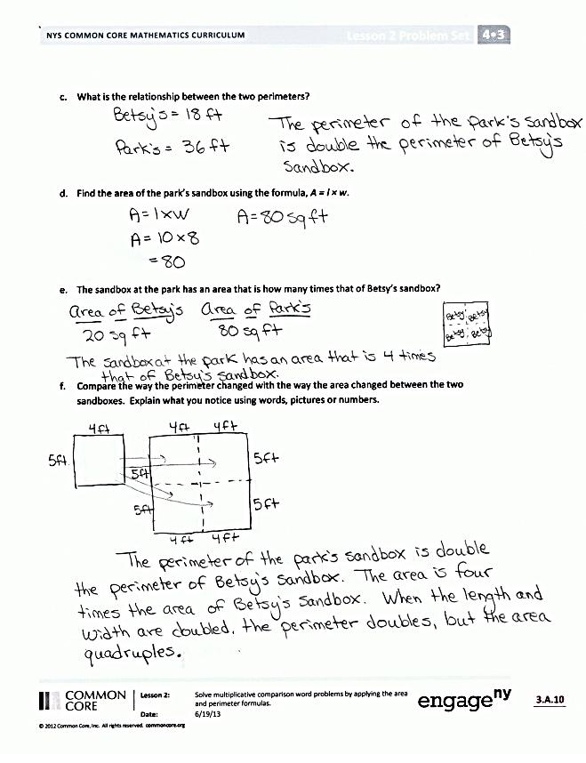
- What significant math vocabulary did we use today to communicate precisely?
- How did the Application Problem connect to today’s lesson?
Exit Ticket (3 minutes)
After the Student Debrief, instruct students to complete the Exit Ticket. A review of their work will help with assessing students’ understanding of the concepts that were presented in today’s lesson and planning more effectively for future lessons. The questions may be read aloud to the students.

Name Date
- A rectangular porch is 4 feet wide. It is 3 times as long as it is wide.

  - Label the diagram with the dimensions of the porch.

  - Find the perimeter of the porch.

- A narrow rectangular banner is 5 inches wide. It is 6 times as long as it is wide.

  - Draw a diagram of the banner, and label its dimensions.

  - Find the perimeter and area of the banner.

- The area of a rectangle is 42 square centimeters. Its length is 7 centimeters.

  - What is the width of the rectangle?

  - Charlie wants to draw a second rectangle that is the same length but is 3 times as wide. Draw and label Charlie’s second rectangle.

  - What is the perimeter of Charlie’s second rectangle?

- The area of Betsy’s rectangular sandbox is 20 square feet. The longer side measures 5 feet. The sandbox at the park is twice as long and twice as wide as Betsy’s.

  - Draw and label a diagram of Betsy’s sandbox. What is its perimeter?
  - Draw and label a diagram of the sandbox at the park. What is its perimeter?

  - What is the relationship between the two perimeters?

  - Find the area of the park’s sandbox using the formula A = l × w.

  - The sandbox at the park has an area that is how many times that of Betsy’s sandbox?

  - Compare how the perimeter changed with how the area changed between the two sandboxes. Explain what you notice using words, pictures, or numbers.

Name Date
- A table is 2 feet wide. It is 6 times as long as it is wide.

  - Label the diagram with the dimensions of the table.

  - Find the perimeter of the table.

- A blanket is 4 feet wide. It is 3 times as long as it is wide.

  - Draw a diagram of the blanket, and label its dimensions.

  - Find the perimeter and area of the blanket.

Name Date
- A rectangular pool is 7 feet wide. It is 3 times as long as it is wide.

  - Label the diagram with the dimensions of the pool.

  - Find the perimeter of the pool.

- A poster is 3 inches long. It is 4 times as wide as it is long.

  - Draw a diagram of the poster, and label its dimensions.

  - Find the perimeter and area of the poster.

- The area of a rectangle is 36 square centimeters, and its length is 9 centimeters.

  - What is the width of the rectangle?

  - Elsa wants to draw a second rectangle that is the same length but is 3 times as wide. Draw and label Elsa’s second rectangle.

  - What is the perimeter of Elsa’s second rectangle?

- The area of Nathan’s bedroom rug is 15 square feet. The longer side measures 5 feet. His living room rug is twice as long and twice as wide as the bedroom rug.

- Draw and label a diagram of Nathan’s bedroom rug. What is its perimeter?

- Draw and label a diagram of Nathan’s living room rug. What is its perimeter?

- What is the relationship between the two perimeters?

- Find the area of the living room rug using the formula A = l × w.

- The living room rug has an area that is how many times that of the bedroom rug?

- Compare how the perimeter changed with how the area changed between the two rugs. Explain what you notice using words, pictures, or numbers.

