Lesson 19
Objective: Use a line plot to record the number of rectangles constructed from a given number of unit squares.

Suggested Lesson Structure
 Fluency Practice (12 minutes)
 Application Problem (8 minutes)
 Concept Development (30 minutes)
 Student Debrief (10 minutes)
Total Time (60 minutes)
Fluency Practice (12 minutes)
- Draw Tape Diagrams 3.MD.7 (6 minutes)
- Find the Perimeter 3.MD.8 (6 minutes)
Draw Tape Diagrams (6 minutes)
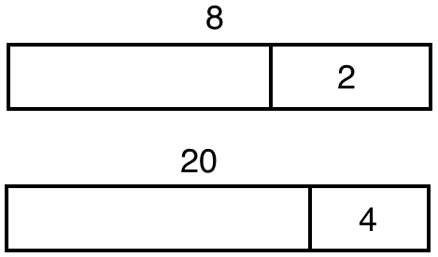
Materials: (S) Personal white board
14
4
10
14
4
10
14
4
10
5
5
Note: This activity prepares students for today’s lesson.
T: (Project a tape diagram that has a whole of 14 and a given part of 4.) What is the value of the whole?
S: 14.
T: (Point to the unknown part.) What’s the value of the unknown part?
S: 10.
T: (Write 10 beneath the unknown part. Partition the unit of 10 into 2 equal parts.) Write the value of each unknown unit as a division sentence.
S: (Write 10 ÷ 2 = 5.)
T: (Write 5 inside each unit.)
Repeat the process for the other tape diagrams.

Find the Perimeter (6 minutes)
Materials: (S) Grid paper
Note: This activity reviews Lesson 18.
T: Shade rectangles that have an area of 6 square units.

P = 14 units

P = 10 units
S: (Shade a 1 × 6 rectangle and a 2 × 3 rectangle.)
T: Next to each rectangle, write the perimeter.
S: (Next to the 1 × 6 rectangle, write P = 14 units. Next to the 2 × 3 rectangle, write P = 10 units.)
Continue with the following possible sequence: 8 square units and 12 square units.
Application Problem (8 minutes)
Marci says, “If a rectangle has a greater area than another rectangle, it must have a larger perimeter.” Do you agree or disagree? Show an example to prove your thinking.
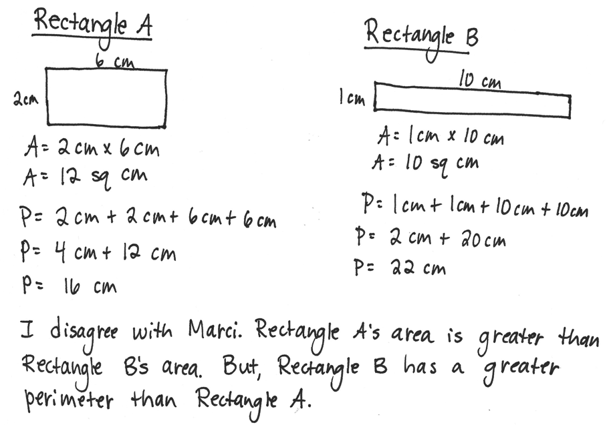

NOTES ON
MULTIPLE MEANS
OF ACTION AND EXPRESSION:
Students working below grade level may find success manipulating unit square tiles to solve the Application Problem.

Note: This problem contributes to the growing number of examples that help students conclude that there is no relationship between area and perimeter. It also reviews using multiplication to calculate area, which students use in today’s lesson.

Concept Development (30 minutes)
Materials: (S) Personal white board, Problem Set, unit square tiles
Note: Save students’ Problem Sets for use in Lesson 22.
Part 1: Use unit square tiles to make rectangles with a given number of unit squares.
T: Read the directions for Problem 1 on your Problem Set.
S: (Read: Use unit square tiles to make rectangles for each given number of unit squares. Complete the charts to show how many rectangles you can make for each given number of unit squares. [12, 13, 14, 15, 16, 17, 18.] The first one is done for you. You might not use all the spaces in each chart.)
T: Look at the completed chart for 12 unit squares. It shows a 1 by 12 rectangle. Talk to a partner. Why doesn’t the chart also list a 12 by 1 rectangle?
S: They’re really the same rectangle, just turned.
T: How do we know the chart shows all the rectangles that we can make with our 12 unit square tiles?
S: We can list the multiplication facts that equal 12 and check to make sure they’re on the chart.
T: Work with a partner and use your unit square tiles to make as many rectangles as you can for each given number of unit squares. Record the widths and lengths of the rectangles in the charts.
Once students have completed Problem 1, take a few minutes to review the data to be sure that everyone has the correct information because it is used in Part 2 of this lesson.
Part 2: Create a line plot to display how many rectangles can be made with a given number of unit squares.
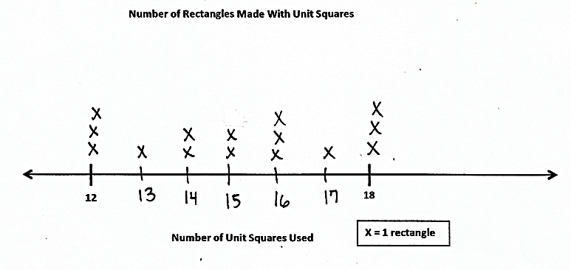
T: Let’s record our data on the line plot in Problem 2. (Create a line plot with the data collected in Problem 1.)
T: What symbol will we use to represent a rectangle on our line plot? How do you know?
S: We’ll use an X. I know because the key says an X equals 1 rectangle.
T: Is the number line in Problem 2 fully labeled and ready to have data plotted?

NOTES ON
MULTIPLE MEANS
OF ACTION AND EXPRESSION:
Ease the task of estimating to make equal spaces between numbers on the number line for students working below grade level and others. Direct students to estimate and draw the midpoint first, if helpful. Use of grid paper and colored pencils may also be helpful.

S: No!
T: What’s missing?
S: The numbers between 12 and 18.
T: Which numbers do we need to add?
S: We need to add 13, 14, 15, 16, and 17.
T: Add those numbers to the number line. Estimate to make equal spaces between numbers.
S: (Add the missing numbers.)

T: Tell your partner how you’ll record the data for 12 unit squares on the line plot.
S: There were three possible rectangles for 12 unit squares, so I’ll draw 3 X’s above the number 12.
T: Go ahead and do that now. Then, plot the data for each of the other numbers of unit squares, too. (Allow students time to work.)
T: Study your line plot, and think about a true statement to share with others about the data. (Allow students time to think of a statement.)
S: 13 and 17 had the least number of rectangles. 12, 16, and 18 had the most. 14 and 15 had the same number of possible rectangles. You can make 15 total rectangles using the given numbers of unit squares. None of the odd numbers had the greatest number of rectangles.
T: Why do you think 12, 16, and 18 unit squares have the largest possible number of rectangles?
S: Because there are more factor pairs that make those numbers than the other ones.
T: Talk to a partner. Why do you think 13 and 17 unit squares have the least possible rectangles?
S: 13 and 17 had the least because they can both make only one rectangle. The only two numbers that multiply to get 13 are 1 and 13. And the only two numbers that multiply to get 17 are 1 and 17.
T: Record your thinking on Problems 3 and 4 of your Problem Set.
Consider extending the activity by asking students to find and then plot data for numbers greater than 18 unit squares.
Student Debrief (10 minutes)
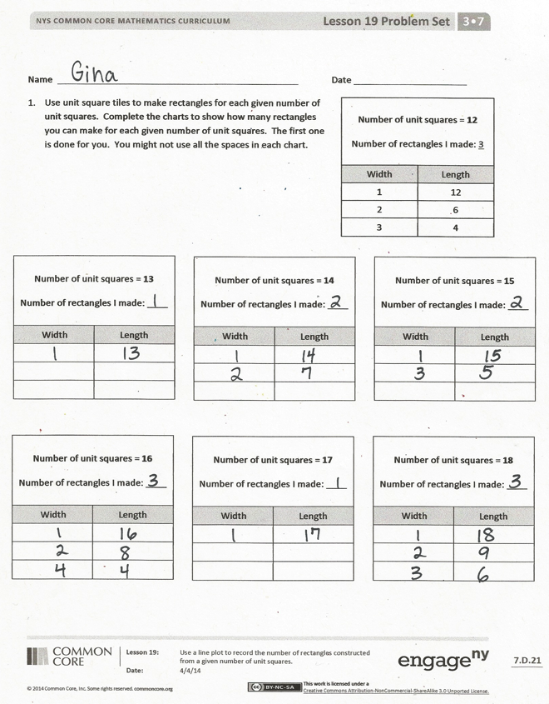
Lesson Objective: Use a line plot to record the number of rectangles constructed from a given number of unit squares.
The Student Debrief is intended to invite reflection and active processing of the total lesson experience.
Invite students to review their solutions for the Problem Set. They should check work by comparing answers with a partner before going over answers as a class. Look for misconceptions or misunderstandings that can be addressed in the Debrief. Guide students in a conversation to debrief the Problem Set and process the lesson.
Any combination of the questions below may be used to lead the discussion.
- For which number of unit squares in Problem 1 can a square be drawn? How do you know? Can you brainstorm other numbers of unit squares from which a square can be drawn? Can you think of other numbers of unit squares, like 13 and 17, that only have one possible rectangle? How did you come up with them?
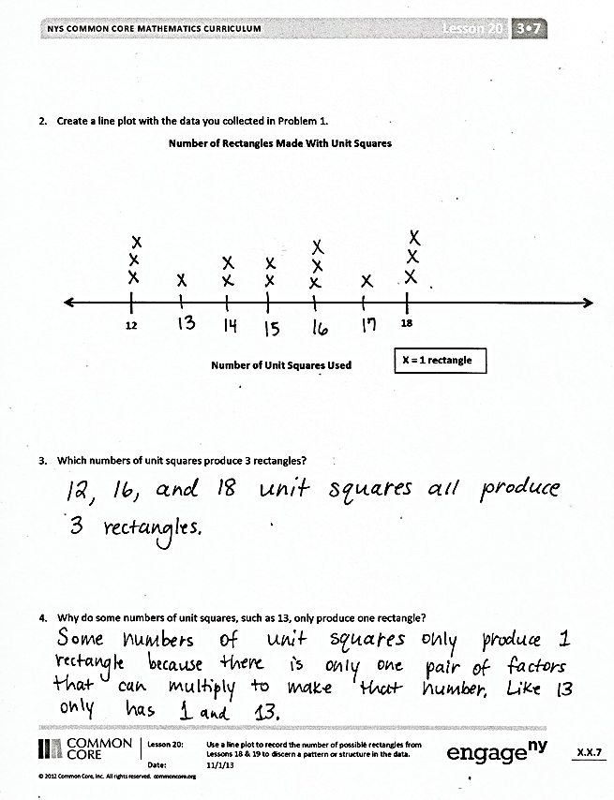
- Can you think of a number of unit squares that would allow us to make four rectangles? What’s the smallest number for which this is true?
- How is the number of unit squares used to make a rectangle related to the rectangle’s area? How do you know?
Exit Ticket (3 minutes)
After the Student Debrief, instruct students to complete the Exit Ticket. A review of their work will help with assessing students’ understanding of the concepts that were presented in today’s lesson and planning more effectively for future lessons. The questions may be read aloud to the students.

Name Date
- Use unit square tiles to make rectangles for each given number of unit squares. Complete the charts to show how many rectangles you can make for each given number of unit squares. The first one is done for you. You might not use all the spaces in each chart.
Number of unit squares = 12

Number of rectangles I made: 3
Width | Length
1 | 12
2 | 6
3 | 4

Number of unit squares = 13

Number of rectangles
I made: ____
Width | Length

Number of unit squares = 14

Number of rectangles
I made: ____
Width | Length

Number of unit squares = 15

Number of rectangles
I made: ____
Width | Length

Number of unit squares = 16

Number of rectangles
I made: ____
Width | Length

Number of unit squares = 17

Number of rectangles
I made: ____
Width | Length

Number of unit squares = 18

Number of rectangles
I made: ____
Width | Length

- Create a line plot with the data you collected in Problem 1.
Number of Rectangles Made with Unit Squares
Number of Unit Squares Used
12
18

X = 1 Rectangle

- Which numbers of unit squares produce three rectangles?

- Why do some numbers of unit squares, such as 13, only produce one rectangle?

Name Date
Use unit square tiles to make rectangles for the given number of unit squares. Complete the chart to show how many rectangles you made for the given number of unit squares. You might not use all the spaces in the chart.

Number of unit squares = 20

Number of rectangles I made: ____
Width | Length

Name Date
- Cut out the unit squares at the bottom of the page. Then, use them to make rectangles for each given number of unit squares. Complete the charts to show how many rectangles you can make for each given number of unit squares. You might not use all the spaces in each chart.
Number of unit squares = 6

Number of rectangles
I made: ____
Width | Length

Number of unit squares = 7

Number of rectangles
I made: ____
Width | Length

Number of unit squares = 8

Number of rectangles
I made: ____
Width | Length

Number of unit squares = 9

Number of rectangles
I made: ____
Width | Length

Number of unit squares = 10

Number of rectangles
I made: ____
Width | Length

Number of unit squares = 11

Number of rectangles
I made: ____
Width | Length

--------------------------------------------------------------------------------------------------------------------------------------------

- Create a line plot with the data you collected in Problem 1.
Number of Rectangles Made with Unit Squares
Number of Unit Squares Used

6
11

X = 1 Rectangle

  - Luke looks at the line plot and says that all odd numbers of unit squares produce only 1 rectangle. Do you agree? Why or why not?

  - How many X’s would you plot for 4 unit squares? Explain how you know.

