Lesson 15
Objective: Solve word problems to determine perimeter with given side lengths.

Suggested Lesson Structure
 Fluency Practice (15 minutes)
 Application Problem (5 minutes)
 Concept Development (30 minutes)
 Student Debrief (10 minutes)
Total Time (60 minutes)
Fluency Practice (15 minutes)
- Multiply by 9 3.OA.7 (7 minutes)
- Equivalent Counting with Units of 5 3.OA.7 (4 minutes)
- Find the Perimeter 3.MD.8 (4 minutes)

Multiply by 9 (7 minutes)
Materials: (S) Multiply by 9 (1–5) Pattern Sheet
Note: This activity builds fluency with multiplication facts using units of 9. It works toward students knowing from memory all the products of two one-digit numbers. See Lesson 1 for the directions for administration of a Multiply-By Pattern Sheet.
T: (Write 7 × 9 = ____.) Let’s skip-count up by nines. I’ll raise a finger for each nine. (Raise a finger for each number to track the count.)
S: 9, 18, 27, 36, 45, 54, 63.
T: Let’s skip-count up by nines starting at 45. Why is 45 a good place to start?
S: It’s a fact we already know, so we can use it to figure out a fact we don’t know.
T: (Track with fingers as students say the numbers.)
S: 45 (5 fingers), 54 (6 fingers), 63 (7 fingers).
T: Let’s see how we can skip-count down to find the answer, too. Start at 90 with 10 fingers, 1 for each nine. (Count down with fingers as students say the numbers.)
S: 90 (10 fingers), 81 (9 fingers), 72 (8 fingers), 63 (7 fingers).
Continue with the following possible sequence: 9 × 9, 6 × 9, and 8 × 9.
T: (Distribute the Multiply by 9 Pattern Sheet.) Let’s practice multiplying by 9. Be sure to work left to right across the page.

Equivalent Counting with Units of 5 (4 minutes)
Note: This activity builds fluency with multiplication facts using units of 5.
T: Count by fives to 50. (Write as students count.)
S: 5, 10, 15, 20, 25, 30, 35, 40, 45, 50.
T: (Write 1 five beneath the 5.) Count to 10 fives. (Write as students count.)
5 10 15 20 25 30 35 40 45 50
1 five 2 fives 3 fives 4 fives 5 fives 6 fives 7 fives 8 fives 9 fives 10 fives

S: 1 five, 2 fives, 3 fives, 4 fives, 5 fives, 6 fives, 7 fives, 8 fives, 9 fives, 10 fives.
T: Let’s count to 10 fives again. This time, stop when I raise my hand.
S: 1 five, 2 fives, 3 fives.
T: (Raise hand.) Say the multiplication sentence.
S: 3 × 5 = 15.
T: Continue.
S: 4 fives, 5 fives.
T: (Raise hand.) Say the multiplication sentence.
S: 5 × 5 = 25.
T: Continue.
S: 6 fives, 7 fives, 8 fives.
T: (Raise hand.) Say the multiplication sentence.
S: 8 × 5 = 40.
T: Continue.
S: 9 fives, 10 fives.
T: (Raise hand.) Say the multiplication sentence.
S: 10 × 5 = 50.
T: Let’s count back down starting at 10 fives.
Continue the process back down to 1 five.
Find the Perimeter (4 minutes)
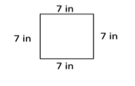
Materials: (S) Personal white board
Note: This activity reviews finding perimeter.
T: (Project a square with side lengths of 7 inches. Write P = __ in + __ in
+ __ in + __ in.) Copy the equation on your personal white board, and fill in the blanks. Then, write the perimeter of the square.
S: (Write P = 7 in + 7 in + 7 in + 7 in and P = 28 in.)
Continue the process with other polygons.
2 cm
2 cm
2 cm
2 cm
2 cm
2 cm
2 cm
2 cm
5 cm
5 cm
4 cm
4 cm
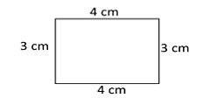
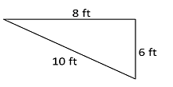
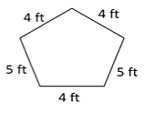

Application Problem (5 minutes)
Clara and Pedro each use four 3-inch by 5-inch cards to make the rectangles below. Whose rectangle has a greater perimeter?
5 in
3 in
Pedro’s Rectangle

5 in
3 in
Clara’s Rectangle

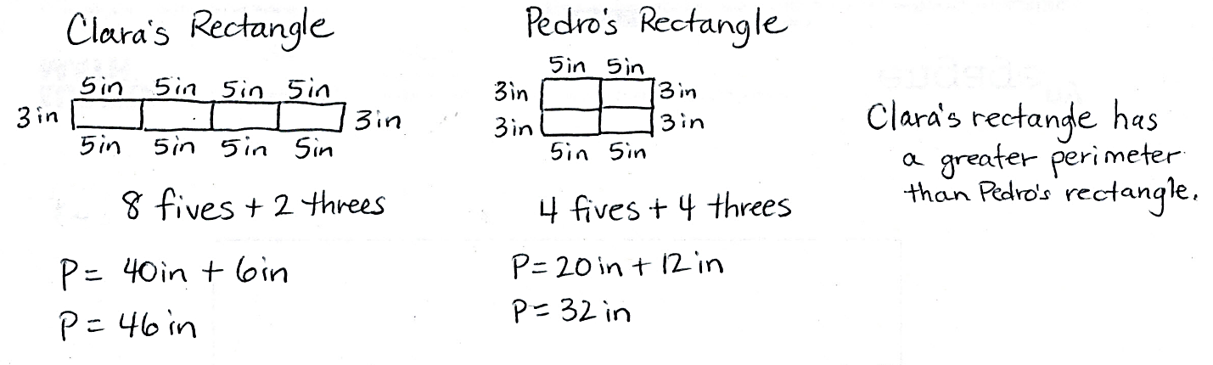

Note: This problem reviews adding side lengths to find the perimeter.
Concept Development (30 minutes)
Materials: (S) Problem Set
Problem 1: Solve perimeter word problems with rectangles.
Mrs. Kozlow put a border around a 5-foot by 6-foot rectangular bulletin board. How many feet of border did Mrs. Kozlow use?
T: Read Problem 1. (Allow students time to read.) What can you draw to help you solve this problem?
S: A rectangle!
T: Draw and label a rectangle to represent Mrs. Kozlow’s bulletin board.

NOTES ON
MULTIPLE MEANS
OF ENGAGEMENT:
Students working above grade level may solve Problem 1 in the Concept Development quickly using mental math. Allow students to work independently, provided that they include a labeled model, number sentence, and answer sentence for their solutions. Extend the problem by asking students to model a rectangular bulletin board with the same area as Mrs. Kozlow’s but with a greater perimeter.

S: (Draw a rectangle and label the side lengths.)
T: (Point to the width and length of the rectangle.) How did you label the width and the length?
S: 5 feet for the width and 6 feet for the length!
MP.5
T: (Label the length and width.) Check your rectangle against mine. (Allow students to check and make adjustments, if necessary.) Talk to a partner. Can you find the perimeter of the bulletin board with the information in your picture?
S: No. I need to know all the side lengths. Wait. We can use the side lengths we know to label the unknown ones. Yeah. Since it’s a rectangle, opposite sides are equal. I already labeled all the side lengths.
T: Use what you know about rectangles to label the unknown side lengths if you didn’t already.
5 ft
6 ft
5 ft
5 ft
6 ft
6 ft
S: (Label the unknown side lengths.)
T: Write a number sentence including the units to show the perimeter as the sum of the side lengths.
S: 5 ft + 6 ft + 5 ft + 6 ft = 22 ft. 2 × 5 ft + 2 × 6 ft = 22 ft.
10 ft + 12 ft = 22 ft. 11 ft + 11 ft = 22 ft.
T: What is the perimeter of the bulletin board?
S: 22 feet!
T: How many feet of border did Mrs. Kozlow use?
S: 22 feet of border!
T: Look at your number sentence. What strategy did you use or could you use to find the perimeter?
S: I could add 5 and 6 and then double the sum to get 22.
I could multiply each side length by 2 and then add the products.
T: How would you find the total amount of border Mrs. Kozlow used if she put a border around three bulletin boards that are the same size as this one?
S: I would add 22, plus 22, plus 22. I could multiply 22 times 3, but I don’t know that fact. I could do 3 times 2 tens plus 3 times 3 ones.

Problem 2: Solve perimeter word problems with regular polygons.
Jason built a model of the Pentagon for a social studies project. He made each outside wall 33 centimeters long. What is the perimeter of Jason’s model pentagon?

NOTES ON
MULTIPLE MEANS
OF ACTION AND EXPRESSION:
The Problem Set makes reference to the Pentagon (see the problem text to the left). Students may not know what the word pentagon refers to when it is used as a proper noun. Clarify before starting Problem 2.

T: Read Problem 2. (Allow students time to read.) What can you draw to help you solve this problem?
S: A pentagon!
T: Draw and label a pentagon to represent Jason’s model pentagon.
S: (Draw a pentagon and label the side lengths.)
T: Talk to a partner. What did you label the side lengths? Why?
S: I labeled them 33 centimeters because it said each side is 33 centimeters long.

NOTES ON
MULTIPLE MEANS
OF REPRESENTATION:
Students who find drawing a regular pentagon challenging may draw an alternative model, such as a tape diagram or number bond, in which the whole is the sum of the sides.

T: Write a number sentence to show the perimeter as the sum of the side lengths.
S: (Write 33 cm + 33 cm + 33 cm + 33 cm + 33 cm = 165 cm.)
T: What is the perimeter of Jason’s model pentagon?
S: 165 centimeters!
T: Look at your number sentence. Is there another way you can find the perimeter?
MP.5

S: I could add 66 twice and then 33 more. I could multiply 33 times 5, but I don’t know that fact.
I could break apart 33 into 30 and 3. Then, I could multiply 5 times 3 tens and 5 times 3 ones and add the products. I can use the break apart and distribute strategy!
Problem Set (10 minutes)
Students should do their personal best to complete Problems 3–6 on the Problem Set within the allotted 10 minutes. For some classes, it may be appropriate to modify the assignment by specifying which problems they work on first. Some problems do not specify a method for solving. Students should solve these problems using the RDW approach used for Application Problems.
Student Debrief (10 minutes)
Lesson Objective: Solve word problems to determine perimeter with given side lengths.
The Student Debrief is intended to invite reflection and active processing of the total lesson experience.
Invite students to review their solutions for the Problem Set. They should check work by comparing answers with a partner before going over answers as a class. Look for misconceptions or misunderstandings that can be addressed in the Debrief. Guide students in a conversation to debrief the Problem Set and process the lesson.
Any combination of the questions below may be used to lead the discussion.
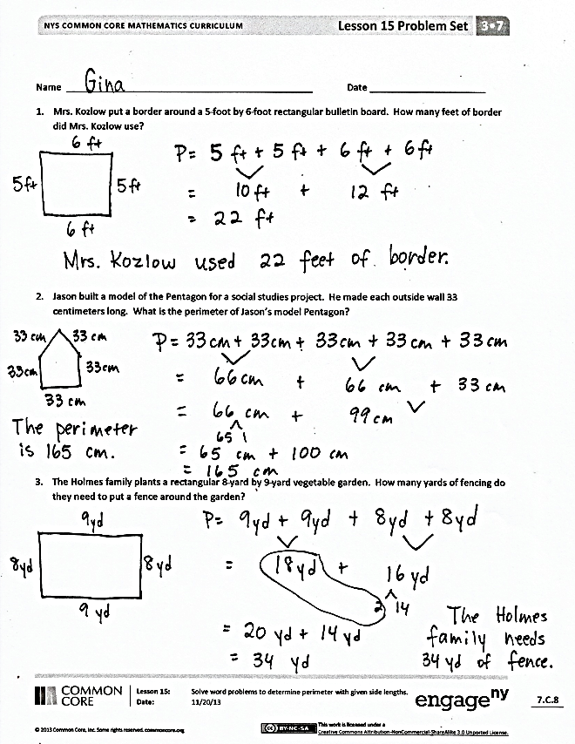
- Share your solution to Problem 3 with a partner. Compare your equations. How are they the same? How are they different?
- What multiplication equation could you use to solve Problem 4? What is 18 tens?
- How was solving Problems 5 and 6 different from the rest of the problems?
- Explain to a partner how you solved Problem 6. Did you use the break apart and distribute strategy? How did you use it?
- Describe a different real-world situation in which it would be necessary to find the perimeter.
Exit Ticket (3 minutes)
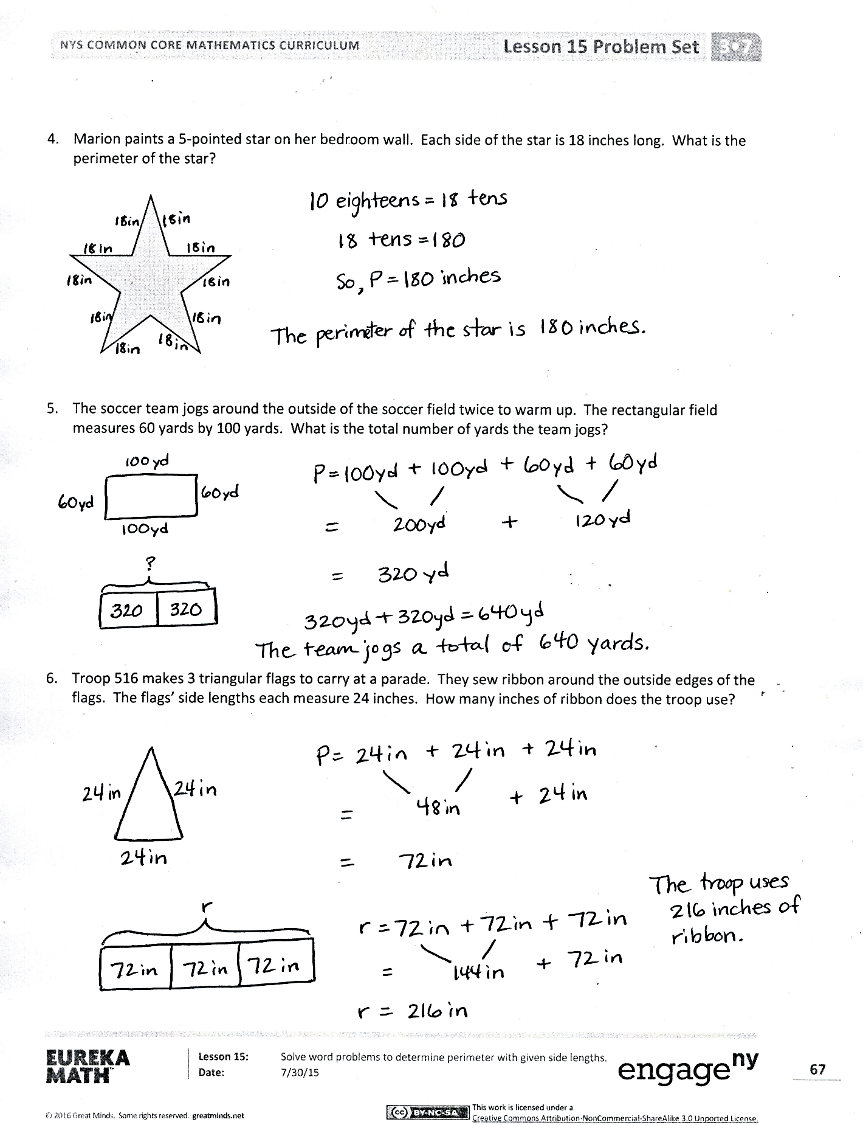
After the Student Debrief, instruct students to complete the Exit Ticket. A review of their work will help with assessing students’ understanding of the concepts that were presented in today’s lesson and planning more effectively for future lessons. The questions may be read aloud to the students.

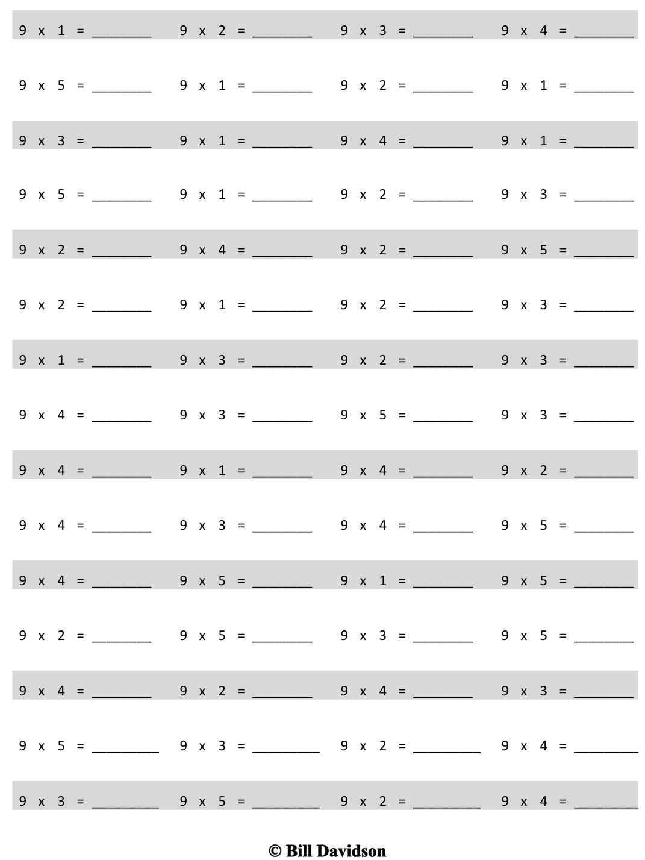
Multiply.

Name Date
- Mrs. Kozlow put a border around a 5-foot by 6-foot rectangular bulletin board. How many feet of border did Mrs. Kozlow use?

- Jason built a model of the Pentagon for a social studies project. He made each outside wall
33 centimeters long. What is the perimeter of Jason’s model pentagon?

- The Holmes family plants a rectangular 8-yard by 9-yard vegetable garden. How many yards of fencing do they need to put a fence around the garden?

- Marion paints a 5-pointed star on her bedroom wall. Each side of the star is 18 inches long. What is the perimeter of the star?

- The soccer team jogs around the outside of the soccer field twice to warm up. The rectangular field measures 60 yards by 100 yards. What is the total number of yards the team jogs?

- Troop 516 makes 3 triangular flags to carry at a parade. They sew ribbon around the outside edges of the flags. The flags’ side lengths each measure 24 inches. How many inches of ribbon does the troop use?

Name Date
Marlene ropes off a square section of her yard where she plants grass. One side length of the square measures 9 yards. What is the total length of rope Marlene uses?

Name Date
- Miguel glues a ribbon border around the edges of a 5-inch by 8-inch picture to create a frame. What is the total length of ribbon Miguel uses?

- A building at Elmira College has a room shaped like a regular octagon. The length of each side of the room is 5 feet. What is the perimeter of this room?

- Manny fences in a rectangular area for his dog to play in the backyard. The area measures 35 yards by 45 yards. What is the total length of fence that Manny uses?

- Tyler uses 6 craft sticks to make a hexagon. Each craft stick is 6 inches long. What is the perimeter of Tyler’s hexagon?

- Francis made a rectangular path from her driveway to the porch. The width of the path is 2 feet. The length is 28 feet longer than the width. What is the perimeter of the path?

- The gym teacher uses tape to mark a 4-square court on the gym floor as shown. The outer square has side lengths of 16 feet. What is the total length of tape the teacher uses to mark Square A?
D
C

16 ft
A
B

multiply by 9 (1–5)

