Lesson 11
Objective: Tessellate to understand perimeter as the boundary of a shape. (Optional.)

Suggested Lesson Structure

NOTES ON
MULTIPLE MEANS
OF REPRESENTATION:
Topic C presents two possible optional lessons related to perimeter, including this lesson. The second option is a culminating lesson using the text below, along with the lesson plan found at the end of that text.
Burns, Marilyn. Spaghetti and Meatballs for All! A Mathematical Story. New York: Scholastic Press, 1997.
With the Marilyn Burns option, the recommended sequence is after Lesson 17 and before the Mid-Module Assessment because the lesson explores the relationship between perimeter and area. It works well as a culmination of Topic C while anticipating Topic D, which incorporates area.
 Concept Development (50 minutes)
 Student Debrief (10 minutes)
Total Time (60 minutes)

Concept Development (50 minutes)
Materials: (T) Shape created in Lesson 10 (S) Shape created in Lesson 10, blank piece of paper, crayons, white string, black marker, Problem Set
Problem 1(a–c): Tessellate to explore perimeter.
Follow the directions below using the shape you created yesterday.
- Tessellate your shape on a blank piece of paper.
- Color your tessellation to create a pattern.
- Outline the perimeter of your tessellation with a highlighter.
T: (Project Image A.) What shape do you see repeated in this figure?
Image A
S: Hexagons!
T: Do all of the hexagons look the same? Discuss with your partner.
S: Some are yellow, and some are orange. But they all look like they’re the same size.
T: You’re right. All of the hexagons are the same size. In fact, this figure was made by tracing the same hexagon over and over. Do you see any gaps or overlaps between each hexagon?
S: No!
T: We call this figure a tessellation because it was made by copying a shape many times, without any gaps or overlaps. You’re going to create your own tessellation using the shape you made yesterday.
Prepare students by doing the following:

NOTES ON
MULTIPLE MEANS
OF ACTION AND EXPRESSION:
Students working below grade level and others may find tessellating concrete or virtual pattern blocks, or drawing on grid paper, a helpful step toward tessellating their shapes on a blank piece of paper.

- Model how to tessellate, emphasizing that there should not be any gaps or overlaps. As students tessellate, ask them to notice how the perimeter of the figure increases with each tessellation.
- Convey the idea that even though these tessellations are restricted by the paper size, a tessellation could, in fact, go on forever.
- Remind students that when coloring their designs, they should be creating a pattern.
If time permits, students can outline the perimeter of each tessellated shape within their designs using a black marker.
When tessellations are complete, allow time for a gallery walk.
Problem 1(d) and Problem 2: Use a string to measure and compare perimeters.

NOTES ON
MULTIPLE MEANS
OF ACTION AND EXPRESSION:
Support English language learners as they write their responses to Problems 2–4 on the Problem Set. Provide sentence starters and a word bank.
Sentence starters may include the following:
“The tessellation with the longer perimeter was ____.”
“I know because…”
Possible words for the word bank may include the following:
measure string more
shorter tessellate row

Problem 1(d): Use a string to measure the perimeter of your tessellation.
Problem 2: Compare the perimeter of your tessellation to a partner’s. Whose tessellation has a greater perimeter? How do you know?
Have students work with a partner and use a white string to measure the total perimeter of the figure they created when they tessellated. They should switch roles so that each partner can measure the total perimeter of his figure. Have them compare the perimeters of their figures using the marks on their strings and then answer Problem 2 on the Problem Set.
Problem Set (5 minutes)
Students should do their personal best to complete Problems 3 and 4 of the Problem Set within the allotted 5 minutes.

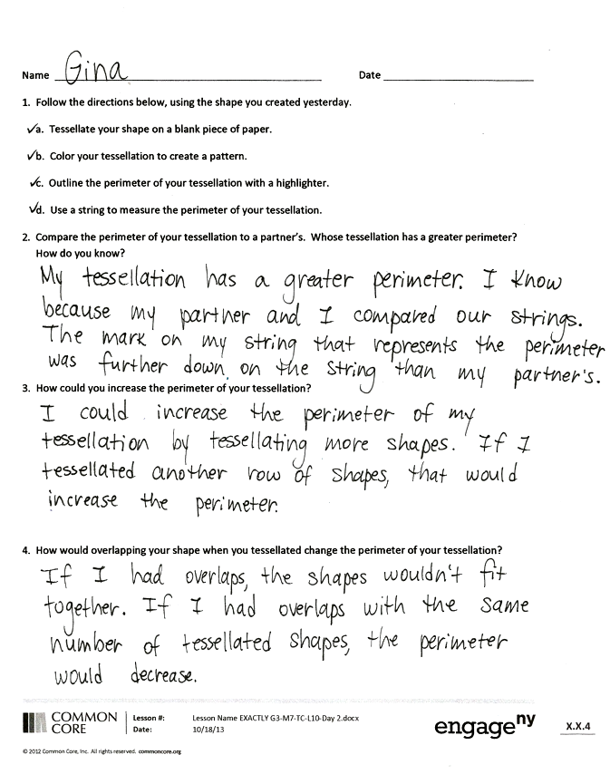
Student Debrief (10 minutes)
Lesson Objective: Tessellate to understand perimeter as the boundary of a shape. (Optional.)
The Student Debrief is intended to invite reflection and active processing of the total lesson experience. Invite students to review their solutions for the Problem Set. They should check work by comparing answers with a partner before going over answers as a class. Look for misconceptions or misunderstandings that can be addressed in the Debrief. Guide students in a conversation to debrief the Problem Set and process the lesson.
Any combination of the questions below may be used to lead the discussion.
- Explain to a partner the steps you used to tessellate your shape in Problem 1(a).
- Share your answer to Problem 3. How could you decrease the perimeter of your tessellation?
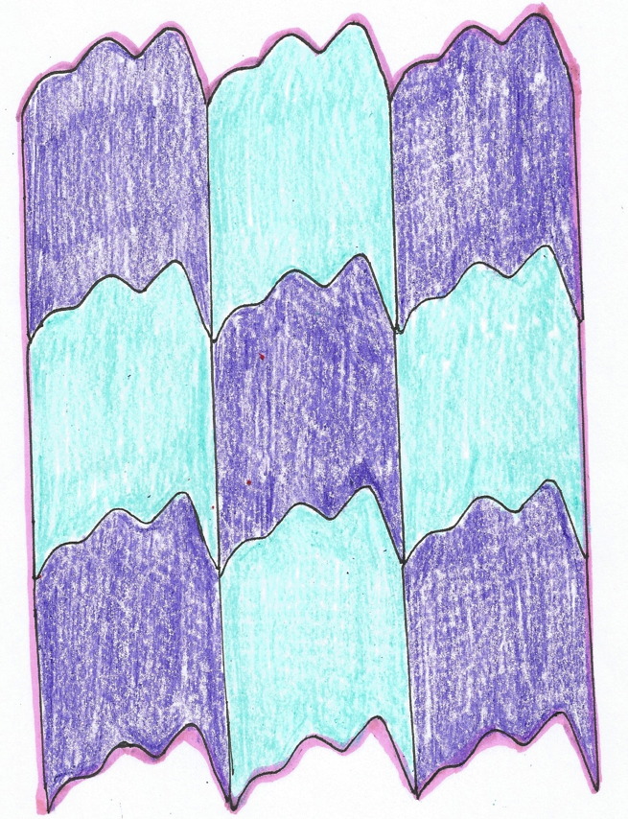
- Use your string to measure the perimeter of the piece of paper on which you made your tessellation. Compare the perimeter of the paper to the perimeter of your tessellation.
- Discuss the tessellations you saw during the gallery walk. Were any the same? Why or why not? How were they similar to your tessellation? How were they different?
Exit Ticket (3 minutes)
After the Student Debrief, instruct students to complete the Exit Ticket. A review of their work will help with assessing students’ understanding of the concepts that were presented in today’s lesson and planning more effectively for future lessons. The questions may be read aloud to the students.

Name Date
- Follow the directions below using the shape you created yesterday.
  - Tessellate your shape on a blank piece of paper.
- Color your tessellation to create a pattern.
- Outline the perimeter of your tessellation with a highlighter.
- Use a string to measure the perimeter of your tessellation.

- Compare the perimeter of your tessellation to a partner’s. Whose tessellation has a greater perimeter? How do you know?

- How could you increase the perimeter of your tessellation?

- How would overlapping your shape when you tessellated change the perimeter of your tessellation?

Name Date
Estimate to draw at least four copies of the given regular hexagon to make a new shape, without gaps or overlaps. Outline the perimeter of your new shape with a highlighter. Shade in the area with a colored pencil.

Name Date
- Samson tessellates regular hexagons to make the shape below.

- Outline the perimeter of Samson’s new shape with a highlighter.

- Explain how Samson could use a string to measure the perimeter of his new shape.

- How many sides does his new shape have?

- Shade in the area of his new shape with a colored pencil.

- Estimate to draw at least four copies of the given triangle to make a new shape, without gaps or overlaps. Outline the perimeter of your new shape with a highlighter. Shade in the area with a colored pencil.

- The marks on the strings below show the perimeters of Shyla’s and Frank’s shapes. Whose shape has a greater perimeter? How do you know?
Shyla’s String:
Frank’s String:

- India and Theo use the same shape to create the tessellations shown below.
India’s Tessellation
Theo’s Tessellation

- Estimate to draw the shape India and Theo used to make their tessellations.

- Theo says both tessellations have the same perimeter. Do you think Theo is right? Why or why not?

