Lesson 9
Objective: Reason about composing and decomposing polygons using tangrams.

Suggested Lesson Structure
 Fluency Practice (12 minutes)
 Application Problem (5 minutes)
 Concept Development (33 minutes)
 Student Debrief (10 minutes)
Total Time (60 minutes)
Fluency Practice (12 minutes)
- Multiply by 6 3.OA.7 (8 minutes)
- Equivalent Counting with Units of 9 3.OA.7 (4 minutes)

Multiply by 6 (8 minutes)
Materials: (S) Multiply by 6 (6–10) Pattern Sheet
Note: This activity builds fluency with multiplication facts using units of 6. It works toward students knowing from memory all products of two one-digit numbers. See Lesson 1 for the directions for administration of a Multiply-By Pattern Sheet.
T: (Write 7 × 6 = ____.) Let’s skip-count up by sixes. I’ll raise a finger for each six. (Raise a finger for each number to track the count.)
S: 6, 12, 18, 24, 30, 36, 42.
T: Let’s skip-count up by sixes starting at 30. Why is 30 a good place to start?
S: It’s a fact we already know, so we can use it to figure out a fact we don’t know.
T: (Track with fingers as students say the numbers.)
S: 30 (5 fingers), 36 (6 fingers), 42 (7 fingers).
T: Let’s see how we can skip-count down to find the answer, too. Start at 60 with 10 fingers, 1 for each six. (Count down with fingers as students say the numbers.)
S: 60 (10 fingers), 54 (9 fingers), 48 (8 fingers), 42 (7 fingers).
Continue with the following possible sequence: 9 × 6, 6 × 6, and 8 × 6.
T: (Distribute the Multiply by 6 Pattern Sheet.) Let’s practice multiplying by 6. Be sure to work left to right across the page.

Equivalent Counting with Units of 9 (4 minutes)
Note: This activity builds fluency with multiplication facts using units of 9. The progression builds in complexity. Work students up to the highest level of complexity where they can confidently participate.
T: Count to 10. (Write as students count. See the chart below.)
S: 1, 2, 3, 4, 5, 6, 7, 8, 9, 10.
1 2 3 4 5 6 7 8 9 10
1 nine 2 nines 3 nines 4 nines 5 nines 6 nines 7 nines 8 nines 9 nines 10 nines
9 18 27 36 45 54 63 72 81 90
1 nine 18 3 nines 36 5 nines 54 7 nines 72 9 nines 90
9 2 nines 27 4 nines 45 6 nines 63 8 nines 81 10 nines

T: (Write 1 nine beneath the 1.) Count to 10 nines. (Write as students count.)
S: 1 nine, 2 nines, 3 nines, 4 nines, 5 nines, 6 nines, 7 nines, 8 nines, 9 nines, 10 nines.
T: Count by nines to 90. (Write as students count.)
S: 9, 18, 27, 36, 45, 54, 63, 72, 81, 90.
T: (Write 1 nine beneath the 9. Write 18 beneath the 18.) I’m going to give you a challenge. Let’s alternate between saying the units of nine and the number. (Write as students count.)
S: 1 nine, 18, 3 nines, 36, 5 nines, 54, 7 nines, 72, 9 nines, 90.
T: (Write 9 beneath 1 nine and 2 nines beneath the 18.) Let’s alternate again. (Write as students count.)
S: 9, 2 nines, 27, 4 nines, 45, 6 nines, 63, 8 nines, 81, 10 nines.
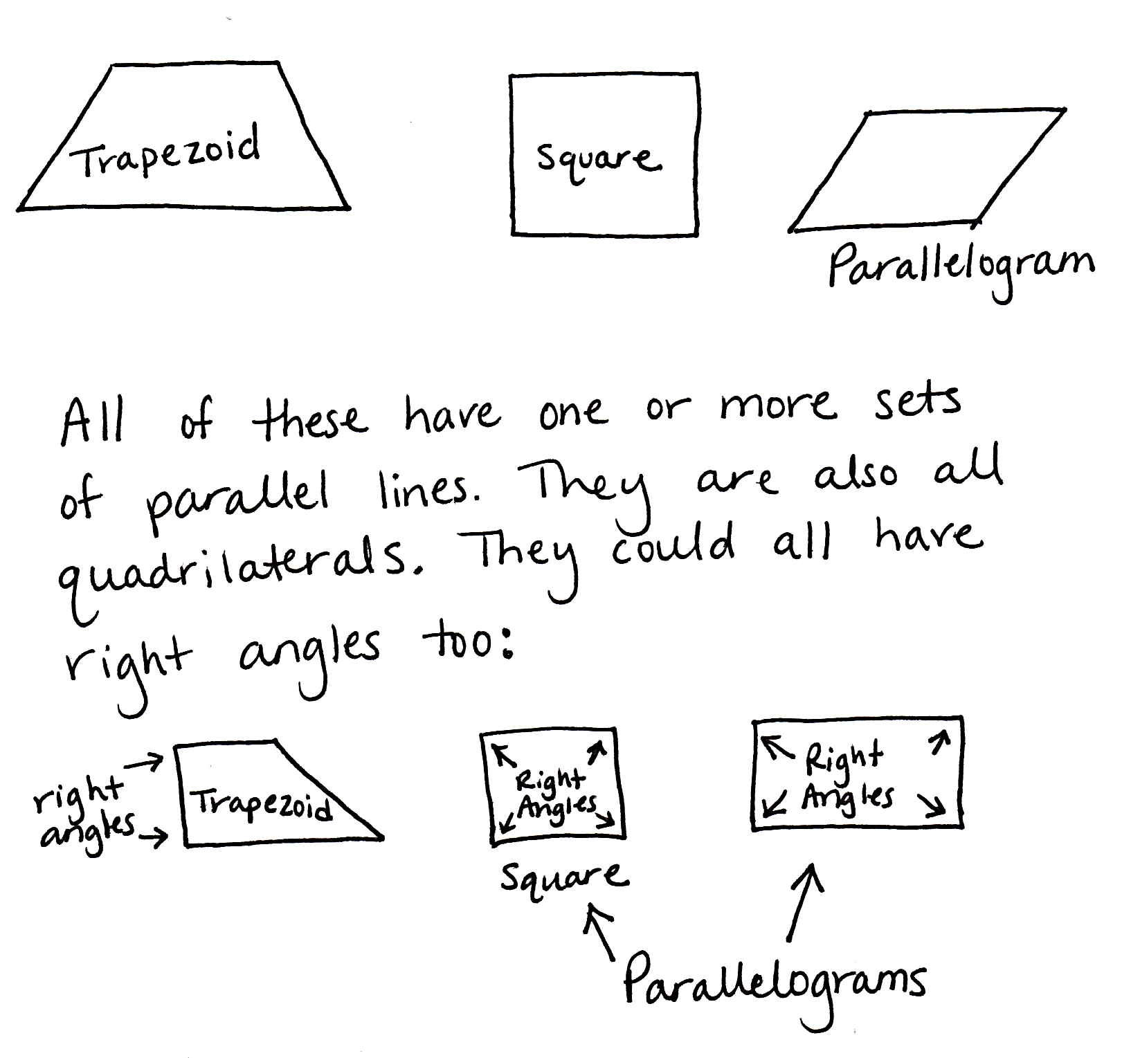
Application Problem (5 minutes)
Name at least two attributes that a trapezoid, a square, and a parallelogram all have in common. Draw a diagram to support your ideas.
Note: This problem is designed to bridge learning from prior lessons and lead up to the Concept Development for the current lesson.

Concept Development (33 minutes)
Materials: (S) Tangram pieces (from Lesson 8), blank piece of paper, Problem Set
Problem 1

NOTES ON
MULTIPLE MEANS
OF ACTION AND EXPRESSION:
It may be beneficial to have a variety of tangrams to meet the needs of students. Plastic or virtual tangrams may be easier for some students to manipulate. Alternatively, tangram pieces (from Lesson 8) can be copied on heavier paper, such as cardstock.
Use at least two tangram pieces to make and draw two of each of the following shapes. Draw lines to show where the tangram pieces meet.
- A rectangle that does not have all equal sides.
- A triangle.
- A parallelogram.
- A trapezoid.
T: Use the square and the two small triangles to make a rectangle. (Allow students time to work.) Estimate to draw your rectangle in Problem 1(a). Draw lines to show where the triangles and square meet to make
the rectangle.
S: (Draw a rectangle in Problem 1(a).)
T: Use at least two tangram pieces to make another rectangle. (Allow students time to work.) Which shapes did you use to make another rectangle?
S: I used the medium triangle and the two small triangles. I used the square, the medium triangle, and the two small triangles. I used the square, the medium triangle, the two small triangles, and the parallelogram.
T: Compare your rectangle to a partner’s. Discuss how they are similar and how they are different.
S: (Compare rectangles and discuss similarities and differences.)
T: Estimate to draw your rectangle in Problem 1(a). Draw lines to show where the tangram pieces meet to make the rectangle.
S: (Draw a rectangle in Problem 1(a).)
Continue the process to make the rest of the shapes in Problem 1.
Note: Students should try to make parallelograms and trapezoids that are not rectangles.
Problem 2
Use your two smallest triangles to create a square, a parallelogram, and a triangle. Show how you created them below.
T: Use the two small triangles to make a square. (Allow students time to work.) Estimate to draw your square in Problem 2. Draw lines to show where the triangles meet to make the square.
S: (Draw a square in Problem 2.)

T: Compare the square you made using two small triangles with the square tangram piece. What do you notice?
S: They’re the same! Two small triangles equal the square tangram piece!
T: Now, use the two small triangles to make a parallelogram. (Allow students time to work.) Estimate to draw your parallelogram in Problem 2. Draw lines to show where the triangles meet to make the parallelogram.
S: (Draw a parallelogram in Problem 2.)
T: Finally, use the two small triangles to make a new triangle. (Allow students time to work.) Estimate to draw your triangle in Problem 2. Draw lines to show where the small triangles meet to make the new triangle.
S: (Draw a triangle in Problem 2.)
T: Talk to a partner: Compare the size of the parallelogram and the new triangle that you made to the size of the square tangram piece.
S: They’re all equal! We saw that the two small triangles are the same size as the square. Since we used the two small triangles to make the parallelogram and the new triangle, then those shapes are the same size as the square tangram piece.
Problems 3 and 4
Problem 3: Create your own shape on a separate sheet of paper using all seven pieces. Describe its attributes below.
Problem 4: Trade your outline with a partner to see if you can re-create his shape using your tangram pieces. Reflect on your experience below. What was easy? What was challenging?
T: Use all seven tangram pieces to create a new shape. Trace the outline of the shape on the blank piece of paper. Describe attributes of your shape in Problem 3. When you’ve answered Problem 3, trade outlines with a partner, and try to re-create your partner’s shape with your tangram pieces. Then, answer Problem 4.
To prepare students, do the following:
- Remind them that the shapes they create cannot have gaps or overlaps.
- Generate a list of possible attributes that they might use to describe their new shapes.
- Clarify that, if necessary, they can gently guide their partners to re-create shapes if their partners have independently put forth significant effort in attempting to re-create the shapes.
If time permits, students can perform a gallery walk to view the shapes that their classmates created with all seven tangram pieces.
Note: Students need their tangram pieces for the Exit Ticket and Homework.

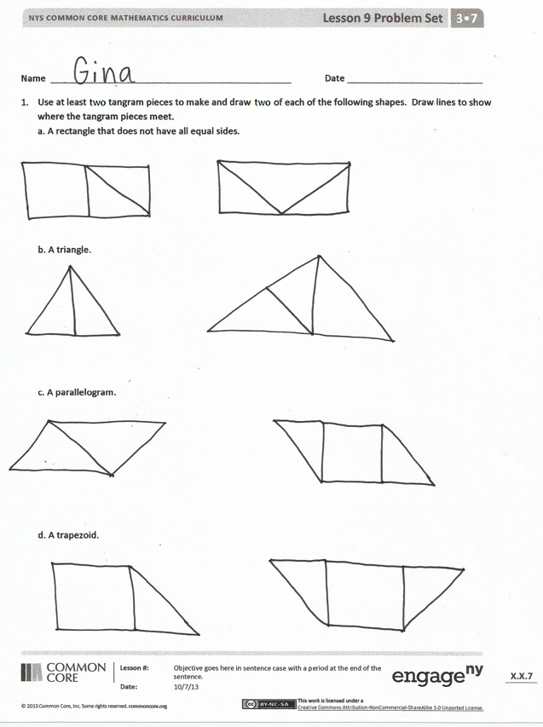
Student Debrief (10 minutes)
Lesson Objective: Reason about composing and decomposing polygons using tangrams.
The Student Debrief is intended to invite reflection and active processing of the total lesson experience. Invite students to review their solutions for the Problem Set. They should check work by comparing answers with a partner before going over answers as a class. Look for misconceptions or misunderstandings that can be addressed in the Debrief. Guide students in a conversation to debrief the Problem Set and process the lesson.
Any combination of the questions below may be used to lead the discussion.
- Which shape was the most challenging for you to make in Problem 1? Why?
- Could you make the same shapes you made in Problem 2 with the large triangles? Why or why not?
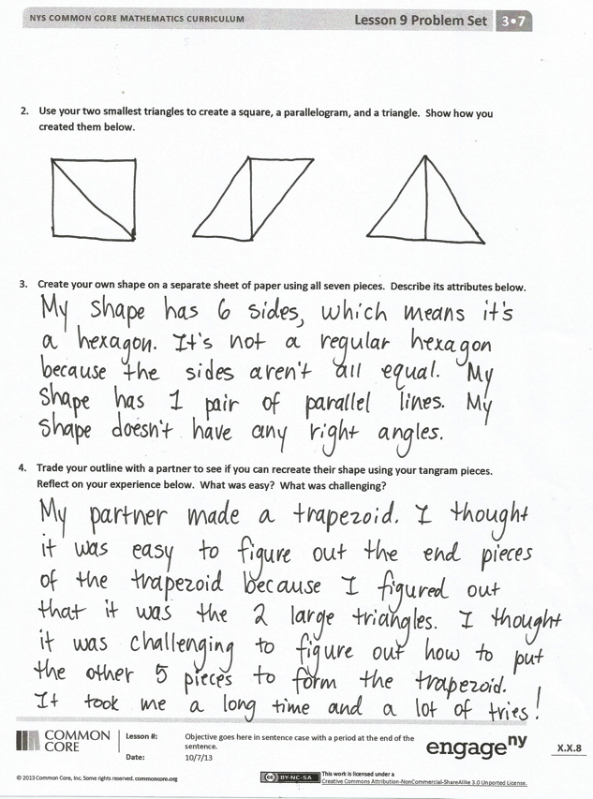
- What can you say about the areas of the shapes you made in Problem 2? How about the areas of these shapes compared to the area of the square tangram piece?
- Compare your answer to Problem 3 with a partner’s answer. What attributes do your shapes have in common? What attributes are different?
- Share your answers to Problem 4. Was something easy for you but challenging for others? Likewise, was something easy for others but challenging for you? Why?
Exit Ticket (3 minutes)
After the Student Debrief, instruct students to complete the Exit Ticket. A review of their work will help with assessing students’ understanding of the concepts that were presented in today’s lesson and planning more effectively for future lessons. The questions may be read aloud to the students.
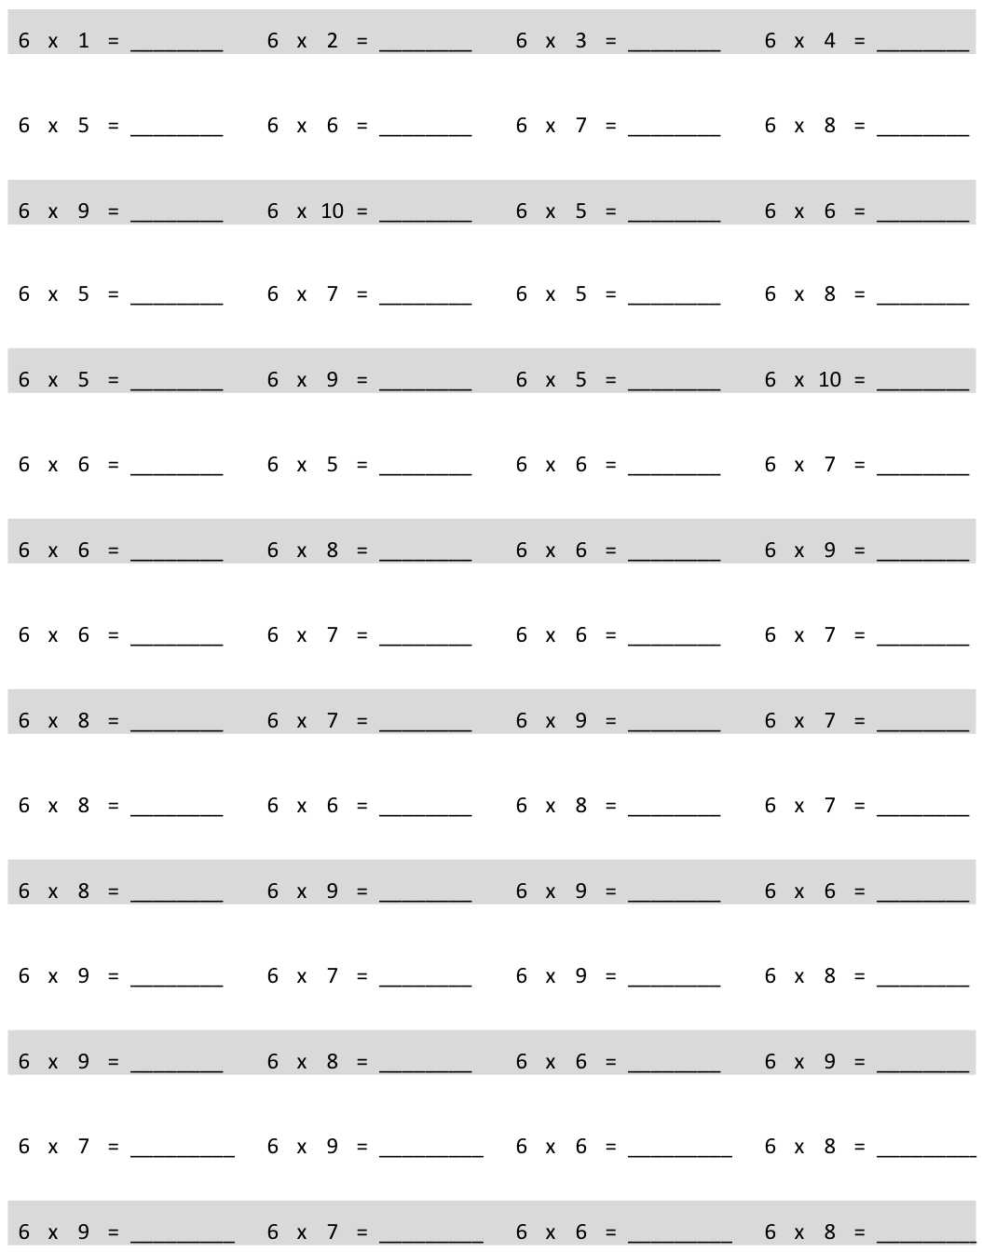
Multiply.
Name Date
- Use at least two tangram pieces to make and draw two of each of the following shapes. Draw lines to show where the tangram pieces meet.
  - A rectangle that does not have all equal sides.

- A triangle.

- A parallelogram.

- A trapezoid.

- Use your two smallest triangles to create a square, a parallelogram, and a triangle. Show how you created them below.

- Create your own shape on a separate sheet of paper using all seven pieces. Describe its attributes below.

- Trade your outline with a partner to see if you can re-create her shape using your tangram pieces. Reflect on your experience below. What was easy? What was challenging?

Name Date
Nancy uses her tangram pieces to make a trapezoid without using the square piece. Below, sketch how she might have created her trapezoid.

Name Date
- Use at least two tangram pieces to make and draw each of the following shapes. Draw lines to show where the tangram pieces meet.
  - A triangle.

- A square.

- A parallelogram.

- A trapezoid.

- Use your tangram pieces to create the cat below. Draw lines to show where the tangram pieces meet.

- Use the five smallest tangram pieces to make a square. Sketch your square below, and draw lines to show where the tangram pieces meet.

multiply by 6 (6─10)

