Lesson 8
Objective: Create a tangram puzzle and observe relationships among the shapes.

Suggested Lesson Structure
 Fluency Practice (15 minutes)
 Concept Development (35 minutes)
 Student Debrief (10 minutes)
Total Time (60 minutes)
Fluency Practice (15 minutes)
- Multiply by 6 3.OA.7 (7 minutes)
- Equivalent Counting with Units of 8 3.OA.7 (4 minutes)
- Shade Rectangles of Equal Area 3.G.2 (4 minutes)

Multiply by 6 (7 minutes)
Materials: (S) Multiply by 6 (1–5) Pattern Sheet
Note: This activity builds fluency with multiplication facts using units of 6. It works toward students knowing from memory all products of two one-digit numbers. See Lesson 1 for the directions for administration of a Multiply-By Pattern Sheet.
T: (Write 5 × 6 = ____.) Let’s skip-count up by sixes to find the answer. (Raise a finger for each number to track the count. Record the skip-count answers on the board.)
S: 6, 12, 18, 24, 30.
T: (Circle 30, and write 5 × 6 = 30 above it. Write 3 × 6 = ____.) Let’s skip-count up by sixes again. (Track with fingers as students count.)
S: 6, 12, 18.
T: Let’s see how we can skip-count down to find the answer, too. Start at 30 with 5 fingers, 1 for each six. (Count down with fingers as students say the numbers.)
S: 30 (five fingers), 24 (4 fingers), 18 (3 fingers).
Repeat the process for 4 × 6.
T: (Distribute the Multiply by 6 Pattern Sheet.) Let’s practice multiplying by 6. Be sure to work left to right across the page.

Equivalent Counting with Units of 8 (4 minutes)
Note: This activity builds fluency with multiplication facts using units of 8. The progression builds in complexity. Work students up to the highest level of complexity where they can confidently participate.
T: Count to 10. (Write as students count. See the chart below.)
S: 1, 2, 3, 4, 5, 6, 7, 8, 9, 10.
T: (Write 1 eight beneath the 1.) Count to 10 eights. (Write as students count.)
1 2 3 4 5 6 7 8 9 10
1 eight 2 eights 3 eights 4 eights 5 eights 6 eights 7 eights 8 eights 9 eights 10 eights
8 16 24 32 40 48 56 64 72 80
1 eight 16 3 eights 32 5 eights 48 7 eights 64 9 eights 80
8 2 eights 24 4 eights 40 6 eights 56 8 eights 72 10 eights

S: 1 eight, 2 eights, 3 eights, 4 eights, 5 eights, 6 eights, 7 eights, 8 eights, 9 eights, 10 eights.
T: Count by eights to 80. (Write as students count.)
S: 8, 16, 24, 32, 40, 48, 56, 64, 72, 80.
T: (Write 1 eight beneath the 8. Write 16 beneath the 16.) I’m going to give you a challenge. Let’s alternate between saying the units of eight and the number. (Write as students count.)
S: 1 eight, 16, 3 eights, 32, 5 eights, 48, 7 eights, 64, 9 eights, 80.
T: (Write 8 beneath 1 eight and 2 eights beneath the 16.) Let’s alternate again. (Write as students count.)
S: 8, 2 eights, 24, 4 eights, 40, 6 eights, 56, 8 eights, 72, 10 eights.
Shade Rectangles of Equal Area (4 minutes)
Materials: (S) Personal white board with grid paper
Note: This activity reviews Lesson 7.
T: (Write Area = 6 square units.) On your grid paper, shade a rectangle with an area of 6 square units with one row.
S: (Shade a 1 unit by 6 unit rectangle.)
T: Shade a rectangle with the same area using two rows.
S: (Shade a 2 unit by 3 unit rectangle.)
T: (Write Area = 8 square units.) Shade a rectangle with an area of 8 square units.
S: (Shade a 1 unit by 8 unit rectangle, 2 unit by 4 unit rectangle, 4 unit by 2 unit rectangle, or 8 unit by
1 unit rectangle.)
T: Shade a rectangle with different side lengths but the same area.
S: (Shade a rectangle with different side lengths but the same area.)
Repeat process for Area = 12 square units.
Concept Development (35 minutes)
Materials: (T) 8½″ × 11″ sheet of paper, scissors (S) 8½″ × 11″ sheet of paper, scissors, Problem Set
Part 1: Create a tangram puzzle.

NOTES ON
MULTIPLE MEANS
OF ENGAGEMENT:
Give English language learners and others who may not otherwise quickly articulate names of polygons a fair chance to participate. Offer the alternative of nonverbal responses, such as pointing to a rectangle, triangle, quadrilateral, trapezoid, or square, or by gesturing or drawing on personal white boards. To preserve the lesson, students may be allowed to respond in their first languages. However, offer students ample practice and encouragement to speak polygon names in English prior to and after the lesson.

Note: Have students store their tangram pieces to be used in Lesson 9.
T: Today, we will cut out different shapes from this one large shape. What is this shape? (Hold up a sheet of paper.)
S: A rectangle.
Problem 1
T: First, we need to make a square. Fold your paper so that a shorter side lies along a longer side. Cut off the extra strip of paper. Unfold the remaining paper. (Model.)
T: We have drawn diagonals inside quadrilaterals and discovered they can be decomposed into what two shapes?
S: Two triangles.
T: Look how I fold my paper down the diagonal line that goes through the middle of the square. (Fold and unfold the paper.) Do I get the same shapes?
S: Yes. You get two triangles!
T: Fold your square on the diagonal. Then, cut out the two triangles on your paper as I cut out my triangles. (Cut out the triangles as students cut out the triangles.) How many pieces do you have now?
S: Two pieces!
T: Draw and label these two new shapes in Problem 1 on the Problem Set.
S: (Draw and label.)

Problem 2
T: Take one of your triangles. (Model.) Fold it in half to make two equal sides, and crease it. Open the paper, and cut on the fold. (Allow students time to fold and cut.) Which smaller shapes is the big triangle composed of?
S: Two smaller triangles.
T: Draw and label these two new shapes in Problem 2.
S: (Draw and label.)
Problem 3
T: Take the remaining big triangle. (Model.) First, fold it in half to make our two triangles. Then, open the paper, and fold the tip of the triangle down to meet the bottom side of the triangle in the middle. Make a horizontal crease, and open it up. Cut only on the horizontal crease. What shapes did we make?
S: A quadrilateral and a triangle. A trapezoid and a smaller triangle.
T: Draw and label these two new shapes in Problem 3 as a trapezoid and triangle.
S: (Draw and label.)
Problem 4
T: Take the trapezoid. Fold it in half, and cut it on the fold. Now you
have two of what type of shape?
S: Quadrilaterals. Trapezoids.
T: Draw and label these two new shapes in Problem 4.
S: (Draw and label.)
Problem 5
T: Take one of the trapezoids, and fold the longest point in. Make the long point meet the opposite corner, and crease it. Open it up, and cut on the fold. What shapes did we make?
S: We made a triangle and a square.
T: Draw and label these two new shapes in Problem 5.
S: (Draw and label.)

Problem 6
T: Use the last trapezoid. Put the longest side at the bottom, with the right angles to the left. Fold the bottom left angle up to meet the diagonal corner, and crease it. Open it up, and cut on the crease line. (Allow students time to fold and cut.) What shapes did we make?
S: We made a small triangle and a parallelogram.
T: Draw and label these two new shapes in Problem 6.
S: (Draw and label.)
Part 2: Recompose shapes to form a square.
MP.1
T: Put your pieces back together to form the large square with which we started. (Allow students ample time to position the pieces. Make every effort not to interfere as students work at positioning the shapes during this sequence of the lesson. Encourage students to persevere, providing the least direction possible. Have students who finish quickly shuffle their pieces and try to make new shapes.)
T: Great job! These seven pieces that form a large square are called a tangram. You can make many different and interesting shapes by combining some or all of the parts.
Students complete Problems 7(a) and 7(b).
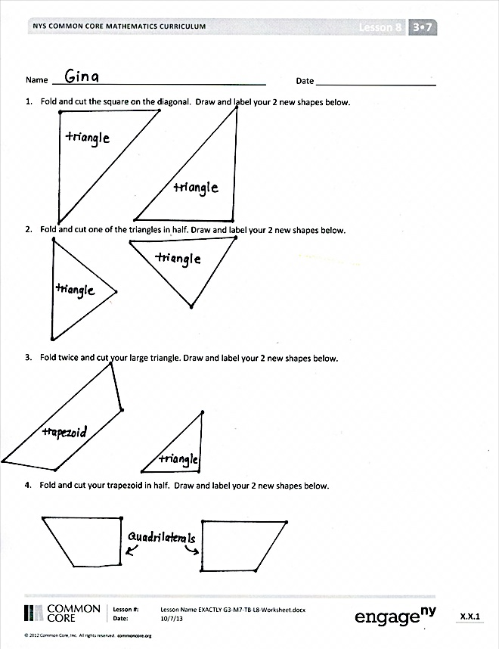
Student Debrief (10 minutes)

Lesson Objective: Create a tangram puzzle and observe relationships among the shapes.
The Student Debrief is intended to invite reflection and active processing of the total lesson experience.
Invite students to review their solutions for the Problem Set. They should check work by comparing answers with a partner before going over answers as a class. Look for misconceptions or misunderstandings that can be addressed in the Debrief. Guide students in a conversation to debrief the Problem Set and process the lesson.
Any combination of the questions below may be used to lead the discussion.
- How do you know the triangles in Problem 1 have right angles without having to check with your tool?

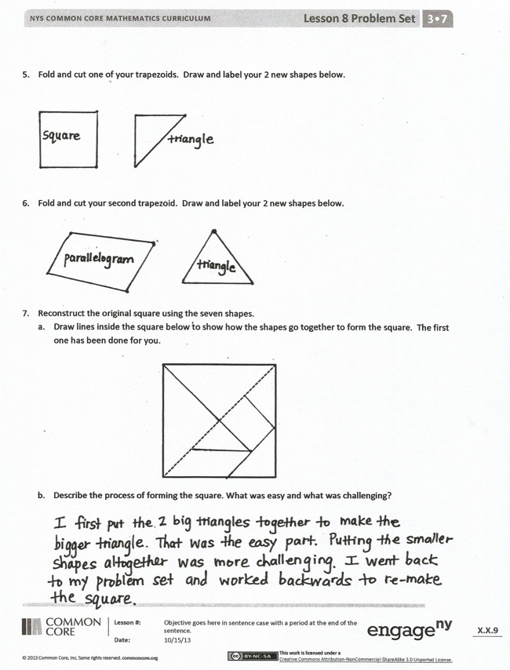
- What do you notice about the size and shape of the triangles in Problem 2? Are they equal in size? How do you know? Are they regular polygons?
- Out of the seven tangram pieces, how many shapes are triangles? How many shapes are quadrilaterals? Are any of the shapes regular polygons?
- Explain to your partner the steps you took to recompose the seven shapes to a square.
- Share your answers to Problem 7(b). What was challenging? What are some strategies you used to recompose the square?
Exit Ticket (3 minutes)
After the Student Debrief, instruct students to complete the Exit Ticket. A review of their work will help with assessing students’ understanding of the concepts that were presented in today’s lesson and planning more effectively for future lessons. The questions may be read aloud to the students.
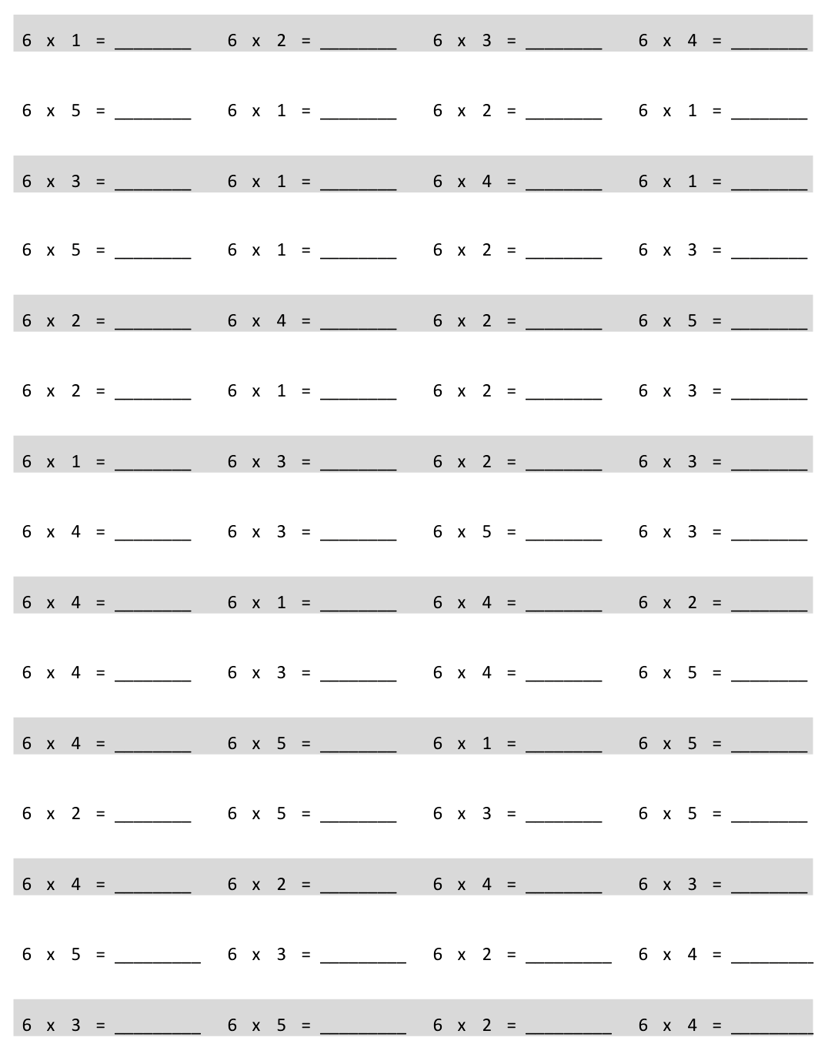
Multiply.
Name Date
- Fold and cut the square on the diagonal. Draw and label your 2 new shapes below.

- Fold and cut one of the triangles in half. Draw and label your 2 new shapes below.

- Fold twice, and cut your large triangle. Draw and label your 2 new shapes below.

- Fold and cut your trapezoid in half. Draw and label your 2 new shapes below.

- Fold and cut one of your trapezoids. Draw and label your 2 new shapes below.

- Fold and cut your second trapezoid. Draw and label your 2 new shapes below.

- Reconstruct the original square using the seven shapes.
- Draw lines inside the square below to show how the shapes go together to form the square. The first one has been done for you.

- Describe the process of forming the square. What was easy, and what was challenging?

Name Date
Choose three shapes from your tangram puzzle. Trace them below. Label the name of each shape, and describe at least one attribute that they have in common.

Name Date
- Draw a line to divide the square below into 2 equal triangles.

- Draw a line to divide the triangle below into 2 equal, smaller triangles.
- Draw a line to divide the trapezoid below into 2 equal trapezoids.

- Draw 2 lines to divide the quadrilateral below into 4 equal triangles.

- Draw 4 lines to divide the square below into 8 equal triangles.

- Describe the steps you took to divide the square in Problem 5 into 8 equal triangles.

multiply by 6 (1─5)

