Lesson 6
Objective: Draw polygons with specified attributes to solve problems.

Suggested Lesson Structure
 Fluency Practice (12 minutes)
 Application Problem (8 minutes)
 Concept Development (30 minutes)
 Student Debrief (10 minutes)
Total Time (60 minutes)
Fluency Practice (12 minutes)
- Equivalent Counting with Units of 7 3.OA.7 (4 minutes)
- Classify the Polygon 3.G.1 (5 minutes)
- Physiometry 3.G.1 (3 minutes)

Equivalent Counting with Units of 7 (4 minutes)
Note: This activity builds fluency with multiplication facts using units of 7. The progression builds in complexity. Work students up to the highest level of complexity where they can confidently participate.
T: Count to 10. (Write as students count. See the chart below.)
1 2 3 4 5 6 7 8 9 10
1 seven 2 sevens 3 sevens 4 sevens 5 sevens 6 sevens 7 sevens 8 sevens 9 sevens 10 sevens
7 14 21 28 35 42 49 56 63 70
1 seven 14 3 sevens 28 5 sevens 42 7 sevens 56 9 sevens 70
7 2 sevens 21 4 sevens 35 6 sevens 49 8 sevens 63 10 sevens

S: 1, 2, 3, 4, 5, 6, 7, 8, 9, 10.
T: (Write 1 seven beneath the 1.) Count to 10 sevens. (Write as students count.)
S: 1 seven, 2 sevens, 3 sevens, 4 sevens, 5 sevens, 6 sevens, 7 sevens, 8 sevens, 9 sevens, 10 sevens.
T: Count by sevens to 70. (Write as students count.)
S: 7, 14, 21, 28, 35, 42, 49, 56, 63, 70.

T: (Write 1 seven beneath the 7. Write 14 beneath the 14.) I’m going to give you a challenge. Let’s alternate between saying the units of seven and the number. (Write as students count.)
S: 1 seven, 14, 3 sevens, 28, 5 sevens, 42, 7 sevens, 56, 9 sevens, 70.
T: (Write 7 beneath 1 seven and 2 sevens beneath the 14.) Let’s alternate again. (Write as students count.)
S: 7, 2 sevens, 21, 4 sevens, 35, 6 sevens, 49, 8 sevens, 63, 10 sevens.
Classify the Polygon (5 minutes)

NOTES ON
MULTIPLE MEANS
OF REPRESENTATION:
If necessary, adjust questions for Classify the Polygon for English language learners and others who may not easily name shapes. Instead of asking, “What are shapes that have four sides called?” ask, “This is a trapezoid. Say ‘trapezoid.’ How many sides does a trapezoid have?”
Materials: (S) Personal white board
Repeat Classify the Polygon from Lesson 5 using different shapes or orienting the same shapes differently.
Note: This activity reviews identifying attributes and naming shapes.
Physiometry (3 minutes)
Note: Kinesthetic memory is strong memory. This activity reviews vocabulary from Lessons 4 and 5.
T: Stand up. (After students stand, stretch one arm up directly toward the ceiling. Stretch the other arm toward a wall, parallel to the floor.) What type of angle am I modeling with my arms?
S: A right angle.
T: Model a right angle with your arms.
S: (Mirror the teacher.)
T: (Stretch the arm pointing toward a wall directly up toward the ceiling. Move the arm pointing toward the ceiling so that it points directly toward the opposite wall.) Model another right angle.
S: (Mirror the teacher.)
T: How many sides does a triangle have?
S: Three sides.
T: Using your arms, model a triangle with the person standing next to you.
S: (Connect arms with partner to model a three-sided figure.)
T: What do we call a four-sided figure?
S: Quadrilateral.
T: Use your body to make a quadrilateral with your partner.
S: (Model a four-sided figure with partner.)

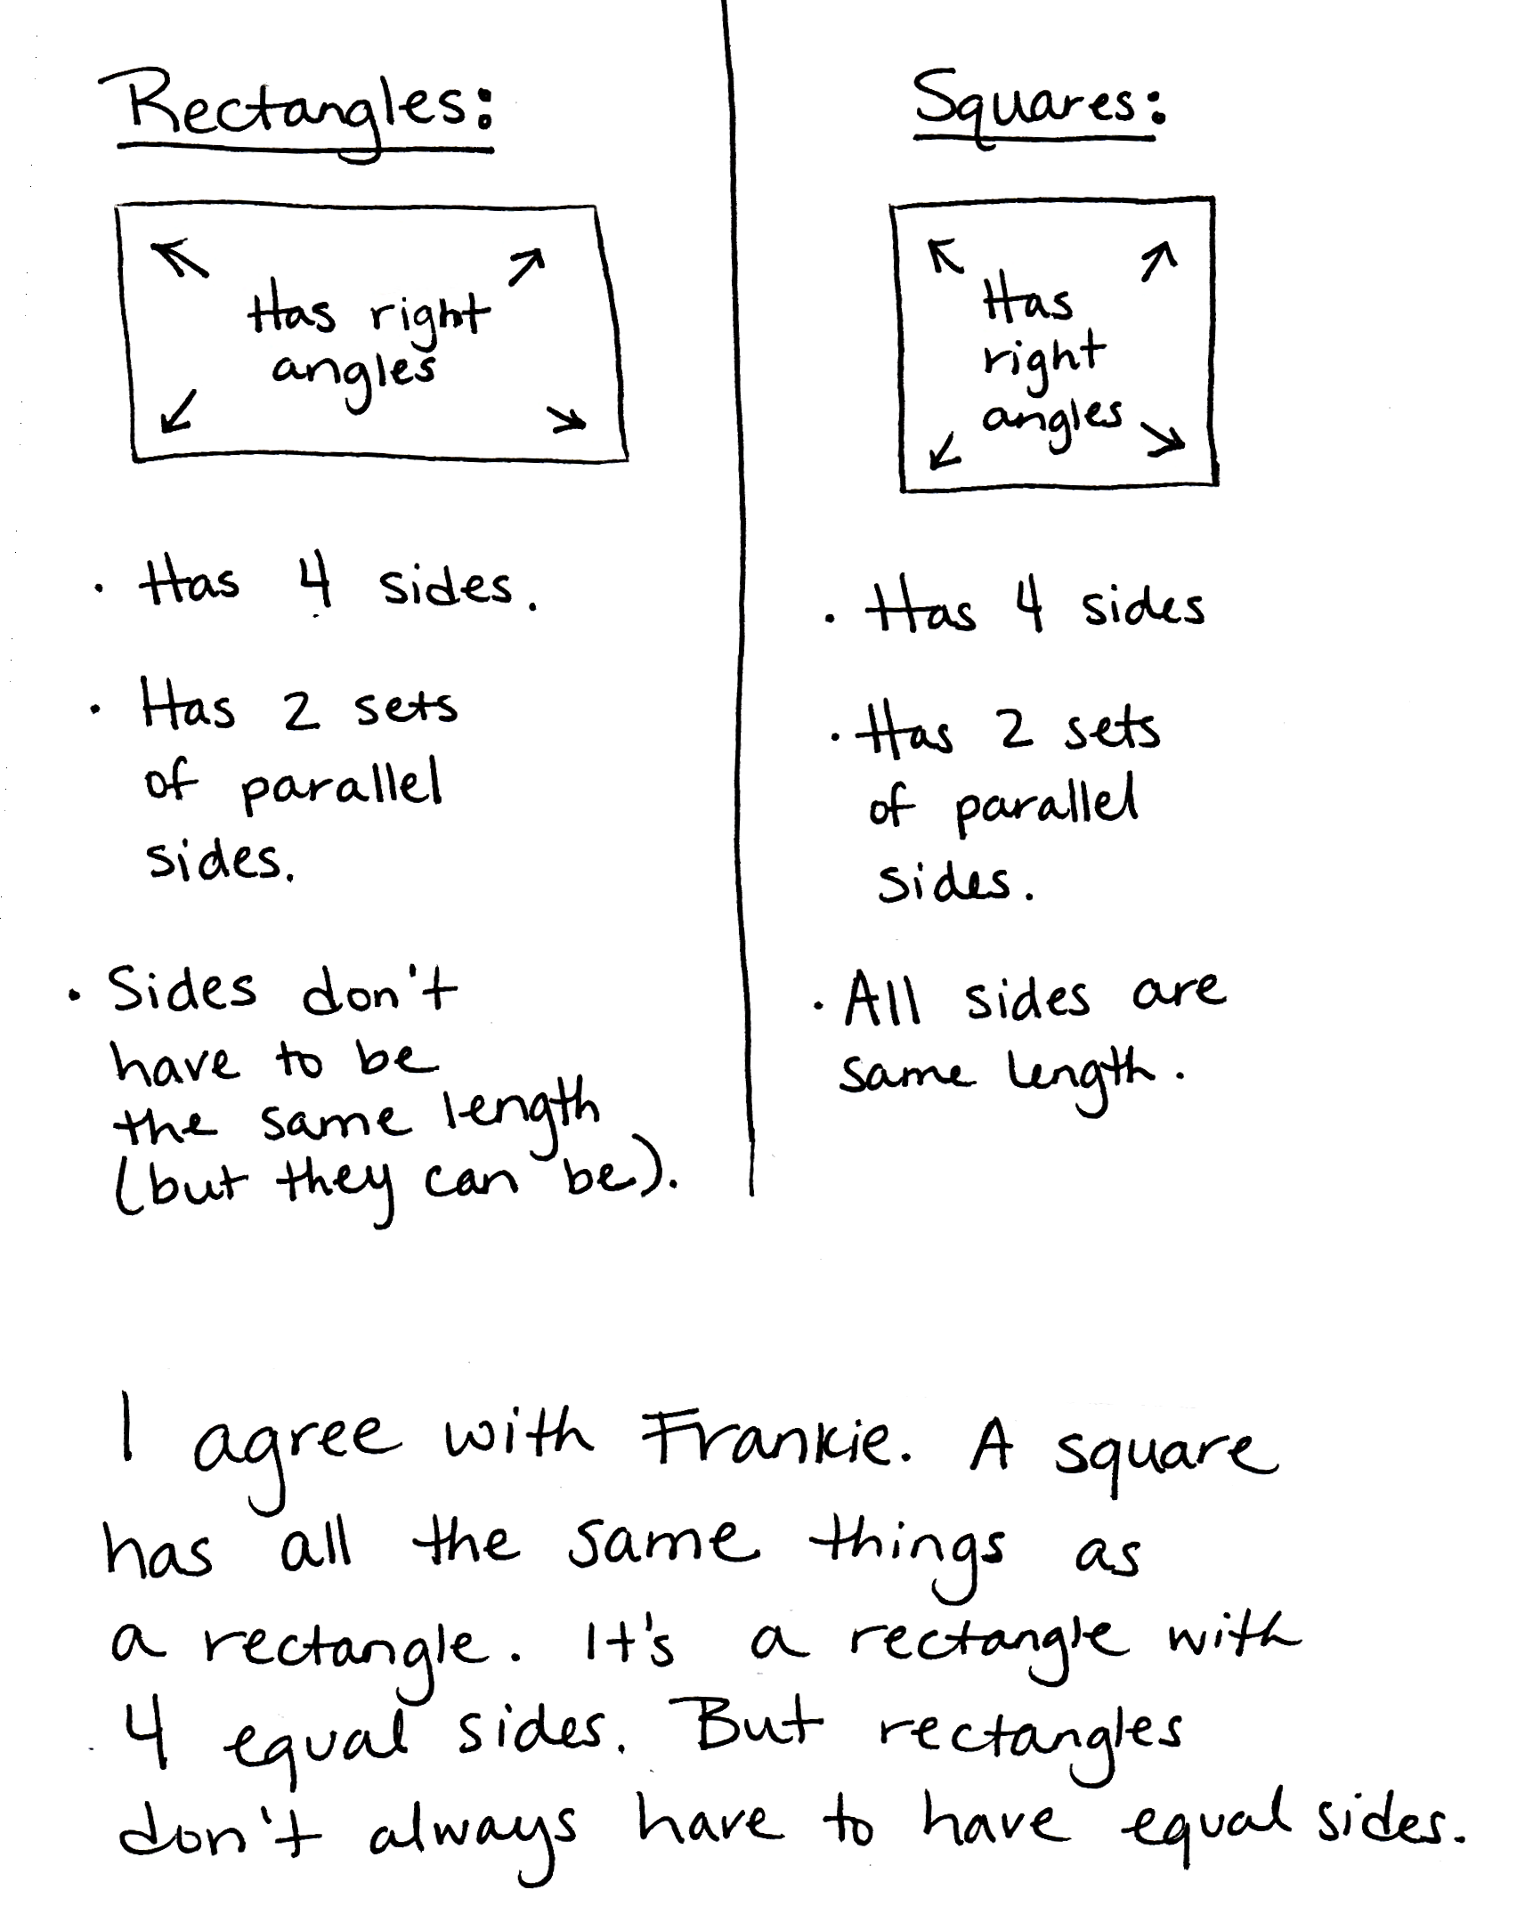
Application Problem (8 minutes)
Frankie says that all squares are rectangles, but not all rectangles are squares. Do you agree with this statement? Why or why not? Draw diagrams to support your statement.
Note: This Application Problem engages students in MP.3, constructing viable arguments and critiquing the reasoning of others, while revisiting the classification of squares as being a special type of rectangle.
Concept Development (30 minutes)
Materials: (T) Game cards (Template 2) (S) Personal white board, ruler, right angle tool, math journal, polygon (Template 1) (1 per pair), game cards (Template 2) (1 set per pair, cut out)
Project Template 1 as shown, and give a copy of the shape to each pair of students.
Template 1
T: Work with a partner to analyze this shape, and list as many attributes as you can on your personal white board. Use your right angle tools and rulers to help you.
S: (Work in pairs. Produce these possible responses: quadrilateral, trapezoid, four-sided, one pair of parallel sides,
two right angles, two equal sides.)
Build class consensus by inviting different pairs to share attributes. Use a right angle tool to verify the two right angles and a ruler to verify the equal sides. Write the list of attributes on the board as students share. Then, ask students to erase their boards.

NOTES ON
MULTIPLE MEANS
OF ACTION AND EXPRESSION:
Scaffold shape analysis with questions or sentence frames:
- I see _____ angles.
- How many right angles do you count?
- How many equal sides do you measure?
- This shape is called a _____.
- How many sets of parallel sides do you see?

T: We found two angles that are right angles. Let’s talk about a way to describe the other angles, too. Now compare this angle with our right angle tool. (Place the right angle tool so that students can see that one angle is greater than a right angle.) Is this angle greater than or less than a right angle? How do you know?
S: It’s greater than a right angle because it’s bigger than the right angle tool! The sides of the angle open wider than the right angle. The right angle is just a part of the bigger angle.

T: Some angles are greater than a right angle. Let’s add
1 angle greater than a right angle to our list of attributes for this shape. (Place right angle tool so that students can see that 1 angle is less than a right angle.) What about this angle?

NOTES ON
MULTIPLE MEANS
OF ENGAGEMENT:
If appropriate for the class, continue to use the written list with the attributes discussed at the beginning of the lesson to support students with drawing until they are ready to move on.
S: It’s less than a right angle. I can see that because it’s smaller than the right angle tool.
T: True. Some angles are less than a right angle. Let’s add 1 angle less than a right angle to our list of attributes for this shape.
T: (Circle 1 angle greater than a right angle on the list of attributes on the board.) Draw a shape with one angle that is greater than a right angle.
S: (Draw. There are a variety of possibilities.)
MP.5
T: (Compare a few different shapes, and ask the class to confirm their validity. Circle 2 right angles on the list of attributes.) Talk to a partner: What tool or tools will you use to draw a different shape that has at least two right angles?
S: My right angle tool! I think I’ll use my ruler, too. The right angle tool will help me make sure
I have at least two right angles, and my ruler will help me draw straight lines.
T: I agree! Use your ruler and right angle tool to draw a different shape that has at least two right angles.
S: (Draw. There are a variety of possibilities.)
T: (Circulate to see that students have drawn shapes that have at least two right angles, and then have students erase their boards. Circle quadrilateral, 2 equal sides, and 1 pair of parallel sides.) Talk to a partner: What tool or tools will you use to draw a shape with the circled attributes?
S: A ruler. I’ll use my ruler to make sure I have two equal sides. My ruler will also help me draw straight lines. Since I don’t have to worry about drawing any right angles, I can just use my ruler to measure the side lengths and draw straight lines.
T: Use your ruler to draw a shape with the circled attributes. Label the equal side lengths.
Continue as necessary.
T: Work with a partner to figure out whether or not you can draw a quadrilateral with more than four angles. (Allow students time to work.) What do you think?
S: No. You can’t. Every time we made an extra angle, it made an extra side, too! In the shapes we drew, the number of sides matched the number of angles. To get more than four angles, you need more than four sides, and then the shape isn’t a quadrilateral anymore!

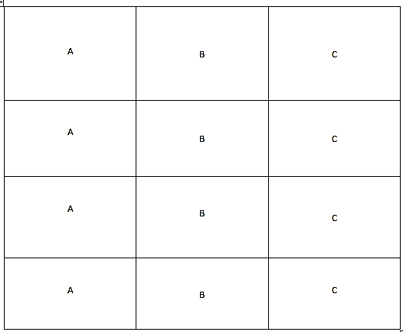
T: True. Let’s play a game! (Hold up Template 2.) These are
the directions:
Template 2 Front
Template 2 Back

- Place the cards facedown.
- Pick one card from each letter, A, B, and C.
- Flip over the cards you chose. Record the game card descriptions in your journal.
- Use the appropriate tools to draw the shape in your math journal. If the shape is not possible, list reasons in your math journal why it is not.
T: Ready? (Draw three cards, and read or project the cards. Is a quadrilateral, has all equal sides, and has at least 1 right angle are the cards used in the example that follows.)
S: This one is easy! I can just draw a square! (Record descriptions, and draw the shape.)
T: At the signal, show your drawing. (Signal. Validate shapes, and repeat the process. The cards has no parallel sides, has more than 4 angles, and is a parallelogram are used in the example that follows.)
S: Wait! I can’t draw this shape! (Note descriptions and reasons in math journals.)
T: Tell your partner why this shape can’t be drawn.
S: Because a parallelogram has to have two sets of parallel sides! It can’t have no parallel sides!
Repeat the process. As students are ready, have them work independently, in pairs, or in small groups to play the game on their
own. Have them play two or three rounds on their own.
Problem Set (10 minutes)
Students should do their personal best to complete the Problem Set within the allotted 10 minutes. For some classes, it may be appropriate to modify the assignment by specifying which problems they work on first. Some problems do not specify a method for solving. Students should solve these problems using the RDW approach used for Application Problems.
Student Debrief (10 minutes)
Lesson Objective: Draw polygons with specified attributes to solve problems.
The Student Debrief is intended to invite reflection and active processing of the total lesson experience.
Invite students to review their solutions for the Problem Set. They should check work by comparing answers with a partner before going over answers as a class. Look for misconceptions or misunderstandings that can be addressed in the Debrief. Guide students in a conversation to debrief the Problem Set and process the lesson.
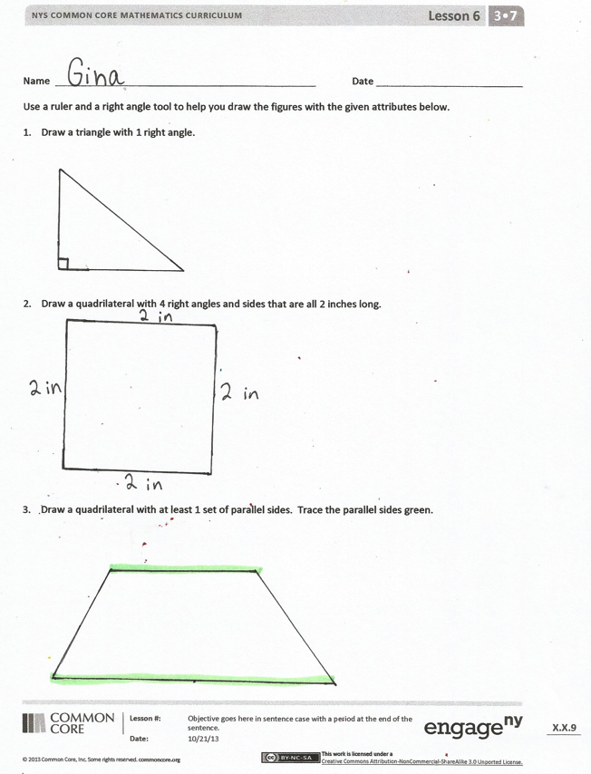
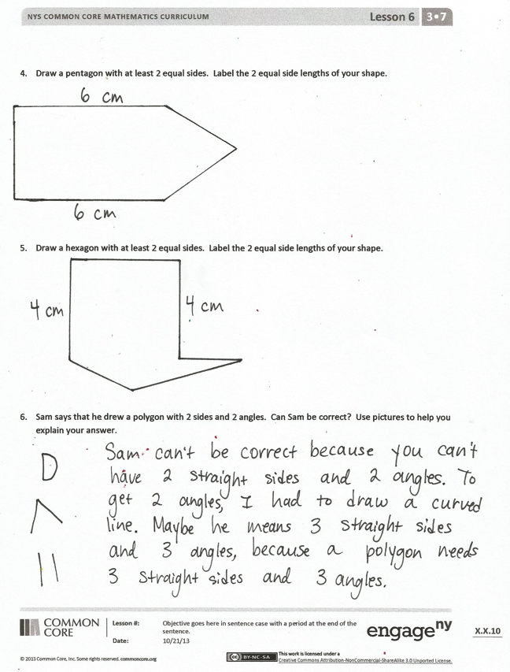
Any combination of the questions below may be used to lead the discussion.

- Besides quadrilateral, what is another name for the shape you drew for Problem 3? (Possible answers are trapezoid, parallelogram, rectangle, square, and rhombus.) How can it be that so many names describe our shape?
- Which shape was most difficult to draw precisely? Why?
- Ask students to share their ideas about Problem 6. How did our work in today’s lesson prepare you to answer that question?
- Invite students to share some of the combinations that they drew or could not draw during the game. Why couldn’t you draw some of the combinations? For which combinations could you draw more than one shape?
- How did today’s Fluency Practice connect to the lesson?
Exit Ticket (3 minutes)
After the Student Debrief, instruct students to complete the Exit Ticket. A review of their work will help with assessing students’ understanding of the concepts that were presented in today’s lesson and planning more effectively for future lessons. The questions may be read aloud to the students.

Name Date
Use a ruler and a right angle tool to help you draw the figures with the attributes given below.
- Draw a triangle with 1 right angle.

- Draw a quadrilateral with 4 right angles and sides that are all 2 inches long.

- Draw a quadrilateral with at least 1 set of parallel sides. Trace the parallel sides green.

- Draw a pentagon with at least 2 equal sides. Label the 2 equal side lengths of your shape.

- Draw a hexagon with at least 2 equal sides. Label the 2 equal side lengths of your shape.

- Sam says that he drew a polygon with 2 sides and 2 angles. Can Sam be correct? Use pictures to help you explain your answer.

Name Date
Use a ruler and a right angle tool to help you draw a shape that matches the attributes of Jeanette’s shape. Label your drawing to explain your thinking.
Jeanette says her shape has 4 right angles and 2 sets of parallel sides. It is not a regular quadrilateral.

Name Date
Use a ruler and a right angle tool to help you draw the figures with the given attributes below.
- Draw a triangle that has no right angles.

- Draw a quadrilateral that has at least 2 right angles.

- Draw a quadrilateral with 2 equal sides. Label the 2 equal side lengths of your shape.

- Draw a hexagon with at least 2 equal sides. Label the 2 equal side lengths of your shape.

- Draw a pentagon with at least 2 equal sides. Label the 2 equal side lengths of your shape.

- Cristina describes her shape. She says it has 3 equal sides that are each 4 centimeters in length. It has no right angles. Do your best to draw Cristina’s shape, and label the side lengths.

has at least 1 angle  greater than  a right angle | is a quadrilateral | has all equal sides  (label side lengths)
has at least 1 angle  less than  a right angle | is a trapezoid | has at least  2 equal sides  (label side lengths)
has at least  1 right angle | is a hexagon | has at least 1 set  of parallel sides
has more than  4 angles | is a parallelogram | has no parallel sides

A | B | C
A | B | C
A | B | C
A | B | C

polygon
game cards
game cards

