Lesson 4
Objective: Compare and classify quadrilaterals.

Suggested Lesson Structure
 Fluency Practice (12 minutes)
 Application Problem (7 minutes)
 Concept Development (31 minutes)
 Student Debrief (10 minutes)
Total Time (60 minutes)
Fluency Practice (12 minutes)
- Multiply by 4 3.OA.7 (8 minutes)
- Equivalent Counting with Units of 5 3.OA.7 (4 minutes)

Multiply by 4 (8 minutes)
Materials: (S) Multiply by 4 (6─10) Pattern Sheet
Note: This activity builds fluency with multiplication facts using units of 4. It works toward students knowing from memory all products of two one-digit numbers. See Lesson 1 for the directions for administration of a Multiply-By Pattern Sheet.
T: (Write 7 × 4 = ____.) Let’s skip-count up by fours. I’ll raise a finger for each four. (Raise a finger for each number to track the count.)
S: 4, 8, 12, 16, 20, 24, 28.
T: Let’s skip-count up by fours starting at 20. Why is 20 a good place to start?
S: It’s a fact we already know, so we can use it to figure out a fact we don’t know.
T: (Track with fingers as students say the numbers.)
S: 20 (5 fingers), 24 (6 fingers), 28 (7 fingers).
T: Let’s see how we can skip-count down to find the answer, too. Start at 40 with 10 fingers, 1 for each four. (Count down with fingers as students say the numbers.)
S: 40 (10 fingers), 36 (9 fingers), 32 (8 fingers), 28 (7 fingers).
Continue with the following possible sequence: 9 × 4, 6 × 4, and 8 × 4.
T: (Distribute the Multiply by 4 Pattern Sheet.) Let’s practice multiplying by 4. Be sure to work left to right across the page.

Equivalent Counting with Units of 5 (4 minutes)
Note: This activity builds fluency with multiplication facts using units of 5. The progression builds in complexity. Work students up to the highest level where they can confidently participate.
T: Count to 10. (Write as students count. See the chart below.)
S: 1, 2, 3, 4, 5, 6, 7, 8, 9, 10.
1 2 3 4 5 6 7 8 9 10
1 five 2 fives 3 fives 4 fives 5 fives 6 fives 7 fives 8 fives 9 fives 10 fives
5 10 15 20 25 30 35 40 45 50
1 five 10 3 fives 20 5 fives 30 7 fives 40 9 fives 50
5 2 fives 15 4 fives 25 6 fives 35 8 fives 45 10 fives
T: (Write 1 five beneath the 1.) Count to 10 fives. (Write as students count.)
S: 1 five, 2 fives, 3 fives, 4 fives, 5 fives, 6 fives, 7 fives, 8 fives, 9 fives, 10 fives.
T: Count by fives to 50. (Write as students count.)
S: 5, 10, 15, 20, 25, 30, 35, 40, 45, 50.
T: (Write 1 five beneath the 5. Write 10 beneath the 10.) I’m going to give you a challenge. Let’s alternate between saying the units of five and the number. (Write as students count.)
S: 1 five, 10, 3 fives, 20, 5 fives, 30, 7 fives, 40, 9 fives, 50.
T: (Write 5 beneath 1 five and 2 fives beneath the 10.) Let’s alternate again. (Write as students count.)
S: 5, 2 fives, 15, 4 fives, 25, 6 fives, 35, 8 fives, 45, 10 fives.
Application Problem (7 minutes)

NOTES ON
MULTIPLE MEANS
OF REPRESENTATION:
Modeling a tape diagram for the money fourth graders raise, as well as the total money raised, helps English language learners and students working below grade level better grasp the meaning of the phrase $68 less than the third graders. Ask, “Who raised less money? Did the fourth graders raise $68? Use the model to estimate about how much the fourth graders raised.”

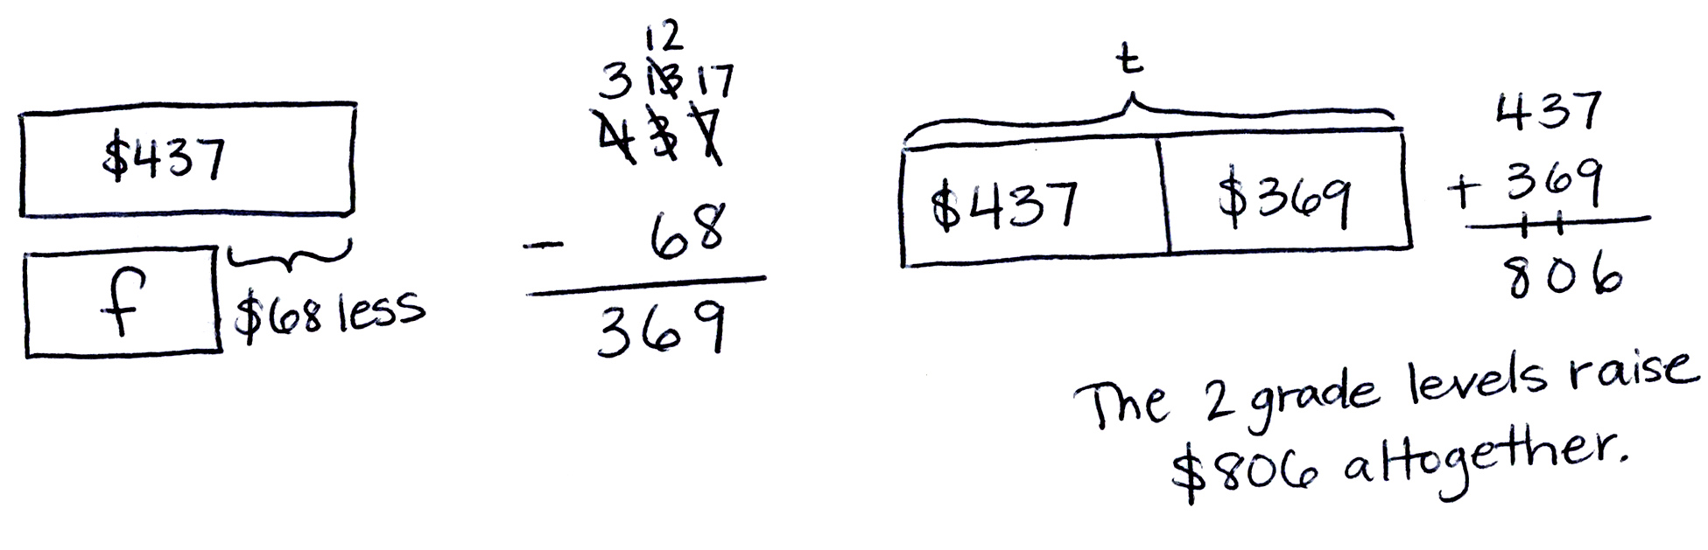
The third graders raised $437 in a fundraiser. The fourth graders raised $68 less than the third graders. How much money did the two grade levels raise altogether?
Note: This problem reviews two-step word problems from
Topic A.
Concept Development (31 minutes)

NOTES ON
VOCABULARY:
All of the bold-type terms in this lesson were introduced in Grade 2 Module 8. However, given the specificity of the words and the time that has passed since students’ work in Grade 2 Module 8, it may be best to approach teaching the vocabulary as if it were new.
Materials: (T) 2 rulers (S) Index card for use as right angle tool, polygons (A–L) (Template), ruler, Problem Set, scissors
Part 1: Group polygons by attributes.
Pass out the index cards and Template.
T: We’ll use these cards as tools. Put a finger on each corner.
S: (Touch each corner.)
T: Remember from second grade that we call the point where sides meet to make a corner an angle. These are right angles because they have square corners. We’ll use our cards as right angle tools to help us find other shapes that have right angles. (Save the right angle tools for the entire module.)

NOTES ON
MULTIPLE MEANS
OF REPRESENTATION:
Clarify for English language learners and others the term group. In past modules, they have grouped like units, such as 10 tens to make 100 or 3 fives to make 15. Here, grouping does not mean bundling units that are exactly the same but rather sorting polygons by one or more shared attribute.

T: Now, cut out shapes A–L on your template.
S: (Cut.)
T: Look at your shapes. Discuss with a partner: What are some different ways we can group these shapes together?
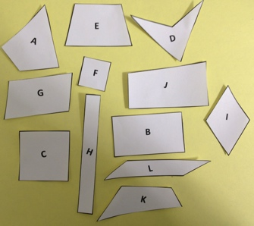
S: We can group them by name, like all the squares together. We can group them by the number of sides. We can also group them by the number of angles.
4-sided:
T: Remember from second grade that closed shapes like these that have no gaps or overlaps between the straight sides are called polygons. Polygons with four straight sides are called quadrilaterals. Tell your partner what a quadrilateral is, and then find and group the quadrilaterals.
S: A quadrilateral is a polygon with four sides. (Group the quadrilaterals.)
T: What do you notice about the polygons you grouped?
S: They don’t look the same. Some are slanted, and some are boxy. Some are squares and rectangles, but others are strange looking. One polygon even looks like a boomerang. They have four angles.
T: The polygons look different, but they share the attributes of having four sides and four angles. Complete the first row of the chart on the Problem Set. Make sure to sketch one polygon from the group.

T: Next, we’ll find and group trapezoids. These are quadrilaterals that have at least one set of parallel sides. Think of parallel sides like the two side lines of a capital H, or a slanted H, since not all parallel sides stand vertical. (Demonstrate using two rulers.) Imagine these two lines go on forever. Do you think they will ever cross? Why or why not?

NOTES ON
TRAPEZOIDS:
According to the K–6 Geometry Progressions, the term trapezoid can have two different meanings:
- Exclusive Definition: A trapezoid is a quadrilateral with exactly one pair of parallel sides.
- Inclusive Definition: A trapezoid is a quadrilateral with at least one pair of parallel sides.
A Story of Units uses the inclusive definition. Therefore, a parallelogram is also considered a trapezoid.

S: I don’t think they will cross. No, they won’t cross because they’re straight and going in the same direction all the time.
T: (Slant the rulers so they are not parallel anymore but are still not touching.) These lines are not touching. Are they parallel? Why or why not?
S: No. The sides don’t look like an H anymore. If we imagine the lines keep going, they will eventually cross!
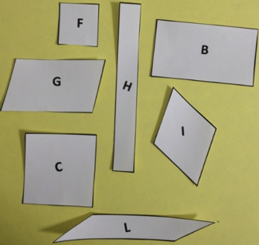
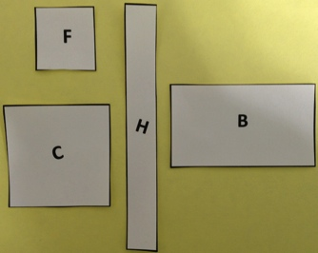
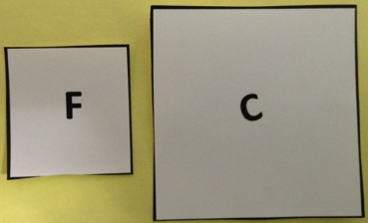
T: If trapezoids must have at least one set of parallel sides, can they have more than one set?
2 parallel sides:
4 right angles:
Squares:
S: Yeah. At least means one or more.
T: Group the trapezoids. Complete the second row of the chart on the Problem Set. Make sure to sketch one polygon from the group.
S: (Group all shapes, except A, D, and K, and sketch one shape.)
T: What do you notice about the polygons you grouped?
S: I found a bunch! No. There’s only one shape that has only one set of parallel sides. Polygon E! Remember, though, a trapezoid has at least one set! That’s almost all of them!
T: Now we’ll find and group parallelograms. These are four-sided polygons that have two sets of parallel sides.
T: Group the parallelograms. Then, complete the next row of the chart on your Problem Set.
S: (Group the polygons, and complete the chart.)
T: Now, use your right angle tool to measure and group all the polygons that have four right angles. Then, complete the chart.
S: (Measure, group, and complete the chart.)
T: Next, find and group all the squares. Which attributes make squares special?
S: They have four equal sides and four right angles.
T: Use your ruler and right angle tool to confirm that with these polygons. Then, complete the chart.
S: (Measure, group, and complete the chart.)
Part 2: Analyze quadrilaterals.
T: In our set of polygons A–L, did the number of polygons get smaller or larger as we added attributes?
S: It got smaller.
T: Discuss with your partner why you think the number of polygons in each group got smaller as we added attributes.
S: I think it’s because the attributes in our chart become more special. The last category only includes the most special polygon, a square, because it has to have four right angles and four equal sides.
Each time we added a new attribute, fewer polygons belonged to the group.
T: As the attributes become more specific, fewer shapes in our set share all of the attributes. Look at Polygons C and F. They are included in every group. Why do you think that is?
S: They have four sides, two sets of parallel lines, and four right angles.
MP.3
T: Why aren’t Polygons B and H included in the last category? These specific rectangles have four sides, two sets of parallel lines, and four right angles.
S: Polygons B and H don’t have all equal sides.
T: Look at Polygon I. It has four equal sides and two sets of parallel lines. Why isn’t it included in the last category?
S: It doesn’t have four right angles. It needs to have them all, not just one attribute.
T: Let’s make a new category, one that has shapes with 4 equal sides. Work with your partner.
T: (Move Polygons C, F, and I to form a new group.) A shape with 4 equal sides is called a rhombus.
T: Why is a square a rhombus?
S: Because it has 4 equal sides!
T: Why isn’t shape I a square?
S: Because it doesn’t have right angles!
Part 3: Decompose quadrilaterals into two triangles.
T: Problem 4 asks you to use a straightedge to draw a line between opposite corners in each quadrilateral you drew in the chart. This kind of line is called a diagonal line. Do that now.
S: (Draw diagonals in each polygon.)
T: Which new polygons did you make by drawing the diagonal line?
S: Triangles.
T: Complete Problem 4 on your Problem Set.
T: Pick other polygons we used that you did not draw on your chart. Draw diagonal lines inside the polygons. Do you still get two triangles? (Allow time for students to draw.)
S: Yes!
T: All quadrilaterals are made up of two triangles.
Students should now go back and finish Problems 2 and 3 on the Problem Set.

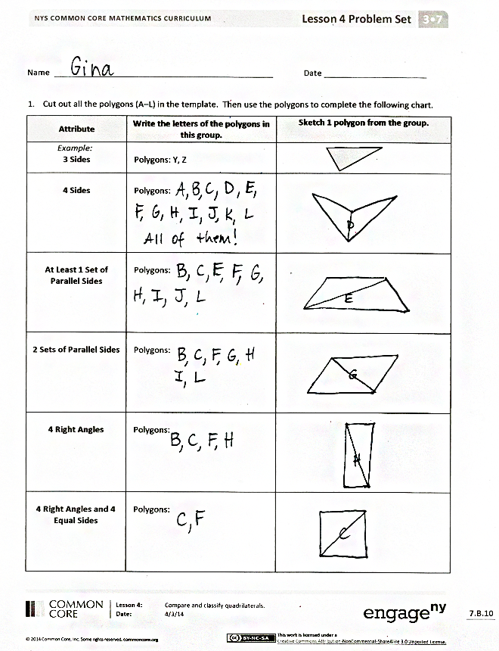
Student Debrief (10 minutes)
Lesson Objective: Compare and classify quadrilaterals.
The Student Debrief is intended to invite reflection and active processing of the total lesson experience.
Invite students to review their solutions for the Problem Set. They should check work by comparing answers with a partner before going over answers as a class. Look for misconceptions or misunderstandings that can be addressed in the Debrief. Guide students in a conversation to debrief the Problem Set and process the lesson.
Any combination of the questions below may be used to lead the discussion.
- How does grouping quadrilaterals by attributes, like you did in Problem 1, help us see the similarities and differences between the polygons?
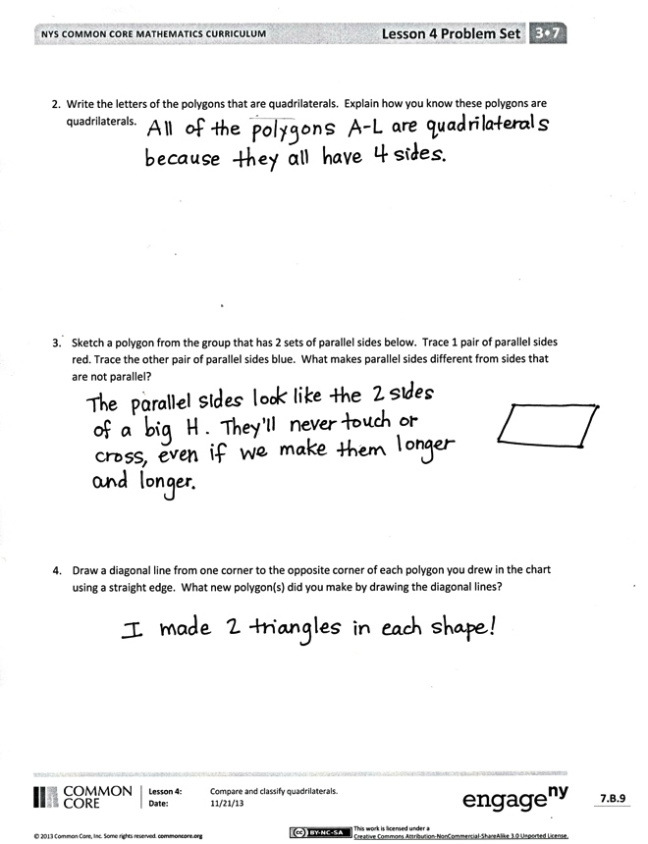
- Share sketches of parallelograms from Problem 3. Have students describe parallel lines through their color-coded tracing.
- For Problem 4, share drawings of different quadrilaterals to reinforce how every quadrilateral can be decomposed into two triangles.
- What math vocabulary did we use today to name polygons with four sides? (Quadrilateral.) At least one set of parallel sides? (Trapezoid.) Two sets of parallel sides? (Parallelogram.) A shape with 4 equal sides? (Rhombus.) An angle that makes square corners? (Right angle.) The line between opposite corners in each quadrilateral? (Diagonal.)
Exit Ticket (3 minutes)
After the Student Debrief, instruct students to complete the Exit Ticket. A review of their work will help with assessing students’ understanding of the concepts that were presented in today’s lesson and planning more effectively for future lessons. The questions may be read aloud to the students.
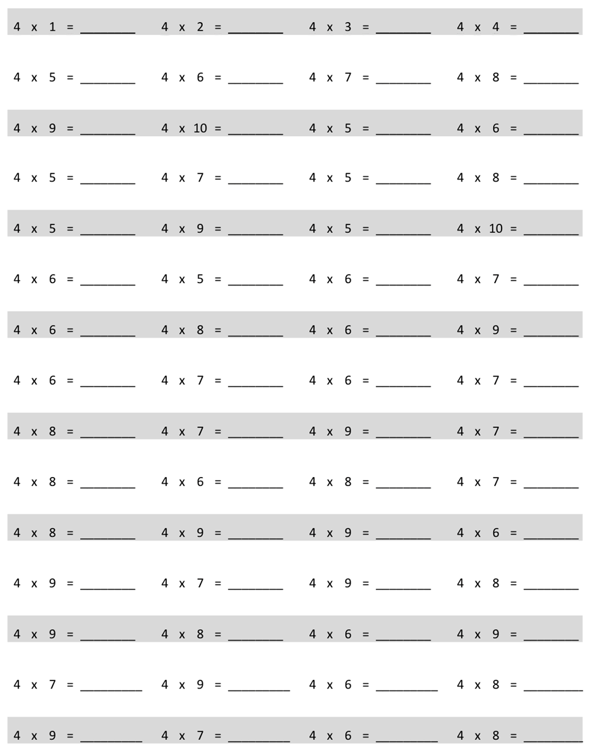
Multiply.

Name Date
- Cut out all the polygons (A–L) in the Template. Then, use the polygons to complete the following chart.
Attribute | Write the letters of the polygons in this group. | Sketch 1 polygon from the group.
Example:  3 Sides | Polygons: Y, Z
4 Sides | Polygons:
At Least 1 Set of Parallel Sides | Polygons:
2 Sets of Parallel Sides | Polygons:
4 Right Angles | Polygons:
4 Right Angles and  4 Equal Sides | Polygons:
- Write the letters of the polygons that are quadrilaterals. Explain how you know these polygons are quadrilaterals.

- Sketch a polygon below from the group that has 2 sets of parallel sides. Trace 1 pair of parallel sides red. Trace the other pair of parallel sides blue. What makes parallel sides different from sides that are not parallel?

- Draw a diagonal line from one corner to the opposite corner of each polygon you drew in the chart using a straightedge. What new polygon(s) did you make by drawing the diagonal lines?

Name Date
List as many attributes as you can to describe each polygon below.
M

N

Name Date
- Complete the chart by answering true or false.
Attribute | Polygon | True or False
Example:  3 Sides |  | True
4 Sides

2 Sets of Parallel Sides

4 Right Angles

Quadrilateral

- a. Each quadrilateral below has at least 1 set of parallel sides. Trace each set of parallel sides with a colored pencil.

- Using a straightedge, sketch a different quadrilateral with at least 1 set of parallel sides.

A
B
C
E
F
G
H
I
D
K
J

L

multiply by 4 (6─10)
polygons (A─L)

