Lesson 30
Objective: Partition various wholes precisely into equal parts using a number line method.

Suggested Lesson Structure
 Fluency Practice (12 minutes)
 Concept Development (40 minutes)
 Student Debrief (8 minutes)
Total Time (60 minutes)
Fluency Practice (12 minutes)
- Multiply by 9 3.OA.4 (8 minutes)
- Compare Fractions with the Same Numerator 3.NF.3d (4 minutes)
Multiply by 9 (8 minutes)
Materials: (S) Multiply by 9 (1─5) Pattern Sheet
Note: This Pattern Sheet supports fluency with multiplication using units of 9.
T: Skip-count by nines. (Write multiples horizontally as students count.)
S: 9, 18, 27, 36, 45, 54, 63, 72, 81, 90.
T: (Write 5 × 9 = _____.) Let’s skip-count by nines to find the answer. (Count with fingers to 5 as students count.)
S: 9, 18, 27, 36, 45.
T: (Circle 45, and write 5 × 9 = 45 above it. Write 4 × 9 = _____.) Skip-count by nines. (Count with fingers to 4 as students count.)
S: 9, 18, 27, 36.
T: Let’s arrive at the answer by skip-counting down, starting at 45. (Hold up 5 fingers as students say 45, and take away 1 finger as students count.)
S: 45, 36.
T: (Write 7 × 9 = _____.) Skip-count by nines. (Count with fingers to 7 as students count.)
S: 9, 18, 27, 36, 45, 54, 63.
T: Let’s skip-count, starting at 45. (Hold up 5 fingers as students say 45, and count up with fingers as students count.)
S: 45, 54, 63.
T: (Write 9 × 9 = _____.) Skip-count by nines. (Count with fingers to 9 as students count.)
S: 9, 18, 27, 36, 45, 54, 63, 72, 81.
T: Let’s skip-count down starting at 90. (Hold up 10 fingers as students say 90 and remove 1 finger as students count.)
S: 90, 81.
T: Let’s practice multiplying by 9. Be sure to work left to right across the page. (Distribute
Multiply by 9 Pattern Sheet.)
Compare Fractions with the Same Numerator (4 minutes)
Materials: (S) Personal white board
Note: This fluency activity reviews the concept of pictorially comparing fractions with the same numerators from Lessons 28 and 29.

NOTES ON
MULTIPLE MEANS
OF ACTION AND EXPRESSION:
Students working below grade level may benefit from naming the fractional unit (e.g., eighths) before naming the shaded fraction. Solidify understanding of greater than and less than symbols by soliciting a simultaneous oral response (e.g., “3 fourths is greater than 3 eighths”)
Provide sentence frames for English language learners, such as “___ is greater than ___.”

T: (Project a figure showing 3 fourths shaded.) Say the fraction of the figure that is shaded.
S: 3 fourths.
T: (Write $\frac{3}{4}$ directly below the figure. To the right of the first figure, project one that is the same size and shape that is 3 eighths shaded.) Say the fraction of the figure that is shaded.
S: 3 eighths.
T: (Write $\frac{3}{8}$ directly below the second figure.) On your personal white board, write each fraction. Between the fractions, use the greater than or less than symbol (write > and <) to show which fraction is larger.
S: (Write $\frac{3}{4}$ > $\frac{3}{8}$.)
Continue with the following possible sequence: $\frac{5}{10}$ and $\frac{5}{8}$,
$\frac{2}{5}$ and $\frac{2}{3}$, and $\frac{4}{5}$ and $\frac{4}{6}$.

NOTES ON
MATERIALS:
It is highly recommended to try the activity with the prepared materials before presenting it to students. Even small variations in the width of spaces on wide-ruled notebook paper or in the 9-inch × 1-inch paper strips may result in adjusting the directions slightly to obtain the desired result.

Concept Development (40 minutes)
Materials: (S) 9-inch × 1-inch strips of red construction paper (at least 5 per student), lined paper (Template) or wide-ruled notebook paper (several pieces per student), 12-inch ruler
Note: Please read the directions for the Exit Ticket before beginning.
T: Think back on our lessons. Talk to your partner about how to partition a number line into thirds.
S: Draw the line, and then estimate 3 equal parts. Use your folded fraction strip to measure. Measure a 3-inch line with a ruler, and then mark off each inch. Or on a 6-inch line, 1 mark would be at each 2 inches. Don’t forget to mark 0. Yes, you always have to start measuring from 0.
T: Let’s explore a method to mark off any fractional unit precisely without the use of a ruler, just with lined paper.
MP.6
Step 1: Draw a number line and mark the 0 endpoint.
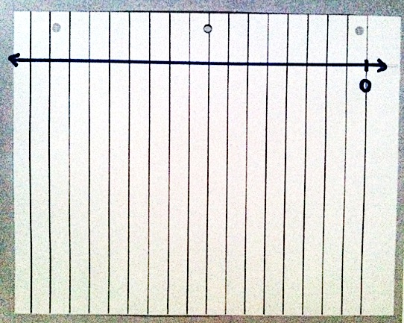
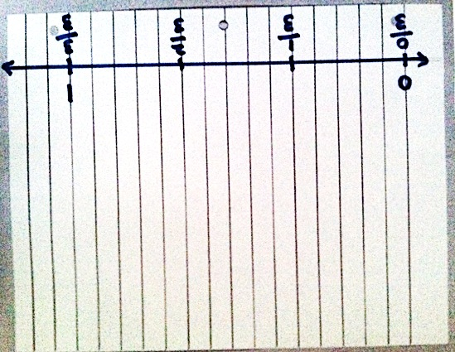
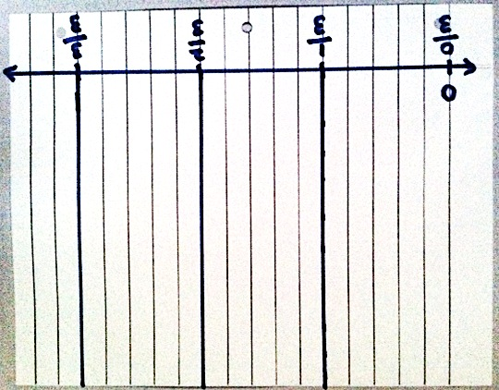
T: (Give students the lined paper or notebook paper.) Turn your paper so the margin is horizontal. Draw a number line on top of the margin.
T: Mark 0 on the point where I did. (Demonstrate.) Talk to your partner: How can we equally and precisely partition this number line into thirds?
S: We can use the vertical lines. Each line can be an equal part.
We can count 2 lines for each third. Or 3 spaces or 4 to make an equal part, just so long as each part has the same number.
Oh, I see; this is the answer. But the teacher said any piece of paper. If we make thirds on this paper, it won’t help us make thirds on every paper.
Step 2: Measure equal units using the paper’s lines.
T: Use the paper’s vertical lines to measure. Let’s make each part 5 spaces long. Label the number line from 0 to 1 using 5 spaces for each third. Discuss in pairs how you know these are precise thirds.
Step 3: Extend the equal parts to the top of the notebook paper with a line.
T: Draw vertical lines up from your number line to the top of the paper at each third. (Hold up 1 red strip of paper.) Talk to your partner about how we might use these lines to partition this red strip into thirds.
S: (Discuss.)
T: (Pass out 1 red strip to each student.) The challenge is to partition the red strip precisely into thirds. Let the left end of the strip be 0. The right end of the strip is 1.
S: The strip is too long. We can’t cut it? No. The teacher said no. How can we do this? (Circulate and listen, but don’t give an answer.)

Step 4: Angle the red strip so that the left end touches the 0 endpoint on the original number line. The right end touches the line at 1.
MP.6
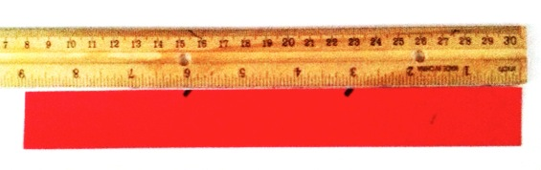
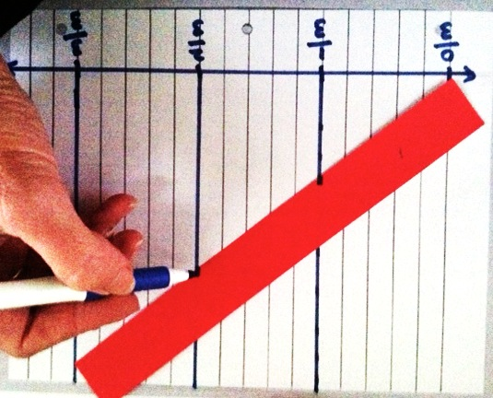
Step 5: Mark off equal units, which are indicated by the vertical extensions of the points on the original number line.
T: Do your units look equal?
S: I’m not sure. They look equal. I think they’re equal because we used the spaces on the paper to make equal units of thirds.
T: Verify that they are equal with your ruler. Measure the full length of the red strip in inches. Measure the equal parts.
S: (Measure.)
T: I made this strip 9 inches long just so you could verify that our method partitions precisely.
Have students think about why this method works. Have them review the process step by step.
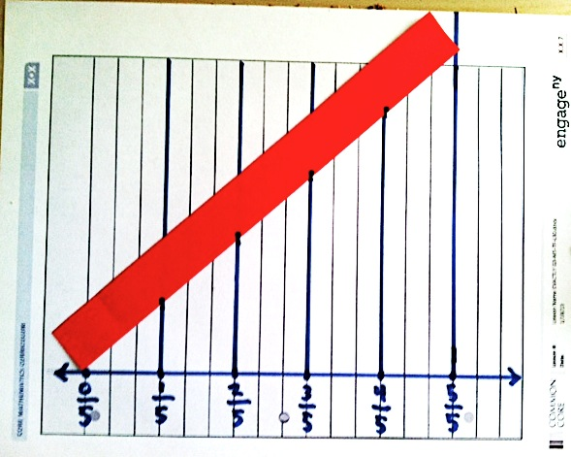
Problem Set (10 minutes)
There is no Problem Set sheet for this lesson. In cooperative groups, challenge students to use the same process to precisely mark off other red strips into halves, fourths, etc. It is particularly exciting to partition fifths, sevenths, ninths, and tenths since those are so challenging to fold.
Student Debrief (8 minutes)
Lesson Objective: Partition various wholes precisely into equal parts using a number line method.
The Student Debrief is intended to invite reflection and active processing of the total lesson experience.
Look for misconceptions or misunderstandings that can be addressed in the Student Debrief.
Any combination of the questions below may be used to lead the discussion.
- (Possibly present a meter strip.) Could we use this method to partition strips of any length? Talk to your partner about how we could partition this longer strip. Model partitioning the meter strip by using the same method. Simply tape additional lined papers above the lined paper with the thirds. This allows you to make a sharper angle with the meter strip.
- This long strip (the meter strip), shorter strip (the red strip), and number line (the one at the base of the paper) were all partitioned during our work. What is the same and different about them?
- Why do you think this method works? Why are the fractional units still equal when we angle the paper? Do you need to measure to check that they are?
- How might having this skill be helpful in your lives or math class?

- Explain to students that this lesson will be very important in their high school mathematics. Also explain that a mathematician invented it to prepare them for success later in their math journey.
Exit Ticket
There is no Exit Ticket sheet for this lesson. Instead, assess students by circulating and taking notes. Consider the following:
- Is the student able to generalize the method to partition into other fractional units?
- The quality of the new efforts and what mistakes a student made either conceptually (not understanding the angling of the strip) or at a skill level (such as not using the paper’s lines properly to partition equal units).
- The role students take within cooperative groups for the Problem Set. Which students articulate directions? Explanations? Which students execute well but silently?

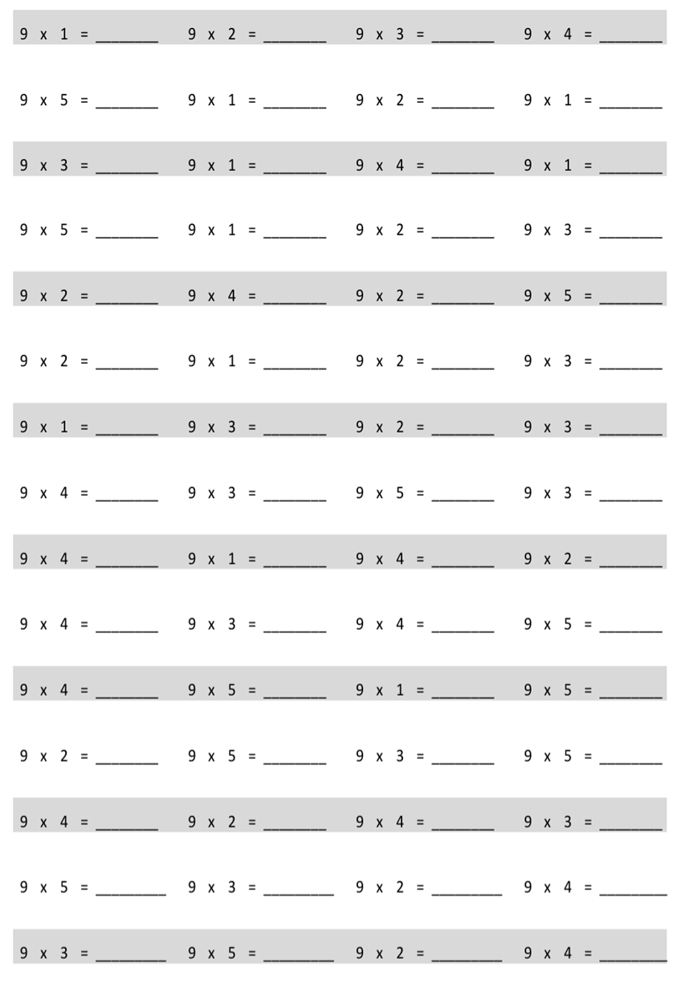
Multiply.

Name Date
Describe step by step the experience you had of partitioning a length into equal units by simply using a piece of notebook paper and a straight edge. Illustrate the process.

multiply by 9 (1–5)
lined paper

