Lesson 27
Objective: Explain equivalence by manipulating units and reasoning about their size.

Suggested Lesson Structure
 Fluency Practice (12 minutes)
 Application Problem (8 minutes)
 Concept Development (30 minutes)
 Student Debrief (10 minutes)
Total Time (60 minutes)
Fluency Practice (12 minutes)
- Sprint: Subtract by Seven 2.NBT.5 (8 minutes)
- Recognize the Fraction 3.G.2 (4 minutes)
Sprint: Subtract by Seven (8 minutes)
Materials: (S) Subtract by Seven Sprint
Note: This Sprint supports fluency with subtraction by 7.
Recognize the Fraction (4 minutes)
Materials: (S) Personal white board
Note: This activity reviews the concept of naming various fractions, depending on the designation of the whole.

NOTES ON
MULTIPLE MEANS
OF REPRESENTATION:
Have English language learners practice Recognize the Fraction orally to practice speaking math language in English with the support of a model.

T: (Project or draw a shaded rectangular model.) This equals 1 whole. (Project or draw 1 whole partitioned into 3 equal shaded units.) On your personal white board, write the fraction.
S: (Write $\frac{3}{3}$.)
T: (Project or draw 2 wholes, each partitioned into 3 equal shaded units.) On your board, write the fraction.
S: (Write $\frac{6}{3}$.)
T: (Project or draw 3 wholes, each partitioned into 3 shaded parts.) On your board, write the fraction.
S: (Write $\frac{9}{3}$.)
T: (Project or draw 3 wholes, each partitioned into 3 parts. 3 parts in the first 2 wholes are shaded.
1 part of the third whole is shaded.) On your board, write the fraction.
S: (Write $\frac{7}{3}$.)
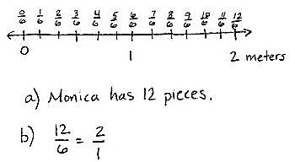
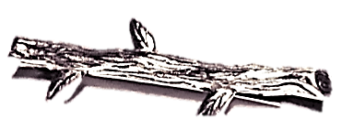
Continue with the following possible sequence: $\frac{4}{4}$, $\frac{8}{4}$, $\frac{12}{4}$, $\frac{9}{4}$, $\frac{6}{5}$, and $\frac{9}{8}$.
Application Problem (8 minutes)
The branch of a tree is 2 meters long. Monica chops the branch for firewood. She cuts pieces that are $\frac{1}{6}$ meter long. Draw a number line to show the total length of the branch. Partition and label each of Monica’s cuts.
- How many pieces does Monica have altogether?
- Write 2 equivalent fractions to describe the total length of Monica’s branch.

NOTES ON
MULTIPLE MEANS
OF ENGAGEMENT:
For English language learners, demonstrate that words can have multiple meanings. Here, cut means to draw a line (or lines) that divides the unit into smaller equal parts.
Students working below grade level may benefit from revisiting the discussion of doubling, tripling, halving, and cutting unit fractions as presented in Lesson 22.

Note: This problem reviews partitioning wholes on the number line, labeling fractions on a number line, and naming equivalent fractions.
Concept Development (30 minutes)
Materials: (S) 3 wholes (Lesson 25 Template 1), personal white board, fraction strips (3 per student), math journal
Pass out 3 wholes, and have students slip it into their personal white boards.
T: Each rectangle represents 1 whole. Estimate to partition each rectangle into thirds.
3 wholes (Lesson 25 Template 1)
S: (Partition.)
T: How can we double the number of units in the second rectangle?
S: We cut each third in 2.
T: Go ahead and partition.
S: (Partition.)
T: What’s our new unit?
S: Sixths!
Repeat this process for the third rectangle. Instead of having students double, have them triple the original thirds.
T: Label the fractions in each model.
MP.3
S: (Label.)
T: What is different about these models?
S: They all started as thirds, but then we cut them into different parts. The parts are different sizes. Yes, they’re different units.
T: What is the same about these models?
S: The whole.
T: Talk to your partner about the relationship between the number of parts and the size of parts in each model.
S: 3 is the smallest number, but thirds have the biggest size. As I drew more lines to partition, the size of the parts got smaller. That’s because the whole is cut into more pieces when there are ninths than when there are thirds.
T: (Give each student 3 fraction strips.) Fold all 3 fraction strips into halves.
S: (Fold.)
T: Fold your second and third fraction strips to double the number of units.
S: (Fold.)
T: What’s the new unit on these fraction strips?
S: Fourths!
T: Fold your third fraction strip to double the number of units again.
S: (Fold.)
T: What’s the new unit on your third fraction strip?
S: Eighths!
T: Compare the number of parts and the size of the parts with the number of times you folded the strip. What happens to the size of the parts when you fold the strip more times?
S: The more I folded, the smaller the parts got. Yeah, that’s because you folded the whole to make more units.
T: Open your math journal to a new page, and glue your strips in a column, making sure the ends line up. Glue them from the largest unit to the smallest.
S: (Glue.)
T: Use your fraction strips to find the fractions equivalent to $\frac{4}{8}$. Shade them.
S: (Shade $\frac{4}{8},\frac{2}{4},$ and $\frac{1}{2}$.)
T: Talk with your partner: What do you notice about the size of parts and number of parts in equivalent fractions?
S: You can see that there are more eighths than halves or fourths shaded to cover the same amount of the strip. It’s the same as before then. As the number of parts gets larger, the size of them gets smaller. That’s because the shaded area in equivalent fractions doesn’t change, even though the number of parts gets larger.
If necessary, reinforce the concept with other examples using these fraction strips.
Image 1
T: (Show Image 1.) Let’s practice this idea a bit more on our personal white boards. Draw my shape on your board. The entire figure represents 1 whole.
S: (Draw.)
T: Write the shaded fraction.
S: (Write $\frac{1}{4}$.)
T: Talk to your partner: How can you partition this shape to make an equivalent fraction with smaller units?
S: We can cut each small rectangle in 2 pieces from top to bottom to make eighths. Or we can make 2 horizontal cuts to make twelfths.
T: Use one of these strategies now. (Circulate as students work to select a few different examples to share with the class.)
S: (Partition.)
T: Let’s look at our classmates’ work. (Show examples of $\frac{2}{8},\frac{3}{12},\frac{4}{16},$ etc.) As we partitioned with more parts, what happens to the shaded area and number of parts needed to make them equivalent?
S: The size of the parts gets smaller, but the number of them gets larger.
T: Even though the parts changed, did the area covered by the shaded region change?
S: No.
Consider having students practice independently. The shape to the right is more challenging because triangles are more difficult to make into equal parts.
Problem Set (10 minutes)

NOTES ON
MULTIPLE MEANS
OF ENGAGEMENT:
Extend Problem 5 on the Problem Set for students working above grade level. Instead of doubling, have students triple or quadruple. Let students choose the fractional unit into which the rectangle is partitioned.

Students should do their personal best to complete the Problem Set within the allotted 10 minutes. For some classes, it may be appropriate to modify the assignment by specifying which problems they work on first. Some problems do not specify a method for solving. Students should solve these problems using the RDW approach used for Application Problems.

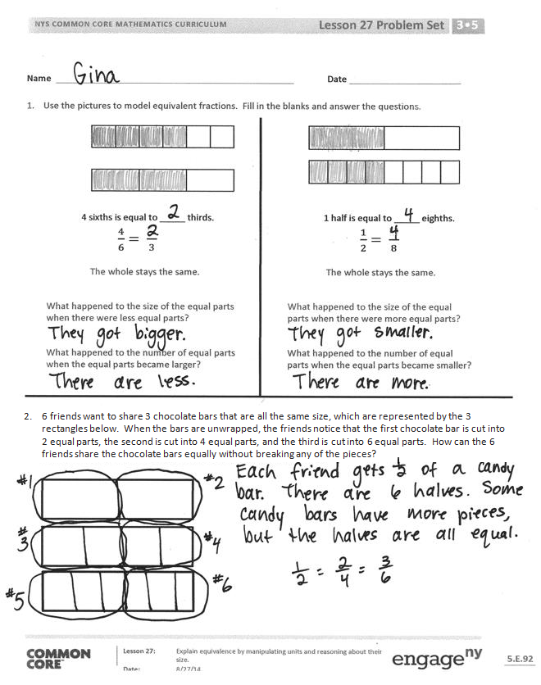
Student Debrief (10 minutes)
Lesson Objective: Explain equivalence by manipulating units and reasoning about their size.
The Student Debrief is intended to invite reflection and active processing of the total lesson experience.
Invite students to review their solutions for the Problem Set. They should check work by comparing answers with a partner before going over answers as a class. Look for misconceptions or misunderstandings that can be addressed in the Student Debrief. Guide students in a conversation to debrief the Problem Set and process the lesson.
Any combination of the questions below may be used to lead the discussion.
- How did using the fraction strips help you with Problem 2? Talk about the relationship between them.
- What was your strategy for Problems 3 and 4? How did it change or stay the same?
- Why is it important that the magic wand in Problem 5 keeps the whole the same?
- How does the magic wand in Problem 5 make it easy to create equivalent fractions?
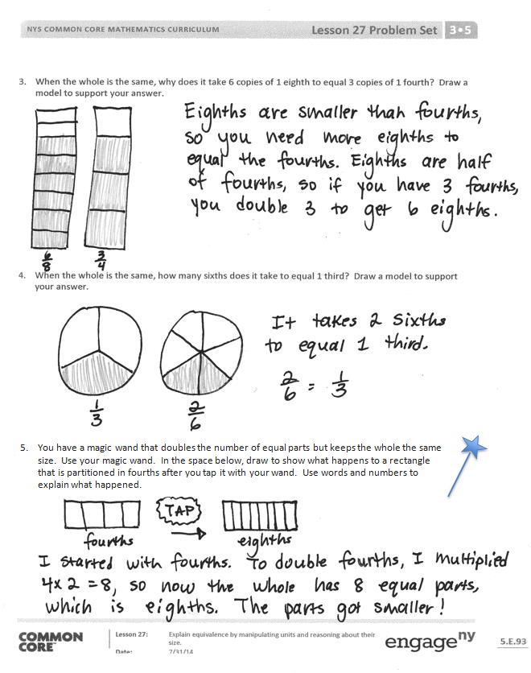
Exit Ticket (3 minutes)
After the Student Debrief, instruct students to complete the Exit Ticket. A review of their work will help with assessing students’ understanding of the concepts that were presented in today’s lesson and planning more effectively for future lessons. The questions may be read aloud to the students.

Number Correct:
A
Subtract by Seven
 | 17 – 7 = |  |  |  | 24 – 7 =
 | 7 – 7 = |  |  |  | 34 – 7 =
 | 27 – 7 = |  |  |  | 64 – 7 =
 | 8 – 7 = |  |  |  | 84 – 7 =
 | 18 – 7 = |  |  |  | 15 – 7 =
 | 38 – 7 = |  |  |  | 25 – 7 =
 | 9 – 7 = |  |  |  | 35 – 7 =
 | 19 – 7 = |  |  |  | 75 – 7 =
 | 49 – 7 = |  |  |  | 55 – 7 =
 | 10 – 7 = |  |  |  | 16 – 7 =
 | 20 – 7 = |  |  |  | 26 – 7 =
 | 60 – 7 = |  |  |  | 36 – 7 =
 | 11 – 7 = |  |  |  | 86 – 7 =
 | 21 – 7 = |  |  |  | 66 – 7 =
 | 71 – 7 = |  |  |  | 90 – 7 =
 | 12 – 7 = |  |  |  | 53 – 7 =
 | 22 – 7 = |  |  |  | 42 – 7 =
 | 82 – 7 = |  |  |  | 71 – 7 =
 | 13 – 7 = |  |  |  | 74 – 7 =
 | 23 – 7 = |  |  |  | 56 – 7 =
 | 83 – 7 = |  |  |  | 95 – 7 =
 | 14 – 7 = |  |  |  | 92 – 7 =
B
[KEY]

Number Correct: _______
Improvement: _______
Subtract by Seven
 | 7 – 7 = |  |  |  | 24 – 7 =
 | 17 – 7 = |  |  |  | 34 – 7 =
 | 27 – 7 = |  |  |  | 54 – 7 =
 | 8 – 7 = |  |  |  | 74 – 7 =
 | 18 – 7 = |  |  |  | 15 – 7 =
 | 68 – 7 = |  |  |  | 25 – 7 =
 | 9 – 7 = |  |  |  | 35 – 7 =
 | 19 – 7 = |  |  |  | 65 – 7 =
 | 79 – 7 = |  |  |  | 45 – 7 =
 | 10 – 7 = |  |  |  | 16 – 7 =
 | 20 – 7 = |  |  |  | 26 – 7 =
 | 90 – 7 = |  |  |  | 36 – 7 =
 | 11 – 7 = |  |  |  | 76 – 7 =
 | 21 – 7 = |  |  |  | 56 – 7 =
 | 91 – 7 = |  |  |  | 70 – 7 =
 | 12 – 7 = |  |  |  | 63 – 7 =
 | 22 – 7 = |  |  |  | 52 – 7 =
 | 42 – 7 = |  |  |  | 81 – 7 =
 | 13 – 7 = |  |  |  | 74 – 7 =
 | 23 – 7 = |  |  |  | 66 – 7 =
 | 43 – 7 = |  |  |  | 85 – 7 =
 | 14 – 7 = |  |  |  | 52 – 7 =

Name Date
- Use the pictures to model equivalent fractions. Fill in the blanks, and answer the questions.
4 sixths is equal to _____ thirds.
$\frac{4}{6}= \frac{}{3}$

1 half is equal to _____ eighths.
$\frac{1}{2}= \frac{}{8}$

The whole stays the same.

What happened to the size of the equal parts when there were fewer equal parts?

What happened to the number of equal parts when the equal parts became larger?

The whole stays the same.

What happened to the size of the equal parts when there were more equal parts?

What happened to the number of equal parts when the equal parts became smaller?

- 6 friends want to share 3 chocolate bars that are all the same size, which are represented by the 3 rectangles below. When the bars are unwrapped, the friends notice that the first chocolate bar is cut into 2 equal parts, the second is cut into 4 equal parts, and the third is cut into 6 equal parts. How can the 6 friends share the chocolate bars equally without breaking any of the pieces?

- When the whole is the same, why does it take 6 copies of 1 eighth to equal 3 copies of 1 fourth? Draw a model to support your answer.

- When the whole is the same, how many sixths does it take to equal 1 third? Draw a model to support your answer.

- You have a magic wand that doubles the number of equal parts but keeps the whole the same size. Use your magic wand. In the space below, draw to show what happens to a rectangle that is partitioned in fourths after you tap it with your wand. Use words and numbers to explain what happened.

Name Date
- Solve.
2 thirds is equal to _____ twelfths.

$\frac{2}{3}= \frac{}{12}$

- Draw and label two models that show fractions equivalent to those in Problem 1.

- Use words to explain why the two fractions in Problem 1 are equal.

Name Date
- Use the pictures to model equivalent fractions. Fill in the blanks, and answer the questions.

1 third is equal to _____ ninths.
$\frac{1}{3}= \frac{}{9}$

2 tenths is equal to _____ fifths.
$\frac{2}{10}= \frac{}{5}$

The whole stays the same.

What happened to the size of the equal parts when there were more equal parts?

What happened to the number of equal parts when the equal parts became smaller?

The whole stays the same.

What happened to the size of the equal parts when there were fewer equal parts?

What happened to the number of equal parts when the equal parts became larger?

- 8 students share 2 pizzas that are the same size, which are represented by the 2 circles below. They notice that the first pizza is cut into 4 equal slices, and the second is cut into 8 equal slices. How can the 8 students share the pizzas equally without cutting any of the pieces?

- When the whole is the same, why does it take 4 copies of 1 tenth to equal 2 copies of 1 fifth? Draw a model to support your answer.

- When the whole is the same, how many eighths does it take to equal 1 fourth? Draw a model to support your answer.

- Mr. Pham cuts a cake into 8 equal slices. Then, he cuts every slice in half. How many of the smaller slices does he have? Use words and numbers to explain your answer.

