Lesson 26
Objective: Decompose whole number fractions greater than 1 using whole number equivalence with various models.

Suggested Lesson Structure
 Fluency Practice (14 minutes)
 Application Problem (6 minutes)
 Concept Development (30 minutes)
 Student Debrief (10 minutes)
Total Time (60 minutes)
Fluency Practice (14 minutes)
- Sprint: Add by Eight 2.NBT.5 (8 minutes)
- Write Equal Fractions 3.NF.3d (6 minutes)
Sprint: Add by Eight (8 minutes)
Materials: (S) Add by Eight Sprint
Note: This Sprint supports fluency with addition by 8.
Write Equal Fractions (6 minutes)
Materials: (S) Personal white board
Note: This activity reviews the skill of finding equivalent fractions with pictorial models from Lesson 20.
T: (Project $\frac{1}{2}$.) Say the fraction.
S: 1 half.
T: Draw a shape, shade 1 half, and write the fraction below it.
S: (Draw a shape partitioned into 2 equal parts with one part shaded. Write $\frac{1}{2}$ below the shape.)
T: (Write $\frac{1}{2}=\frac{}{4}.$) Draw the same shape, and partition it into fourths. Shade the fourths to show a fraction equivalent to $\frac{1}{2}$, and complete the number sentence.
S: (Draw the same shape partitioned into 4 equal parts with 2 parts shaded. Write $\frac{1}{2}=\frac{2}{4}$ below the shape.)
Repeat with the following possible sequence: $\frac{1}{3}=\frac{}{6}$, $\frac{1}{4}=\frac{}{8}$, and $\frac{1}{5}=\frac{2}{}$.
Application Problem (6 minutes)
Antonio works on his project for 4 thirds hours. His mom tells him that he must spend another 2 thirds of an hour on it. Draw a number bond and number line with copies of thirds to show how long Antonio needs to work altogether. Write the amount of time Antonio needs to work altogether as a whole number.
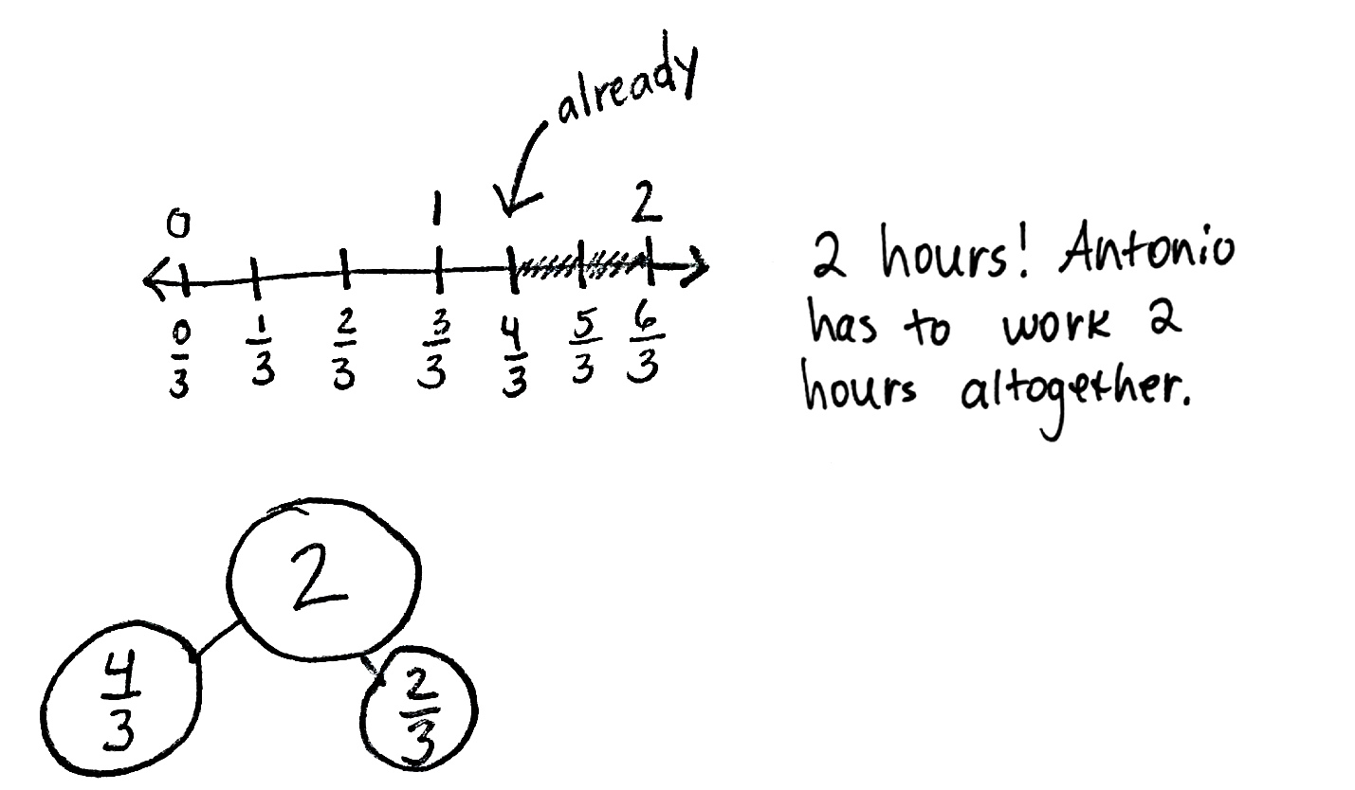
Note: This problem reviews placing fractions on a number line, using number bonds to compose fractions, and representing whole number fractions as whole numbers.
Concept Development (30 minutes)
$$\frac{1}{2}$$
$$\frac{1}{2}$$
$$\frac{1}{4}$$
$$\frac{1}{4}$$
$$\frac{1}{4}$$
$$\frac{1}{4}$$
Image 1
Materials: (S) Personal white board
Draw or project Image 1 on the right, which was also used in Lesson 24.
T: Turn and tell your partner why the number bond is true.
S: Because fourths come from cutting halves in 2 equal pieces. Yeah, so $\frac{2}{2}$ and $\frac{4}{4}$ both equal 1 whole.
T: (Add 2 more halves to the whole, as shown in Image 2.) Talk to a partner: How do the parts change if we change the whole to look like this?
$$\frac{1}{2}$$
$$\frac{1}{2}$$
$$\frac{1}{4}$$
$$\frac{1}{4}$$
$$\frac{1}{4}$$
$$\frac{1}{4}$$
$$\frac{1}{2}$$
$$\frac{1}{2}$$
Image 2
S: (Discuss.)
T: Work with a partner to draw the new model on your personal white board, and change the parts so that the number bond is true.
S: (Draw.)
T: (Draw or project Models 1 and 2, as shown on the next page.) As I look around the room, I see these two models. Discuss with your partner. Are they equivalent?
S: There are many more parts in the first model, so they aren’t equal. There are 8 total parts in both models. 4 copies of $\frac{1}{4}$ makes $\frac{4}{4}$, and another 4 copies of $\frac{1}{4}$ makes another $\frac{4}{4}.$ So, they are equivalent. In the second model, they just made copies of 1 whole to show the total as 2 wholes.

$$\frac{4}{4}$$
$$\frac{4}{4}$$
$$\frac{1}{2}$$
$$\frac{1}{2}$$
$$\frac{1}{2}$$
$$\frac{1}{2}$$
Model 2
$$\frac{1}{2}$$
$$\frac{1}{2}$$
$$\frac{1}{4}$$
$$\frac{1}{4}$$
$$\frac{1}{4}$$
$$\frac{1}{4}$$
$$\frac{1}{2}$$
$$\frac{1}{4}$$
$$\frac{1}{4}$$
$$\frac{1}{2}$$
Model 1
$$\frac{1}{4}$$
$$\frac{1}{4}$$
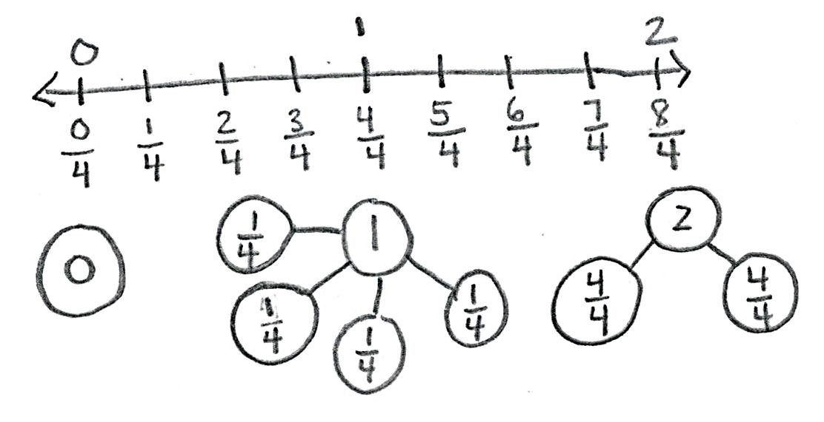
T: Model 2 does show a different way of writing the copies in Model 1. Instead of showing copies of unit fractions, the second model shows copies of 1 whole.

NOTES ON
MULTIPLE MEANS
OF ACTION AND EXPRESSION:
Partner talk is a valuable opportunity for English language learners to speak about their math ideas in English confidently and comfortably. Support limited English speakers with a sentence frame such as, “They are equivalent because Model 1 shows _____ fourths, and Model 2 shows _____ fourths.”

T: Let’s see if we can show the equivalence of the number bonds on the number line. Draw a number line with endpoints 0 and 2. Label the wholes on top of the number line. Partition the number line into fourths, and label the fractions.
S: (Draw.)
T: How many fourths in 0?
S: 0 fourths!
T: How many fourths in 1?
S: 4 fourths!
T: How many fourths in 2?
S: 8 fourths!
T: Below each whole number on your number line, work with a partner to draw a number bond. As you draw number bonds, show copies of 1 whole instead of unit fractions if you can.
S: (Draw.)
T: What is the relationship between Models 1 and 2, as well as the number line and number bonds you just drew?
S: Our number bond for 2 on the number line looks just like Model 2. But Model 2 has halves as the whole.
4 halves make 2, so they’re the same.

T: What about Model 1?
S: There are 8 fourths on the number line, just like Model 1 shows.
T: What is the difference between these 2 ways of showing the number bond?
S: One is way faster to write. It’s also easier to read because you can see the number of wholes inside of 2.
Problem Set (10 minutes)

NOTES ON
MULTIPLE MEANS
OF ENGAGEMENT:
As an alternative to the Problem Set, offer students working above grade level the option of drawing their own number lines with larger intervals (e.g., 6, 7, and 8) and their choice of fractional unit for partitioning (e.g., fifths).

Students should do their personal best to complete the Problem Set within the allotted 10 minutes. For some classes, it may be appropriate to modify the assignment by specifying which problems they work on first. Some problems do not specify a method for solving. Students should solve these problems using the RDW approach used for Application Problems.
Student Debrief (10 minutes)
Lesson Objective: Decompose whole number fractions greater than 1 using whole number equivalence with various models.

NOTES ON
MULTIPLE MEANS
OF ENGAGEMENT:
Use the chart on the Problem Set to help students working below grade level build understanding. After students have completed the halves and thirds, ask, “How is the whole related to the whole number fraction?” Discuss and verify predictions for sixths.

The Student Debrief is intended to invite reflection and active processing of the total lesson experience.
Invite students to review their solutions for the Problem Set. They should check work by comparing answers with a partner before going over answers as a class. Look for misconceptions or misunderstandings that can be addressed in the Student Debrief. Guide students in a conversation to debrief the Problem Set and process the lesson.
Any combination of the questions below may be used to lead the discussion.
- Compare the number lines and number bonds in Problem 1. What does each representation help you see?
- In Problem 2, what strategy did you use to find the whole number fractions without having to partition a number line again?
- Draw number bonds to demonstrate your answers in Problems 3 and 4 using copies of wholes.
- How is the way that we expressed whole number fractions today different from the way we’ve been doing it?
- Why is it helpful to know how to rename wholes to make number bonds with larger whole numbers?
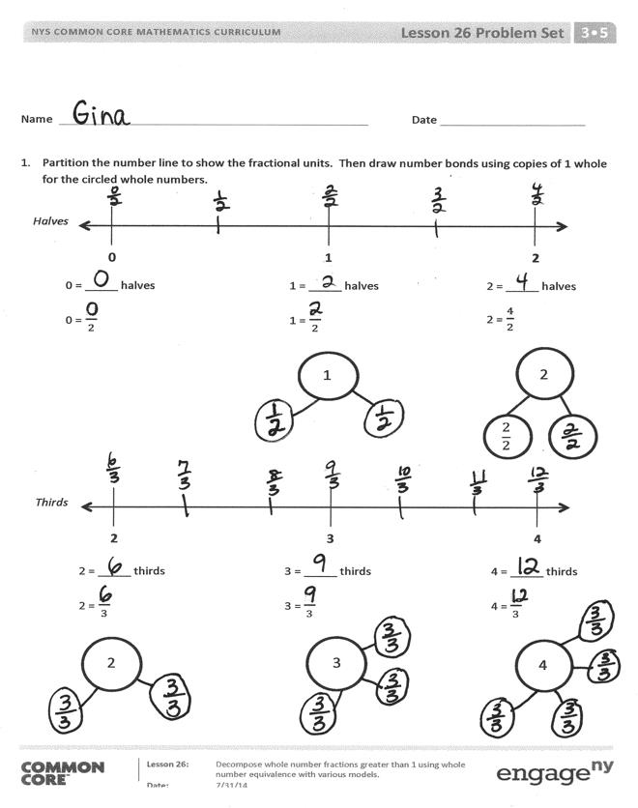
Exit Ticket (3 minutes)
After the Student Debrief, instruct students to complete the Exit Ticket. A review of their work will help with assessing students’ understanding of the concepts that were presented in today’s lesson and planning more effectively for future lessons. The questions may be read aloud to the students.

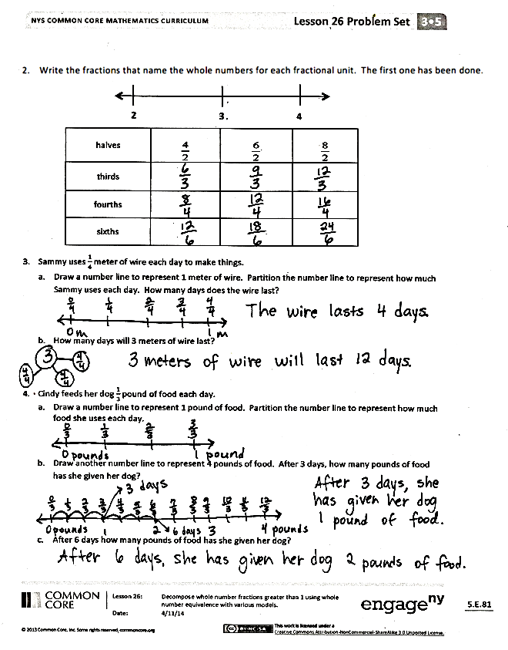

Number Correct:
A
Add by Eight
 | 0 + 8 = |  |  |  | 65 + 8 =
 | 1 + 8 = |  |  |  | 6 + 8 =
 | 2 + 8 = |  |  |  | 16 + 8 =
 | 8 + 2 = |  |  |  | 26 + 8 =
 | 1 + 8 = |  |  |  | 36 + 8 =
 | 0 + 8 = |  |  |  | 86 + 8 =
 | 3 + 8 = |  |  |  | 46 + 8 =
 | 13 + 8 = |  |  |  | 7 + 8 =
 | 23 + 8 = |  |  |  | 17 + 8 =
 | 33 + 8 = |  |  |  | 27 + 8 =
 | 43 + 8 = |  |  |  | 37 + 8 =
 | 83 + 8 = |  |  |  | 77 + 8 =
 | 4 + 8 = |  |  |  | 8 + 8 =
 | 14 + 8 = |  |  |  | 18 + 8 =
 | 24 + 8 = |  |  |  | 28 + 8 =
 | 34 + 8 = |  |  |  | 38 + 8 =
 | 44 + 8 = |  |  |  | 68 + 8 =
 | 74 + 8 = |  |  |  | 9 + 8 =
 | 5 + 8 = |  |  |  | 19 + 8 =
 | 15 + 8 = |  |  |  | 29 + 8 =
 | 25 + 8 = |  |  |  | 39 + 8 =
 | 35 + 8 = |  |  |  | 89 + 8 =
Number Correct:
Improvement:
B
[KEY]

Add by Eight
 | 8 + 0 = |  |  |  | 55 + 8 =
 | 8 + 1 = |  |  |  | 6 + 8 =
 | 8 + 2 = |  |  |  | 16 + 8 =
 | 2 + 8 = |  |  |  | 26 + 8 =
 | 1 + 8 = |  |  |  | 36 + 8 =
 | 0 + 8 = |  |  |  | 66 + 8 =
 | 3 + 8 = |  |  |  | 56 + 8 =
 | 13 + 8 = |  |  |  | 7 + 8 =
 | 23 + 8 = |  |  |  | 17 + 8 =
 | 33 + 8 = |  |  |  | 27 + 8 =
 | 43 + 8 = |  |  |  | 37 + 8 =
 | 73 + 8 = |  |  |  | 67 + 8 =
 | 4 + 8 = |  |  |  | 8 + 8 =
 | 14 + 8 = |  |  |  | 18 + 8 =
 | 24 + 8 = |  |  |  | 28 + 8 =
 | 34 + 8 = |  |  |  | 38 + 8 =
 | 44 + 8 = |  |  |  | 78 + 8 =
 | 84 + 8 = |  |  |  | 9 + 8 =
 | 5 + 8 = |  |  |  | 19 + 8 =
 | 15 + 8 = |  |  |  | 29 + 8 =
 | 25 + 8 = |  |  |  | 39 + 8 =
 | 35 + 8 = |  |  |  | 89 + 8 =

Name Date
- Partition the number line to show the fractional units. Then, draw number bonds using copies of 1 whole for the circled whole numbers.
2
$$\frac{2}{2}$$

2 = _____ halves
2 = $\frac{4}{2}$

1 = _____ halves
1 = $\frac{}{2}$

1
0 = _____ halves
0 = $\frac{}{2}$

0 1 2
Halves

3
3 = _____ thirds
3 = $\frac{}{3}$

4
4 = _____ thirds
4 = $\frac{}{3}$

2 = _____ thirds
2 = $\frac{}{3}$

2
2 3 4
Thirds

- Write the fractions that name the whole numbers for each fractional unit. The first one has been done.
2
4
3
Halves
Thirds
Fourths
Sixths

- Sammy uses $\frac{1}{4}$ meter of wire each day to make things.
- Draw a number line to represent 1 meter of wire. Partition the number line to represent how much Sammy uses each day. How many days does the wire last?

- How many days will 3 meters of wire last?

- Cindy feeds her dog $\frac{1}{3}$pound of food each day.
- Draw a number line to represent 1 pound of food. Partition the number line to represent how much food she uses each day.

- Draw another number line to represent 4 pounds of food. After 3 days, how many pounds of food has she given her dog?

- After 6 days, how many pounds of food has she given her dog?

Name Date
Irene has 2 yards of fabric.
- Draw a number line to represent the total length of Irene’s fabric.

- Irene cuts her fabric into pieces of $\frac{1}{5}$ yard in length. Partition the number line to show her cuts.

- How many $\frac{1}{5}$-yard pieces does she cut altogether? Use number bonds with copies of wholes to help you explain.

Name Date
- Partition the number line to show the fractional units. Then, draw number bonds with copies of 1 whole for the circled whole numbers.
$$\frac{6}{6}$$

$$\frac{6}{6}$$

2
2 = _____ sixths
2 = $\frac{12}{6}$
1 = _____ sixths
1 = $\frac{}{6}$

1
0 = _____ sixths
0 = $\frac{}{6}$

0 1 2
Sixths

3
3 = _____ fifths
3 = $\frac{}{5}$

4
4 = _____ fifths
4 = $\frac{}{5}$

2 = _____ fifths
2 = $\frac{}{5}$

2
2 3 4
Fifths

- Write the fractions that name the whole numbers for each fractional unit. The first one has been done for you.
2
4
3

Thirds
Sevenths
Eighths
Tenths

- Rider dribbles the ball down $\frac{1}{3}$ of the basketball court on the first day of practice. Each day after that, he dribbles $\frac{1}{3}$ of the way more than he did the day before. Draw a number line to represent the court. Partition the number line to represent how far Rider dribbles on Day 1, Day 2, and Day 3 of practice. What fraction of the way does he dribble on Day 3?

