Lesson 20
Objective: Recognize and show that equivalent fractions have the same size, though not necessarily the same shape.

Suggested Lesson Structure
 Fluency Practice (9 minutes)
 Application Problem (8 minutes)
 Concept Development (33 minutes)
 Student Debrief (10 minutes)
Total Time (60 minutes)
Fluency Practice (9 minutes)
- Multiply by 7 3.OA.4 (9 minutes)
Multiply by 7 (9 minutes)
Materials: (S) Multiply by 7 (1–5) Pattern Sheet
Note: This Pattern Sheet supports fluency with multiplication using units of 7.
T: Skip-count by sevens. (Write multiples horizontally as students count.)
S: 7, 14, 21, 28, 35, 42, 49, 56, 63, 70.
T: (Write 5 × 7 = ____.) Let’s skip-count by sevens to find the answer. (Count with fingers to 5 as students count.)
S: 7, 14, 21, 28, 35.
T: (Circle 35 and write 5 × 7 = 35 above it. Write 3 × 7 = ____.) Let’s skip-count up by sevens again.
(As students count, show fingers to count with them.)
S: 7, 14, 21.
T: Let’s see how we can skip-count down to find the answer, too. Start at 35. (Count down with fingers as students say numbers.)
S: 35, 28, 21.
T: (Write 9 × 7 = ____.) Let’s skip-count up by sevens. (Count with fingers to 9 as students count.)
S: 7, 14, 21, 28, 35, 42, 49, 56, 63.
T: Let’s see how we can skip-count down to find the answer, too. Start at 70. (Count down with fingers as student say numbers.)
S: 70, 63.
Continue with the following possible sequence: 6 × 7, 8 × 7, and 4 × 7.
T: (Distribute the Multiply by 7 Pattern Sheet.) Let’s practice multiplying by 7. Be sure to work left to right across the page.
Directions for administration of Multiply-By Pattern Sheet are as follows:
- Distribute the Pattern Sheet.
- Allow a maximum of two minutes for students to complete as many problems as possible.
- Direct students to work left to right across the page.
- Encourage skip-counting strategies to solve unknown facts.
Application Problem (8 minutes)
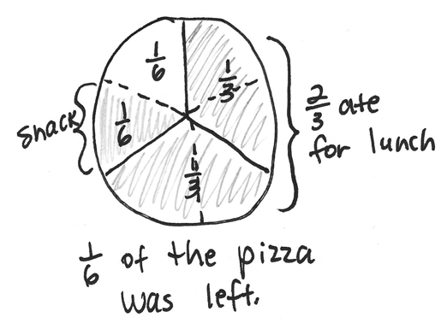
Max ate $\frac{2}{3}$ of his pizza for lunch. He wanted to eat a small snack in the afternoon, so he cut the leftover pizza in half and ate 1 slice. How much of the pizza was left? Draw a picture to help you think about the pizza.

NOTES ON
MULTIPLE MEANS
OF REPRESENTATION:
Empower English language learners to solve the Application Problem by connecting its context to their prior knowledge. Discuss their experiences at lunch, eating pizza, having leftovers, and eating a snack.

Note: This problem reviews partitioning a whole into equal parts from Topic A. Invite students to share their models and discuss why $\frac{1}{2}$ is not a reasonable answer, even though Max cut the leftover pizza in half.
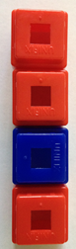
Concept Development (33 minutes)
Model 1
Materials: (T) Linking cubes in 2 colors (S) Thirds (Template), red crayon, scissors, glue stick, and blank paper
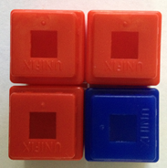
Use linking cubes to create Model 1, as shown to the right.
Model 2
T: The whole is all of the cubes. Whisper to your partner the fraction of cubes that are blue.
S: (Whisper $\frac{1}{4}$.)
Use linking cubes to create Model 2, as shown to the right.
T: Again, the whole is all of the cubes. Whisper to your partner the fraction of cubes that are blue.
S: (Whisper $\frac{1}{4}$.)
T: Discuss with your partner whether the fraction of cubes that are blue in these models is equal, even though the models are not the same shape.
S: They don’t look the same, so they are different.
I disagree. They are equal because they are both $\frac{1}{4}$blue. They are equal because the units are still the same size, and the wholes have the same number of units. They are in a different shape.

NOTES ON
VOCABULARY:
The concept of equivalent fractions was first introduced in Lesson 16 in reference to fractions that are at the same point on the number line. In this lesson, the students’ understanding of equivalent fractions expands to include pictorial models, where the equivalent fractions name the same size. Guide students to recognize the differences and similarities between these methods for finding equivalent fractions.

T: I hear you noticing that the units make a different shape in the second model. It’s square rather than rectangular. Good observation. Take another minute to notice what is similar about our models.
S: They both use the same linking cubes as units.
They both have the same amount of blues and reds.
Both wholes have the same number of units, and the units are the same size.
T: The size of the units and the size of the whole didn’t change. That means $\frac{1}{4}$ and$\frac{1}{4}$ are equal, or what we call equivalent fractions, even though the shapes of our wholes are different.
If necessary, do other examples to demonstrate the point made with Model 2.
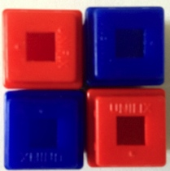
Use linking cubes to create Model 3, as shown to the right.
Model 3
T: Why isn’t the fraction represented by the blue cubes equal to the other fractions we made with cubes?
S: This fraction shows $\frac{2}{4}$ of the cubes are blue.
T: When we are finding equivalent fractions, the shapes of the wholes can be different. However, equivalent fractions must describe parts of the whole that are the same size.
Equivalent Shapes Collage Activity
Thirds Template
Students use the thirds template, and follow the directions below to create various representations of 2 thirds.
Directions for this activity are as follows:
- Color the white 1 third red.
- Cut out the rectangle. Cut it into 2–4 smaller shapes.
- Reassemble all of the pieces into a new shape with no overlaps.
- Glue the new shape onto a blank paper.
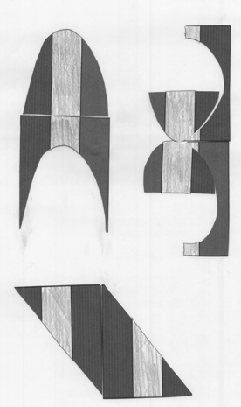
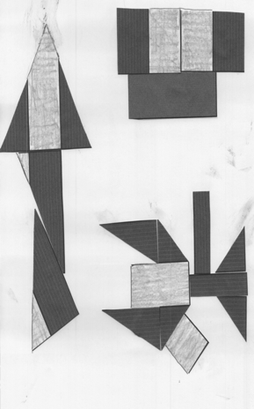
Invite students to look at their classmates’ work and discuss the equivalence represented by these shapes. Each of the 6 shapes pictured to the right is an example of possible student work. These shapes are equivalent because they all show $\frac{2}{3}$ grey, although clearly in different shapes.
Sample Student Work
Problem Set (10 minutes)
Students should do their personal best to complete the Problem Set within the allotted 10 minutes. For some classes, it may be appropriate to modify the assignment by specifying which problems they work on first. Some problems do not specify a method for solving. Students should solve these problems using the RDW approach used for Application Problems.
Student Debrief (10 minutes)

NOTES ON
MULTIPLE MEANS
OF ACTION AND EXPRESSION:
For students working below grade level, break the task of labeling fractions on the Problem Set into steps with sentence frames:
- There are ____ equal parts.
- ____ parts are shaded.
- The fraction shaded is _____.
The open-ended questions on the Problem Set are just right for students working above grade level who enjoy independence. Communicate high expectations for explaining their reasoning clearly with evidence.

Lesson Objective: Recognize and show that equivalent fractions have the same size, though not necessarily the same shape.
The Student Debrief is intended to invite reflection and active processing of the total lesson experience.
Invite students to review their solutions for the Problem Set. They should check work by comparing answers with a partner before going over answers as a class. Look for misconceptions or misunderstandings that can be addressed in the Student Debrief. Guide students in a conversation to debrief the Problem Set and process the lesson.
Any combination of the questions below may be used to lead the discussion.
- Invite students to share their models for Problems 2(a) and 2(b). Although answers will vary, students should consistently represent equivalent fractions for each question. Revisit the different work from the Equivalent Shapes Collage Activity.
MP.6
- Problem 3(c) presents seeing triangles as halves of squares. Some students might put $\frac{4}{8}$ as the answer since they see 8 units. You may want to pose the question, “Are all 8 parts equal units?” Discuss how the answer can be $\frac{4}{12}$ if students choose to use the base unit of triangles or $\frac{2}{6}$ if they choose to use the base unit of squares. Guide them to see that the two fractions are equivalent.

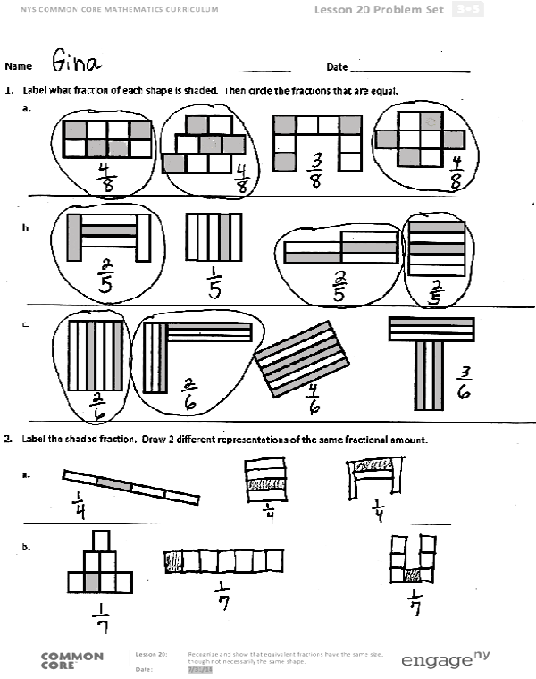
- Problem 4 also presents an interesting discussion topic because of the use of containers that are different shapes with the same capacity. Without reading carefully, students are likely to make a mistake in their answer. This may provide an opportunity to further explore the difference between different-sized wholes and different-looking wholes.
- Earlier, you learned that equivalent fractions are at the same point on the number line. How did your understanding of equivalent fractions change today?
Exit Ticket (3 minutes)
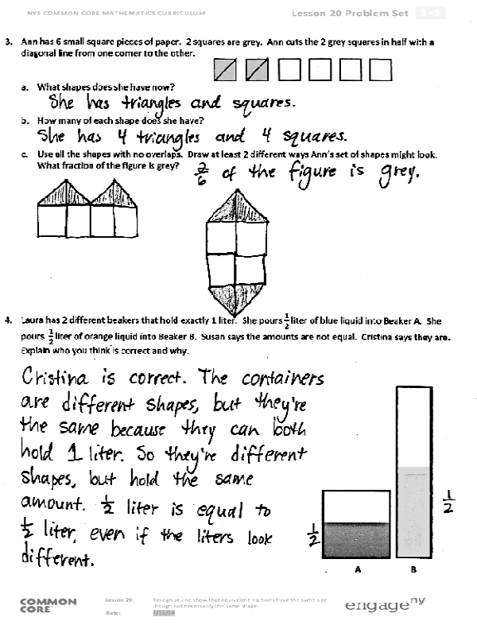
After the Student Debrief, instruct students to complete the Exit Ticket. A review of their work will help with assessing students’ understanding of the concepts that were presented in today’s lesson and planning more effectively for future lessons. The questions may be read aloud to the students.
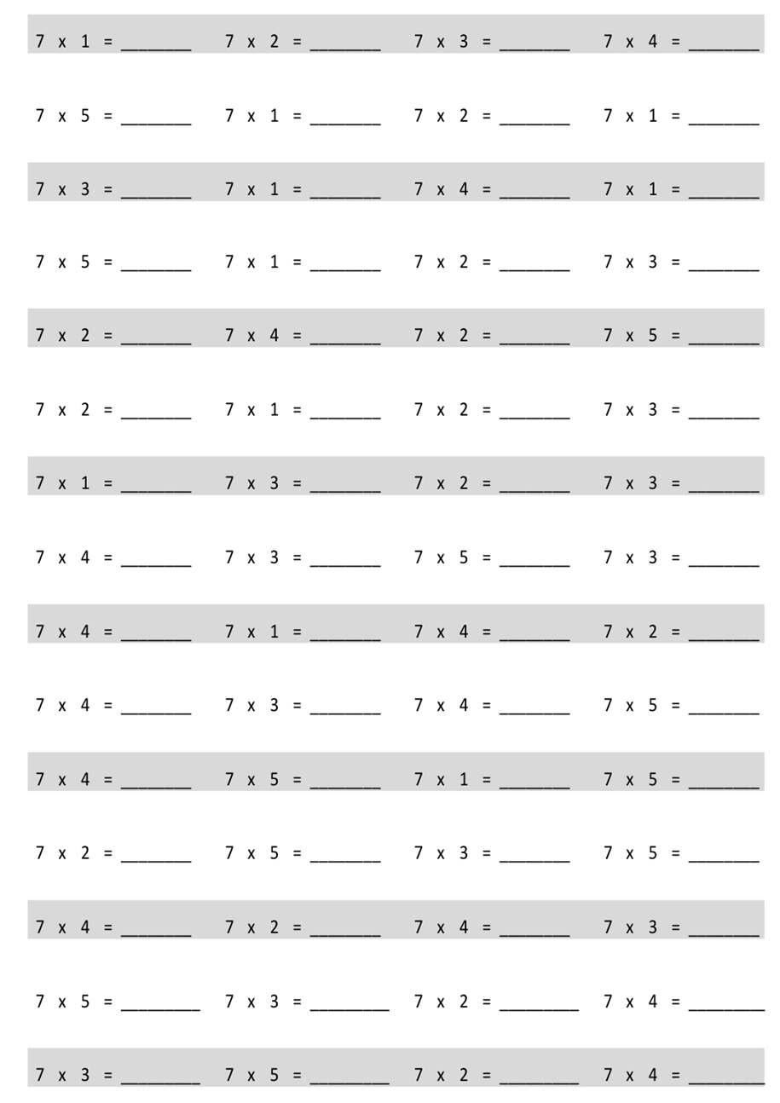
Multiply.

Name Date
- Label what fraction of each shape is shaded. Then, circle the fractions that are equal.

- Label the shaded fraction. Draw 2 different representations of the same fractional amount.

- Ann has 6 small square pieces of paper. 2 squares are grey. Ann cuts the 2 grey squares in half with a diagonal line from one corner to the other.

- What shapes does she have now?

- How many of each shape does she have?

- Use all the shapes with no overlaps. Draw at least 2 different ways Ann’s set of shapes might look. What fraction of the figure is grey?

- Laura has 2 different beakers that hold exactly 1 liter. She pours $\frac{1}{2}$ liter of blue liquid into Beaker A. She pours $\frac{1}{2}$ liter of orange liquid into Beaker B. Susan says the amounts are not equal. Cristina says they are. Explain who you think is correct and why.
A B

Name Date
  - Label what fraction of the figure is shaded. Then, circle the fractions that are equal.

  - Label the shaded fraction. Draw 2 different representations of the same fractional amount.

b.

Name Date
- Label the shaded fraction. Draw 2 different representations of the same fractional amount.

- These two shapes both show $\frac{4}{5}$.

  - Are the shapes equivalent? Why or why not?

  - Draw two different representations of $\frac{4}{5}$ that are equivalent.

- Diana ran a quarter mile straight down the street. Becky ran a quarter mile on a track. Who ran more? Explain your thinking.

Diana

Becky

multiply by 7 (1–5)
thirds

