Lesson 17
Objective: Practice placing various fractions on the number line.

Suggested Lesson Structure
 Fluency Practice (12 minutes)
 Application Problem (6 minutes)
 Concept Development (32 minutes)
 Student Debrief (10 minutes)
Total Time (60 minutes)
Fluency Practice (12 minutes)
- Sprint: Division 3.OA.2 (8 minutes)
- Place Fractions on a Number Line 3.NF.2b (3 minutes)
- Compare Unit Fractions 3.NF.3d (1 minutes)
Sprint: Division (8 minutes)
Materials: (S) Division Sprint
Note: This Sprint supports fluency with division using various units.
Place Fractions on a Number Line (3 minutes)
Materials: (S) Personal white board
Note: This activity reviews the concept of placing fractions on a number line from Lesson 16.
T: (Draw a number line marked at 0, 1, 2, and 3.) Draw my number line on your personal white board.
S: (Draw.)
T: Estimate to mark and label 1 half within the interval 0 to 1.
S: (Estimate the halfway point between 0 and 1 and write $\frac{1}{2}.$)
T: Estimate to mark 2 halves. Label 2 halves as a fraction.
S: (Write $\frac{2}{2}$ above the 1 on the number line.)
Continue with the following possible sequence, drawing a new number line for the different fractional units: $\frac{4}{2}$, $\frac{6}{2}$, $\frac{1}{5}$, $\frac{5}{5}$, $\frac{10}{5}$, $\frac{15}{5}$, $\frac{1}{3}$, $\frac{3}{3}$, $\frac{9}{3}$, $\frac{6}{3}$, $\frac{1}{4}$, $\frac{8}{4}$, $\frac{12}{4}$, and $\frac{4}{4}$.
Compare Unit Fractions (1 minute)
Note: This activity reviews the concept of comparing unit fractions from Topic C.
T: (Write $\frac{1}{2}$ and $\frac{1}{10}$.) Both fractions refer to the same whole. Say the largest fraction.
S: 1 half.
Continue with the following possible sequence: $\frac{1}{2}$ and $\frac{1}{3}$, $\frac{1}{3}$ and $\frac{1}{4}$, $\frac{1}{4}$ and $\frac{1}{6}$, $\frac{1}{4}$ and $\frac{1}{2}$, $\frac{1}{6}$ and $\frac{1}{8}$, $\frac{1}{6}$ and $\frac{1}{5}$,
and $\frac{1}{5}$ and $\frac{1}{10}$.
Application Problem (6 minutes)
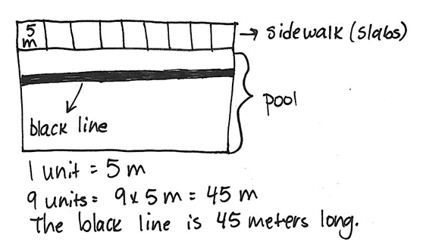
Sammy sees a black line at the bottom of the pool stretching from one end to the other. She wonders how long it is. The black line is the same length as 9 concrete slabs that make the sidewalk at the edge of the pool. One concrete slab is 5 meters long. What is the length of the black line at the bottom of the pool?

Note: This problem reviews multiplication from Modules 1 and 3. It also reviews partitioning a whole into equal parts from Topic A.

NOTES ON
MULTIPLE MEANS
OF ENGAGEMENT:
To help students working below grade level, locate and label fractions on the number line. Elicit answers that specify the whole and the fractional unit. Say, “Point to and count the wholes with me. How many wholes? Into what fractional unit are we partitioning the whole? Label as we count the fractions.”

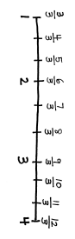
Concept Development (32 minutes)
Materials: (S) Personal white board
T: Draw a number line with endpoints 1 and 4. Label the wholes. Partition each whole into thirds. Label all of the fractions from 1 to 4.

T: After you labeled your whole numbers, what did you think about to place your fractions?
S: Evenly spacing the marks between whole numbers to make thirds. Writing the numbers in order: 3 thirds, 4 thirds, 5 thirds, etc. Starting with 3 thirds because the endpoint was 1.
T: What do the fractions have in common? What do you notice?
S: All of the fractions are thirds. All are equal to or greater than 1 whole. The number of thirds that name whole numbers count by threes: 1 = 3 thirds, 2 = 6 thirds, 3 = 9 thirds. $\frac{3}{3}$, $\frac{6}{3}$, $\frac{9}{3}$, and $\frac{12}{3}$ are at the same point on the number line as 1, 2, 3, and 4. Those fractions are equivalent to whole numbers.
1 2 3 4
T: Draw a number line on your board with endpoints 1 and 4.
T: (Write $\frac{2}{2}$, $\frac{5}{2}$, $\frac{7}{2}$, and $\frac{8}{2}$.) Look at these fractions. What do you notice?

NOTES ON
MULTIPLE MEANS
OF ENGAGEMENT:
Ask students working above grade level this more open-ended question: “How many halves are on the number line?”

S: They are all halves. They are all equal to or greater than 1. They are in order, but some are missing.
T: Place these fractions on your number line. (After students place fractions on the number line.) Compare with your partner. Check that your number lines are the same.
Follow a similar sequence with the following possible suggestions:
- Number line with endpoints 1 and 4, marking fractions in thirds
- Number line with endpoints 2 and 5, marking fractions in fifths
- Number line with endpoints 4 and 6, marking fractions in thirds
Close the lesson by having pairs of students generate collections of fractions to place on number lines with specified endpoints. Students might then exchange problems, challenging each other to place fractions on the number line. Students should reason aloud about how the partitioned fractional unit is chosen for each number line.

NOTES ON
MULTIPLE MEANS
OF ACTION AND EXPRESSION:
Support English language learners as they construct written responses. Read the prompt aloud or have students read chorally. Provide sentence starters and a word bank.
Sentence starters may include the following:
- “I think ____ has a longer pinky finger than ____ because…”
Possible words for the word bank may include the following:
less than eighths closer to
greater than zero

Problem Set (10 minutes)
Students should do their personal best to complete the Problem Set within the allotted 10 minutes. For some classes, it may be appropriate to modify the assignment by specifying which problems they work on first. Some problems do not specify a method for solving. Students should solve these problems using the RDW approach used for Application Problems.
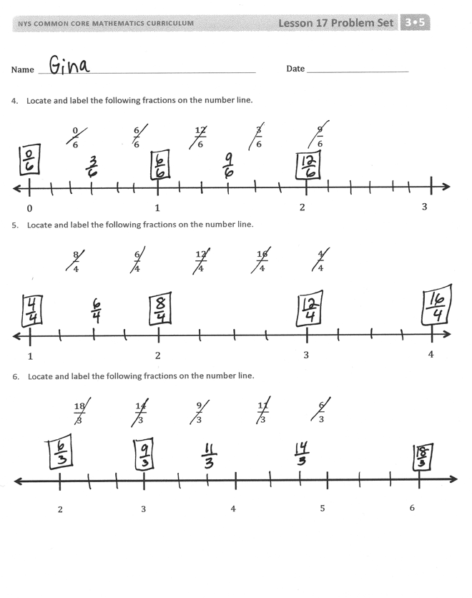
Student Debrief (10 minutes)
Lesson Objective: Practice placing various fractions on the number line.
The Student Debrief is intended to invite reflection and active processing of the total lesson experience.
Invite students to review their solutions for the Problem Set. They should check work by comparing answers with a partner before going over answers as a class. Look for misconceptions or misunderstandings that can be addressed in the Student Debrief. Guide students in a conversation to debrief the Problem Set and process the lesson.
Any combination of the questions below may be used to lead the discussion.
- What did you think about first to help you place the fractions?
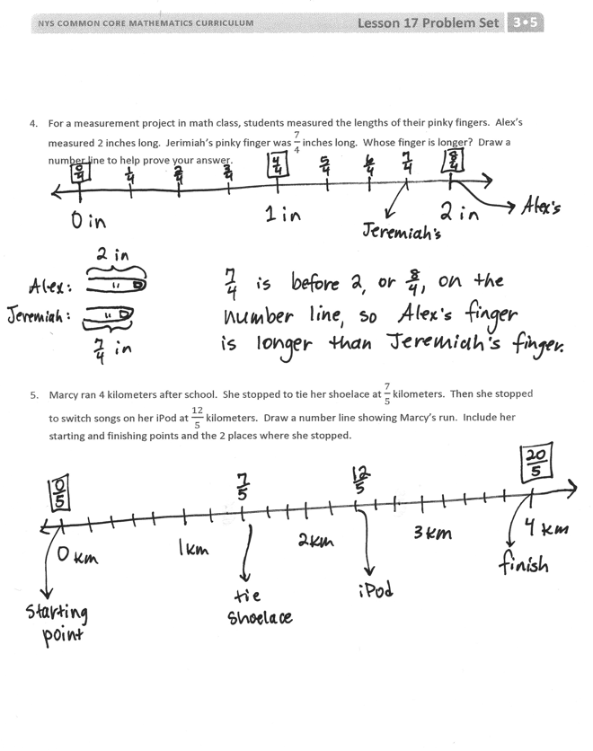
- In Problems 1–3, did you label all of the marks on each number line or just the fractions in the list? Why?
- In Problems 1–3, what was the first fraction that you placed on each number line? Why did you start with that one?
- What advice would you give an absent classmate about completing this Problem Set? What is the most important thing to remember when placing fractions on the number line?
Exit Ticket (3 minutes)
After the Student Debrief, instruct students to complete the Exit Ticket. A review of their work will help with assessing students’ understanding of the concepts that were presented in today’s lesson and planning more effectively for future lessons. The questions may be read aloud to the students.

Number Correct:
A
Division
 | 3 ÷ 3 = |  |  |  | 24 ÷ 3 =
 | 4 ÷ 4 = |  |  |  | 16 ÷ 2 =
 | 5 ÷ 5 = |  |  |  | 30 ÷ 10 =
 | 19 ÷ 19 = |  |  |  | 30 ÷ 3 =
 | 0 ÷ 1 = |  |  |  | 27 ÷ 3 =
 | 0 ÷ 2 = |  |  |  | 18 ÷ 2 =
 | 0 ÷ 3 = |  |  |  | 40 ÷ 10 =
 | 0 ÷ 19 = |  |  |  | 40 ÷ 4 =
 | 6 ÷ 3 = |  |  |  | 20 ÷ 4 =
 | 9 ÷ 3 = |  |  |  | 20 ÷ 5 =
 | 12 ÷ 3 = |  |  |  | 24 ÷ 4 =
 | 15 ÷ 3 = |  |  |  | 30 ÷ 5 =
 | 4 ÷ 2 = |  |  |  | 28 ÷ 4 =
 | 6 ÷ 2 = |  |  |  | 40 ÷ 5 =
 | 8 ÷ 2 = |  |  |  | 32 ÷ 4 =
 | 10 ÷ 2 = |  |  |  | 45 ÷ 5 =
 | 18 ÷ 3 = |  |  |  | 44 ÷ 4 =
 | 12 ÷ 2 = |  |  |  | 36 ÷ 4 =
 | 21 ÷ 3 = |  |  |  | 48 ÷ 6 =
 | 14 ÷ 2 = |  |  |  | 63 ÷ 7 =
 | 20 ÷ 10 = |  |  |  | 64 ÷ 8 =
 | 20 ÷ 2 = |  |  |  | 72 ÷ 9 =
B
[KEY]

Number Correct:
Improvement:
Division
 | 2 ÷ 2 = |  |  |  | 16 ÷ 2 =
 | 3 ÷ 3 = |  |  |  | 24 ÷ 3 =
 | 4 ÷ 4 = |  |  |  | 30 ÷ 3 =
 | 17 ÷ 17 = |  |  |  | 30 ÷ 10 =
 | 0 ÷ 2 = |  |  |  | 18 ÷ 2 =
 | 0 ÷ 3 = |  |  |  | 27 ÷ 3 =
 | 0 ÷ 4 = |  |  |  | 40 ÷ 4 =
 | 0 ÷ 17 = |  |  |  | 40 ÷ 10 =
 | 4 ÷ 2 = |  |  |  | 20 ÷ 5 =
 | 6 ÷ 2 = |  |  |  | 20 ÷ 4 =
 | 8 ÷ 2 = |  |  |  | 30 ÷ 5 =
 | 10 ÷ 2 = |  |  |  | 24 ÷ 4 =
 | 6 ÷ 3 = |  |  |  | 40 ÷ 5 =
 | 9 ÷ 3 = |  |  |  | 28 ÷ 4 =
 | 12 ÷ 3 = |  |  |  | 45 ÷ 5 =
 | 15 ÷ 3 = |  |  |  | 32 ÷ 4 =
 | 12 ÷ 2 = |  |  |  | 55 ÷ 5 =
 | 18 ÷ 3 = |  |  |  | 36 ÷ 4 =
 | 14 ÷ 2 = |  |  |  | 54 ÷ 6 =
 | 21 ÷ 3 = |  |  |  | 56 ÷ 7 =
 | 20 ÷ 2 = |  |  |  | 72 ÷ 8 =
 | 20 ÷ 10 = |  |  |  | 63 ÷ 9 =

Name Date
- Locate and label the following fractions on the number line.

$\frac{0}{6}$ $\frac{6}{6}$ $\frac{12}{6}$ $\frac{3}{6}$ $\frac{9}{6}$
0 1 2 3

- Locate and label the following fractions on the number line.

$\frac{8}{4}$ $\frac{6}{4}$ $\frac{12}{4}$ $\frac{16}{4}$ $\frac{4}{4}$
1 2 3 4

- Locate and label the following fractions on the number line.

$\frac{18}{3}$ $\frac{14}{3}$ $\frac{9}{3}$ $\frac{11}{3}$ $\frac{6}{3}$
2 3 4 5 6

- For a measurement project in math class, students measured the lengths of their pinky fingers. Alex’s measured 2 inches long. Jerimiah’s pinky finger was $\frac{7}{4}$ inches long. Whose finger is longer? Draw a number line to help prove your answer.

- Marcy ran 4 kilometers after school. She stopped to tie her shoelace at $\frac{7}{5}$kilometers. Then, she stopped to switch songs on her iPod at $\frac{12}{5}$ kilometers. Draw a number line showing Marcy’s run. Include her starting and finishing points and the 2 places where she stopped.

Name Date
- Locate and label the following fractions on the number line.
$\frac{7}{3}$ $\frac{2}{3}$ $\frac{4}{3}$
0 1 2 3

- Katie bought 2 one-gallon bottles of juice for a party. Her guests drank $\frac{6}{4}$ gallons of juice. What fraction of a gallon of juice is left over? Draw a number line to show, and explain your answer.

Name Date
- Locate and label the following fractions on the number line.
0 1 2 3
$\frac{1}{2}$ $\frac{4}{2}$ $\frac{5}{2}$

- Locate and label the following fractions on the number line.

2 3 4
$\frac{11}{3}$ $\frac{6}{3}$ $\frac{8}{3}$

- Locate and label the following fractions on the number line.

3 4 5 6
$\frac{20}{4}$ $\frac{13}{4}$ $\frac{23}{4}$

- Wayne went on a 4-kilometer hike. He took a break at $\frac{4}{3}$ kilometers. He took a drink of water at $\frac{10}{3}$ kilometers. Show Wayne’s hike on the number line. Include his starting and finishing place and the 2 points where he stopped.

- Ali wants to buy a piano. The piano measures $\frac{19}{4}$ feet long. She has a space 5 feet long for the piano in her house. Does she have enough room? Draw a number line to show, and explain your answer.

4 ft 5 ft

