Lesson 15
Objective: Place any fraction on a number line with endpoints 0 and 1.

Suggested Lesson Structure
 Fluency Practice (9 minutes)
 Application Problem (7 minutes)
 Concept Development (35 minutes)
 Student Debrief (9 minutes)
Total Time (60 minutes)
Fluency Practice (9 minutes)
- Counting by Fractional Units 3.NF.1, 3.NF.3c (3 minutes)
- Division 3.OA.2 (3 minutes)
- Place Unit Fractions on a Number Line Between 0 and 1 3.NF.2a (3 minutes)
Counting by Fractional Units (3 minutes)
Note: This activity reviews counting by fractional units and supports students as they work with fractions on the number line in Topic D.
T: Count by fourths from 1 fourth to 8 fourths and back to 0.
S: $\frac{1}{4}, \frac{2}{4}, \frac{3}{4}, \frac{4}{4}, \frac{5}{4},\frac{6}{4},\frac{7}{4},\frac{8}{4},\frac{7}{4},\frac{6}{4},\frac{5}{4},\frac{4}{4},\frac{3}{4},\frac{2}{4},\frac{1}{4}, 0.$
Continue with the following possible sequence: thirds, halves, and fifths.
Division (3 minutes)
Note: This activity supports fluency with division facts.
T: (Write 4 ÷ 4 = .) Say the number sentence and answer.
S: 4 divided by 4 equals 1.
Continue with the following possible sequence: 4 ÷ 2, 4 ÷ 1, 10 ÷ 10, 10 ÷ 5, 10 ÷ 2, 10 ÷ 1, 6 ÷ 6, 6 ÷ 3, 6 ÷ 1, 8 ÷ 8, 8 ÷ 4, 8 ÷ 2, 8 ÷ 1, 15 ÷ 15, 15 ÷ 5, 15 ÷ 3, 15 ÷ 1, 12 ÷ 12, 12 ÷ 6, 12 ÷ 4, 12 ÷ 3, 12 ÷ 2, 12 ÷ 1, 16 ÷ 16,
16 ÷ 8, 16 ÷ 4, 16 ÷ 2, and 16 ÷ 1.

Place Unit Fractions on a Number Line Between 0 and 1 (3 minutes)
Materials: (S) Personal white board

NOTES ON
MULTIPLE MEANS
OF REPRESENTATION:
As students estimate to equally partition fourths and eighths on the number line, guide them to begin by finding the midpoint—first by drawing 2 equal parts and then continuing halving until the desired unit fraction is created.

Note: This activity reviews the concept of placing unit fractions on a number line from Lesson 14.
T: (Draw a number line with endpoints 0 and 1.) Draw my number line on your personal white board.
S: (Draw.)
T: Estimate to show and label 1 half.
S: (Estimate the halfway point between 0 and 1, and write $\frac{1}{2 }.$)
Continue with the following possible sequence: $\frac{1}{10}$, $\frac{1}{4}$, $\frac{1}{8}$, $\frac{1}{3}$, $\frac{1}{5}$,
and $\frac{1}{6}$.
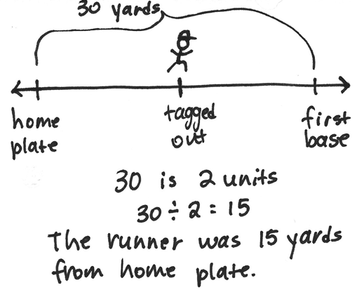
Application Problem (7 minutes)
In baseball, it is about 30 yards from home plate to first base. The batter got tagged out about halfway to first base. About how many yards from home plate was he when he got tagged out? Draw a number line to show the point where he was when he got tagged out.
Note: This problem reviews the concept of placing fractions on a number line from Lesson 14. It also reviews division by units of 2. Invite students to share their strategies for dividing 30 by 2.
Concept Development (35 minutes)
Materials: (S) Personal white board
Problem 1: Locate the point 2 thirds on a number line.
T: 2 thirds. How many equal parts are in the whole?
S: Three.
T: How many of those equal parts have been counted?
S: Two.
T: Count up to 2 thirds, starting at 1 third.
S: 1 third, 2 thirds.
T: Draw a 2-part number bond of 1 whole with 1 part as 2 thirds.
S: (Draw a number bond.)
T: What is the unknown part?
S: 1 third.
T: Draw a number line with endpoints of 0 and 1—with 0 thirds and 3 thirds—to match your number bond.
S: (Draw a number line, and label the endpoints.)
T: Mark off your thirds without labeling the fractions.
S: (Mark the thirds.)
T: Slide your finger along the length of the first part of your number bond. Speak the fraction as you do.
S: 2 thirds (sliding up to the point 2 thirds).
T: Label that point as 2 thirds.
S: (Label 2 thirds.)
T: Put your finger back on 2 thirds. Slide and speak the next part.
S: 1 third.
T: At what point are you now?
S: 3 thirds or 1 whole.
T: Our number bond is complete.
Problem 2: Locate the point 3 fifths on a number line.
T: 3 fifths. How many equal parts are in the whole?
S: Five.
T: How many of those equal parts have been counted?
S: Three.
T: Count up to 3 fifths, starting at 1 fifth.
S: 1 fifth, 2 fifths, 3 fifths.
T: Draw a 2-part number bond of 1 whole with 1 part as 3 fifths.
S: (Draw a number bond.)
T: What is the unknown part?
S: 2 fifths.
T: Draw a number line with endpoints of 0 and 1—with 0 fifths and 5 fifths—to match your number bond.
S: (Draw a number line, and label the endpoints.)
T: Mark off your fifths without labeling the fractions.
S: (Mark the fifths.)
T: Slide your finger along the length of the first part of your number. Speak the fraction as you do.
S: 3 fifths (sliding up to the point 3 fifths).

T: Label that point as 3 fifths.
S: (Label 3 fifths.)
T: Put your finger back on 3 fifths. Slide and speak the next part.
S: 2 fifths.
T: At what point are you now?
S: 5 fifths or 1 whole.
T: Our number bond is complete.
Repeat the process with other fractions such as 3 fourths, 6 eighths, 2 sixths, and 1 seventh. Release the students to work independently as they demonstrate their skills and understanding.
Problem Set (10 minutes)

NOTES ON
MULTIPLE MEANS
OF ENGAGEMENT:
The Problem Set offers practice of increasing difficulty. Expect and coach students working above grade level to complete the entire Problem Set with excellence.

Students should do their personal best to complete the Problem Set within the allotted 10 minutes. For some classes, it may be appropriate to modify the assignment by specifying which problems they work on first. Some problems do not specify a method for solving. Students should solve these problems using the RDW approach used for Application Problems.
Student Debrief (9 minutes)
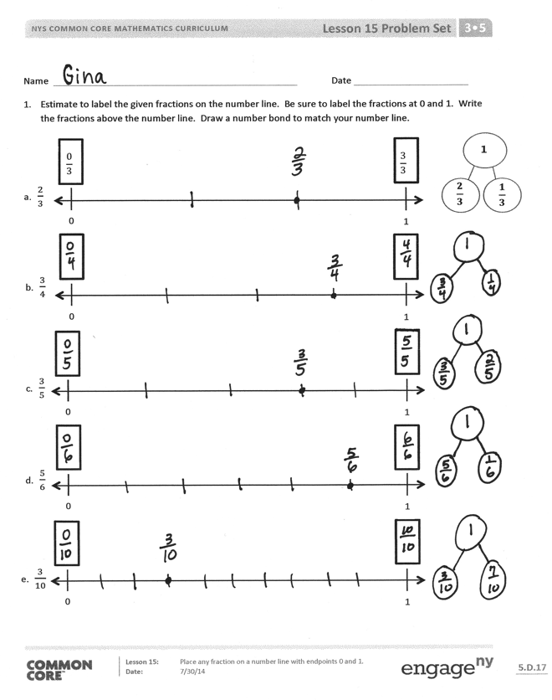
Lesson Objective: Place any fraction on a number line with endpoints 0 and 1.
The Student Debrief is intended to invite reflection and active processing of the total lesson experience.
Invite students to review their solutions for the Problem Set. They should check work by comparing answers with a partner before going over answers as a class. Look for misconceptions or misunderstandings that can be addressed in the Student Debrief. Guide students in a conversation to debrief the Problem Set and process the lesson.
Any combination of the questions below may be used to lead the discussion.
- How does the number bond relate to the number line?
- How do the number bond and number line with fractions relate to the number bond and number line with whole numbers?

- Part–part–whole thinking has been in your life since kindergarten. When might a kindergartener draw a number bond? A first grader? Second grader? Third grader?

NOTES ON
MULTIPLE MEANS
OF ACTION AND EXPRESSION:
Facilitate math meaning for English language learners through discussion. The daily debriefs and frequent Turn and Talks in each lesson enhance the English language learners’ understanding of math concepts and language, build confidence and comfort, and communicate high expectations for English language learners’ participation.

- When you think of a number bond, do you usually think of chunks of things? To you, does using it with the number line give it a new meaning? It does for me. Now, I see it can also be about distances on a line, too.
Exit Ticket (3 minutes)
After the Student Debrief, instruct students to complete the Exit Ticket. A review of their work will help with assessing students’ understanding of the concepts that were presented in today’s lesson and planning more effectively for future lessons. The questions may be read aloud to the students.

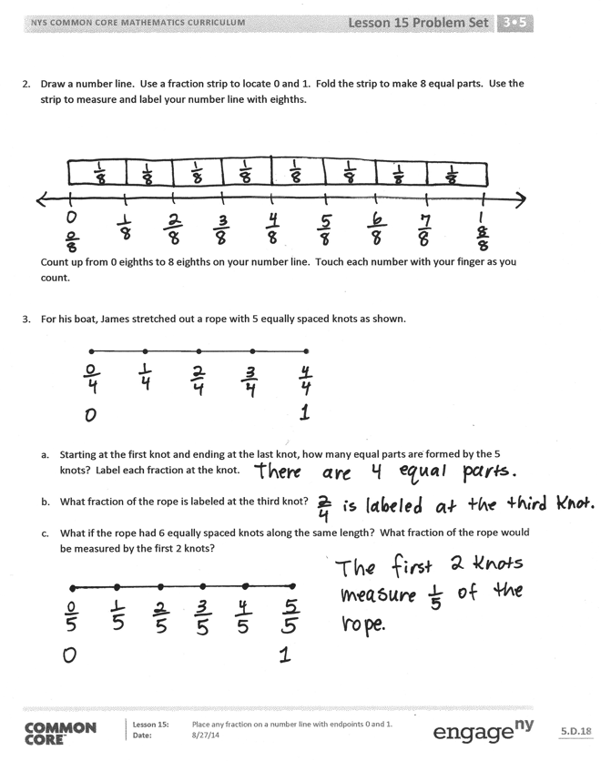

Name Date
- Estimate to label the given fractions on the number line. Be sure to label the fractions at 0 and 1.
Write the fractions above the number line. Draw a number bond to match your number line.
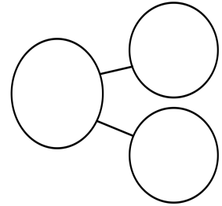
$$\frac{2}{3}$$
$$\frac{1}{3}$$
1
$$\frac{0}{3}$$

$$\frac{3}{3}$$
2
0
1
0
1

- $\frac{2}{3}$

b. $\frac{3}{4}$

0
1
0
1

c. $\frac{3}{5}$

d. $\frac{5}{6}$

0
1

e. $\frac{3}{10}$

- Draw a number line. Use a fraction strip to locate 0 and 1. Fold the strip to make 8 equal parts. Use the strip to measure and label your number line with eighths.

Count up from 0 eighths to 8 eighths on your number line. Touch each number with your finger as you count.

- For his boat, James stretched out a rope with 5 equally spaced knots as shown.

  - Starting at the first knot and ending at the last knot, how many equal parts are formed by the 5 knots? Label each fraction at the knot.

  - What fraction of the rope is labeled at the third knot?

  - What if the rope had 6 equally spaced knots along the same length? What fraction of the rope would be measured by the first 2 knots?

Name Date
- Estimate to label the given fraction on the number line. Be sure to label the fractions at 0 and 1. Write the fractions above the number line. Draw a number bond to match your number line.

0
1
$$\frac{3}{5}$$

- Partition the number line. Then, place each fraction on the number line: $\frac{3}{6}$, $\frac{1}{6}$, and $\frac{5}{6}$.

0 1

Name Date
- Estimate to label the given fractions on the number line. Be sure to label the fractions at 0 and 1. Write the fractions above the number line. Draw a number bond to match your number line. The first one is done for you.
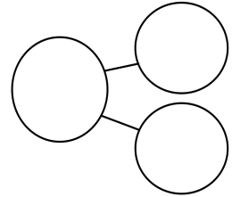
0
1
0
1
0
1
$$\frac{0}{3}$$

$$\frac{3}{3}$$
2
$$\frac{1}{3}$$
$$Aπr^{2}$$
0
1
0
1
$$\frac{2}{3}$$
$$\frac{1}{3}$$
1

- $\frac{1}{3}$

- $\frac{3}{6}$

- $\frac{2}{5}$

- $\frac{7}{10}$

- $\frac{3}{7}$

- Henry has 5 dimes. Ben has 9 dimes. Tina has 2 dimes.
  - Write the value of each person’s money as a fraction of a dollar:

Henry:
Ben:
Tina:

  - Estimate to place each fraction on the number line.
$0 $1

- Draw a number line. Use a fraction strip to locate 0 and 1. Fold the strip to make 8 equal parts.
  - Use the strip to measure and label your number line with eighths.

  - Count up from 0 eighths to 8 eighths on your number line. Touch each number with your finger as you count.

