Lesson 8
Objective: Represent parts of one whole as fractions with number bonds.

Suggested Lesson Structure
 Fluency Practice (12 minutes)
 Application Problem (10 minutes)
 Concept Development (28 minutes)
 Student Debrief (10 minutes)
Total Time (60 minutes)
Fluency Practice (12 minutes)
- Unit and Non-Unit Fractions of 1 Whole 3.NF.1 (2 minutes)
- Sprint: Identify Fractions 3.G.2, 3.NF.2 (10 minutes)
Unit and Non-Unit Fractions of 1 Whole (2 minutes)
Materials: (S) Personal white board
Note: This activity reviews naming the shaded and unshaded equal parts of a whole.
T: (Draw a shape partitioned in halves with 1 half shaded.) Write the fraction that is shaded.
S: (Write $\frac{1}{2}$.)
T: Write the fraction that is not shaded.
S: (Write $\frac{1}{2}$.)
Continue with the following possible sequence of shaded and non-shaded parts: $\frac{2}{3}$ and $\frac{1}{3}$, $\frac{4}{5}$ and $\frac{1}{5}$, $\frac{9}{10}$ and $\frac{1}{10}$, and $\frac{7}{8}$ and $\frac{1}{8}$.
Sprint: Identify Fractions (10 minutes)
Materials: (S) Identify Fractions Sprint
Note: This Sprint supports fluency with identifying shaded parts of shapes. Have students keep Sprint B to use in the Concept Development.

Application Problem (10 minutes)
For breakfast, Mr. Schwartz spent 1 sixth of his money on a coffee and 1 sixth of his money on a bagel.
What fraction of his money did Mr. Schwartz spend on breakfast?

NOTES ON
MULTIPLE MEANS
OF ENGAGEMENT:
Challenge students working above grade level with extension questions, such as, “Did Mr. Schwartz spend more or less than 1 half of his money? How do you know?”

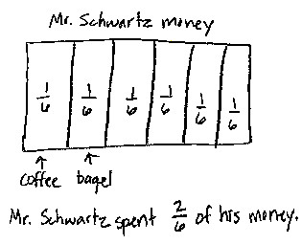

Note: This problem reviews building and naming non-unit fractions from Lesson 6.
Concept Development (28 minutes)
Materials: (S) Personal white board, Sprint B from the Fluency Practice
Problem 1: Decompose 4 into ones.

NOTES ON
MULTIPLE MEANS
OF REPRESENTATION:
Emphasize key concepts and clarify unfamiliar words with gestures when speaking with English language learners. For example, illustrate the word decompose by showing hands held together. Then, indicate breaking apart, separation, splitting, or partitioning by using a downward motion to open the hands. Doing this can also help English speakers.

T: On your personal white board, draw a number bond decomposing 4 into 4 ones.
S: (Draw a number bond.)
T: Now, work with your partner to show a number bond decomposing 4 into 2 parts. One part should be composed of 3 ones.
S: (Work with a partner to draw the number bond.)
T: It took 3 copies of one to make 3. What are the two parts of your number bond? Please specify the unit.
S: 3 ones and 1 one.
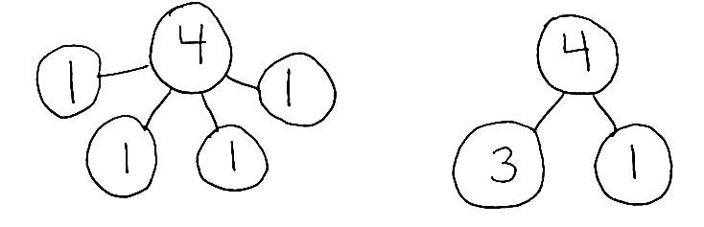
T: Talk to your partner about the difference between these two number bonds.
S: The first bond has the ones all separated. The second bond has 3 instead of 3 ones. Both bonds are different ways of showing the same number—4.
You could also show 4 as one part 2 and one part 2. The first bond has more parts than the second one.

Problem 2: Decompose 1 into fourths.
MP.7
T: Draw a number bond decomposing 1 into 4 unit fractions.
S: (Draw a number bond.)
T: Now, work with your partner to show a number bond decomposing 1 into 2 parts. One part should be composed of 3 copies of the unit fraction.
S: (Work with a partner to draw the number bond.)
T: What unit fraction did we copy to make the number
3 fourths?
S: 1 fourth.
T: What are the two parts of your number bond? Please specify the unit.
S: 3 fourths and 1 fourth.
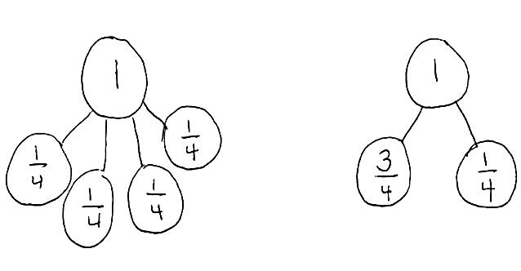
T: (Encourage students to compare the two number bonds just as they did with the number bond of 4.)
T: Look at your Sprint B. Discuss with your partner which of the figures on Sprint B match your number bond.
S: Numbers 3, 6, 9, 11, and 18–25 on Sprint B match my number bond.
Problem 3: Decompose 1 into fifths (2 non-unit fractions).
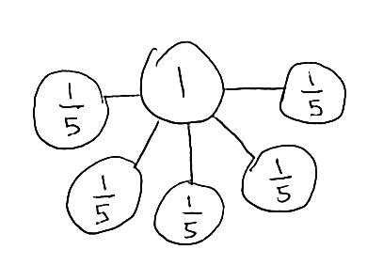
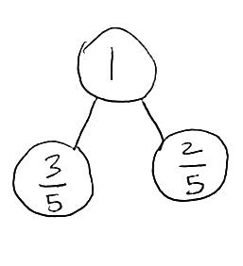
T: Draw a number bond decomposing 1 into 5 unit fractions.
S: (Draw a number bond.)
T: Now, work with your partner to show a number bond decomposing 1 into 2 parts. One part should be composed of 2 copies of the unit fraction.
S: (Work with a partner to draw the number bond.)

NOTES ON
MULTIPLE MEANS
OF ACTION AND EXPRESSION:
When supporting a small group, go step-by-step. Avoid talking and doing at the same time. Draw a number bond in silence. Turn and face the group, and ask them to explain to a partner what they just saw. Then, perform the next action silently. Ask them to explain the action again. Doing this gives them the opportunity to analyze and reconstruct these actions so that they internalize a process they can use.

T: What unit fraction did we copy to make the number
2 fifths?
S: 1 fifth.
T: What are the two parts of your number bond? Please specify the unit.
S: 2 fifths and 3 fifths.
T: Look at your Sprint B. Discuss with your partner which of these figures match your number bond.
S: Numbers 30–33 on Sprint B match my number bond.
T: Yes, 3 fifths can represent either the shaded or un-shaded part.
After doing these three problems, having students use the same process to model Questions 1, 12, 28, 39, and 44 from Sprint B could be helpful. Ask them to find other models on the Sprint that are represented by the same bond.

Problem Set (10 minutes)
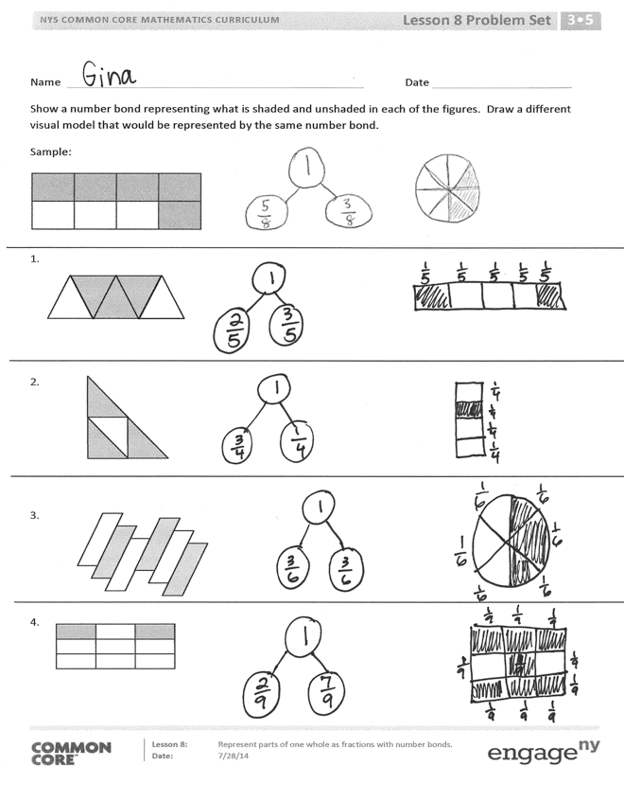
Students should do their personal best to complete the Problem Set within the allotted 10 minutes. For some classes, it may be appropriate to modify the assignment by specifying which problems they work on first. Some problems do not specify a method for solving. Students should solve these problems using the RDW approach used for Application Problems.
Student Debrief (10 minutes)
Lesson Objective: Represent parts of one whole as fractions with number bonds.
The Student Debrief is intended to invite reflection and active processing of the total lesson experience.
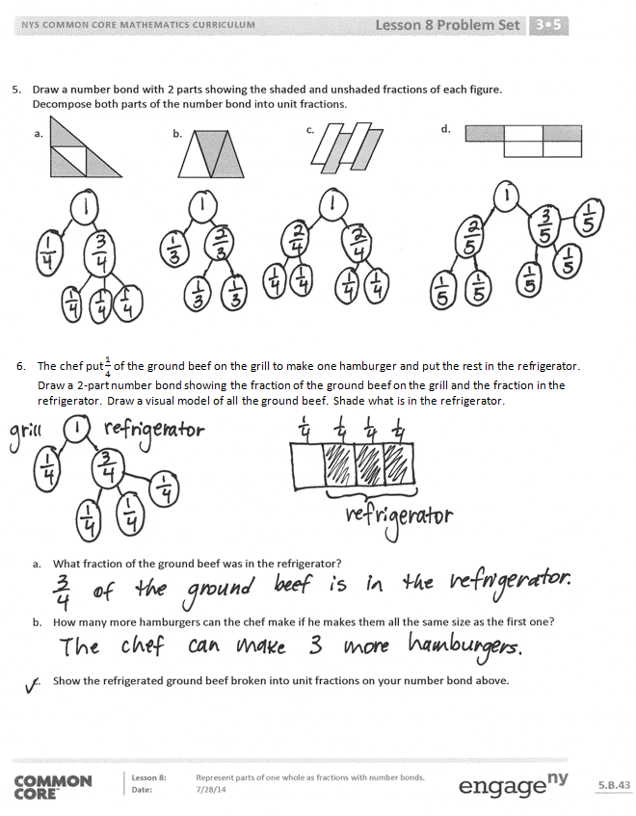
Invite students to review their solutions for the Problem Set. They should check work by comparing answers with a partner before going over answers as a class. Look for misconceptions or misunderstandings that can be addressed in the Debrief. Guide students in a conversation to debrief the Problem Set and process the lesson.
Any combination of the questions below may be used to lead the discussion.
- Share different representations for Problem 6 about the hamburger. Guide students to see that the chef’s refrigerated meat can be made into 3 more burgers and that each of those burgers is $\frac{1}{4}$ of the meat.
- As in Lesson 7’s Debrief, return to the shaded and unshaded figures so that students articulate that 1 whole can ultimately be decomposed into unit fractions. The number bond is a perfect tool for seeing the transition from 1 whole to 2 parts to unit fractions. It is analogous as well to the beginning problem, when the number 4 was decomposed into 4 ones.

Exit Ticket (3 minutes)
After the Student Debrief, instruct students to complete the Exit Ticket. A review of their work will help with assessing students’ understanding of the concepts that were presented in today’s lesson and planning more effectively for future lessons. The questions may be read aloud to the students.

Number Correct: _______
A
Identify Fractions.
 | 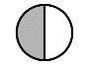 | / |  |  | 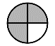 | /
 | 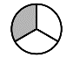 | / |  |  | 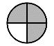 | /
 |  | / |  |  | 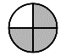 | /
 | 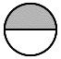 | / |  |  |  | /
 | 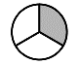 | / |  |  |  | /
 |  | / |  |  | 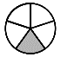 | /
 | 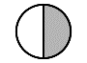 | / |  |  |  | /
 | 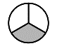 | / |  |  | 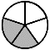 | /
 |  | / |  |  |  | /
 | 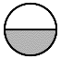 | / |  |  | 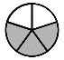 | /
 |  | / |  |  |  | /
 |  | / |  |  | 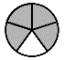 | /
 |  | / |  |  |  | /
 |  | / |  |  |  | /
 |  | / |  |  |  | /
 |  | / |  |  |  | /
 |  | / |  |  |  | /
 | 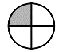 | / |  |  |  | /
 | 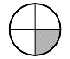 | / |  |  |  | /
 |  | / |  |  |  | /
 |  | / |  |  | 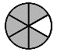 | /
 | 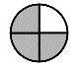 | / |  |  | 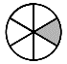 | /

Number Correct: _______
Improvement: _______
B
[KEY]

Identify Fractions.
 |  | / |  |  | 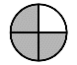 | /
 | 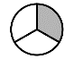 | / |  |  | 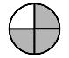 | /
 |  | / |  |  |  | /
 |  | / |  |  |  | /
 |  | / |  |  |  | /
 |  | / |  |  |  | /
 |  | / |  |  | 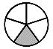 | /
 | 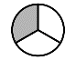 | / |  |  |  | /
 |  | / |  |  |  | /
 |  | / |  |  |  | /
 |  | / |  |  |  | /
 |  | / |  |  |  | /
 |  | / |  |  |  | /
 |  | / |  |  |  | /
 |  | / |  |  |  | /
 |  | / |  |  |  | /
 |  | / |  |  |  | /
 |  | / |  |  |  | /
 |  | / |  |  |  | /
 |  | / |  |  |  | /
 |  | / |  |  |  | /
 | 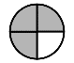 | / |  |  | 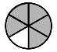 | /

Name Date
Show a number bond representing what is shaded and unshaded in each of the figures. Draw a different visual model that would be represented by the same number bond.
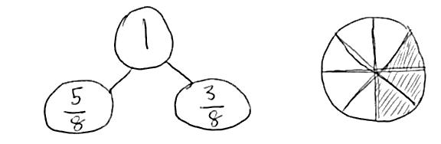
Sample:

- Draw a number bond with 2 parts showing the shaded and unshaded fractions of each figure. Decompose both parts of the number bond into unit fractions.

a.
b.
c.
d.

- The chef put $\frac{1}{4}$ of the ground beef on the grill to make one hamburger and put the rest in the refrigerator. Draw a 2-part number bond showing the fraction of the ground beef on the grill and the fraction in the refrigerator. Draw a visual model of all the ground beef. Shade what is in the refrigerator.

- What fraction of the ground beef was in the refrigerator?

- How many more hamburgers can the chef make if he makes them all the same size as the first one?

- Show the refrigerated ground beef broken into unit fractions on your number bond above.

Name Date
- Draw a number bond that shows the shaded and the unshaded parts of the shape below. Then, show each part decomposed into unit fractions.

- Complete the number bond. Draw a shape that has shaded and unshaded parts that match the completed number bond.
1
$$\frac{2}{7}$$

Name Date
Show a number bond representing what is shaded and unshaded in each of the figures. Draw a different visual model that would be represented by the same number bond.
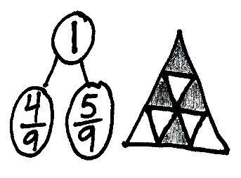
Sample:

- Draw a number bond with 2 parts showing the shaded and unshaded fractions of each figure. Decompose both parts of the number bond into unit fractions.
c.
a.
b.

- Johnny made a square peanut butter and jelly sandwich. He ate $\frac{1}{3}$ of it and left the rest on his plate. Draw a picture of Johnny’s sandwich. Shade the part he left on his plate, and then draw a number bond that matches what you drew. What fraction of his sandwich did Johnny leave on his plate?

