Lesson 7
Objective: Identify and represent shaded and non-shaded parts of one whole as fractions.

Suggested Lesson Structure
 Fluency Practice (12 minutes)
 Application Problem (10 minutes)
 Concept Development (28 minutes)
 Student Debrief (10 minutes)
Total Time (60 minutes)
Fluency Practice (12 minutes)
- Group Counting 3.OA.1 (2 minutes)
- Sprint: Multiply and Divide by Seven 3.OA.4 (8 minutes)
- Skip-Count by Halves on the Clock 3.G.2, 3.NF.1 (2 minutes)
Group Counting (2 minutes)
Materials: (S) Personal white board
Note: Group counting reviews interpreting multiplication as repeated addition.
Direct students to count forward and backward by nine to 90 on their personal white boards.
T: Circle 27. How many nines did you count?
S: 3 nines.
T: What is 27 divided by 9?
S: 3.
Continue with the following possible sequence: 18, 81, 45, 36, 54, 72, 9, and 63.
Sprint: Multiply and Divide by Seven (8 minutes)
Materials: (S) Multiply and Divide by Seven Sprint
Note: This Sprint supports fluency with multiplication and division using units of 7.

Skip-Count by Halves on the Clock (2 minutes)
Materials: (T) Clock
Note: This activity reviews counting by halves on the clock from Module 2.
T: (Hold or project a clock.) Let’s skip-count by halves on the clock starting with 1 o’clock.
S: 1, half past 1, 2, half past 2, 3, half past 3, 4, (switch direction), half past 3, 3, half past 2, 2, half past 1, 1.
Continue counting up and down.

NOTES ON
MULTIPLE MEANS
OF ACTION AND EXPRESSION:
Give explicit steps for problem solving to students working below grade level. These steps can be organized as a checklist such as, “Underline important words, draw a model, label your model.”

Application Problem (10 minutes)
Robert ate half of the applesauce in a container. He split the remaining applesauce equally into 2 bowls for his mother and sister. Robert said, “I ate 1 half, and each of you gets 1 half.”
Is Robert right? Draw a picture to prove your answer.
Extension:
- What fraction of the applesauce did his mother get?
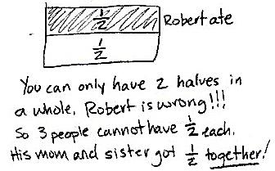
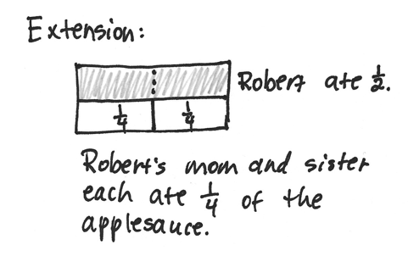
- What fraction of the applesauce did Robert’s sister eat?

NOTES ON
MULTIPLE MEANS
OF REPRESENTATION:
These daily class discussions, as well as “Think-pair-share,” support English language learners’ English language acquisition. They offer students an opportunity to talk about their math ideas in English and actively use the language of mathematics.

Note: This problem reviews the concept that a whole is made of 2 halves. The extension challenges students to see the whole partitioned into halves and fourths.
Concept Development (28 minutes)

NOTES ON
MATERIALS:
If a beaker is not available, use a clear container that has a consistent diameter from bottom to top, and measure the amount of liquid to precisely show the container half full.

Materials: (T) 1-liter beaker, water (S) Paper, scissors, crayons, math journal
Show a beaker of liquid half full.
T: Whisper the fraction of liquid that you see to your partner.
S: 1 half.
T: What about the part that is not full? Talk to your partner: Could that be a fraction, too? Why or why not?
S: No, because there’s nothing there. I disagree. It’s another part. It’s just not full. It’s another half. Because half is full and half is empty. Two halves make one whole.
T: Even though parts might not be full or shaded, they are still part of the whole. Let’s explore this idea some more. I’ll give you 1 sheet of paper. Partition it into equal parts. Just be sure of these 3 things:
- The parts must be equal.
- There are no fewer than 5 and no more than 20 parts in all.
- You use the entire sheet of paper.
S: (Partition by estimating to fold the paper into equal parts.)
T: Now, use a crayon to shade one unit.
S: (Shade one part.)
T: Next, you’re going to cut your whole into parts by cutting along the lines you created when you folded the paper. You’ll reassemble your parts into a unique piece of art for our fraction museum. As you make your art, make sure that all parts are touching but not on top of or under each other.
S: (Cut along the folds and reassemble pieces.)
T: As you tour our museum admiring the art, identify which unit fraction the artist chose and identify the fraction representing the unshaded equal parts of the art. Write both fractions in your journal next to each other.
S: (Walk around and collect data, which will be used in the Debrief portion of the lesson.)
Problem Set (10 minutes)

NOTES ON
MULTIPLE MEANS
OF ENGAGEMENT:
Offer students working above grade level a Problem Set alternative of constructing a word problem for one of the models (pictured in number 10 of the Problem Set). Constructively review errors with students who are accustomed to always scoring correctly or who may be perfectionists.

Students should do their personal best to complete the Problem Set within the allotted 10 minutes. For some classes, it may be appropriate to modify the assignment by specifying which problems they work on first. Some problems do not specify a method for solving. Students should solve these problems using the RDW approach used for Application Problems.
Student Debrief (10 minutes)
Lesson Objective: Identify and represent shaded and
non-shaded parts of one whole as fractions.
The Student Debrief is intended to invite reflection and active processing of the total lesson experience.
Invite students to review their solutions for the Problem Set. They should check work by comparing answers with a partner before going over answers as a class. Look for misconceptions or misunderstandings that can be addressed in the Debrief. Guide students in a conversation to debrief the Problem Set and process the lesson.
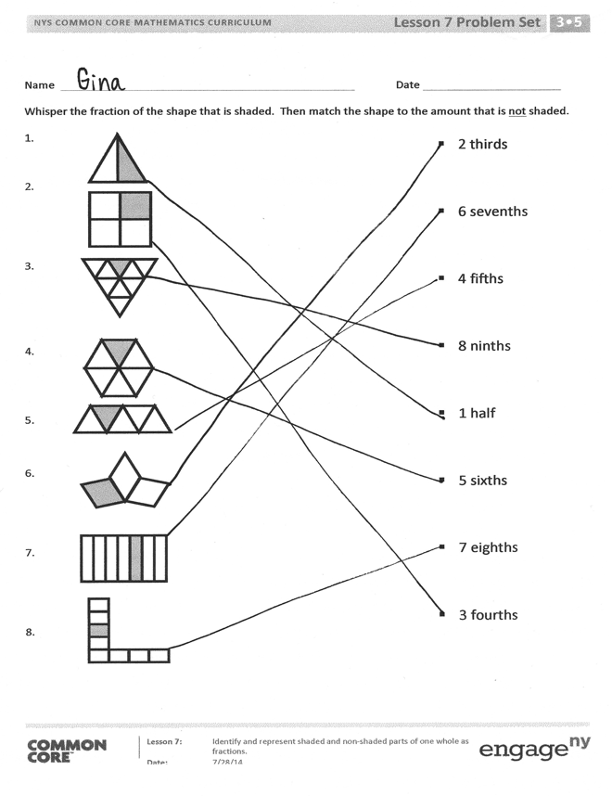
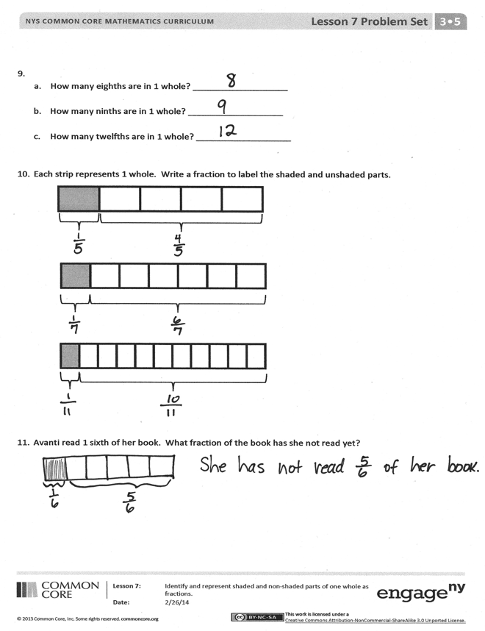
Any combination of the questions below may be used to lead the discussion.
- Show examples of student work for Problem 11. Avanti read 1 sixth of her book. What fraction of her book has she not read yet? Isn’t Avanti’s goal to read the whole book? (Guide students to notice that the whole book can be depicted as the part she has read and the part she has not read.)
MP.3
- From the discussion above the teacher might briefly return to the shaded and unshaded figures in Problem 1 and help students notice that the whole can be expressed as two parts—the shaded and unshaded.
- Revisit students’ art. Guide a discussion helping them recognize that while each student’s art depicts a whole, each whole is composed of different fractional units (e.g., fourths, fifths, or sixths).
Exit Ticket (3 minutes)
After the Student Debrief, instruct students to complete the Exit Ticket. A review of their work will help with assessing students’ understanding of the concepts that were presented in today’s lesson and planning more effectively for future lessons. The questions may be read aloud to the students.

A
Number Correct: _______
Multiply and Divide by Seven
 | 2 × 7 = |  |  |  | ___ × 7 = 70
 | 3 × 7 = |  |  |  | ___ × 7 = 14
 | 4 × 7 = |  |  |  | ___ × 7 = 21
 | 5 × 7 = |  |  |  | 70 ÷ 7 =
 | 1 × 7 = |  |  |  | 35 ÷ 7 =
 | 14 ÷ 7 = |  |  |  | 7 ÷ 7 =
 | 21 ÷ 7 = |  |  |  | 14 ÷ 7 =
 | 35 ÷ 7 = |  |  |  | 21 ÷ 7 =
 | 7 ÷ 7 = |  |  |  | ___ × 7 = 42
 | 28 ÷ 7 = |  |  |  | ___ × 7 = 49
 | 6 × 7 = |  |  |  | ___ × 7 = 63
 | 7 × 7 = |  |  |  | ___ × 7 = 56
 | 8 × 7 = |  |  |  | 49 ÷ 7 =
 | 9 × 7 = |  |  |  | 63 ÷ 7 =
 | 10 × 7 = |  |  |  | 42 ÷ 7 =
 | 56 ÷ 7 = |  |  |  | 56 ÷ 7 =
 | 49 ÷ 7 = |  |  |  | 11 × 7 =
 | 63 ÷ 7 = |  |  |  | 77 ÷ 7 =
 | 42 ÷ 7 = |  |  |  | 12 × 7 =
 | 70 ÷ 7 = |  |  |  | 84 ÷ 7 =
 | ___ × 7 = 35 |  |  |  | 14 × 7 =
 | ___ × 7 = 7 |  |  |  | 98 ÷ 7 =
B
[KEY]

Number Correct:
Improvement:
Multiply and Divide by Seven
 | 1 × 7 = |  |  |  | × 7 = 14
 | 2 × 7 = |  |  |  | × 7 = 70
 | 3 × 7 = |  |  |  | × 7 = 21
 | 4 × 7 = |  |  |  | 14 ÷ 7 =
 | 5 × 7 = |  |  |  | 7 ÷ 7 =
 | 21 ÷ 7 = |  |  |  | 70 ÷ 7 =
 | 14 ÷ 7 = |  |  |  | 35 ÷ 7 =
 | 28 ÷ 7 = |  |  |  | 21 ÷ 7 =
 | 7 ÷ 7 = |  |  |  | × 7 = 21
 | 35 ÷ 7 = |  |  |  | × 7 = 28
 | 10 × 7 = |  |  |  | × 7 = 63
 | 6 × 7 = |  |  |  | × 7 = 49
 | 7 × 7 = |  |  |  | 56 ÷ 7 =
 | 8 × 7 = |  |  |  | 63 ÷ 7 =
 | 9 × 7 = |  |  |  | 42 ÷ 7 =
 | 49 ÷ 7 = |  |  |  | 49 ÷ 7 =
 | 42 ÷ 7 = |  |  |  | 11 × 7 =
 | 56 ÷ 7 = |  |  |  | 77 ÷ 7 =
 | 70 ÷ 7 = |  |  |  | 12 × 7 =
 | 63 ÷ 7 = |  |  |  | 84 ÷ 7 =
 | × 7 = 7 |  |  |  | 13 × 7 =
 | × 7 = 35 |  |  |  | 91 ÷ 7 =

Name Date
Whisper the fraction of the shape that is shaded. Then, match the shape to the amount that is not shaded.

- 2 thirds

- 6 sevenths

- 4 fifths

- 8 ninths

- 1 half

- 5 sixths

- 7 eighths

- 3 fourths

- a. How many eighths are in 1 whole? _________________

  - How many ninths are in 1 whole? ___________________

  - How many twelfths are in 1 whole? ___________________

- Each strip represents 1 whole. Write a fraction to label the shaded and unshaded parts.

- Avanti read 1 sixth of her book. What fraction of the book has she not read yet?

Name Date
- Write the fraction that is not shaded. 2. There are __________ sixths in 1 whole.

- The fraction strip is 1 whole. Write fractions to label the shaded and unshaded parts.

- Justin mows part of his lawn. Then, his lawnmower runs out of gas. He has not mowed $\frac{9}{10}$ of the lawn. What part of his lawn is mowed?

Name Date
Whisper the fraction of the shape that is shaded. Then, match the shape to the amount that is not shaded.

- 9 tenths

- 4 fifths

- 10 elevenths

- 5 sixths

- 1 half

- 2 thirds

- 3 fourths

- 6 sevenths

- Each strip represents 1 whole. Write a fraction to label the shaded and unshaded parts.

- Carlia finished 1 fourth of her homework on Saturday. What fraction of her homework has she not finished? Draw and explain.

- Jerome cooks 8 cups of oatmeal for his family. They eat 7 eighths of the oatmeal. What fraction of the oatmeal is uneaten? Draw and explain.

