Lesson 6
Objective: Build non-unit fractions less than one whole from unit fractions.

Suggested Lesson Structure
 Fluency Practice (12 minutes)
 Application Problem (10 minutes)
 Concept Development (28 minutes)
 Student Debrief (10 minutes)
Total Time (60 minutes)
Fluency Practice (12 minutes)
- Sprint: Multiply with Seven 3.OA.4 (8 minutes)
- Write the Unit Fraction 3.G.2, 3.NF.1 (2 minutes)
- Find the Whole 3.NF.3d (2 minutes)
Sprint: Multiply with Seven (8 minutes)
Materials: (S) Multiply with Seven Sprint
Note: This Sprint supports fluency with multiplication using units of 7.
Write the Unit Fraction (2 minutes)
Materials: (S) Personal white board
Note: This activity reviews naming unit fractions from Lesson 5.
T: (Draw a shape with $\frac{1}{2}$ shaded.) Write the unit fraction.
S: (Write $\frac{1}{2}$.)
Continue with the following possible sequence: $\frac{1}{4}, \frac{1}{8}, \frac{1}{ 6}, \frac{1}{10},$ and $\frac{1}{5}$.
Find the Whole (2 minutes)
Note: This activity prepares students for their work with non-unit fractions in this lesson.
T: (Project a number bond with parts $\frac{3}{5}$ and $\frac{2}{5}$.) Say the bigger part.
S: 3 fifths.

T: Say the smaller part.
S: 2 fifths.
T: How many fifths are in the whole?
S: 5 fifths.
T: (Write $\frac{5}{5}$ in the whole space.) Say the number sentence.
S: 3 fifths and 2 fifths equals 5 fifths.
Continue with the following possible sequence: $\frac{7}{10} and \frac{3}{10}, \frac{5}{8} and \frac{3}{8}.$ Replace 8 eighths with 1 whole.
Application Problem (10 minutes)
Chloe’s dad partitions his garden into 4 equal-sized sections to plant tomatoes, squash, peppers, and cucumbers. What fraction of the garden is available for growing tomatoes?
Extension: Chloe talked her dad into planting beans and lettuce, too. He used equal-sized sections for all the vegetables. What fraction do the tomatoes have now?
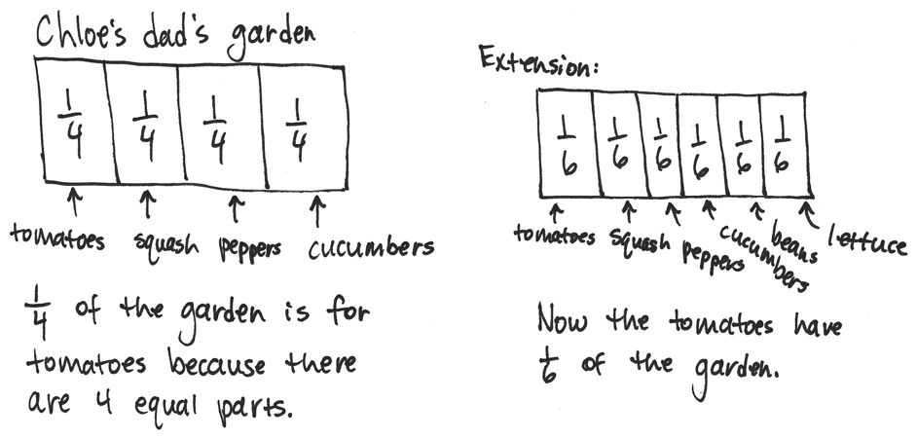
Note: This problem reviews partitioning shapes into equal parts and naming unit fractions.
Concept Development (28 minutes)
Materials: (S) Personal white board

NOTES ON
MULTIPLE MEANS
OF REPRESENTATION:
Recording choral responses on the board alongside the model supports English language acquisition.

T: Here is unit form. (Write 1 half.) Here it is written in fraction form. (Write $\frac{1}{2}$.) What does the 2 mean?
S: 2 is the number of equal parts that the whole is cut into.
T: What does the 1 mean?
S: We are talking about 1 of the equal parts.

Shape 1:

NOTES ON
MULTIPLE MEANS
OF REPRESENTATION:
To assist comprehension, develop multiple ways to ask the same question, for example, by changing the question, “What’s happening to my parts?” to “How are my parts changing?” or “Do you notice an increase or decrease?” or “Is the amount growing or shrinking?”

T: (Project or draw a circle partitioned into thirds.) This is 1 whole.
2 thirds; $\frac{2}{3}$

T: What unit is it partitioned into?
S: Thirds.
T: What is the unit fraction?
S: 1 third.
T: (Shade 1 third.) I’m going to make a copy of my shaded unit fraction. (Shade one more unit.)
How many units are shaded now?
S: 2 thirds.
T: Let’s count them.
S: 1 third, 2 thirds.
T: We can write the number 2 thirds in unit form (Write 2 thirds under the circle.) or fraction form. (Write $\frac{2}{3}$ under the circle.) What happened to our unit fraction when we made a copy? Turn and share.
S: We started with one unit shaded and then shaded in another unit to make a copy. 2 copies make
2 thirds. True. That’s why we changed 1 third to 2 thirds. Now we’re talking about 2 copies.
T: Yes! Just like 2 copies of one make 2, we can make 2 copies of 1 third to make 2 thirds.
Continue with the following suggested shapes. Students identify the unit fraction and then make copies to build the new fraction.
Shape 2: Shape 3:
5 eighths; $\frac{5}{8}$
3 quarters or 3 fourths; $\frac{3}{4}$

Students transition into guided practice using personal white boards.

NOTES ON
MULTIPLE MEANS
OF ENGAGEMENT:
Offer students working above grade level a Problem Set alternative of constructing written responses to open-ended questions, such as, “What do these wholes and fractions (pictured on the Problem Set) remind you of?”

Give the following directions:
- Draw a unit fraction (select examples).
- Make copies of the unit fraction to build a new fraction.
- Count the unit fractions.
- Identify the new fraction both in unit form and fraction form.
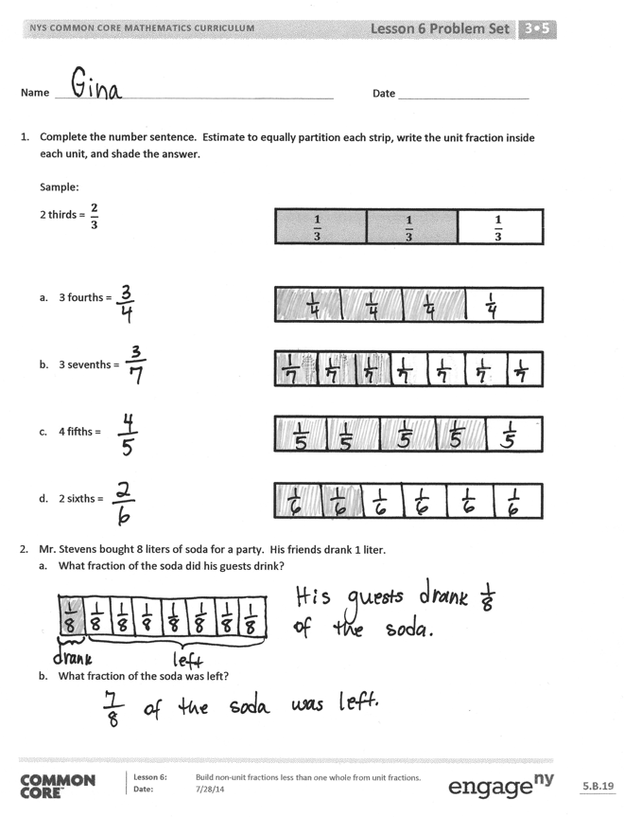
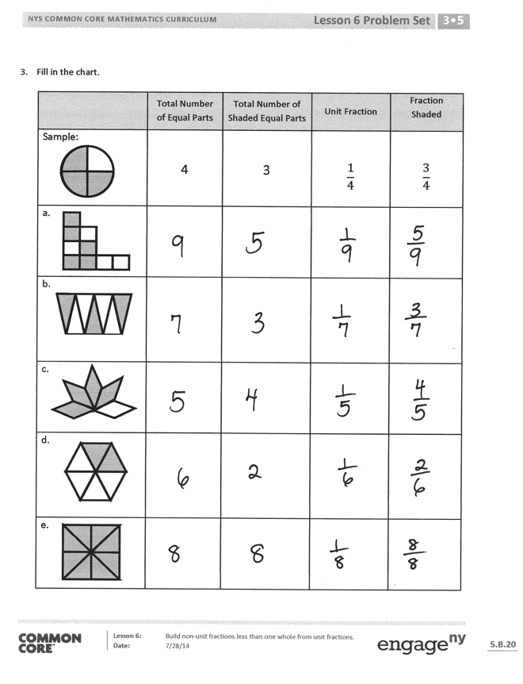
Problem Set (10 minutes)
Students should do their personal best to complete the Problem Set within the allotted 10 minutes. For some classes, it may be appropriate to modify the assignment by specifying which problems they work on first. Some problems do not specify a method for solving. Students should solve these problems using the RDW approach used for Application Problems.
Student Debrief (10 minutes)
Lesson Objective: Build non-unit fractions less than one whole from unit fractions.
The Student Debrief is intended to invite reflection and active processing of the total lesson experience.
Invite students to review their solutions for the Problem Set. They should check work by comparing answers with a partner before going over answers as a class. Look for misconceptions or misunderstandings that can be addressed in the Debrief. Guide students in a conversation to debrief the Problem Set and process the lesson.
- Through discussion, guide students to articulate the idea that to show non-unit fractions, they create copies of unit fractions. This resembles counting 3 ones to make 3, or counting by eights to make copies of 8.
Exit Ticket (3 minutes)
After the Student Debrief, instruct students to complete the Exit Ticket. A review of their work will help with assessing students’ understanding of the concepts that were presented in today’s lesson and planning more effectively for future lessons. The questions may be read aloud to the students.

Number Correct:
A
Multiply with Seven
 | 1 × 7 = |  |  |  | 10 × 7 =
 | 7 × 1 = |  |  |  | 9 × 7 =
 | 2 × 7 = |  |  |  | 4 × 7 =
 | 7 × 2 = |  |  |  | 8 × 7 =
 | 3 × 7 = |  |  |  | 7 × 3 =
 | 7 × 3 = |  |  |  | 7 × 7 =
 | 4 × 7 = |  |  |  | 6 × 7 =
 | 7 × 4 = |  |  |  | 7 × 10 =
 | 5 × 7 = |  |  |  | 7 × 5 =
 | 7 × 5 = |  |  |  | 7 × 6 =
 | 6 × 7 = |  |  |  | 7 × 1 =
 | 7 × 6 = |  |  |  | 7 × 9 =
 | 7 × 7 = |  |  |  | 7 × 4 =
 | 8 × 7 = |  |  |  | 7 × 3 =
 | 7 × 8 = |  |  |  | 7 × 2 =
 | 9 × 7 = |  |  |  | 7 × 7 =
 | 7 × 9 = |  |  |  | 7 × 8 =
 | 10 × 7 = |  |  |  | 11 × 7 =
 | 7 × 10 = |  |  |  | 7 × 11 =
 | 7 × 3 = |  |  |  | 12 × 7 =
 | 1 × 7 = |  |  |  | 7 × 12 =
 | 2 × 7 = |  |  |  | 13 × 7 =
B
[KEY]

Number Correct:
Improvement:
Multiply with Seven
 | 7 × 1 = |  |  |  | 9 × 7 =
 | 1 × 7 = |  |  |  | 3 × 7 =
 | 7 × 2 = |  |  |  | 8 × 7 =
 | 2 × 7 = |  |  |  | 4 × 7 =
 | 7 × 3 = |  |  |  | 7 × 7 =
 | 3 × 7 = |  |  |  | 5 × 7 =
 | 7 × 4 = |  |  |  | 6 × 7 =
 | 4 × 7 = |  |  |  | 7 × 5 =
 | 7 × 5 = |  |  |  | 7 × 10 =
 | 5 × 7 = |  |  |  | 7 × 1 =
 | 7 × 6 = |  |  |  | 7 × 6 =
 | 6 × 7 = |  |  |  | 7 × 4 =
 | 7 × 7 = |  |  |  | 7 × 9 =
 | 7 × 8 = |  |  |  | 7 × 2 =
 | 8 × 7 = |  |  |  | 7 × 7 =
 | 7 × 9 = |  |  |  | 7 × 3 =
 | 9 × 7 = |  |  |  | 7 × 8 =
 | 7 × 10 = |  |  |  | 11 × 7 =
 | 10 × 7 = |  |  |  | 7 × 11 =
 | 1 × 7 = |  |  |  | 12 × 7 =
 | 10 × 7 = |  |  |  | 7 × 12 =
 | 2 × 7 = |  |  |  | 13 × 7 =

Name Date
- Complete the number sentence. Estimate to partition each strip equally, write the unit fraction inside each unit, and shade the answer.
Sample:
$$\frac{2}{3}$$
2 thirds =
$$\frac{1}{3}$$
$$\frac{1}{3}$$
$$\frac{1}{3}$$

- 3 fourths =

- 3 sevenths =

- 4 fifths =

- 2 sixths =

- Mr. Stevens bought 8 liters of soda for a party. His guests drank 1 liter.
- What fraction of the soda did his guests drink?

- What fraction of the soda was left?

- Fill in the chart.
 | Total Number of Equal Parts | Total Number of Shaded Equal Parts | Unit Fraction | Fraction Shaded
Sample: | 4 | 3 | $$\frac{1}{4}$$ | $$\frac{3}{4}$$
a.

b.

c.

d.

e.

Name Date
- Complete the number sentence. Estimate to partition the strip equally. Write the unit fraction inside each unit. Shade the answer.
2 fifths =

- What fraction of the circle is shaded?

- What fraction of the circle is not shaded?

- Complete the chart.
 | Total Number of Equal Parts | Total Number of Shaded Equal Parts | Unit Fraction | Fraction Shaded

Name Date
- Complete the number sentence. Estimate to partition each strip equally, write the unit fraction inside each unit, and shade the answer.

Sample:

$$\frac{1}{4}$$

$$\frac{1}{4}$$

$$\frac{1}{4}$$

$$\frac{1}{4}$$

$$\frac{3}{4}$$
3 fourths =

- 2 thirds =

- 5 sevenths =

- 3 fifths =

- 2 eighths =

- Mr. Abney bought 6 kilograms of rice. He cooked 1 kilogram of it for dinner.
- What fraction of the rice did he cook for dinner?

- What fraction of the rice was left?

- Fill in the chart.
 | Total Number of Equal Parts | Total Number of Shaded Equal Parts | Unit Fraction | Fraction Shaded
Sample: | 6 | 5 | $$\frac{1}{6}$$ | $$\frac{5}{6}$$
a.

b.

c.

d.

