Lesson 4
Objective: Represent and identify fractional parts of different wholes.

Suggested Lesson Structure
 Fluency Practice (11 minutes)
 Application Problem (4 minutes)
 Concept Development (35 minutes)
 Student Debrief (10 minutes)
Total Time (60 minutes)
Fluency Practice (11 minutes)
- Sprint: Multiply and Divide by Six 3.OA.4 (9 minutes)
- Group Counting 3.OA.1 (2 minutes)
Sprint: Multiply and Divide by Six (9 minutes)
Materials: (S) Multiply and Divide by Six Sprint

NOTES ON
MULTIPLE MEANS
OF ACTION AND EXPRESSION:
If students struggle with higher multiples, have them work with the first 3 or 4 multiples of each number (e.g., 8, 16, 24, 32, 24, 16, 8).
Stop before students become frustrated. End with success.

Note: This Sprint supports fluency with multiplication and division using units of 6.
Group Counting (2 minutes)
Note: Group counting reviews interpreting multiplication as repeated addition.
Direct students to count forward and backward, occasionally changing the direction of the count.
- Sixes to 60
- Eights to 80
- Nines to 90
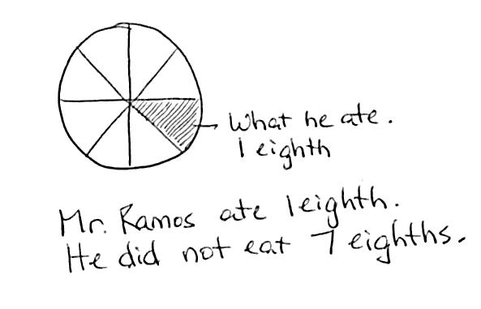
Application Problem (4 minutes)
Mr. Ramos sliced an orange into 8 equal pieces. He ate 1 slice.
Draw a picture to represent the 8 slices of an orange. Shade in the slice
Mr. Ramos ate. What fraction of the orange did Mr. Ramos eat?
What fraction did he not eat?
Note: This problem reviews the skills learned in Topic A.
Concept Development (35 minutes)
Materials: (S) Problem Set, see additional items for stations listed below

NOTES ON
MULTIPLE MEANS
OF ENGAGEMENT:
Organize students working below grade level at the stations with easier fractional units and students working above grade level at stations with the most challenging fractional units. To create a greater challenge, make stations for sevenths and twelfths.

Exploration: Students work at stations to represent a given fractional unit using a variety of materials. Designate the following stations for groups of 3 students (more than 3 not suggested).
Station A: Halves Station E: Sixths
Station B: Fourths Station F: Ninths
Station C: Eighths Station G: Fifths
Station D: Thirds Station H: Tenths
Equip each station with the following suggested materials:
- 1-meter length of yarn
- 1 rectangular piece of yellow construction paper (1” × 12”)
- 1 piece of brown construction paper (candy bar) (2” × 6”)
- 1 square piece of orange construction paper (4” × 4”)
- A large cup containing a whole amount of water that corresponds to the denominator of the station’s fractional unit (e.g., the fourths station gets a whole of 4 ounces of water)
- A number of small, clear plastic cups corresponding to the denominator of the station’s fractional unit (e.g., the fourths station gets 4 cups)
- A 200-gram ball of clay or play dough (be sure to have precisely the same amount at each station)
To help students start, give as little direction as possible but enough depending on the particular class. It is suggested that students work without scissors or cutting. Paper and yarn can be folded. Pencil can be used on paper to designate equal parts rather than folding.
Below are some possible directions for students:
- You will partition each item and make a display at your station according to your fractional unit.
- Each item at your station represents 1 whole. You must use all of each whole. (For example, if showing thirds, all of the clay must be used.)
- Use your fractional unit to show each whole partitioned into equal parts.
- Partition the clay by dividing it into smaller equal pieces. (Possibly do this by forming the clay into equal-sized balls. If necessary, demonstrate.)
- Partition the whole amount of water by estimating to pour equal amounts from the large cup into each of the smaller cups. The water in each smaller cup represents an equal part of the whole.
Give students 15 minutes to create their display. Next, conduct a museum walk where they tour the work of the other stations.

Before the museum walk, chart and review the following points. If the analysis dwindles during the tour, circulate and refer students back to the chart. Students complete their Problem Sets as they move between stations; they may also use their Problem Sets as a guide.

NOTES ON
MULTIPLE MEANS
OF ACTION AND EXPRESSION:
As students move around the room during the museum walk, have them gently pick up the materials to encourage better analysis. This encourages more conversation, too.

- Identify the fractional unit.
- Think about how the units relate to each other at that station.
- Compare the yarn to the yellow strip.
- Compare the yellow strip to the brown paper or candy bar.
- Compare the water to the clay.
- Think about how that unit relates to your own and to other units.
Student Debrief (10 minutes)
Lesson Objective: Represent and identify fractional parts of different wholes.
The Student Debrief is intended to invite reflection and active processing of the total lesson experience.
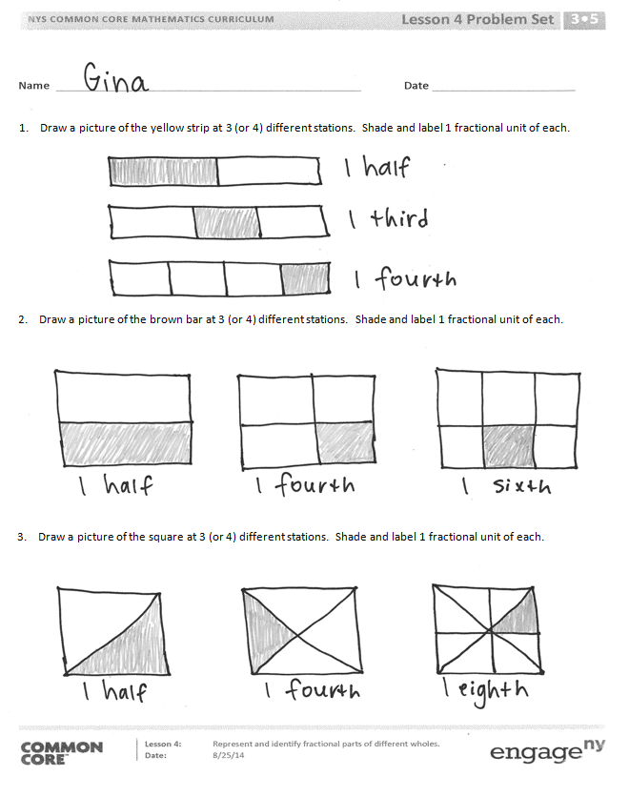
Invite students to review their solutions for the Problem Set. They should check work by comparing answers with a partner before going over answers as a class. Look for misconceptions or misunderstandings that can be addressed in the Debrief. Guide students in a conversation to debrief the Problem Set and process the lesson.
Any combination of the questions below may be used to lead the discussion.
- What was the same at each station? What was different?
- What different fractional units did you see as you went from station to station?
- What did you notice about different fractional units at the stations?
- Which fractional units had the most equal parts?
- Which fractional units had the least equal parts?
- What surprised you when you were looking at the different fractional units?

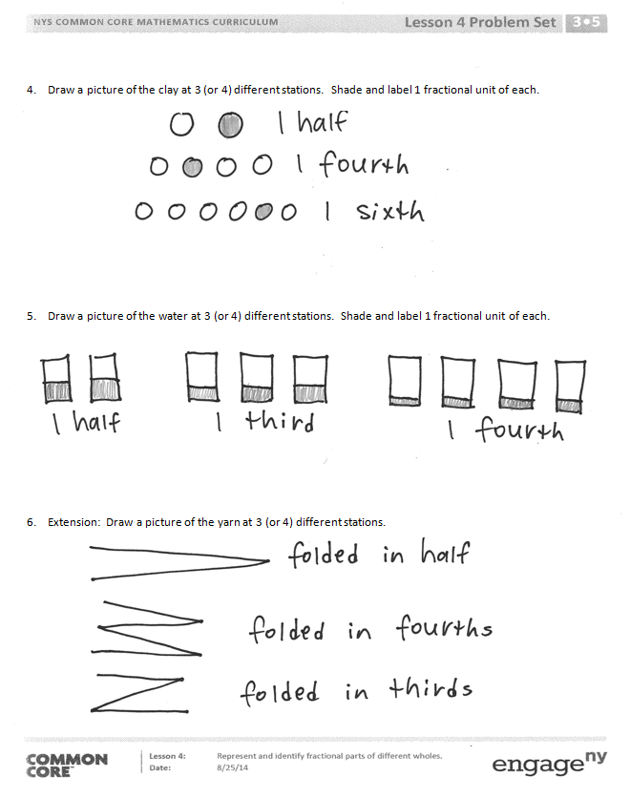
Exit Ticket (3 minutes)
After the Student Debrief, instruct students to complete the Exit Ticket. A review of their work will help with assessing students’ understanding of the concepts that were presented in today’s lesson and planning more effectively for future lessons. The questions may be read aloud to the students.
Number Correct:
A
Multiply and Divide by Six
 | 2 × 6 = |  |  |  | × 6 = 60
 | 3 × 6 = |  |  |  | × 6 = 12
 | 4 × 6 = |  |  |  | × 6 = 18
 | 5 × 6 = |  |  |  | 60 ÷ 6 =
 | 1 × 6 = |  |  |  | 30 ÷ 6 =
 | 12 ÷ 6 = |  |  |  | 6 ÷ 6 =
 | 18 ÷ 6 = |  |  |  | 12 ÷ 6 =
 | 30 ÷ 6 = |  |  |  | 18 ÷ 6 =
 | 6 ÷ 6 = |  |  |  | × 6 = 36
 | 24 ÷ 6 = |  |  |  | × 6 = 42
 | 6 × 6 = |  |  |  | × 6 = 54
 | 7 × 6 = |  |  |  | × 6 = 48
 | 8 × 6 = |  |  |  | 42 ÷ 6 =
 | 9 × 6 = |  |  |  | 54 ÷ 6 =
 | 10 × 6 = |  |  |  | 36 ÷ 6 =
 | 48 ÷ 6 = |  |  |  | 48 ÷ 6 =
 | 42 ÷ 6 = |  |  |  | 11 × 6 =
 | 54 ÷ 6 = |  |  |  | 66 ÷ 6 =
 | 36 ÷ 6 = |  |  |  | 12 × 6 =
 | 60 ÷ 6 = |  |  |  | 72 ÷ 6 =
 | × 6 = 30 |  |  |  | 14 × 6 =
 | × 6 = 6 |  |  |  | 84 ÷ 6 =

B
[KEY]

Number Correct:
Improvement:
Multiply and Divide by Six
 | 1 × 6 = |  |  |  | × 6 = 12
 | 2 × 6 = |  |  |  | × 6 = 60
 | 3 × 6 = |  |  |  | × 6 = 18
 | 4 × 6 = |  |  |  | 12 ÷ 6 =
 | 5 × 6 = |  |  |  | 6 ÷ 6 =
 | 18 ÷ 6 = |  |  |  | 60 ÷ 6 =
 | 12 ÷ 6 = |  |  |  | 30 ÷ 6 =
 | 24 ÷ 6 = |  |  |  | 18 ÷ 6 =
 | 6 ÷ 6 = |  |  |  | × 6 = 18
 | 30 ÷ 6 = |  |  |  | × 6 = 24
 | 10 × 6 = |  |  |  | × 6 = 54
 | 6 × 6 = |  |  |  | × 6 = 42
 | 7 × 6 = |  |  |  | 48 ÷ 6 =
 | 8 × 6 = |  |  |  | 54 ÷ 6 =
 | 9 × 6 = |  |  |  | 36 ÷ 6 =
 | 42 ÷ 6 = |  |  |  | 42 ÷ 6 =
 | 36 ÷ 6 = |  |  |  | 11 × 6 =
 | 48 ÷ 6 = |  |  |  | 66 ÷ 6 =
 | 60 ÷ 6 = |  |  |  | 12 × 6 =
 | 54 ÷ 6 = |  |  |  | 72 ÷ 6 =
 | × 6 = 6 |  |  |  | 13 × 6 =
 | × 6 = 30 |  |  |  | 78 ÷ 6 =

Name Date
- Draw a picture of the yellow strip at 3 (or 4) different stations. Shade and label 1 fractional unit of each.

- Draw a picture of the brown bar at 3 (or 4) different stations. Shade and label 1 fractional unit of each.

- Draw a picture of the square at 3 (or 4) different stations. Shade and label 1 fractional unit of each.

- Draw a picture of the clay at 3 (or 4) different stations. Shade and label 1 fractional unit of each.

- Draw a picture of the water at 3 (or 4) different stations. Shade and label 1 fractional unit of each.

- Extension: Draw a picture of the yarn at 3 (or 4) different stations.

Name Date
Each shape is 1 whole. Estimate to equally partition the shape and shade to show the given fraction.

- 1 fourth

- 1 fifth

- The shape represents 1 whole. Write the fraction for the shaded part.

.

The shaded part is

Name Date
Each shape is 1 whole. Estimate to equally partition the shape and shade to show the given fraction.

- 1 half

A B C D

- 1 fourth

A B C D

- 1 third

A B C D

- Each of the shapes represents 1 whole. Match each shape to its fraction.
1 fifth

1 twelfth

1 third

1 fourth

1 half

1 eighth

1 tenth

1 sixth

