Lesson 1
Objective: Specify and partition a whole into equal parts, identifying and counting unit fractions using concrete models.

NOTES ON
STANDARDS ALIGNMENT:
In this module, students work with a variety of fractional units. These fractional units include halves, thirds, fourths, sixths, and eighths, which are specified in the Grade 3 standards, as well as additional fractional units such as fifths, ninths, tenths, and twelfths. These additional fractional units are not part of the Grade 3 standards. Their inclusion in this module combats rigid thinking, encouraging students to see any number as a fractional unit. This bridges to content in Grades 4
and 5 (4.NF.1-7 and 5.NF.1-7). Module 5 assessments do not test the additional fractions.

Suggested Lesson Structure
 Fluency Practice (12 minutes)
 Application Problem (8 minutes)
 Concept Development (32 minutes)
 Student Debrief (8 minutes)
Total Time (60 minutes)
Fluency Practice (12 minutes)
- Group Counting 3.OA.1 (6 minutes)
- Multiplication by Four and Eight 3.OA.4 (6 minutes)
Group Counting (6 minutes)
Materials: (S) Personal white board
Note: Group counting reviews interpreting multiplication as repeated addition. Count forward and backward by fours twice using personal white boards. Pause between each counting sequence so students see improvement on the second try. After doing the fours twice, have students underline multiples of 8 (e.g., 0, 4, 8, 12, 16, 20, 24, 28, 32, 36, 40, 36, 32, 28, 24, 20, 16, 12, 8, 4, 0). Then, count forward and backward by eights twice, pausing between each counting sequence to analyze weak points.
Multiplication by Four and Eight (6 minutes)
Materials: (S) Personal white board (optional)
Note: Choose a mode of delivery (e.g., oral work, personal white boards). This activity reviews multiplication using units of four and eight.
Guide students to write and pair facts of 4 and 8 and uncover the doubling:
2 × 4 = 8 2 × 8 = 16
3 × 4 = 12 3 × 8 = 24
4 × 4 = 16 4 × 8 = 32

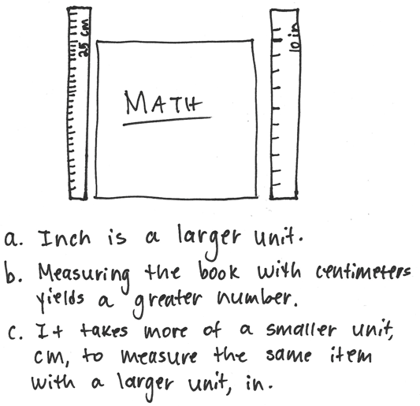
Application Problem (8 minutes)
Materials: (S) Ruler, paper or math book (optional)
Measure the length of your paper or math book using a ruler. Your teacher will tell you whether to measure in inches or centimeters.
Assign partners different units. After students complete the measurement individually and compare answers with a partner, facilitate a discussion using the following suggestions.
- Which is a larger unit—an inch or a centimeter?
- Which would yield a greater number when measuring the book—inches or centimeters?
- Measure at least 2 different items with your partner, again using different units.
What do you notice?
- Change units with your partner. Measure different items again.
Concept Development (32 minutes)

NOTES ON
MULTIPLE MEANS
OF ACTION AND EXPRESSION:
Some students may benefit from a review of how to use a ruler to measure. Suggest the following steps:
1. Identify the 0 mark on the ruler.
2. Line up the 0 mark with the left end of the paper strip.
3. Push down on the ruler as you make your mark.

Materials: (T) 1—clear plastic cup full of colored water,
2—other identical clear plastic cups (empty),
2—12" × 1" strips of construction paper
(S) 2—12" × 1" strips of construction paper, 12-inch ruler
Note: Students should save the fraction strips they create during this lesson for use in future Module 5 lessons.
Part 1: Partition fraction strips into equal parts.
T: Measure your paper strip using inches. How long is it?
S: 12 inches.
T: Make a small mark at 6 inches at both the top and bottom of the strip. Connect the two points with a straight line.
T: (After students do so.) How many equal parts have I split the paper into now?
S: 2.
T: The fractional unit for 2 equal parts is halves. What fraction of the whole strip is one of the parts?
S: 1 half.
T: Point to the halves and count them with me. (Point to each half of the strip as students count “one half, two halves.”) Discuss with your partner how we know these parts are equal.
S: When I fold the strip along the line, the two sides match perfectly. I measured and saw that each part was 6 inches long. The whole strip is 12 inches long. 12 divided by 2 is 6. 6 times 2 or 6 plus 6 is 12, so they are equal in length.
Continue with fourths on the same strip.
Fourths: Repeat the same questions asked when measuring halves. (Students who benefit from a challenge can think about how to find eighths as well.)

NOTES ON
MULTIPLE MEANS
OF REPRESENTATION:
Review and post frequently used vocabulary, such as 1 fourth, accompanied by a picture of 1 fourth,
1 out of 4 equal parts, and $\frac{1}{4}$.

T: Make a small mark at 3 inches and 9 inches at the top and bottom of your strip. Connect the two points with a straight line. How many equal parts do you have now?
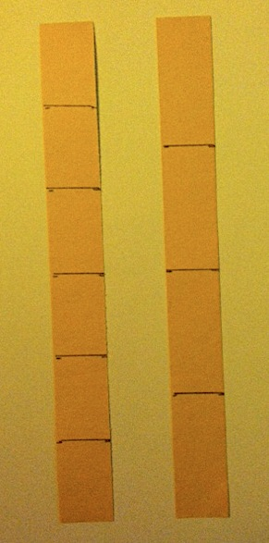
S: 4.
T: The fractional unit for 4 equal parts is fourths. Count the fourths.
S: 1 fourth, 2 fourths, 3 fourths, 4 fourths.
T: Discuss with your partner how you know that these parts are equal.
Distribute a second fraction strip, and repeat the process with thirds and sixths.
Thirds: Have the students mark points at 4 inches and 8 inches at the top and bottom of a new strip. Ask them to identify the fractional unit. Ask them how they know the parts are equal, and then have them count the equal parts, “1 third, 2 thirds, 3 thirds.”
Sixths: Have the students mark points at 2 inches, 6 inches, and 10 inches. Repeat the same process as with halves, fourths, and thirds. Ask students to think about the relationship of the halves to the fourths and the thirds to the sixths.
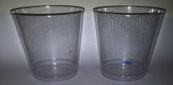
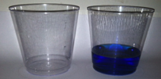
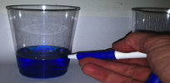
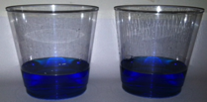
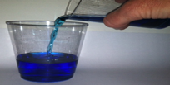
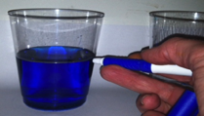
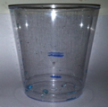
Part 2: Partition a whole amount of liquid into equal parts.
T: Just as we measured a whole strip of paper with a ruler to make halves, let’s now measure precisely to make 2 equal parts of a whole amount of liquid.
Lead a demonstration using the following steps (pictured to the right).
- Present two identical glasses. Make a mark about 1 fourth of the way up the cup to the right.
- Fill the cup to that mark.
- Pour that amount of liquid into the cup on the left, and mark off the top of that amount of liquid.
- Repeat the process. Fill the cup on the right to the mark again, and pour it into the cup on the left.
- Mark the top of the liquid in the cup on the left. The cup on the left now shows the markings for half the amount of water and the whole amount of water.
- Have students discuss how they can make sure the middle mark shows half of the liquid. Compare the strip showing a whole partitioned into 2 equal parts and the liquid partitioned into 2 equal parts. Have students discuss how they are the same and different.
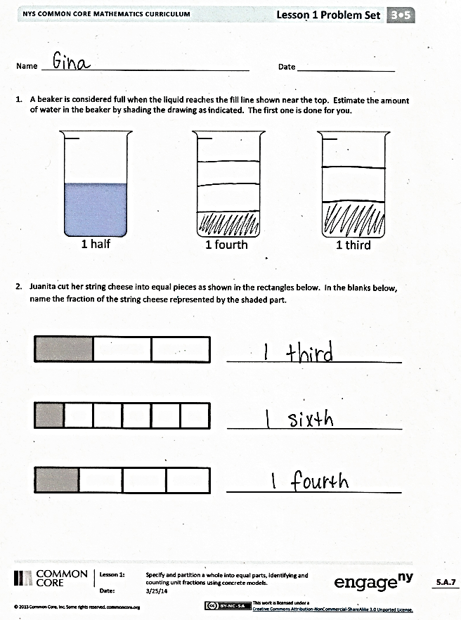
Problem Set (10 minutes)
Students should do their personal best to complete the Problem Set within the allotted 10 minutes. Some problems do not specify a method for solving. This is an intentional reduction of scaffolding that invokes MP.5, Use Appropriate Tools Strategically. Students should solve these problems using the RDW approach used for Application Problems.
For some classes, it may be appropriate to modify the assignment by specifying which problems students should work on first. With this option, let the careful sequencing of the Problem Set guide the selections so that problems continue to be scaffolded. Balance word problems with other problem types to ensure a range of practice. Assign incomplete problems for homework or at another time during the day.
Student Debrief (8 minutes)
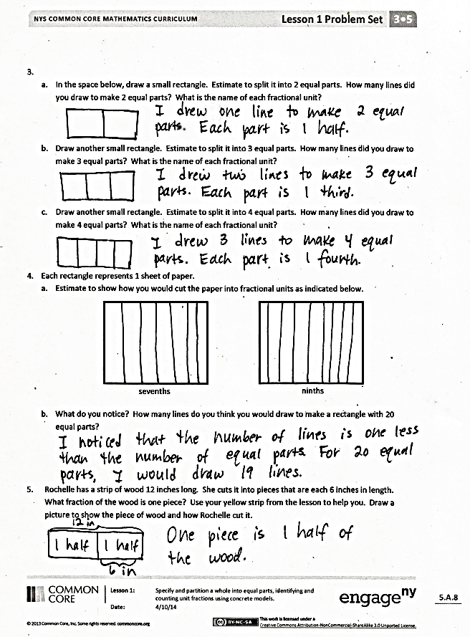
Lesson Objective: Specify and partition a whole into equal parts, identifying and counting unit fractions using concrete models.
The Student Debrief is intended to invite reflection and active processing of the total lesson experience.
Invite students to review their solutions for the Problem Set. They should check work by comparing answers with a partner before going over answers as a class. Look for misconceptions or misunderstandings that can be addressed in the Debrief. Guide students in a conversation to debrief the Problem Set and process the lesson.
Any combination of the questions below may be used to lead the discussion.
- Encourage students to use the words fractional units, equal parts, fraction, whole, halves, fourths, thirds, and sixths.
- The whole in Problem 2 never changes. What happened to the size of an equal part when the string cheese was divided into more parts?
- In Problem 1, which was the harder fraction for you to draw well?
- Using our method with the cups, how could we make a cup that showed thirds?
- In Problem 2, what do you notice about the thirds and sixths? When we marked our measurements on the strips, what did you remember about the measurement of 1 third of the strip and 1 sixth of the strip?
- In Problem 3, did you start drawing fourths by making a half? Can you do the same to draw eighths?
- Walk through the process of estimating to draw a half, then a half of a half to make fourths, etc.
- In Problem 5, let’s look at two different solution strategies and compare them.
Exit Ticket (3 minutes)
After the Student Debrief, instruct students to complete the Exit Ticket. A review of their work will help with assessing students’ understanding of the concepts that were presented in today’s lesson and planning more effectively for future lessons. The questions may be read aloud to the students.

Name Date
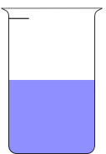
- A beaker is considered full when the liquid reaches the fill line shown near the top. Estimate the amount of water in the beaker by shading the drawing as indicated. The first one is done for you.

1 fourth
1 half
1 third

2. Juanita cut her string cheese into equal pieces as shown in the rectangles below. In the blanks below, name the fraction of the string cheese represented by the shaded part.

- a. In the space below, draw a small rectangle. Estimate to split it into 2 equal parts. How many lines did you draw to make 2 equal parts? What is the name of each fractional unit?

- Draw another small rectangle. Estimate to split it into 3 equal parts. How many lines did you draw to make 3 equal parts? What is the name of each fractional unit?

- Draw another small rectangle. Estimate to split it into 4 equal parts. How many lines did you draw to make 4 equal parts? What is the name of each fractional unit?

- Each rectangle represents 1 sheet of paper.
- Estimate to show how you would cut the paper into fractional units as indicated below.

ninths
sevenths
- What do you notice? How many lines do you think you would draw to make a rectangle with 20 equal parts?

5. Rochelle has a strip of wood 12 inches long. She cuts it into pieces that are each 6 inches in length. What fraction of the wood is one piece? Use your strip from the lesson to help you. Draw a picture to show the piece of wood and how Rochelle cut it.

Name Date
- Name the fraction that is shaded. 2. Estimate to partition the rectangle into thirds.

- A plumber has 12 feet of pipe. He cuts it into pieces that are each 3 feet in length. What fraction of the pipe would one piece represent? (Use your strip from the lesson to help you.)

Name Date
1. A beaker is considered full when the liquid reaches the fill line shown near the top. Estimate the amount of water in the beaker by shading the drawing as indicated. The first one is done for you.
1 half
1 fifth
1 sixth

- Danielle cut her candy bar into equal pieces as shown in the rectangles below. In the blanks below, name the fraction of candy bar represented by the shaded part.

- Each circle represents 1 whole pie. Estimate to show how you would cut the pie into fractional units as indicated below.
halves
thirds
sixths

- Each rectangle represents 1 sheet of paper. Estimate to draw lines to show how you would cut the paper into fractional units as indicated below.
halves
fourths
eighths

- Each rectangle represents 1 sheet of paper. Estimate to draw lines to show how you would cut the paper into fractional units as indicated below.

thirds
sixths

- Yuri has a rope 12 meters long. He cuts it into pieces that are each 2 meters long. What fraction of the rope is one piece? Draw a picture. (You might fold a strip of paper to help you model the problem.)

- Dawn bought 12 grams of chocolate. She ate half of the chocolate. How many grams of chocolate did she eat?

