Lesson 16
Objective: Apply knowledge of area to determine areas of rooms in a given floor plan.

Suggested Lesson Structure
 Fluency Practice (15 minutes)
 Concept Development (35 minutes)
 Student Debrief (10 minutes)
Total Time (60 minutes)
Fluency Practice (15 minutes)
- Group Counting 3.OA.1 (3 minutes)
- Multiply by 9 3.OA.7 (7 minutes)
- Find the Area 3.MD.7 (5 minutes)
Group Counting (3 minutes)
Note: Group counting reviews interpreting multiplication as repeated addition.
Instruct students to count forward and backward, occasionally changing the direction of the count.
- Sixes to 60
- Sevens to 70
- Eights to 80
Multiply by 9 (7 minutes)
Materials: (S) Multiply by 9 (6–10) Pattern Sheet
Note: This activity builds fluency with multiplication facts using units of 9. It works toward students knowing all products of two one-digit numbers from memory. See Lesson 2 for the directions for administration of a Multiply-By Pattern Sheet.
T: (Write 6 × 9 = .) Let’s skip-count up by nine to solve. (Count with fingers to 6 as students count.)
S: 9, 18, 27, 36, 45, 54.
T: Let’s skip-count down to find the answer, too. Start at 90. (Count down with fingers as students count.)
S: 90, 81, 72, 63, 54.
T: Let’s skip-count up again to find the answer, but this time start at 45. (Count up with fingers as students count.)
S: 45, 54.
Continue with the following possible sequence: 8 × 9, 7 × 9, and 9 × 9.
T: (Distribute Multiply by 9 (6–10) Pattern Sheet.) Let’s practice multiplying by 9. Be sure to work left to right across the page.
7 in
5 in
2 in
4 in
6 in
6 in
3 in
2 in
9 in
4 in
4 in
8 in
Find the Area (5 minutes)
Materials: (S) Personal white board
Note: This fluency activity reviews Lesson 14.
T: (Project the first figure on the right.) Find the areas of the large rectangle and the unshaded rectangle. Then, subtract to find the area of the shaded figure. (Write Area = square inches.)
S: (Work and write Area = 27 square inches.)
Continue with other figures.
Concept Development (35 minutes)
Materials: (S) Lesson 15 Problem Set, ruler
T: Today you will continue to find the area of each room in the house in square centimeters.
If students finish early, feel free to use one or both of the following options.
Option 1: Create a floor plan with different side lengths for given areas.
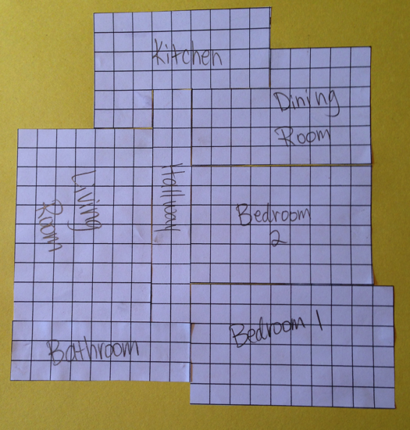
Materials: (S) Centimeter grid (Lesson 3 Template 1), construction paper, glue
Students work with a partner to create a floor plan with the areas of the rooms that they found. The task is for students to find new side lengths for each room. Students should use their answers from the Problem Set to ensure that they find different side lengths with the same area. After they find new side lengths, they mark each room on centimeter grid paper and then cut out the rooms. They use these centimeter grids to fit the rooms together to make their floor plan. They glue their final arrangement of rooms onto a piece of construction paper. Allow students a few minutes to do a gallery walk of the completed floor plans.

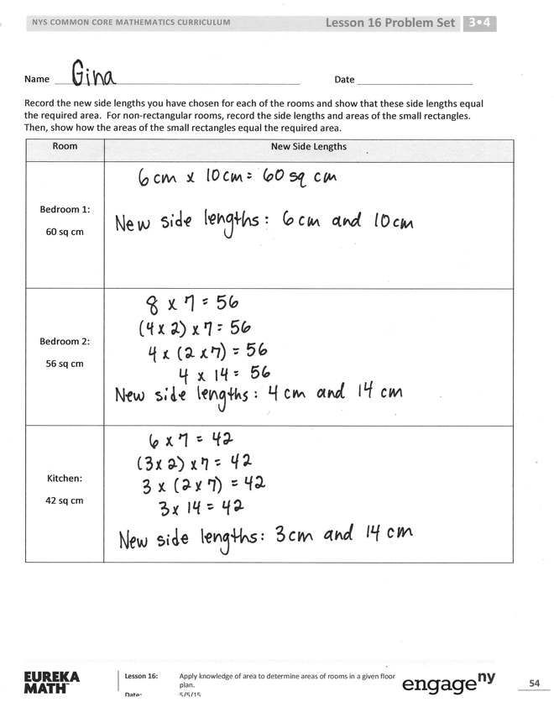
Option 2: Review strategies to find new side lengths of given areas.
Materials: (S) Lesson 16 Problem Set
T: Yesterday you found the areas of the rooms in a floor plan that your clients designed. They like the area of each room, but they want to change the way the rooms look. Your job today is to create rooms with the same areas, but with different side lengths. Are you up for the challenge, architects?
S: Yes!
T: Look at the Problem Set. What is the area of the hallway?
S: 24 square centimeters.
T: What are possible side lengths you can have for the hallway and still have the same area?
S: 3 and 8. 1 and 24. 2 and 12. 6 and 4.
T: Talk to a partner: Which of these choices was used in the floor plan?
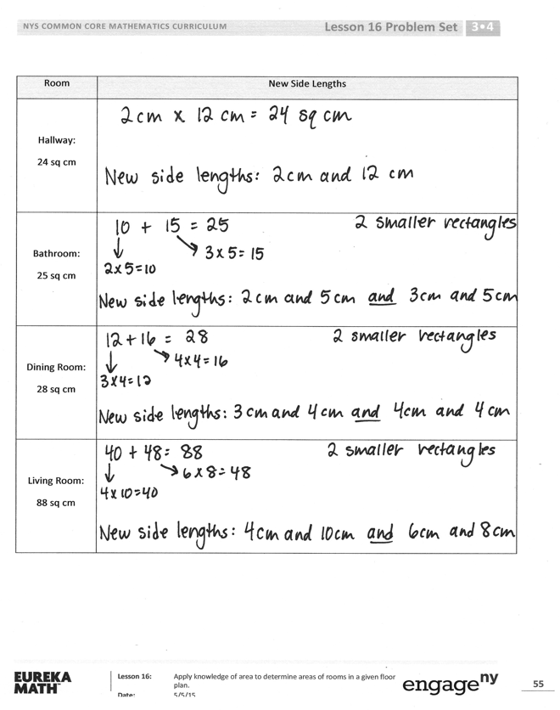
S: 8 and 3. The numbers are just switched.
T: So, when you redesign the floor plan today, be sure you don’t use that combination!
Student Debrief (10 minutes)
Lesson Objective: Apply knowledge of area to determine areas of rooms in a given floor plan.
The Student Debrief is intended to invite reflection and active processing of the total lesson experience.
Invite students to review their solutions for the Problem Set. They should check work by comparing answers with a partner before going over answers as a class. Look for misconceptions or misunderstandings that can be addressed in the Debrief. Guide students in a conversation to debrief the Problem Set and process the lesson.
Any combination of the questions below may be used to lead the discussion.
- Explain to a partner how you found the side lengths of the whole house without using your ruler to measure.
- Can you multiply the side lengths of the house to find the area of the house? Why or why not? How did you find the area of the whole house?
- Do we usually measure rooms in centimeters? What unit might each centimeter in this picture represent on a real house? (Yards, feet, or meters.)
Exit Ticket (3 minutes)
After the Student Debrief, instruct students to complete the Exit Ticket. A review of their work will help with assessing students’ understanding of the concepts that were presented in today’s lesson and planning more effectively for future lessons. The questions may be read aloud to the students.

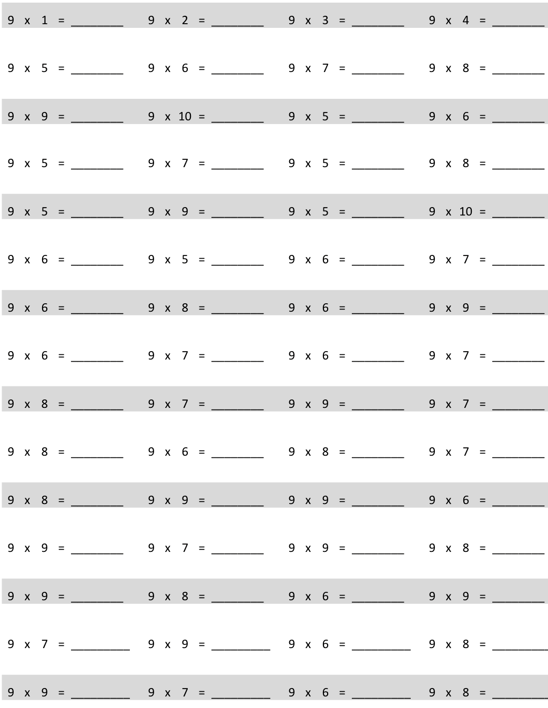
Multiply.
Name Date
Record the new side lengths you have chosen for each of the rooms and show that these side lengths equal the required area. For non-rectangular rooms, record the side lengths and areas of the small rectangles. Then, show how the areas of the small rectangles equal the required area.
Room | New Side Lengths
Bedroom 1:
60 sq cm
Bedroom 2:
56 sq cm
Kitchen:
42 sq cm

Room | New Side Lengths
Hallway:
24 sq cm
Bathroom:
25 sq cm
Dining Room:
28 sq cm
Living Room:
88 sq cm

Name Date
Find the area of the shaded figure. Then, draw and label a rectangle with the same area.
7 cm
4 cm
7 cm
4 cm

Name Date
Jeremy plans and designs his own dream playground on grid paper. His new playground will cover a total area of 100 square units. The chart shows how much space he gives for each piece of equipment, or area.
Use the information in the chart to draw and label a possible way Jeremy can plan his playground.
Basketball court | 10 square units
Jungle gym | 9 square units
Slide | 6 square units
Soccer area | 24 square units

multiply by 9 (6−10)

