Lesson 15
Objective: Apply knowledge of area to determine areas of rooms in a given floor plan.

Suggested Lesson Structure
 Fluency Practice (15 minutes)
 Concept Development (35 minutes)
 Student Debrief (10 minutes)
Total Time (60 minutes)
Fluency Practice (15 minutes)
- Group Counting 3.OA.1 (3 minutes)
- Multiply by 9 3.OA.7 (7 minutes)
- Find the Area 3.MD.7 (5 minutes)
Group Counting (3 minutes)
Note: Group counting reviews interpreting multiplication as repeated addition.
Instruct students to count forward and backward, occasionally changing the direction of the count.
- Threes to 30
- Sixes to 60
- Sevens to 70
- Eights to 80
Multiply by 9 (7 minutes)
Materials: (S) Multiply by 9 (1−5) Pattern Sheet
Note: This activity builds fluency with multiplication facts using units of 9. It works toward students knowing all products of two one-digit numbers from memory. See Lesson 2 for the directions for administration of a Multiply-By Pattern Sheet.
T: (Write 5 × 9 = .) Let’s skip-count by nines to find the answer. (Count with fingers to 5 as students count.)
S: 9, 18, 27, 36, 45. (Record on the board as students count.)

T: (Circle 45 and write 5 × 9 = 45 above it. Write 3 × 9 = .) Let’s skip-count up by nines again. (Count with fingers to 3 as students count.)
S: 9, 18, 27.
T: Let’s see how we can skip-count down to find the answer, too. Start at 45 with 5 fingers,
1 for each 9. (Count down with your fingers as students say numbers.)
S: 45 (5 fingers), 36 (4 fingers), 27 (3 fingers).
Repeat the process for 4 × 9.
T: (Distribute Multiply by 9 (1–5) Pattern Sheet.) Let’s practice multiplying by 9. Be sure to work left to right across the page.
Find the Area (5 minutes)
Materials: (S) Personal white board
Note: This fluency activity reviews the relationship between side lengths and area; additionally, it supports the perception of the composite shape by moving from part to whole using a grid.
T: (Project the figure on the right.) On your personal white board, write a number sentence to show the area of the shaded rectangle.

S: (Write 4 × 2 = 8 or 2 × 4 = 8.)
T: Write a number sentence to show the area of the unshaded rectangle.
S: (Write 3 × 2 = 6 or 2 × 3 = 6.)
T: (Write __ sq units + __ sq units = __ sq units.) Using the areas of the shaded and unshaded rectangles, write an addition sentence to show the area of the entire figure.
S: (Write 8 sq units + 6 sq units = 14 sq units or 6 sq units + 8 sq units = 14 sq units.)
Continue with the figures below:

Concept Development (35 minutes)
A NOTE
TO THE TEACHER:
This lesson is designed to be completed in two days. For early finishers, please refer to the optional activities suggested in Lesson 16.

Materials: (T) Chart paper labeled Strategies We Can Use to Find Area (S) Problem Set, ruler
T: For the next two days, you are going to be architects. Today you are going to use a floor plan that your clients designed to find the area in square centimeters of each room in the house. Look at the floor plan. What will you need to do before you can find the areas?
NOTES ON
MULTIPLE MEANS
OF ACTION AND EXPRESSION:
Some students may benefit from a review of how to use a ruler to measure. Have them try the following:
- Place the zero end of the ruler against the line to be measured.
- Make sure the zero tick mark is lined up against the beginning of the side length.
- Read the last number on the ruler that is by the end of the side length.
To make measuring easier, try the tips below:
- Darken the lines to be measured.
- Outline the lines with glue to make a tactile model.
- Provide large print rulers.
- Give the option of using centimeter blocks to measure.

S: We need to find the side lengths of each room.
We need to know the lengths and widths of the rooms.
T: Use your ruler to measure the side lengths of Bedroom 1 in centimeters. What is the length?
S: 5 centimeters.
T: What is the width?
S: 12 centimeters.
T: Write an expression to show how to find the area of Bedroom 1.
S: (Write 5 × 12.)
T: (Write Multiply Side Lengths on a chart labeled Strategies We Can Use to Find Area.) What strategy can you use to find the area since this fact is so large?
S: The break apart and distribute strategy!
T: (Add the strategy to the chart.) What about the rooms that aren’t rectangles, how will you find their areas?
S: We can find the areas of smaller rectangles and add them together to get the area of a room that isn’t rectangular. Yes, that’s the break apart and add strategy we just learned. Or, we might be able to find the area of a large rectangle and then subtract the area of a smaller rectangle.
T: (Add the strategies to the chart.) Look at the floor plan and use what we’ve learned about area to help you answer Problem 1. (Allow students time to answer Problem 1.) Work with a partner to find the areas of the rooms and the hallway in the floor plan. Record the areas and the strategy you use to find each area in the chart in Problem 2.

Problem Set (20 minutes)
NOTES ON
MULTIPLE MEANS
OF ACTION AND EXPRESSION:
To ease the task of constructing a response for Problems 3–5 of the Problem Set, allow English language learners and others to discuss their reasoning before writing. Discussions can be in first languages, if beneficial. Also provide English language learners with sentence frames, such as those given below.
- The _____ has the biggest area.
My prediction was right/wrong because_____.
- There are/are not enough tiles because _____.

Students should do their personal best to complete the Problem Set within the allotted 20 minutes. For some classes, it may be appropriate to modify the assignment by specifying which problems they work on first. Some problems do not specify a method for solving. Students should solve these problems using the RDW approach used for Application Problems.
Student Debrief (10 minutes)
Lesson Objective: Apply knowledge of area to determine areas of rooms in a given floor plan.
The Student Debrief is intended to invite reflection and active processing of the total lesson experience.
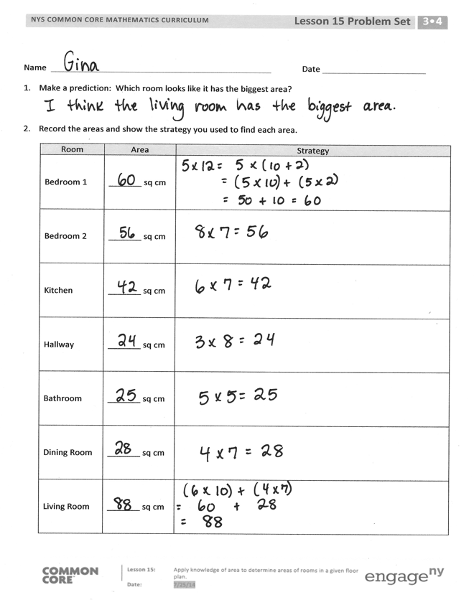
Invite students to review their solutions for the Problem Set. They should check work by comparing answers with a partner before going over answers as a class. Look for misconceptions or misunderstandings that can be addressed in the Debrief. Guide students in a conversation to debrief the Problem Set and process the lesson.
Any combination of the questions below may be used to lead the discussion.
- Explain to a partner your choice for the prediction you made in Problem 1. What have you learned about area that helped you make your prediction?
- What strategy did you use to find the area of the living room? Is there more than one way to break apart the living room into smaller rectangles? Explain two different ways to a partner.
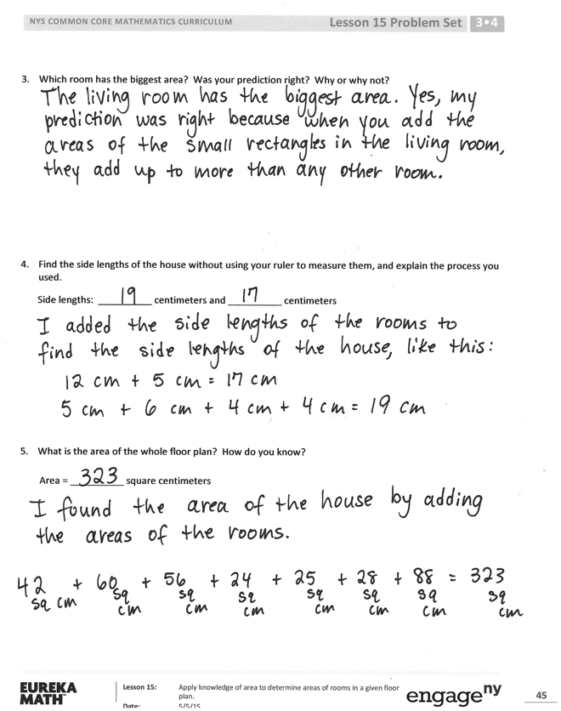
Exit Ticket (3 minutes)
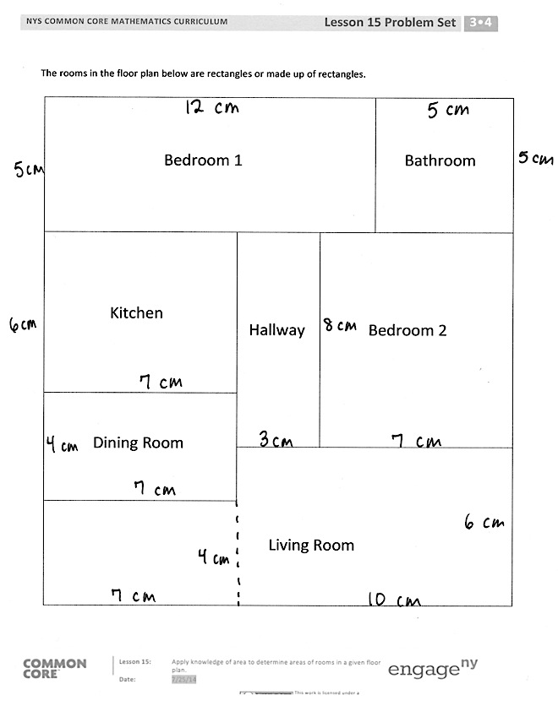
After the Student Debrief, instruct students to complete the Exit Ticket. A review of their work will help with assessing students’ understanding of the concepts that were presented in today’s lesson and planning more effectively for future lessons. The questions may be read aloud to the students.

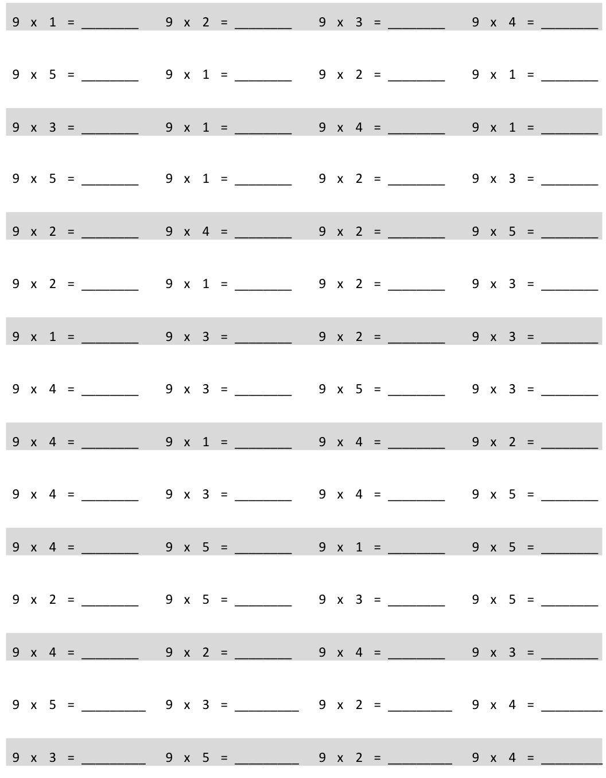
Multiply.
Name Date
- Make a prediction: Which room looks like it has the biggest area?

- Record the areas and show the strategy you used to find each area.
Room | Area | Strategy
Bedroom 1 | _______ sq cm
Bedroom 2 | _______ sq cm
Kitchen | _______ sq cm
Hallway | _______ sq cm
Bathroom | _______ sq cm
Dining Room | _______ sq cm
Living Room | _______ sq cm

- Which room has the biggest area? Was your prediction right? Why or why not?

- Find the side lengths of the house without using your ruler to measure them, and explain the process you used.
Side lengths: __________ centimeters and __________ centimeters

- What is the area of the whole floor plan? How do you know?
Area = __________ square centimeters
The rooms in the floor plan below are rectangles or made up of rectangles.

 |  |  |  | Bedroom 1 |  |  |  |  |  |  |  | Bathroom
 |  | Kitchen
 |  |  |  |  |  |  | Hallway |  |  |  | Bedroom 2
 | Dining Room
 |  |  |  |  |  |  | Living Room

Name Date
Jack uses grid paper to create a floor plan of his room. Label the unknown measurements, and find the area of the items listed below.
Bed
Dresser
Table
Desk
Name | Equations | Total Area
a. Jack’s Room |  | ________ square units
b. Bed |  | ________ square units
c. Table |  | ________ square units
d. Dresser |  | ________ square units
e. Desk |  | ________ square units

Name Date
Use a ruler to measure the side lengths of each numbered room in centimeters. Then, find the area. Use the measurements below to match, and label the rooms with the correct areas.
Kitchen: 45 square centimeters Living Room: 63 square centimeters
Porch: 34 square centimeters Bedroom: 56 square centimeters
Bathroom: 24 square centimeters Hallway: 12 square centimeters
1
3
6
4
2
5

multiply by 9 (1−5)

