Lesson 13
Objective: Find areas by decomposing into rectangles or completing composite figures to form rectangles.

Suggested Lesson Structure
 Fluency Practice (12 minutes)
 Application Problem (6 minutes)
 Concept Development (32 minutes)
 Student Debrief (10 minutes)
Total Time (60 minutes)
Fluency Practice (12 minutes)
- Group Counting 3.OA.1 (4 minutes)
- Find the Common Products 3.OA.7 (8 minutes)
Group Counting (4 minutes)
Note: Group counting reviews interpreting multiplication as repeated addition.
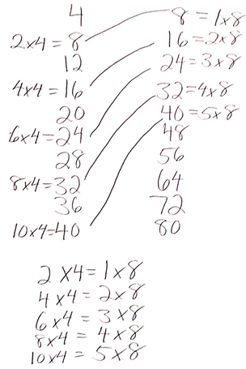
Instruct students to count forward and backward, occasionally changing the direction of the count.
- Threes to 30
- Sixes to 60
- Eights to 80
- Nines to 90
Find the Common Products (8 minutes)
Materials: (S) Blank paper
Note: This fluency activity reviews multiplication patterns.
After listing the products of 4 and 8, guide students through the following steps:
T: Draw a line to match the products that appear in both columns.
S: (Match 8, 16, 24, 32, and 40.)
T: (Write 2 × 4 = 8, etc., next to each matched product on the left half of the paper.) Write the rest of the number sentences like I did.
S: (Write number sentences.)
T: (Write 8 = 1 × 8, etc., next to each matched product on the right half of the paper.) Write the rest of the number sentences like I did.
S: (Write number sentences.)
T: (Write 2 × 4 = __ × 8.) Say the true number sentence.
S: 2 × 4 = 1 × 8.
T: (Write 2 × 4 = 1 × 8.) Write the remaining equal facts as number sentences.
S: (Write 4 × 4 = 2 × 8, 6 × 4 = 3 × 8, 8 × 4 = 4 × 8, and 10 × 4 = 5 × 8.)
T: Discuss the patterns in your number sentences.
Application Problem (6 minutes)
Anil finds the area of a 5-inch by 17-inch rectangle by breaking it into 2 smaller rectangles. Show one way that he could have solved the problem. What is the area of the rectangle?
NOTES ON
MULTIPLE MEANS
OF ENGAGEMENT:
Students who solve the Application Problem quickly may enjoy comparing their solution strategy with others. They may discuss or journal about their reasoning.

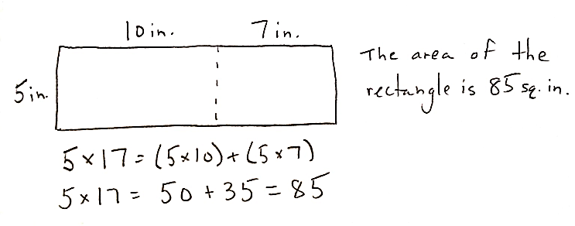
Note: This problem reinforces the strategy of breaking apart a larger shape into 2 smaller shapes to find the total area.
Concept Development (32 minutes)
Materials: (S) Personal white board, large grid (Template)

Large Grid with Shaded Shape
Problem 1: Add using the break apart strategy to find the area of a composite shape.
Distribute one large grid to each student. Draw or project the shaded shape shown to the right.
T: Draw and shade the shape on your grid.
S: (Draw and shade.)
T: How do you find the area of a rectangle?
S: Multiply the side lengths!
T: Talk to your partner: Can we find the area of the shaded figure by multiplying side lengths? How do you know?
S: No, because it isn’t a rectangle. We can count the unit squares inside.
MP.7
T: In the Application Problem, we used the break apart and distribute strategy to find the area of a larger rectangle by breaking it into smaller rectangles. Turn and talk to your partner: How might we use a strategy like that to find the area of the shaded figure?
S: We can break it into a square and a rectangle. We can break it into three squares.
T: Draw a dotted line to show how to break the shaded figure apart into a square and rectangle.
S: (Draw.)

T: (Model as shown on the right.) What equation tells you the area of the square on the top?
S: 2 × 2 = 4.
T: What equation tells you the area of the rectangle on the bottom?
S: 2 × 4 = 8.
T: How do we use those measurements to find the area of the shaded figure?
S: Add them together!
T: What is the sum of 8 and 4?
S: 12.

T: What is the area of the shaded figure?
S: 12 square units!
Draw or project the shape shown to the right.
T: We can also find the area of the shaded figure by thinking about a 4 × 4 square with missing units. Turn and talk to your partner: How can we find the shaded area using the unshaded square?
S: The area of the square is 16 square units. Since the entire square isn’t shaded, we need to subtract the
4 square units that are unshaded. 16 − 4 = 12.
T: There are different strategies of finding the area of a figure. It just depends on how you choose to look at it.
Continue with the following suggested examples:

Problem 2: Subtract to find the area of a composite shape.
6 cm
6 cm
2 cm
4 cm
Draw or project the shape shown to the right.
T: This figure shows a small rectangle cut out of a larger, shaded rectangle. How can we find the area of the shaded figure?
S: We can break apart the shaded part. Or we can subtract the unshaded area from the shaded square.
T: (Shade in the white shape.) We now have a large, shaded square. Write a number sentence to find the area of the large square.
S: (Write 6 × 6 = 36.)
T: What is the area of the square?
S: 36 square centimeters.
T: (Erase the shading inside the white rectangle.) Beneath the number sentence you just wrote, write a number sentence to find the area for the shape we “cut out.”
S: (Write 2 × 4 = 8.)
T: What is the area of the white shape?
S: 8 square centimeters.
T: The area of the square is 36 square centimeters. We cut out, or took away, 8 square centimeters of shading. Turn and talk to your partner: How can we find the area of the shaded region?
S: Subtract 8 square centimeters from 36 square centimeters!
T: Write a number sentence to find the area of the shaded region.
S: (Write 36 – 8 = 28.)
Continue with the following example:
6 in
4 in
2 in
3 in

Problem 3: Subtract to find the area of a composite shape with unknown side lengths.
Draw or project the shape shown to the right.
11 ft
9 ft
_____ ft
_____ ft
5 ft
4 ft
T: This figure also shows a small rectangle cut out of a larger, shaded rectangle, but what is unknown?
S: The side lengths of the smaller rectangle.
T: Do we have enough information to find the side lengths of the smaller rectangle?
S: No, I don’t think so. We know the side lengths of the larger rectangle. Maybe we can subtract to the find the unknown side lengths.
T: Opposite sides of a rectangle are equal. Since we know the length of the rectangle is 9 feet, what is the opposite side length?
NOTES ON
MULTIPLE MEANS
OF ENGAGEMENT:
Extend Problem 3 to students working above grade level. Challenge students to think about a real-life scenario in which this model might be used and to write a matching word problem. Always offer challenges and extensions to learners as alternatives. Here, a student might be given the option of solving one other problem in addition to this extension. Another option would be to direct students to solve the problem that later appears in the Student Debrief.

S: 9 feet.
T: You can then find the unknown lengths by subtracting the known, 4 feet, from the total, 9 feet.
S: The unknown length is 5 feet!
T: Use the same strategy to find the unknown width.
S: (Write 11 – 5 = 6.)
T: What is the unknown width?
S: 6 feet!
T: Can we now find the area of the shaded figure?
S: Yes!
T: With your partner, find the area of the shaded figure.
Problem Set (10 minutes)
Students should do their personal best to complete the Problem Set within the allotted 10 minutes. For some classes, it may be appropriate to modify the assignment by specifying which problems they work on first. Some problems do not specify a method for solving. Students should solve these problems using the RDW approach used for Application Problems.
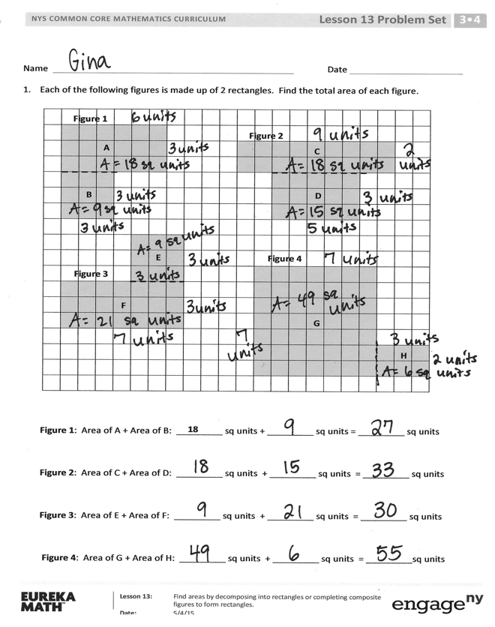
Student Debrief (10 minutes)
Lesson Objective: Find areas by decomposing into rectangles or completing composite figures to form rectangles.
The Student Debrief is intended to invite reflection and active processing of the total lesson experience.
Invite students to review their solutions for the Problem Set. They should check work by comparing answers with a partner before going over answers as a class. Look for misconceptions or misunderstandings that can be addressed in the Debrief. Guide students in a conversation to debrief the Problem Set and process the lesson.
Any combination of the questions below may be used to lead the discussion.
- How did you break apart the rectangles in Figure 4? Did anyone break apart the rectangles in a different way? (A rectangle of 10 by 2.)
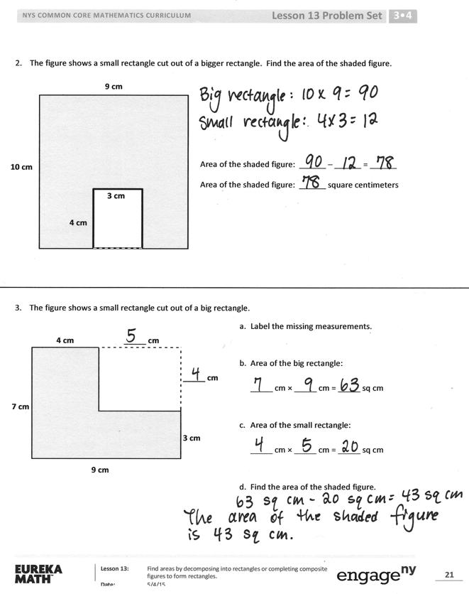
- In Problem 2, a 4-cm by 3-cm rectangle was cut out of a bigger rectangle. What other measurements could have been cut out to keep the same area for the shaded region?
- How did you find the unknown measurements in Problem 3?
- How were today’s strategies examples of using what we know to solve new types of problems?
Exit Ticket (3 minutes)
After the Student Debrief, instruct students to complete the Exit Ticket. A review of their work will help with assessing students’ understanding of the concepts that were presented in today’s lesson and planning more effectively for future lessons. The questions may be read aloud to the students.

Name Date
 | Figure 1
 |  |  | A |  |  |  |  |  |  |  | Figure 2
 |  |  |  |  |  |  |  |  |  |  |  |  |  |  | C
 | B |  |  |  |  |  |  |  |  |  |  |  |  | D
 |  |  |  |  |  | E |  |  |  |  |  | Figure 4
 | Figure 3
 |  |  | F
 |  |  |  |  |  |  |  |  |  |  |  |  |  |  | G
 |  |  |  |  |  |  |  |  |  |  |  |  |  |  |  |  |  |  |  | H
- Each of the following figures is made up of 2 rectangles. Find the total area of each figure.

18
Figure 1: Area of A + Area of B: _________ sq units + _________ sq units = _________ sq units
Figure 2: Area of C + Area of D: _________ sq units + _________ sq units = _________ sq units
Figure 3: Area of E + Area of F: _________ sq units + _________ sq units = _________ sq units
Figure 4: Area of G + Area of H: _________ sq units + _________ sq units = _________sq units
- The figure shows a small rectangle cut out of a bigger rectangle. Find the area of the shaded figure.
10 cm
9 cm
3 cm
4 cm

Area of the shaded figure: ______ – ______ = ______
Area of the shaded figure: ______ square centimeters

- The figure shows a small rectangle cut out of a big rectangle.
- Label the unknown measurements.

- Area of the big rectangle:

_____ cm × _____ cm = _____ sq cm

- Area of the small rectangle:

_____ cm × _____ cm = _____ sq cm

- Find the area of the shaded figure.
9 cm
4 cm
7 cm
_____ cm
3 cm
_____ cm

Name Date
The following figure is made up of 2 rectangles. Find the total area of the figure.
A
B

Area of A + Area of B: ________ sq units + _________ sq units = _________ sq units

Name Date
Figure 1
 | A |  |  |  |  |  |  |  |  | Figure 2 |  |  |  |  |  | C
 |  |  | B
 |  |  |  |  |  |  |  |  |  |  |  |  |  |  |  |  | D
 | Figure 3
 | E |  |  |  | F |  |  |  |  |  |  | Figure 4 |  |  |  |  | H
 |  |  |  |  |  |  |  |  |  |  |  |  | G
- Each of the following figures is made up of 2 rectangles. Find the total area of each figure.

Figure 1: Area of A + Area of B: _________ sq units + _________ sq units = _________ sq units
Figure 2: Area of C + Area of D: _________ sq units + _________ sq units = _________ sq units
Figure 3: Area of E + Area of F: _________ sq units + _________ sq units = _________ sq units
Figure 4: Area of G + Area of H: _________ sq units + _________ sq units = _________ sq units
- The figure shows a small rectangle cut out of a big rectangle. Find the area of the shaded figure.
3 cm
3 cm
8 cm
7 cm

Area of the shaded figure: ______ – ______ = ______
Area of the shaded figure: ______ square centimeters

- The figure shows a small rectangle cut out of a big rectangle.
6 cm
_____ cm
4 cm
9 cm
_____ cm
8 cm
a. Label the unknown measurements.
b. Area of the big rectangle:
______ cm × ______ cm = ______ sq cm
c. Area of the small rectangle:
______ cm × ______ cm = ______ sq cm
d. Find the area of the shaded figure.

large grid

