Lesson 9
Objective: Analyze different rectangles and reason about their area.

Suggested Lesson Structure
 Fluency Practice (12 minutes)
 Application Problem (5 minutes)
 Concept Development (33 minutes)
 Student Debrief (10 minutes)
Total Time (60 minutes)
Fluency Practice (12 minutes)
- Group Counting 3.OA.1 (4 minutes)
- Find the Area 3.MD.7 (4 minutes)
- Decompose the Multiplication Equation 3.OA.5 (4 minutes)
Group Counting (4 minutes)
Note: Group counting reviews interpreting multiplication as repeated addition.
Instruct students to count forward and backward, occasionally changing the direction of the count.
- Fours to 40
- Sevens to 70
- Eights to 80
- Nines to 90
Find the Area (4 minutes)
Note: This fluency activity reviews strategies for finding the area of a rectangle.
T: (Project a rectangular array with 2 rows of 4 units. Write 1 tile = 1 square meter.) What does 1 tile equal?
S: 1 square meter.
T: (Point to the side length of 4 units.) What is the value of this side length?
S: 4 meters.
T: (Point to the side length of 2 units.) What is the value of this side length?
S: 2 meters.

T: Write a multiplication sentence to represent the area of the rectangle.
S: (Write 2 m × 4 m = 8 sq m or 4 m × 2 m = 8 sq m.)
Continue with the following possible sequence: 3 rows of 5 units, 3 rows of 7 units, 4 rows of 6 units, 4 rows of 9 units, and 6 rows of 8 units.
Decompose the Multiplication Equation (4 minutes)
Materials: (S) Personal white board
Note: This activity anticipates the distributive property used in Lesson 10, while reviewing Module 3 concepts.
T: (Write 8 × 6 = (5 + ) × 6.) Copy the equation on your personal white board, and fill in the blank.
Sample Work
8 × 6 = (5 + 3) × 6
= (5 × 6) + (3 × 6)
= 30 + 18
= 48
S: (Write 8 × 6 = (5 + 3) × 6.)
T: (Write = ( × 6) + ( × 6).) Copy the equation on your personal white board, and fill in the blanks.
S: (Write (5 × 6) + (3 × 6).)
T: Solve the multiplication problems and write an addition equation. Below it, write your answer.
S: (Write 30 + 18 and 48 below it.)
Continue with the following possible sequence: 7 × 6, 6 × 6, and 9 × 6.
Application Problem (5 minutes)
Mario plans to completely cover his 8-inch by 6-inch piece of cardboard with square inch tiles.
He has 42 square inch tiles. How many more square inch tiles does Mario need to cover the cardboard without any gaps or overlap? Explain your answer.
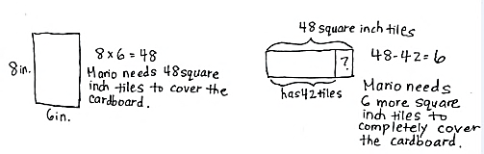
Note: This problem reviews the concept of finding area. Students will likely solve by multiplying side lengths (shown above), having just practiced this strategy in Lesson 8.

Concept Development (33 minutes)
Materials: (S) Small centimeter grid (Template), personal white board, Problem Set
Problems 1 and 2 in the Problem Set
NOTES ON
MULTIPLE MEANS
OF ACTION AND EXPRESSION:
Cutting paper with scissors may be a challenge for some learners. Precision is important to this lesson. Please try the following tips:
- Provide centimeter grids on cardstock or thicker paper.
- Darken and thicken the cutting lines.
- Provide left-handed, loop, spring, self-opening, or other adaptive scissors, if needed.
- Instruct students to turn the paper, not the scissors.
- Offer precut centimeter grids.

T: How can we cut this centimeter grid to get 2 equal rectangles?
S: Cut it in half. If we cut on the line between the fifth and sixth rows, we’ll have 2 equal rectangles.
If we fold the grid in half and cut along the fold,
we can make 2 equal rectangles.
T: Do that now, and then answer Problem 1(a).
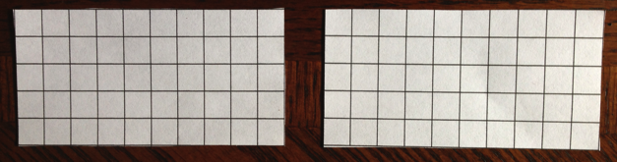
T: (Point to the side length of 10 centimeters.) This is the length of the rectangle. What is its value?
S: 10 centimeters.
T: (Point to the side length of 5 centimeters.) This is the width of the rectangle. What is its value?
S: 5 centimeters.
T: How can you find the area of one of the rectangles?
Small Centimeter
Grid Template
S: Multiply the side lengths. Multiply 5 times 10.
T: Answer Problem 1(b). (Allow students time to work.) What is the area of one of the rectangles?
S: 50 square centimeters!
T: What is the area of the other rectangle? How do you know?
S: 50 square centimeters because the rectangles are equal.
T: How can you find the total area of the rectangles?
S: Add 50 square centimeters plus 50 square centimeters.
T: Answer Problem 1(c). (Allow students time to work.) What is the total area?
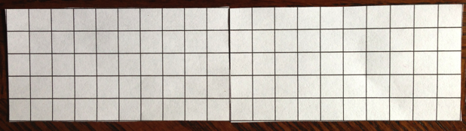
S: 100 square centimeters.
T: Place your rectangles next to each other to make 1 long rectangle. Talk to a partner. What do you think the area of this long rectangle is? Why?
S: 100 square centimeters because I added 50 square centimeters plus 50 square centimeters.
100 square centimeters because that’s the total area of the smaller rectangles and that doesn’t change when we move them to make the longer rectangle.
T: Let’s see if you are right! Answer Problem 2(a). (Allow students time to work.) What multiplication fact can help you find the area of this longer rectangle?
S: 5 × 20.
T: How can you solve this multiplication?
S: We can think of it as 5 times 2 tens. We could think of it as 5 × (2 × 10), which is the same as (5 × 2) × 10. We can think of it the same way as before: as 2 equal rectangles.
T: Choose a strategy and use it to answer Problem 2(b). (Allow students time to work.) What is the area of this longer rectangle?
S: 100 square centimeters!
T: Was your prediction about the area of this longer rectangle correct?
MP.3
S: Yes!
Repeat this process, instructing students to fold 2 columns behind one of the rectangles, so they now have a
5 by 8 rectangle and a 5 by 10 rectangle. They can use their boards to record the total area of the 2 separate rectangles and the area of the longer rectangle that is made by joining the 2 smaller rectangles.
T: What did you notice about the sum of the areas of the 2 small rectangles and the area of the longer rectangle?
S: They’re the same!
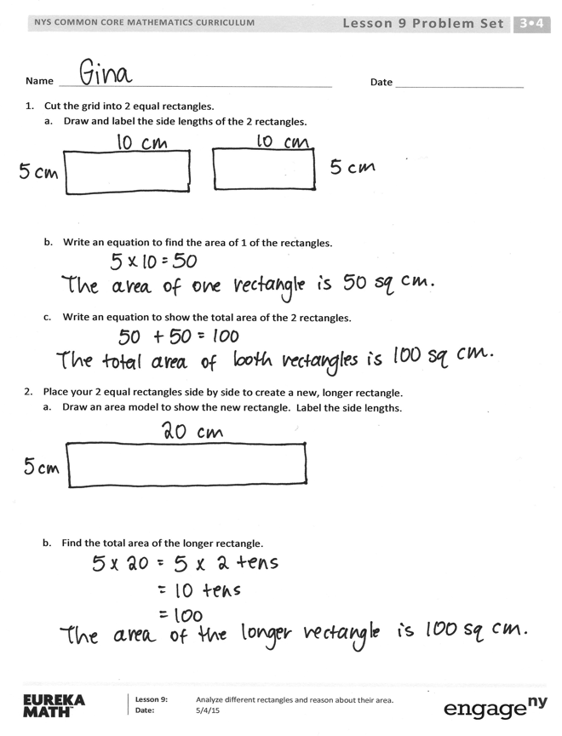
T: How can we use the areas of 2 small rectangles that form a longer rectangle to find the area of the longer rectangle?
S: Add the areas of the smaller rectangles!
Problem Set (10 minutes)
Students should do their personal best to complete the Problem Set within the allotted 10 minutes. For some classes, it may be appropriate to modify the assignment by specifying which problems they work on first. Some problems do not specify a method for solving. Students should solve these problems using the RDW approach used for Application Problems.
Student Debrief (10 minutes)
Lesson Objective: Analyze different rectangles and reason about their area.
The Student Debrief is intended to invite reflection and active processing of the total lesson experience.
Invite students to review their solutions for the Problem Set. They should check work by comparing answers with a partner before going over answers as a class. Look for misconceptions or misunderstandings that can be addressed in the Debrief. Guide students in a conversation to debrief the Problem Set and process the lesson.
Any combination of the questions below may be used to lead the discussion.
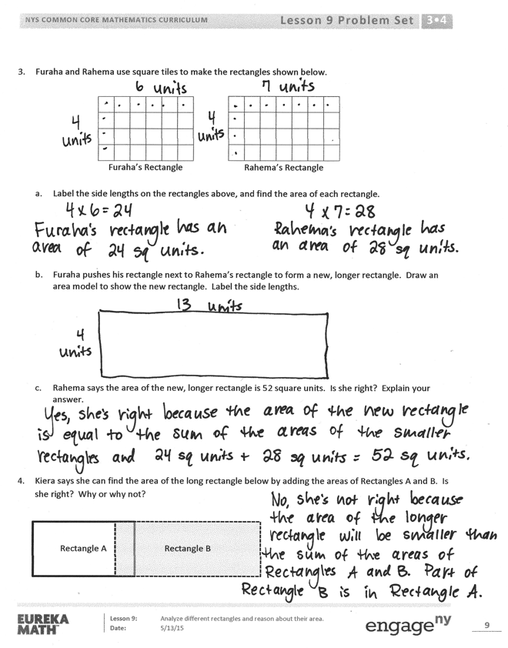
- Talk to a partner: In Problem 1(a), how does knowing the side lengths of the grid help you find the side lengths of the small rectangles without counting?
- Did anyone use the break apart and distribute strategy to solve Problem 2(b)? Explain what you broke apart. Why did you make that choice? (Ahead of Lesson 10, which uses the distributive property, ask students how the paper rectangles show the distributive property.)
- Compare the equations you used to solve Problems 1(b) and 2(b). How are they the same? How are they different?
- Explain to a partner how you found the length and width for the new rectangle in Problem 3(b). If you labeled the width 13 and length 4, how would that change your drawing? How would that affect the area of the rectangle?
- Did anyone multiply the side lengths to solve Problem 3(c)? What strategy did you use to multiply 4 × 13?
- How was Problem 4 different from the other problems?
Exit Ticket (3 minutes)
After the Student Debrief, instruct students to complete the Exit Ticket. A review of their work will help with assessing students’ understanding of the concepts that were presented in today’s lesson and planning more effectively for future lessons. The questions may be read aloud to the students.
Name Date
- Cut the grid into 2 equal rectangles.
  - Draw and label the side lengths of the 2 rectangles.

- Write an equation to find the area of 1 of the rectangles.

- Write an equation to show the total area of the 2 rectangles.

- Place your 2 equal rectangles side by side to create a new, longer rectangle.
  - Draw an area model to show the new rectangle. Label the side lengths.

  - Find the total area of the longer rectangle.

- Furaha and Rahema use square tiles to make the rectangles shown below.
Furaha’s Rectangle
Rahema’s Rectangle

  - Label the side lengths on the rectangles above, and find the area of each rectangle.

- Furaha pushes his rectangle next to Rahema’s rectangle to form a new, longer rectangle. Draw an area model to show the new rectangle. Label the side lengths.

- Rahema says the area of the new, longer rectangle is 52 square units. Is she right? Explain your answer.

- Kiera says she can find the area of the long rectangle below by adding the areas of Rectangles A and B. Is she right? Why or why not?
Rectangle A
Rectangle B

Name Date
Lamar uses square tiles to make the 2 rectangles shown below.
Rectangle A
Rectangle B

- Label the side lengths of the 2 rectangles.

- Write equations to find the areas of the rectangles.

Area of Rectangle A: _______________ Area of Rectangle B: _______________

- Lamar pushes Rectangle A next to Rectangle B to make a bigger rectangle. What is the area of the bigger rectangle? How do you know?

Name Date
- Use the grid to answer the questions below.

- Draw a line to divide the grid into 2 equal rectangles. Shade in 1 of the rectangles that you created.

- Label the side lengths of each rectangle.

- Write an equation to show the total area of the 2 rectangles.

- Alexa cuts out the 2 equal rectangles from Problem 1(a) and puts the two shorter sides together.
- Draw Alexa’s new rectangle and label the side lengths below.

- Find the total area of the new, longer rectangle.

- Is the area of the new, longer rectangle equal to the total area in Problem 1(c)?
Explain why or why not.

small centimeter grid

