Lesson 11
Objective: Demonstrate the possible whole number side lengths of rectangles with areas of 24, 36, 48, or 72 square units using the associative property.

Suggested Lesson Structure
 Fluency Practice (13 minutes)
 Application Problem (5 minutes)
 Concept Development (32 minutes)
 Student Debrief (10 minutes)
Total Time (60 minutes)
Fluency Practice (13 minutes)
- Group Counting 3.OA.1 (3 minutes)
- Find the Unknown Factor 3.OA.4 (5 minutes)
- Find the Area 3.MD.7 (5 minutes)
Group Counting (3 minutes)
Note: Group counting reviews interpreting multiplication as repeated addition.
Instruct students to count forward and backward, occasionally changing the direction of the count.
- Sixes to 60
- Sevens to 70
- Eights to 80
- Nines to 90
Find the Unknown Factor (5 minutes)
Materials: (S) Personal white board
Note: This fluency activity anticipates the objective of today’s lesson.
T: (Write 6 × = 12.) Find the unknown factor, and say the equation.
S: 6 × 2 = 12.
Continue with the following possible sequence: 4 × = 12, 2 × = 12, and 3 × = 12.
T: (Write 3 × = 24.) Copy my equation on your personal white board, and fill in the unknown factor.
S: (Write 3 × 8 = 24.)
Continue with the following possible sequence: 4 × = 24, 8 × = 24, 6 × = 36, 4 × = 36, 6 × = 24, 9 × = 36, 9 × = 72, 6 × = 48, 8 × = 72, 8 × = 48, and 2 × = 24.
Find the Area (5 minutes)
Materials: (S) Personal white board
Note: This fluency activity reviews using the distributive property from Lesson 10.
5 3

3
T: (Project the rectangle as shown.) On your personal white board, write an expression that we could use to find the area of the shaded rectangle.
S: (Write 3 × 5.)
T: On your board, write an expression that we could use to find the area of the unshaded rectangle.
(3 × 5) + (3 × 3)
= 15 + 9
= 24
Sample Work
S: (Write 3 × 3.)
T: How can you use these expressions to find the area of the large rectangle?
S: Add them!
T: Write an equation showing the sum of the shaded and unshaded rectangles. Below it, write the area of the entire rectangle.
NOTES ON
MULTIPLE MEANS
OF ENGAGEMENT:
Alternatively, challenge students working above grade level with this length unknown version:
One fourth of the banquet table has an area of 9 square feet. If the width of the table is 3 feet, what is the length? What is the area of the table?

S: (Write 15 + 9 = 24 and Area: 24 square units.)
Continue with the following possible sequence: 9 × 5 = (5 × 5) + (4 × 5), 13 × 4 = (10 × 4) + (3 × 4), and 17 × 3 = (10 × 3) + (7 × 3).
Application Problem (5 minutes)
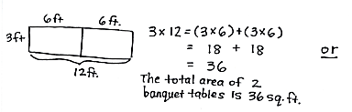
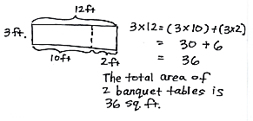
The banquet table in a restaurant measures 3 feet by 6 feet. For a large party, workers at the restaurant place 2 banquet tables side by side to create 1 long table. Find the area of the new, longer table.

Note: This problem reviews Lesson 10’s concept of applying the distributive property to find the total area of a large rectangle by adding two products. It also reviews factors of 36 and multiples of 12 that lead into the Concept Development.
Concept Development (32 minutes)

12
3
Materials: (S) Personal white board
T: Write an expression to show how to find the area of a rectangle with side lengths 3 and 12.
S: (Write 3 × 12.)
T: In the Application Problem, you found that 3 times 12 is…?
S: 36.
T: So, the area of this rectangle is…?
S: 36 square units!
T: (Write 3 × (2 × 6).) Why is this expression equal to the one you just wrote?
S: Because you just wrote 12 as 2 × 6.
T: Write this expression on your personal white board with the parentheses in a different place. At my signal, show me your board. (Signal.)
S: (Show (3 × 2) × 6.)
T: Solve 3 × 2, and write the new expression on your board. (Allow students time to work.) Whisper the new expression to a partner.
S: 6 × 6.
T: What new side lengths did we find for a rectangle with an area of 36 square units?
S: 6 and 6.
T: Let’s look at our expression, (3 × 2) × 6, again. Use the commutative property and switch the order of the factors in the parentheses.
S: (Write (2 × 3) × 6.)
T: Will you be able to find new side lengths by moving the parentheses?
S: (Write 2 × (3 × 6).) Yes, they will be 2 and 18.
T: (Write 3 × (3 × 4).) Why is this expression equal to our first one, 3 × 12?
S: Because you wrote 12 as 3 × 4.
T: Write this expression on your board with the parentheses in a different place. At my signal, show me your board. (Signal.)
S: (Show (3 × 3) × 4.)
T: Solve 3 × 3 and write the expression on your board. (Allow students time to work.) Whisper the new expression to a partner.
S: 9 × 4.

T: What new side lengths did we find for a rectangle with an area of 36 square units?
S: 9 and 4.
T: Let’s look at our expression (3 × 3) × 4 again. If I use the commutative property and switch the order of the factors in the parentheses, will I be able to find new side lengths by moving the parentheses?
S: No, it will still be 9 and 4. No, because both factors in the parentheses are 3, so switching their order won’t change the numbers you get when you move the parentheses.
T: Do you think we found all the possible whole number side lengths for this rectangle?
MP.3
S: Yes. I’m not sure.
T: Let’s look at our side lengths. Do you have a side length of 1?
S: No! We forgot the easiest one. It’s 1 and 36.
T: Do we have a side length of 2?
S: Yes.
T: 3?
S: Yes.
T: Work with a partner to look at the rest of your side lengths to see if you have the numbers 4 through 10. (Allow students time to work.) Which of these numbers, 4 through 10, aren’t included in your side lengths?
S: 5, 7, 8, and 10.
T: Discuss with a partner why these numbers aren’t in your list of side lengths.
S: 5, 7, 8, and 10 can’t be side lengths because there aren’t any whole numbers we can multiply these numbers by to get 36.
T: Would any two-digit number times two-digit number work?
S: No, they would be too big. No, because we know 10 × 10 equals 100, and that’s greater than 36.
NOTES ON
MULTIPLE MEANS
OF REPRESENTATION:
Extend Problem 1 for students working above grade level by inviting experimentation and choice in placing parentheses, as well as number order, in the multiplication sentences. For example, ask, “What would happen if we changed it to 4 × 6 × 2?” Encourage students to discuss or journal about their discoveries.
Assist English language learners by rephrasing Problem 4 in multiple ways. Ask the following: “How does the difference between the length and width of the rectangle change the shape?”

T: Now, do you think we found all the possible side whole number side lengths for a rectangle with an area of 36 square units?
S: Yes!
Repeat the process with rectangles that have areas of 24, 48, and 72 square units.
Problem Set (10 minutes)
Students should do their personal best to complete the Problem Set within the allotted 10 minutes. For some classes, it may be appropriate to modify the assignment by specifying which problems they work on first. Some problems do not specify a method for solving. Students should solve these problems using the RDW approach used for Application Problems.
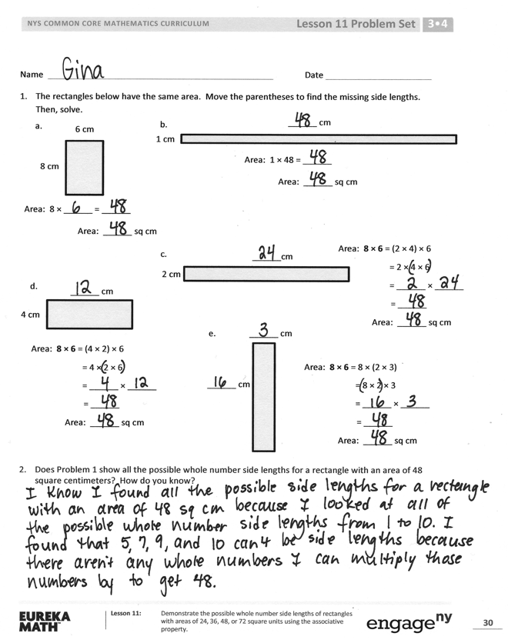
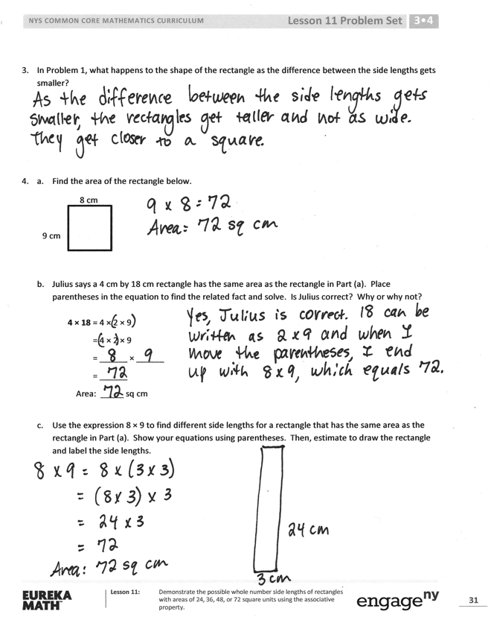
Student Debrief (10 minutes)
Lesson Objective: Demonstrate the possible whole number side lengths of rectangles with areas of 24, 36, 48, or 72 square units using the associative property.
The Student Debrief is intended to invite reflection and active processing of the total lesson experience.
Invite students to review their solutions for the Problem Set. They should check work by comparing answers with a partner before going over answers as a class. Look for misconceptions or misunderstandings that can be addressed in the Debrief. Guide students in a conversation to debrief the Problem Set and process the lesson.
Any combination of the questions below may be used to lead the discussion.
- Turn your paper horizontally and look at
Problem 1. What property does this show?
- Share your answer to Problem 2 with a partner.
- Discuss your answer to Problem 4 with a partner. What would the rectangle look like if the difference between side lengths was 0?
How do you know?
- Compare your answer to Problem 4(c) with a partner’s. Did you both come up with the same side lengths? Why or why not?
- Explain to a partner how to use the strategy we learned today to find all possible whole number side lengths for a rectangle with an area of 60 square units.
Exit Ticket (3 minutes)
After the Student Debrief, instruct students to complete the Exit Ticket. A review of their work will help you assess the students’ understanding of the concepts that were presented in the lesson today and plan more effectively for future lessons. You may read the questions aloud to the students.
Name Date
- The rectangles below have the same area. Move the parentheses to find the unknown side lengths.
Then, solve.
1 cm
______ cm
Area: 1 × 48 = ______
Area: ______ sq cm

b.
6 cm
8 cm
Area: 8 × ______ = ______
Area: ______ sq cm

a.

______cm
2 cm
Area: 8 × 6 = (2 × 4) × 6
= 2 × 4 × 6
= ______ × ______
= ______
Area: ______ sq cm

c.

4 cm
______ cm
Area: 8 × 6 = (4 × 2) × 6
= 4 × 2 × 6
= ______ × ______
= ______
Area: ______ sq cm

d.

Area: 8 × 6 = 8 × (2 × 3)
= 8 × 2 × 3
= ______ × ______
= ______
Area: ______ sq cm

______ cm
______ cm
e.

- Does Problem 1 show all the possible whole number side lengths for a rectangle with an area of 48 square centimeters? How do you know?

- In Problem 1, what happens to the shape of the rectangle as the difference between the side lengths gets smaller?

- a. Find the area of the rectangle below.
8 cm
9 cm

  - Julius says a 4 cm by 18 cm rectangle has the same area as the rectangle in Part (a). Place parentheses in the equation to find the related fact and solve. Is Julius correct? Why or why not?
4 × 18 = 4 × 2 × 9
= 4 × 2 × 9
= ______ × ______
= ______
Area: _____ sq cm

cm

  - Use the expression 8 × 9 to find different side lengths for a rectangle that has the same area as the rectangle in Part (a). Show your equations using parentheses. Then, estimate to draw the rectangle and label the side lengths.

Name Date
- Find the area of the rectangle.
8 cm
8 cm

- The rectangle below has the same area as the rectangle in Problem 1. Move the parentheses to find the unknown side lengths. Then, solve.
______ cm
______ cm
Area: 8 × 8 = (4 × 2) × 8
= 4 × 2 × 8
= ______ × ______
= ______
Area: ______ sq cm

Name Date
- The rectangles below have the same area. Move the parentheses to find the unknown side lengths.
Then, solve.
1 cm
36 cm
Area: 1 × 36 = ______
Area: ______ sq cm

b.
9 cm
4 cm
Area: 4 × ______ = ______
Area: ______ sq cm

a.

______ cm
2 cm
Area: 4 × 9 = (2 × 2) × 9
= 2 × 2 × 9
= ______ × ______
= ______
Area: ______ sq cm

c.

______ cm
______ cm
Area: 4 × 9 = 4 × (3 × 3)
= 4 × 3 × 3
= ______ × ______
= ______
Area: ______ sq cm

d.

______ cm
______ cm
cm
e.
Area: 12 × 3 = (6 × 2) × 3
= 6 × 2 × 3
= ______ × ______
= ______
Area: ______ sq cm

- Does Problem 1 show all the possible whole number side lengths for a rectangle with an area of 36 square centimeters? How do you know?

- a. Find the area of the rectangle below.
6 cm
8 cm

- Hilda says a 4 cm by 12 cm rectangle has the same area as the rectangle in Part (a). Place parentheses in the equation to find the related fact and solve. Is Hilda correct? Why or why not?
4 × 12 = 4 × 2 × 6
= 4 × 2 × 6
= ______ × ______
= ______
Area: ______ sq cm

- Use the expression 8 × 6 to find different side lengths for a rectangle that has the same area as the rectangle in Part (a). Show your equations using parentheses. Then, estimate to draw the rectangle and label the side lengths.

