Lesson 10
Objective: Apply the distributive property as a strategy to find the total area of a large rectangle by adding two products.

Suggested Lesson Structure
 Fluency Practice (8 minutes)
 Application Problem (5 minutes)
 Concept Development (37 minutes)
 Student Debrief (10 minutes)
Total Time (60 minutes)

Fluency Practice (8 minutes)
- Group Counting 3.OA.1 (3 minutes)
- Find the Unknown Factor 3.OA.4 (5 minutes)

Group Counting (3 minutes)
Note: Group counting reviews interpreting multiplication as repeated addition.
Instruct students to count forward and backward, occasionally changing the direction of the count.
- Sixes to 60
- Sevens to 70
- Eights to 80
- Nines to 90
Find the Unknown Factor (5 minutes)
Materials: (S) Personal white board
Note: This fluency activity anticipates finding all possible side lengths of rectangles with areas of 12, 24, 36, 48, and 72 square units in Lesson 11.
T: (Write 4 × = 12.) Find the unknown factor, and say the equation.
S: 4 × 3 = 12.
Continue with the following possible sequence: 6 × = 12, 2 × = 12, and 3 × = 12.
T: (Write 8 × = 24.) Copy my equation on your personal white board, and fill in the unknown factor.
S: (Write 8 × 3 = 24.)
Continue with the following possible sequence:
A NOTE ON
12 AS A FACTOR:
The suggested sequence for this fluency activity helps students solve number sentences with 12 as a factor. While some students might be fluent with these facts, others might rely on the distributive property to write true equations. The expectation is for students to become familiar with 12 as a factor since these equations will be seen in Lesson 11.

6 × = 24 | 3 × = 24 | 6 × = 36 | 9 × = 36
4 × = 24 | 4 × = 36 | 8 × = 72 | 8 × = 48
9 × = 72 | 6 × = 48 | 2 × = 24 | 12 × = 24
12 × = 36 | 12 × = 48 | 12 × = 72 | 3 × = 36
4 × = 48 | 6 × = 72 | 3 × = 72

Application Problem (5 minutes)
Sonya folds a 6-inch by 6-inch piece of paper into 4 equal parts (shown below). What is the area of 1 of the parts?
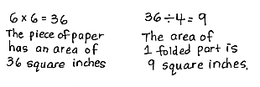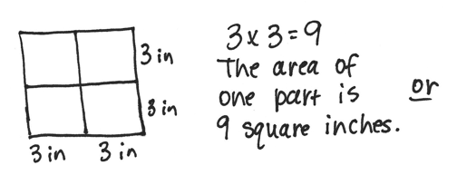
Note: This problem reviews the concept of finding area.
Concept Development (37 minutes)
Materials: (S) Personal white board, square centimeter tiles, tiling (Template)
Students start with the tiling template (the partially shaded rectangle shown on the right) in their personal white boards.

6 cm
5 cm
3 cm
(5 × 6) + (3 × 6)
= 30 + 18
= 48
5 × 6
3 × 6
Tiling Template with Sample Work
T: (Project the tiling template.) There are 3 rectangles we will focus on: the large rectangle (trace its boundary line with your finger), the shaded rectangle (trace its boundary with your finger), and the unshaded rectangle (trace it).
T: Use square centimeter tiles to find the area of the large rectangle. (Allow students time to work.) What is the area of the large rectangle?
S: 48 square centimeters!
T: Use square centimeter tiles to find the side lengths of the shaded rectangle. (Allow students time to work.) What are the side lengths?
S: 5 centimeters and 6 centimeters!
T: Label the side lengths. (Allow students time to label the side lengths.) What multiplication expression can you use to find the area of the shaded rectangle?
S: 5 × 6.
T: Write that expression next to the shaded rectangle. (Allow students time to write the expression.) What side length do we already know for the unshaded rectangle?
S: 6 centimeters!
T: Use square centimeter tiles to find the other side length of the unshaded rectangle. (Allow students time to work.) What is the other side length?
S: 3 centimeters!
T: Label the side length. (Allow students time to label the side length.) What multiplication expression can you use to find the area of the unshaded rectangle?
S: 3 × 6.
T: Write that expression next to the unshaded rectangle. (Allow students time to write the expression.) How can we use these two expressions to help us find the area of the large rectangle?
MP.7
S: We can add them! The area of the shaded rectangle plus the area of the unshaded rectangle equals the area of the large rectangle.
T: Write a number sentence on your board to show this.
S: (Write (5 × 6) + (3 × 6).)
T: Read your number sentence to a partner, and then find its value. (Allow students time to solve.) What is the area of the large rectangle?
S: 48 square centimeters!
T: Is that the answer you got when you tiled the large rectangle?
S: Yes!
T: Write the value of the length of the large rectangle as an addition expression.
S: (Write 5 + 3.)
T: What will you multiply by to find the area?
S: 6.
T: Write that in your expression. Where should we put parentheses?
S: Around 5 + 3 because we need to add first to find the side length; then, we can multiply.
T: Add the parentheses to your expression. What is 5 + 3?
S: 8.
8 × 6
(5 + 3) × 6
(5 × 6) + (3 × 6)

Distributive Property Expressions
T: What is the new expression?
S: 8 × 6.
T: What is the area?
S: 48 square centimeters!
T: Is that the same answer we just found?
S: Yes!

T: (Record distributive property expressions as shown on previous page.) How are these three expressions related?
MP.7
S: They all show the area of the large rectangle. Oh look, they show the break apart and distribute strategy! Yeah, they show that the side length 8 is broken apart into 5 plus 3. Then, 5 and 3 are multiplied by the other side length, 6.
T: Discuss with a partner how the large rectangle on your personal white board also shows the break apart and distribute strategy.
S: (Discuss.)
NOTES ON
MULTIPLE MEANS
OF ACTION AND EXPRESSION:
Consider directing students who may not complete the Problem Set within the allotted time to Problem 2 for valuable application and demonstration of understanding of today’s objective. Offer planning and strategy development support to learners, if needed. Model a think-aloud with two or more possibilities, reason about the selection, and solve.
Repeat the process with the following possible suggestions, providing pictures of rectangles with grid lines:
- A 15 by 8 rectangle. (Students can partition as (10 + 5) × 8. This helps students see that this strategy is helpful when they cannot multiply the side lengths because they do not know these facts.)
- An 18 by 9 rectangle. (Students can decompose as double 9 × 9 or (10 + 8) × 9.)
T: We broke apart the 18 by 9 rectangle into two 9 by 9 rectangles. What other ways could we break apart this rectangle?
S: I would do 10 by 9 and 8 by 9 rectangles.
T: Explain to a partner the process you use to decide how to break apart a side length.
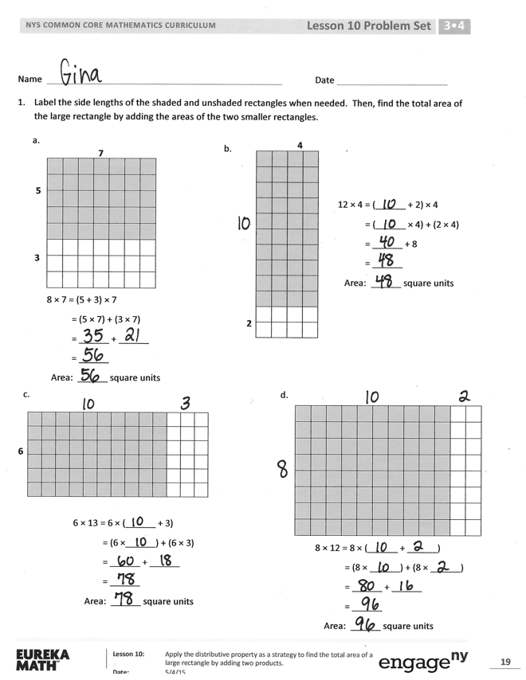
S: I look for facts I know. I try to find a way to make a 5 or 10 because they’re easy facts.

Problem Set (10 minutes)
Students should do their personal best to complete the Problem Set within the allotted 10 minutes. For some classes, it may be appropriate to modify the assignment by specifying which problems they work on first. Some problems do not specify a method for solving. Students should solve these problems using the RDW approach used for Application Problems.

Student Debrief (10 minutes)
Lesson Objective: Apply the distributive property as a strategy to find the total area of a large rectangle by adding two products.
The Student Debrief is intended to invite reflection and active processing of the total lesson experience.
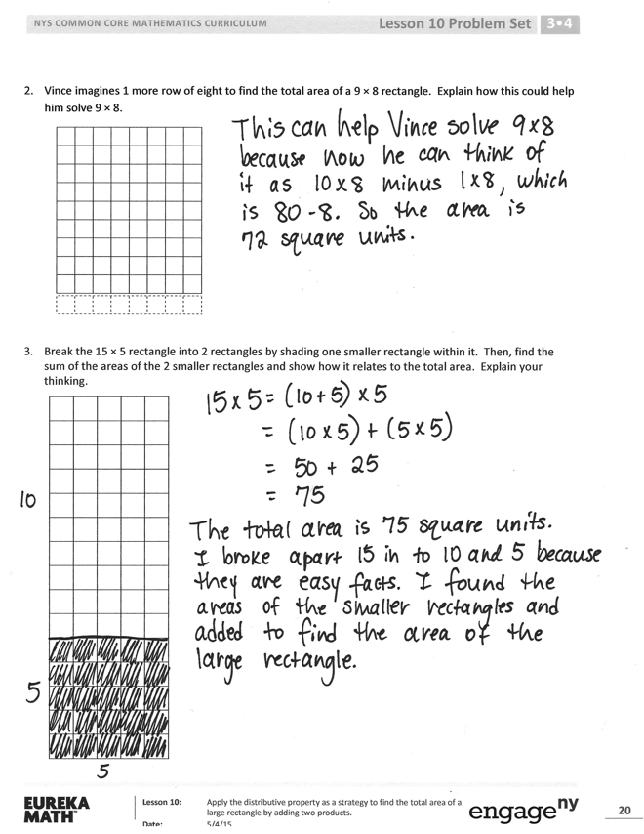
Invite students to review their solutions for the Problem Set. They should check work by comparing answers with a partner before going over answers as a class. Look for misconceptions or misunderstandings that can be addressed in the Debrief. Guide students in a conversation to debrief the Problem Set and process the lesson.
Any combination of the questions below may be used to lead the discussion.
- How is the rectangle in Problem 1(a) similar to the rectangle you tiled in today’s lesson? How is it different?
- What are the side lengths of the large rectangle in Problem 1(c)? Can you multiply these side lengths to find the area? How does the break apart and distribute strategy help you?
- Without multiplying the side lengths of the large rectangle in Problem 1(d), how could you check to make sure your answer is right? (Students might say count the squares or skip-count by eight 12 times.) Discuss with a partner which strategy is most efficient—either counting squares, skip-counting, or using the break apart and distribute strategy.
- How was setting up and solving Problem 2 different from the other problems?
- What side length did you break apart in Problem 3, and how did you break it apart? Why?
- With a partner, list as many possibilities as you can for how you could use the break apart and distribute strategy to find the area of a rectangle with side lengths of 20 and 7. Can we break it into 3 parts if we want to? Which one of your possibilities would you use to solve this problem? Why?

Exit Ticket (3 minutes)
After the Student Debrief, instruct students to complete the Exit Ticket. A review of their work will help with assessing students’ understanding of the concepts that were presented in today’s lesson and planning more effectively for future lessons. The questions may be read aloud to the students.

Name Date
- Label the side lengths of the shaded and unshaded rectangles when needed. Then, find the total area of the large rectangle by adding the areas of the two smaller rectangles.
7
5
3
8 × 7 = (5 + 3) × 7
= (5 × 7) + (3 × 7)
= ______ + ______
= ______
Area: ______ square units
a.

2
4
12 × 4 = (______ + 2) × 4
= (______ × 4) + (2 × 4)
= ______ + 8
= ______
Area: ______ square units
b.

8 × 12 = 8 × (______ + ______)
= (8 × ______) + (8 × ______)
= ______ + ______
= ______
Area: ______ square units
d.

6 × 13 = 6 × (______ + 3)
= (6 ×______) + (6 × 3)
= ______ + ______
= ______
Area: ______ square units
6
c.

- Vince imagines 1 more row of eight to find the total area of a 9 × 8 rectangle. Explain how this could help him solve 9 × 8.

- Break the 15 × 5 rectangle into 2 rectangles by shading one smaller rectangle within it. Then, find the sum of the areas of the 2 smaller rectangles and show how it relates to the total area. Explain your thinking.

Name Date
Label the side lengths of the shaded and unshaded rectangles. Then, find the total area of the large rectangle by adding the areas of the 2 smaller rectangles.
1.
2.

8 × 7 = 8 × (______ + ______)
= (8 ×______) + (8 ×______)
= ______ + ______
= ______
Area: ______ square units
9 × 13 = 9 × (______+______)
= (______ × ______) + (______×______)
= ______ + ______
= ______
Area: ______ square units

Name Date
- Label the side lengths of the shaded and unshaded rectangles. Then, find the total area of the large rectangle by adding the areas of the 2 smaller rectangles.
5
2
12 × 5 = (______ + 2) × 5
= (______ × 5) + (2 × 5)
= ______ + 10
= ______
Area: ______ square units

a. b.
8
5
4
9 × 8 = (5 + 4) × 8
= (5 × 8) + (4 × 8)
= ______ + ______
= ______
Area: ______ square units

c.
d.

7 × 13 = 7 × (______+ 3)
= (7 × ______) + (7 × 3)
= ______ + ______
= ______
Area: ______ square units
7
9 × 12 = 9 × (______ + ______)
= (9 × ______) + (9 × ______)
= ______ + ______
= ______
Area: ______ square units
- Finn imagines 1 more row of nine to find the total area of 9 × 9 rectangle. Explain how this could help him solve 9 × 9.

- Shade an area to break the 16 × 4 rectangle into 2 smaller rectangles. Then, find the sum of the areas of the 2 smaller rectangles to find the total area. Explain your thinking.

tiling

