Lesson 8
Objective: Find the area of a rectangle through multiplication of the side lengths.

Suggested Lesson Structure
 Fluency Practice (11 minutes)
 Application Problem (5 minutes)
 Concept Development (34 minutes)
 Student Debrief (10 minutes)
Total Time (60 minutes)
Fluency Practice (11 minutes)
- Multiply by 6 3.OA.7 (8 minutes)
- Group Counting 3.OA.1 (3 minutes)
Multiply by 6 (8 minutes)
Materials: (S) Multiply by 6 (6–10) Pattern Sheet
Note: This activity builds fluency with respect to multiplication facts using units of 6. It works toward students knowing from memory all products of two one-digit numbers. See Lesson 2 for the directions for administration of a Multiply-By Pattern Sheet.
T: (Write 7 × 6 = ____.) Let us skip-count up by sixes. (Count with fingers to 7 as students count.)
S: 6, 12, 18, 24, 30, 36, 42.
T: Let us see how we can skip-count down to find the answer, too. (Show 10 fingers.) Start at 60. (Count down with your fingers as students say numbers.)
S: 60, 54, 48, 42.
Continue with the following possible sequence: 9 × 6, 6 × 6, and 8 × 6.
T: (Distribute Multiply by 6 (6–10) Pattern Sheet.) Let us practice multiplying by 6. Be sure to work left to right across the page.

Group Counting (3 minutes)
Note: Group counting reviews interpreting multiplication as repeated addition.
Instruct students to count forward and backward, occasionally changing the direction of the count.
- Fours to 40
- Sevens to 70
- Eights to 80
- Nines to 90
Application Problem (5 minutes)
Marnie and Connor both skip-count square units to find the area of the same rectangle. Marnie counts, “3, 6, 9, 12, 15, 18, 21.” Connor counts, “7, 14, 21.” Draw what the rectangle might look like, and then label the side lengths and find the area.
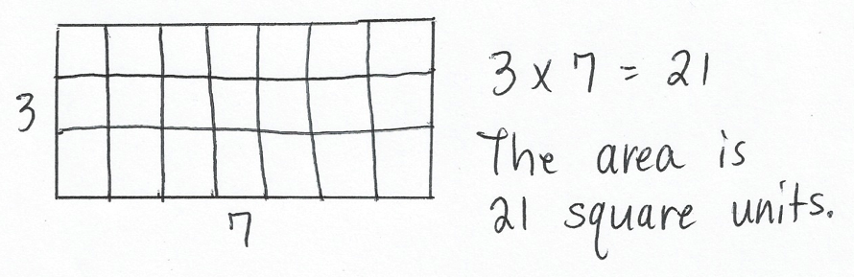
Note: This problem reinforces Lesson 7 and sets the foundation for today’s Concept Development. Invite students to share their drawings and discuss how they are similar and different.
Concept Development (34 minutes)
Grid Template
Materials: (S) Personal white board, inch ruler, grid (Template)
Part 1: Relate side lengths to area.
T: (Project image shown below.) How many rows are in the incomplete array?

S: 4 rows.

NOTES ON
MULTIPLE MEANS
OF ENGAGEMENT:
You may want to help English language learners relate the number of square units in each row to the word columns and relate columns and rows to side lengths. To some students, it may appear that these words are used interchangeably. Help clarify their meaning.

T: How many square units are there in each row?
S: 7 square units.
MP.8
T: Talk to your partner: Do we need to complete the array to find the area of the rectangle? Why or why not?
S: Yes, then we can skip-count each row to find the total. No, we already know the side lengths!
T: How are the side lengths related to the area?
S: If you multiply the side lengths together, the product is the same as the area.
T: Talk to a partner: Can you multiply any two side lengths to find the area?
S: No, you have to multiply the side length that shows the number of rows times the side length that shows the number of squares in each row.
T: What multiplication equation can be used to find the area of this rectangle?
S: 4 × 7 = 28.
T: To check our answer, use your grid template to trace and shade in an area model that is 4 units high and 7 units wide. Label each side length.
S: (Draw and label.)
T: Was our answer correct?
S: Yes, I used the grid paper to count 28 squares inside. I skip-counted 4 sevens to get 28.
Continue with the following possible sequence: 6 × 5, 8 × 7, and 9 × 6.
Area = ? sq cm
6 cm
8 cm
Part 2: Use side lengths to find area.
Draw or project the rectangle shown on the right.
T: What do you notice about this rectangle?
S: We know the side lengths, but there is no grid inside. It is an area model.
T: Do we still have enough information to find the area of this rectangle, even without the grid lines inside?
S: Yes! We know both side lengths.
T: Write the multiplication equation to find the area of this rectangle.
S: 6 × 8 = 48.

Continue with the following suggested examples, having students work independently or in pairs:
Area = ? sq cm
5 cm
9 cm
Area = ? sq ft
10 ft
7 ft
Area = ? sq in
8 in
9 in

Part 3: Use area and side length to find unknown side length.
Draw or project the rectangle shown on the right.
Area = 27 sq cm
3 cm
? cm
T: What do you notice about this rectangle?
S: We know the area but not both side lengths.
One of the side lengths is unknown.
T: Write a multiplication equation on your personal white board to show how to find the area of this rectangle.
Use a question mark for the unknown side length.
S: (Write 3 × ? = 27.)
T: What is the value of the question mark?
S: 9.
T: How do you know?
S: I know that 3 times 9 equals 27.
T: So, what is the unknown side length?
S: 9 centimeters!
T: Write the related division equation on your board.
S: (Write 27 $÷$ 3 = 9.)
Continue with the following suggested examples:
Area = 42 sq in
? in
7 in
Area = 32 sq cm
4 cm
? cm
Area = 24 sq ft
8 ft
? ft

T: When you know the area and one side length of a rectangle, how can you find the other side length?
S: I can think of it as a multiplication equation with an unknown factor. Or, I can divide the area by the known side length.

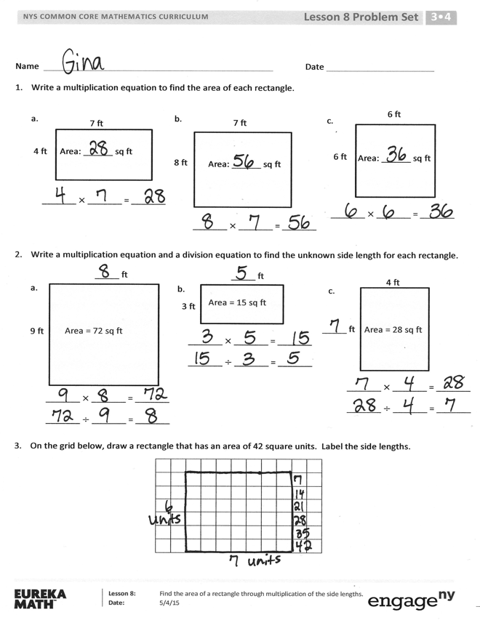
Problem Set (10 minutes)
Students should do their personal best to complete the Problem Set within the allotted 10 minutes. For some classes, it may be appropriate to modify the assignment by specifying which problems they work on first. Some problems do not specify a method for solving. Students should solve these problems using the RDW approach used for Application Problems.
Student Debrief (10 minutes)
Lesson Objective: Find the area of a rectangle through multiplication of the side lengths.
The Student Debrief is intended to invite reflection and active processing of the total lesson experience.
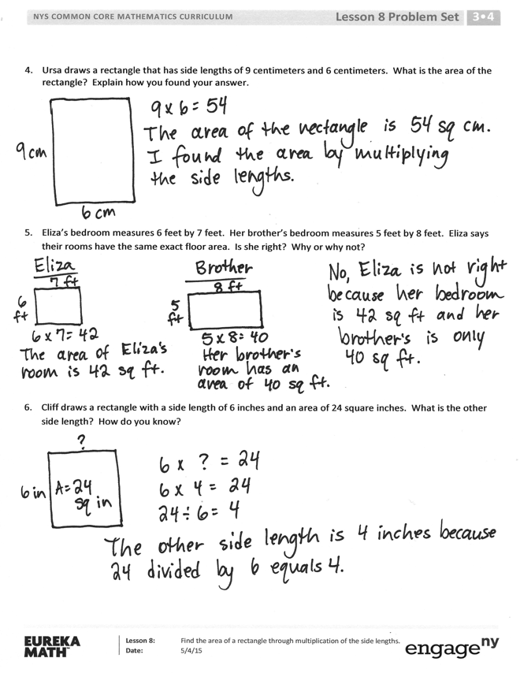
Invite students to review their solutions for the Problem Set. They should check work by comparing answers with a partner before going over answers as a class. Look for misconceptions or misunderstandings that can be addressed in the Debrief. Guide students in a conversation to debrief the Problem Set and process the lesson.
Any combination of the questions below may be used to lead the discussion.
- In what way is the area of Problem 1(b) related to the area of Problem 1(a)? (It is double.) How could you use the side lengths to help you figure out that 8 × 7 is double 4 × 7?
- Which shape in Problem 1 is a square? How do you know?
- How are the rectangles in Problem 1(a) and 2(c) similar? How are they different?
- Address the following possible misconception in Problem 5. Although Eliza’s bedroom has 1 side length (6 feet) that is 1 more than her brother’s bedroom (5 feet), and 1 side length (7 feet) that is 1 less than her brother’s bedroom (8 feet), the floor areas are not equal.
- Why is there a connection between a rectangle’s side lengths and its area?
Exit Ticket (3 minutes)
After the Student Debrief, instruct students to complete the Exit Ticket. A review of their work will help with assessing students’ understanding of the concepts that were presented in today’s lesson and planning more effectively for future lessons. The questions may be read aloud to the students.
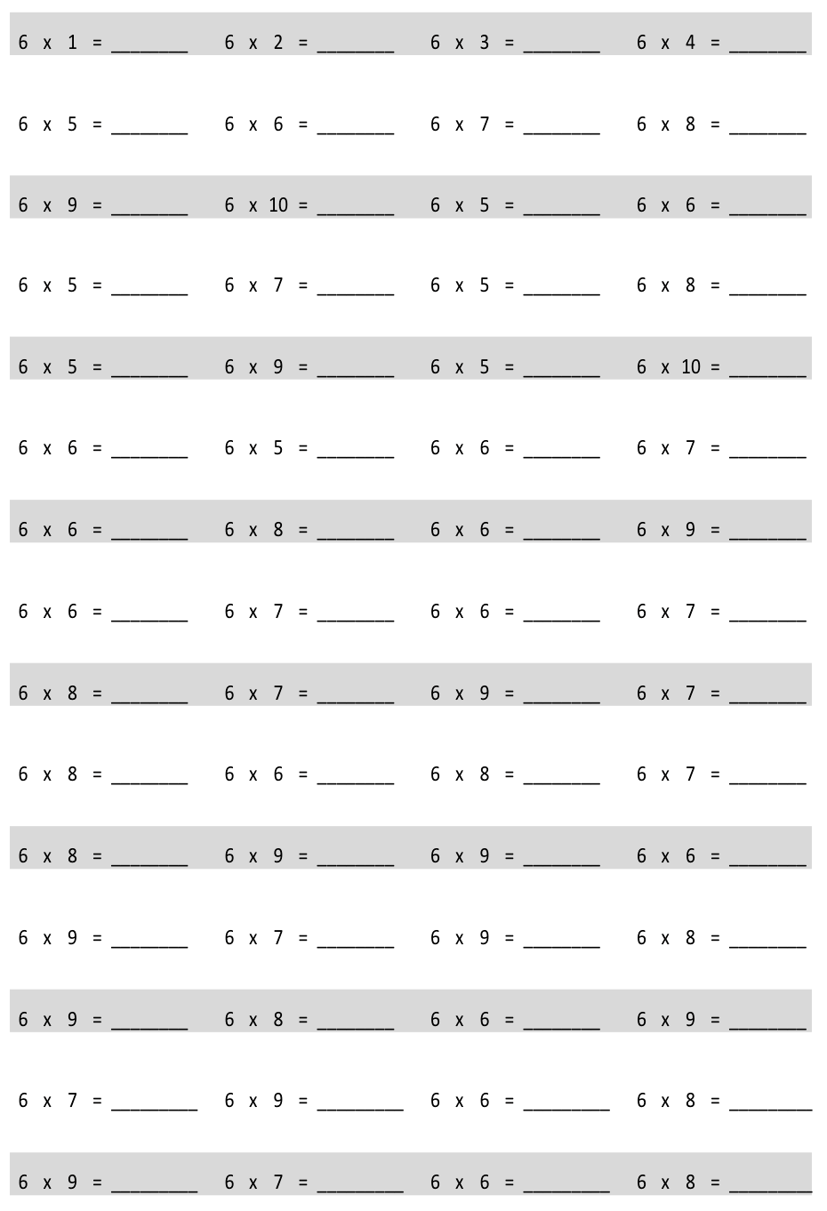
Multiply.
Multiply.
Multiply.
Name Date
- Write a multiplication equation to find the area of each rectangle.
a.
4 ft
7 ft
Area: ______ sq ft
_______ $×$ _______ = _______

b.
7 ft
8 ft
Area: ______ sq ft
_______ $×$ _______ = _______
c.
6 ft
6 ft
_______ $×$ _______ = _______
Area: ______ sq ft

- Write a multiplication equation and a division equation to find the unknown side length for each rectangle.
_____ ft
a.
Area = 72 sq ft
9 ft
_______ $×$ _______ = _______
_______ $÷$ _______ = _______

_____ ft
b.
Area = 15 sq ft
3 ft
_______ $×$ _______ = _______
_______ $÷$ _______ = _______
4 ft
c.
Area = 28 sq ft
_____ ft
_______ $×$ _______ = _______
_______ $÷$ _______ = _______

- On the grid below, draw a rectangle that has an area of 42 square units. Label the side lengths.

- Ursa draws a rectangle that has side lengths of 9 centimeters and 6 centimeters. What is the area of the rectangle? Explain how you found your answer.

- Eliza’s bedroom measures 6 feet by 7 feet. Her brother’s bedroom measures 5 feet by 8 feet. Eliza says their rooms have the same exact floor area. Is she right? Why or why not?

- Cliff draws a rectangle with a side length of 6 inches and an area of 24 square inches. What is the other side length? How do you know?

Name Date
- Write a multiplication equation to find the area of the rectangle below.
3 inches
9 inches
_______ $×$ _______ = _______

Area: _____ sq in
- Write a multiplication equation and a division equation to find the unknown side length for the rectangle below.
6 inches
_____ inches
Area: 54 sq in
_______ $×$ _______ = _______
_______ $÷$ _______ = _______

Name Date
- Write a multiplication equation to find the area of each rectangle.

_______ $×$ _______ = _______

a. b.
8 cm

_______ $×$ _______ = _______

8 cm
3 cm
Area: ______ sq cm

Area: ______ sq cm

6 cm

d.

_______ $×$ _______ = _______
c.
4 ft
Area: ______ sq ft
7 ft
4 ft

_______ $×$ _______ = _______

4 ft

Area: ______ sq ft

- Write a multiplication equation and a division equation to find the unknown side length for each rectangle.
9 ft
b.
_____ ft
_______ $×$ _______ = _______
_______ $÷$ _______ = _______
Area: 36 sq ft

_____ ft.
a.
3 ft
_______ $×$ _______ = _______
_______ $÷$ _______ = _______
Area: 24 sq ft

- On the grid below, draw a rectangle that has an area of 32 square centimeters. Label the side lengths.

- Patricia draws a rectangle that has side lengths of 4 centimeters and 9 centimeters. What is the area of the rectangle? Explain how you found your answer.

- Charles draws a rectangle with a side length of 9 inches and an area of 27 square inches. What is the other side length? How do you know?

multiply by 6 (6–10)
grid

