Lesson 5
Objective: Form rectangles by tiling with unit squares to make arrays.

Suggested Lesson Structure
 Fluency Practice (14 minutes)
 Application Problem (6 minutes)
 Concept Development (30 minutes)
 Student Debrief (10 minutes)
Total Time (60 minutes)
Fluency Practice (14 minutes)
- Group Counting 3.OA.1 (3 minutes)
- Products in an Array 3.OA.3 (3 minutes)
- Find the Common Products 3.OA.7 (8 minutes)
Group Counting (3 minutes)
Note: Group counting reviews interpreting multiplication as repeated addition.
Instruct students to count forward and backward, occasionally changing the direction of the count.
- Threes to 30
- Sixes to 60
- Sevens to 70
- Nines to 90
Products in an Array (3 minutes)
Materials: (S) Personal white board
Note: This fluency activity anticipates relating multiplication with area in Topic B’s lessons.
T: (Project an array with 4 rows of 3 stars.) How many rows of stars do you see?
S: 4 rows.
T: How many stars are in each row?
S: 3 stars.
T: On your personal white board, write two multiplication sentences that can be used to find the total number of stars.
S: (Write 4 × 3 = 12 and 3 × 4 = 12.)
Continue with the following possible sequence: 3 × 6, 7 × 5, 8 × 4, and 9 × 6.
Find the Common Products (8 minutes)
Materials: (S) Blank paper
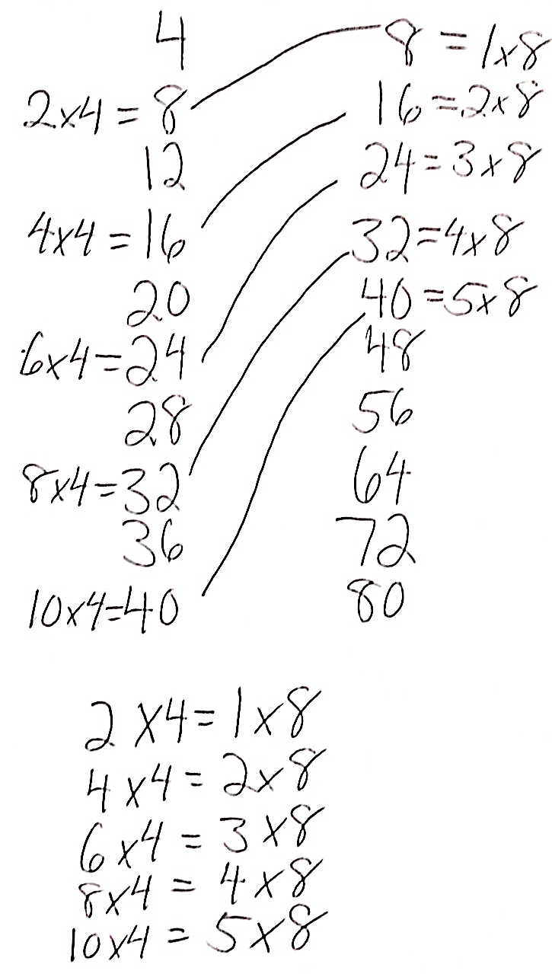
Note: This fluency activity reviews multiplication patterns from Module 3.
T: (List the multiples of 4 and 8 in two different columns.) Draw a line to match the products that appear in both columns.
S: (Match 8, 16, 24, 32, and 40.)
T: (Write 2 × 4 = 8, etc., next to each matched product on the left half of the paper.) Write the rest of the equations like
I did.
S: (Write equations.)
T: (Write 8 = 1 × 8, etc., next to each matched product on the right half of the paper.) Write the rest of the equations like I did.
S: (Write equations.)
T: (Write 2 × 4 = × 8.) Say the true equation.
S: 2 × 4 = 1 × 8.
T: (Write 2 × 4 = 1 × 8.) Write the remaining equal facts
as equations.
S: (Write 4 × 4 = 2 × 8, 6 × 4 = 3 × 8, 8 × 4 = 4 × 8, and 10 × 4 = 5 × 8.)
T: Discuss the patterns in your equations.
S: Each multiple of 8 is also a multiple of 4.
Application Problem (6 minutes)

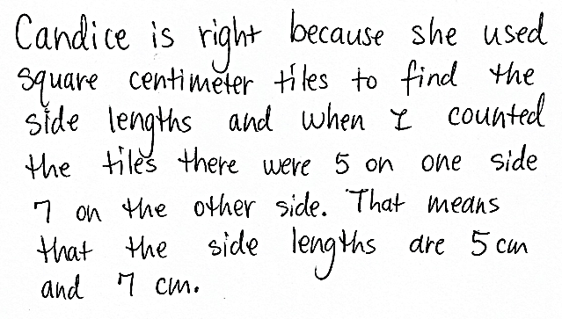
Candice uses square centimeter tiles to find the side lengths of a rectangle as shown on the right. She says the side lengths are 5 centimeters and 7 centimeters. Her partner, Luis, uses a ruler to check Candice’s work and says that the side lengths are 5 centimeters and 6 centimeters. Who is right? How do you know?

Note: This problem reviews Lesson 4, particularly the relationship between the number of tiles and side length. Invite students to discuss what Luis might have done wrong.
Concept Development (30 minutes)
Materials: (S) 15 square inch tiles, personal white board, straight edge, blank paper
Concrete: Understand the relationship between side lengths and area.
Draw or project the rectangle and side length shown on the right.
2 in
T: Use square inch tiles to show this rectangle as an array. What information do we know?
S: There are 2 rows. A side length is 2 inches.

NOTES ON
MULTIPLE MEANS
OF REPRESENTATION:
Simplify and clarify your script for English language learners and others. Rephrase, “What information do we know?” to “How many rows of inch squares? How do you know?”
Place the opaque 2 by 6 rectangle pictured above over a square grid. As an alternate way to check work, lift the rectangle to show the 12 squares covered.

T: At your table, place tiles to make the known side.
S: (Make 1 column of 2 tiles.)
T: (Write below the diagram: Area = 12 square inches.) How many total tiles will we use to make our rectangle?
S: 12 tiles.
T: How many twos are in 12?
S: 6 twos.
T: Use your tiles to make 6 sets of twos, and then
skip-count to check your work.
S: (Make 6 groups of 2 tiles and skip-count.)
2, 4, 6, 8, 10, 12.
T: Push your twos together to make a rectangle. (Allow students time to complete. Add a question mark to the diagram as shown on the right.) What is the unknown side length?
2 in
?
Area = 12 sq in
S: Six. Six tiles. Six inches.
T: (Replace the question mark with 6 in on the diagram.) Tell your partner about the relationship between the side lengths and the area. Write an equation to show your thinking. Be sure to include the units.
S: 2 inches × 6 inches = 12 square inches, so the area is the product of the side lengths.
(Write 2 inches × 6 inches = 12 square inches.)
Repeat the process using a rectangle with a known side length of 5 inches and an area of 15 square inches. Ask students to write an unknown factor problem, 5 × = 15, and then use the tiles to solve.

Concrete/Pictorial: Form rectangles and determine area or side lengths by drawing to make arrays.
T: Lay tiles on your personal white board to make a side 3 inches tall. Trace the outline of all 3 tiles. Then, draw horizontal lines to show where they connect.
S: (Draw a 3-inch tall side.)
3 in
7 in
T: Label the side length.
S: (Label 3 in as shown.)
T: Use your tiles to make another side 7 inches long.
S: (Add tiles horizontally, using the top tile as one of the 7.)
T: Trace the outline of the tiles. Draw vertical lines to show where they connect. Label the side length.
S: (Draw image shown on the right and label 7 in.)
T: How many sets of threes will be in this rectangle?
S: 7 threes.
T: Talk to your partner. Which strategy might you use to find the total area of the rectangle?
S: We can draw in the rest of the squares and count them all. Or, just skip-count 7 threes.
It would be easier to just multiply 7 inches × 3 inches and get 21 square inches.
T: Many students suggested multiplying the side lengths to find the area. Let’s check this strategy by drawing in the rest of the squares. Use your straight edge to draw the rest of the tiles in the rectangle, and then skip-count to find the total area.
S: (Draw the rest of the tiles, and then skip-count.) 3, 6, 9, 12, 15, 18, 21.
T: Does 7 inches × 3 inches = 21 square inches accurately give the area of the rectangle?
S: Yes!
T: Clear your personal white board, and use your tiles to make a side length of 6 inches. Trace the outline of all 6 tiles. Then, draw horizontal lines to show where they connect.
6 in
S: (Draw image shown to the right.)
T: Label the side length.
S: (Label 6 in as shown on the right.)
T: Write 6 × __ = 24 on your personal white board. Talk to a partner about how you can use this equation to help find the other side length.
S: From the equation, I know that the area is 24, so I can add rows of 6 tiles until I have 24 tiles. Then, I can count the rows to find the side length. I can skip-count by 6 to get to 24, and then I know the other side length will be equal to the number of times I skip-count. I know 6 × 4 = 24, so I know that the other side length is 4.
T: Choose a strategy to find the other side length, and then fill in the blank in the equation. (Allow time for students to work.) What is the other side length?
S: 4 inches!

Problem Set (10 minutes)

NOTES ON
MULTIPLE MEANS
OF ACTION AND EXPRESSION:
Some learners may benefit from alternatives to drawing tiles inside rectangles on the Problem Set. Consider the following:
- Magnify the Problem Set to ease small motor tasks.
- Provide virtual or concrete manipulatives.
- Allow students to draw their own rectangles, perhaps with larger tiles, perhaps with smaller areas.

Students should do their personal best to complete the Problem Set within the allotted 10 minutes. For some classes, it may be appropriate to modify the assignment by specifying which problems they work on first. Some problems do not specify a method for solving. Students should solve these problems using the RDW approach used for Application Problems.
Student Debrief (10 minutes)
Lesson Objective: Form rectangles by tiling with unit squares to make arrays.
The Student Debrief is intended to invite reflection and active processing of the total lesson experience.
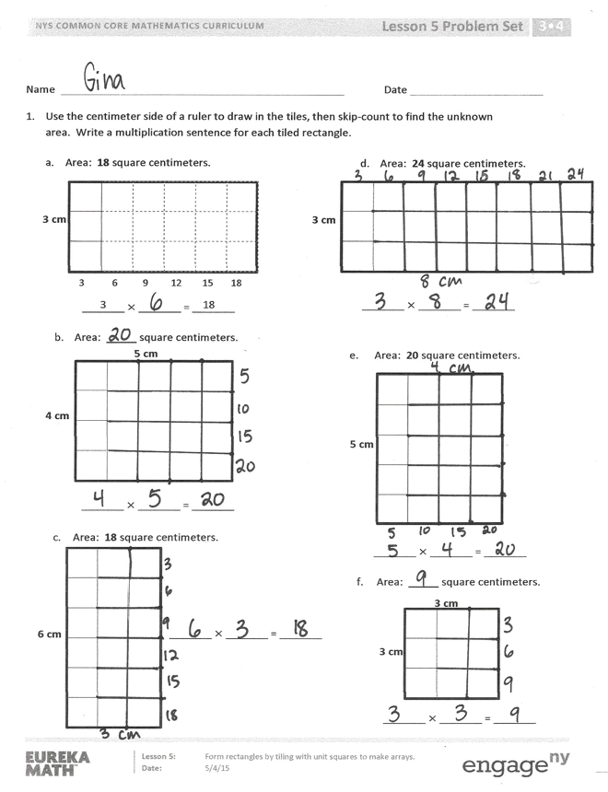
Invite students to review their solutions for the Problem Set. They should check their work by comparing answers with a partner before going over answers as a class. Look for misconceptions or misunderstandings that can be addressed in the Debrief. Guide students in a conversation to debrief the Problem Set and process the lesson.
Any combination of the questions below may be used to lead the discussion.
- Compare Problems 1(b) and 1(e) and Problems 1(a) and 1(c). How does each pair show commutativity?
- How many more threes does the array in Problem 1(d) have compared to the array in Problem 1(a)? How might the side lengths help you know that, even without seeing the tiled array?
MP.8
- Compare Problems 1(c) and 1(f). How are the areas related? (The area of 1(f) is half the area of 1(c).) How might you have figured that out just by knowing the side lengths of each array?
- In Problem 2, what strategy did you use to find the unknown side length? Is there another way you could have figured it out?
- Students may have different solutions for Problem 3. Invite them to share and compare their work.

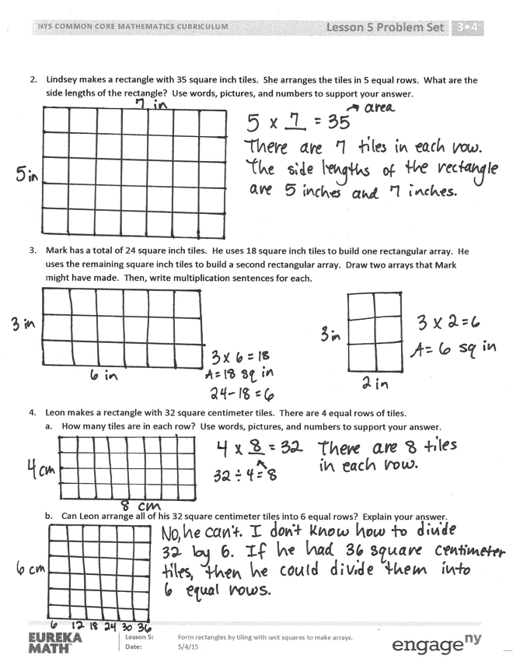
Exit Ticket (3 minutes)
After the Student Debrief, instruct students to complete the Exit Ticket. A review of their work will help with assessing students’ understanding of the concepts that were presented in today’s lesson and planning more effectively for future lessons. The questions may be read aloud to the students.

Name Date
- Use the centimeter side of a ruler to draw in the tiles, and then skip-count to find the unknown area. Write a multiplication sentence for each tiled rectangle.

_______ $×$ _______ = _______
3 cm
- Area: 24 square centimeters.

- Area: 18 square centimeters.
3 6 9 12 15 18
3 18
_______ $×$ _______ = _______
3 cm

_______ $×$ _______ = _______
4 cm
5 cm

- Area: _____ square centimeters.

_______ $×$ _______ = _______
6 cm
- Area: 18 square centimeters.

_______ $×$ _______ = _______
5 cm

- Area: 20 square centimeters.

- Area: _____ square centimeters.

3 cm
3 cm
_______ $×$ _______ = _______

- Lindsey makes a rectangle with 35 square inch tiles. She arranges the tiles in 5 equal rows. What are the side lengths of the rectangle? Use words, pictures, and numbers to support your answer.

- Mark has a total of 24 square inch tiles. He uses 18 square inch tiles to build one rectangular array. He uses the remaining square inch tiles to build a second rectangular array. Draw two arrays that Mark might have made. Then, write multiplication sentences for each.

- Leon makes a rectangle with 32 square centimeter tiles. There are 4 equal rows of tiles.
  - How many tiles are in each row? Use words, pictures, and numbers to support your answer.

  - Can Leon arrange all of his 32 square centimeter tiles into 6 equal rows? Explain your answer.

Name Date
Darren has a total of 28 square centimeter tiles. He arranges them into 7 equal rows. Draw Darren’s rectangle. Label the side lengths, and write a multiplication sentence to find the total area.

Name Date
- Use the centimeter side of a ruler to draw in the tiles, and then skip-count to find the unknown area. Write a multiplication sentence for each tiled rectangle.

_______ $×$ _______ = _______
4 cm
- Area: 24 square centimeters.

4 24

_______ $×$ _______ = _______
6 cm
- Area: 24 square centimeters.

_______ $×$ _______ = _______
5 cm
- Area: 15 square centimeters.

3 cm
- Area: 15 square centimeters.

_______ $×$ _______ = _______

- Ally makes a rectangle with 45 square inch tiles. She arranges the tiles in 5 equal rows. How many square inch tiles are in each row? Use words, pictures, and numbers to support your answer.

- Leon makes a rectangle with 36 square centimeter tiles. There are 4 equal rows of tiles.
  - How many tiles are in each row? Use words, pictures, and numbers to support your answer.

- Can Leon arrange all of his 36 square centimeter tiles into 6 equal rows? Use words, pictures, and numbers to support your answer.

- Do the rectangles in Parts (a) and (b) have the same total area? Explain how you know.

