Lesson 4
Objective: Relate side lengths with the number of tiles on a side.

Suggested Lesson Structure
 Fluency Practice (12 minutes)
 Application Problem (5 minutes)
 Concept Development (33 minutes)
 Student Debrief (10 minutes)
Total Time (60 minutes)
Fluency Practice (12 minutes)
- Group Counting 3.OA.1 (3 minutes)
- Products in an Array 3.OA.3 (3 minutes)
- Count the Square Units 3.MD.6 (6 minutes)
Group Counting (3 minutes)
Note: Group counting reviews interpreting multiplication as repeated addition.
Instruct students to count forward and backward, occasionally changing the direction of the count.
- Sixes to 60
- Sevens to 70
- Eights to 80
- Nines to 90
Products in an Array (3 minutes)
Materials: (S) Personal white board
Note: This fluency activity anticipates relating multiplication with area in Topic B.
T: (Project an array with 5 rows of 3 stars.) How many rows of stars do you see?
S: 5 rows.
T: How many stars are in each row?
S: 3 stars.
T: On your personal white board, write two different multiplication sentences that can be used to find the total number of stars.
S: (Write 5 × 3 = 15 and 3 × 5 = 15.)
Continue with the following possible sequence: 4 × 6, 7 × 3, 8 × 5, and 9 × 7.
Count the Square Units (6 minutes)
Materials: (T) 12 square tiles
Note: This fluency activity reviews comparing the area of different shapes.
T: (Project an 8 × 1 tiled array.) How many square units are in the rectangle?
S: 8 square units.
T: (Write 8 square units next to the rectangle. Project a 4 × 2 tiled array.) How many square units are in the rectangle?
S: 8 square units.
T: (Write 8 square units next to the rectangle. Project a 2 × 4 tiled array.) How many square units are in the rectangle?
S: 8 square units.
T: (Write 8 square units next to the rectangle. Project a 1 × 8 tiled array.) How many square units are in the rectangle?
S: 8 square units.
T: (Write 8 square units next to the rectangle.) Do the four rectangles look the same?
S: No.
T: What do the rectangles have in common?
S: They are each composed of 8 square units.
Continue with the following possible sequence: 12 × 1, 1 × 12, 6 × 2, 3 × 4, 2 × 6, and 4 × 3.
Application Problem (5 minutes)
Mara uses 15 square-centimeter tiles to make a rectangle. Ashton uses 9 square-centimeter tiles to make a rectangle.
- Draw what Mara and Ashton’s rectangles might look like.
- Whose rectangle has a bigger area? How do you know?
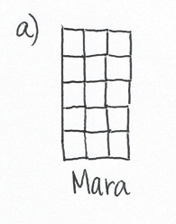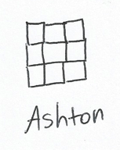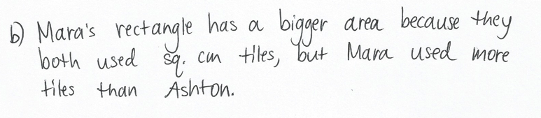
Note: This problem reviews Lesson 2, particularly tiling with square units. Invite students to share and compare their drawings for Mara and Ashton’s rectangles.
Concept Development (33 minutes)
Materials: (S) 15 square inch and square centimeter tiles, ruler, personal white board
Note: The ones cubes included in sets of Dienes blocks (base ten blocks) may also be used as square centimeter tiles.
Pass out 15 square-inch tiles to each student.
T: These tiles are square…?
S: Inches!
T: Use the tiles to make a 3 by 5 array. (Allow students time to make an array.) Push the tiles together to form a rectangle with no gaps or overlaps. What is the area of your rectangle?

Rectangle A
S: 15 square inches.
T: I see your squares are nicely arranged to form a rectangle. What about these? (Project Rectangles A and B shown to the right.) I used 15 square-inch tiles to make both of these rectangles. Talk to a partner. Is the area of both rectangles 15 square inches?
S: Yes. The number of tiles is the same. No. A’s area is bigger than 15 square inches because there are gaps between the tiles. B’s area is smaller because some of the tiles are on top of each other.
Rectangle B
T: Why is it important to avoid gaps or overlaps when we measure area?
S: If there are gaps or overlaps, the amount of space the rectangle takes up changes. The square unit would be wrong because some area is taken away if there are overlaps, or some is added if there are gaps.
T: Use your ruler to measure across the top of your rectangle in inches. What is the length of this side?

NOTES ON
MULTIPLE MEANS
OF REPRESENTATION:
Scaffold student contrast of length and area. Consider placing a long string along the side of the rectangle, or have students trace the side with a finger to better illustrate length. In contrast, have students shade in the area before writing 15 square inches.

S: 5 inches.
T: How many tiles are on this side?
S: 5 tiles.
T: Use your ruler to measure the shorter side of the rectangle in inches. What is the length of this side?
MP.8
S: 3 inches.
T: How many tiles are on this side?
S: 3 tiles!
T: What is the relationship between the number of tiles on a side and the side length of the rectangle?
S: They are the same.
T: What do you notice about the lengths of the opposite sides of the rectangles?
S: They are equal.
T: Trace the rectangle on your personal white board. Then, remove the tiles and label the side lengths. Now, write the area inside the rectangle. What are the units for the side lengths?
S: Inches.
T: What are the units for the area?
S: Square inches.
T: Talk to a partner. Why are the units different for side lengths and area?
S: The unit for side lengths is inches because we used a ruler to measure the length of the side in inches. For area, the unit is square inches because we counted the number of square inch tiles that we used to make the rectangle.
T: Inches are used to measure lengths, such as the side lengths, and square inches are used to measure the amount of flat space a figure takes up, which is the area.
Direct students to exchange square inch tiles for square centimeter tiles.
T: These tiles are square…?
S: Centimeters.
T: Use them to make a rectangle with side lengths of 5 centimeters and 4 centimeters. (Write 5 cm and 4 cm.) Tell your partner how many tiles you will count to make each side.
S: I will make one side with 5 tiles and the other with 4 tiles. Actually, we will count 5 tiles each for two sides of the rectangle and 4 tiles each for the other two sides. Opposite sides are the same, remember?
T: Make your rectangle on top of your board. Label the side lengths.

NOTES ON
MULTIPLE MEANS
OF REPRESENTATION:
Alternatively, build the rectangle in 4 rows of 5 centimeter tiles. As students place each row, encourage careful and meaningful counting. Students may benefit from counting each tile in the row so as not to add extra tiles. Then, recapture by counting by fives, “5, 10, 15, 20.”

S: (Make rectangle and label side lengths 5 cm and 4 cm.)
T: How many fives did you make? Why?
S: 4 fives because the other side length is 4.
T: What is the total of 4 fives?
S: 20.
T: Skip-count your fives to find the total area of the rectangle. (Pause.) What is the total area?
S: 20 square centimeters.
T: What is the relationship between the side lengths and area?
S: If you multiply 5 times 4, then you get 20.
If time allows, repeat the process using a rectangle with side lengths of 3 centimeters and 6 centimeters. As students are ready, tell them the area, and let them build a rectangle and name the side lengths.

Problem Set (10 minutes)
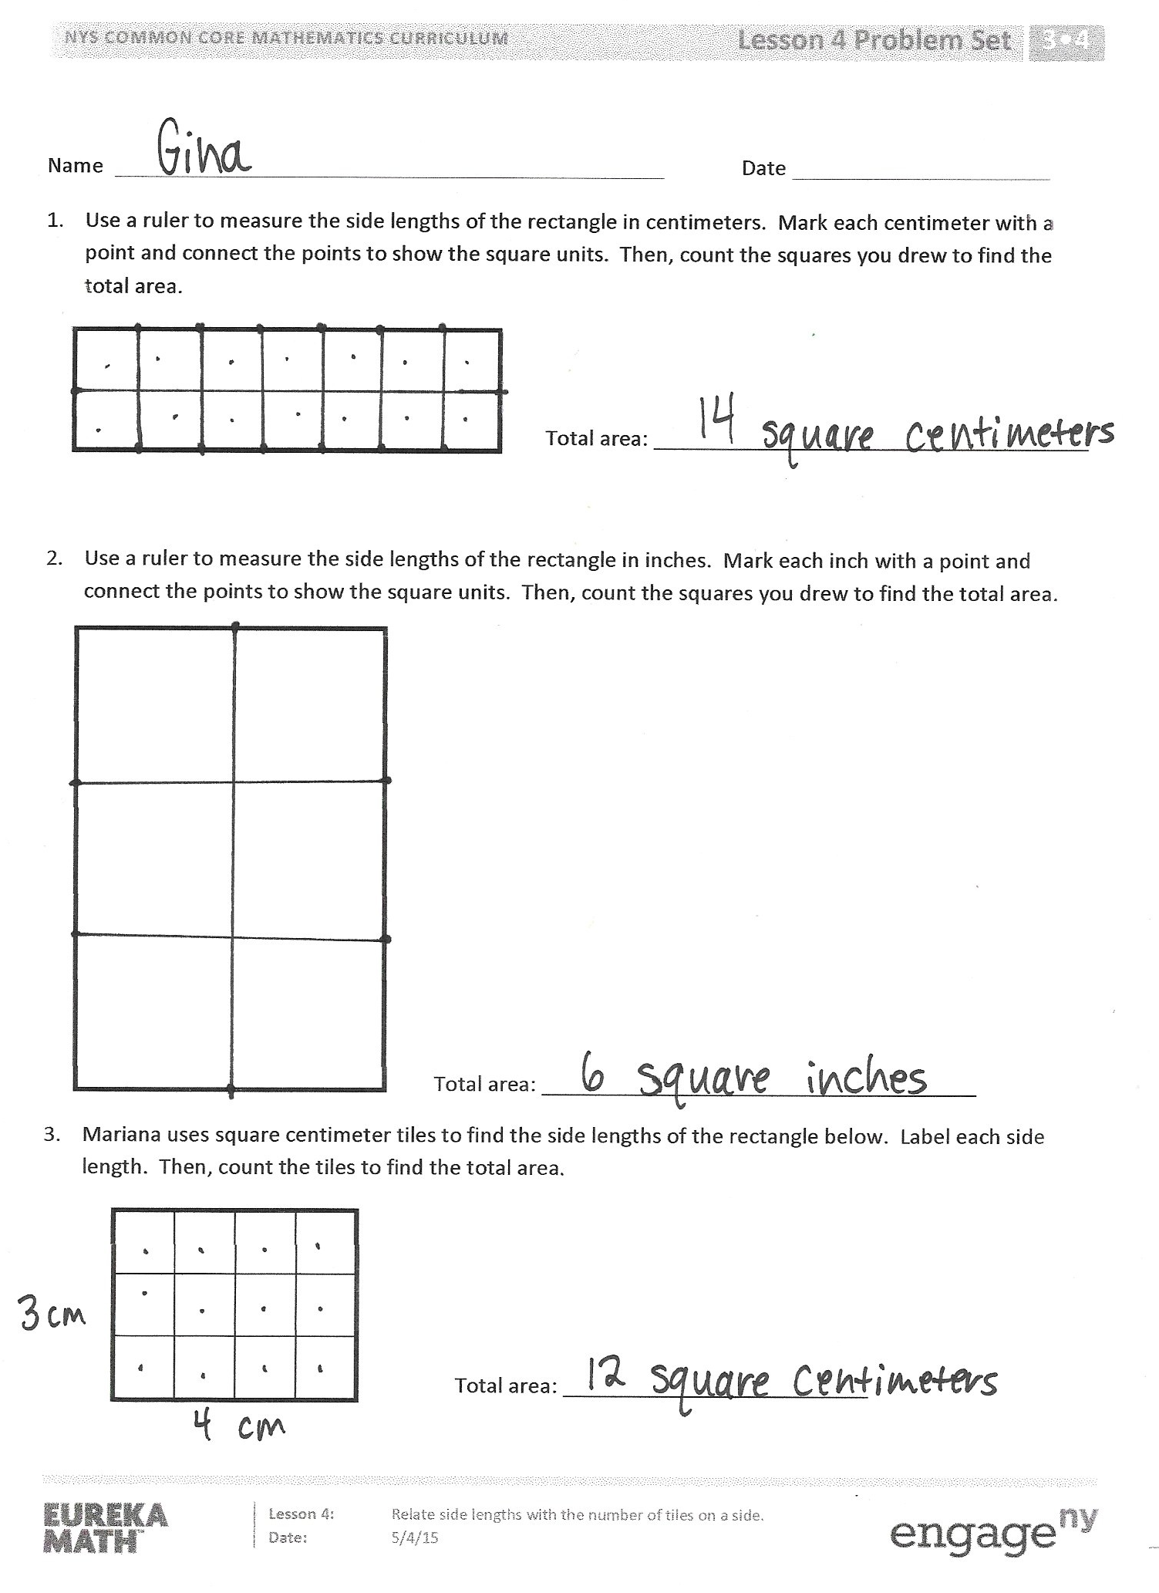
Students should do their personal best to complete the Problem Set within the allotted 10 minutes. For some classes, it may be appropriate to modify the assignment by specifying which problems they work on first. Some problems do not specify a method for solving. Students should solve these problems using the RDW approach used for Application Problems.
Student Debrief (10 minutes)
Lesson Objective: Relate side lengths with the number of tiles on a side.
The Student Debrief is intended to invite reflection and active processing of the total lesson experience.
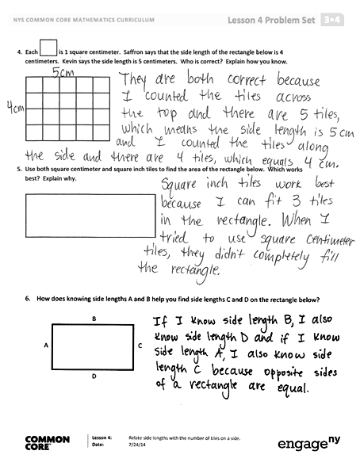
Invite students to review their solutions for the Problem Set. They should check work by comparing answers with a partner before going over answers as a class. Look for misconceptions or misunderstandings that can be addressed in the Debrief. Guide students in a conversation to debrief the Problem Set and process the lesson.
Any combination of the questions below may be used to lead the discussion.
- Tell a partner how you could use square centimeter tiles to check your work in Problem 1.
- Compare the areas of the rectangles in Problems 1 and 2. Which rectangle has a larger area? How do you know?
- What are the side lengths of the shape in Problem 3? Are all of the sides the same? How do you know? What shape is this?
- What is the area of the rectangle in Problem 4? Explain how you found the area to a partner.
- How many centimeter tiles fit in the rectangle in Problem 5? Is that the area of the rectangle in square centimeters? Why or why not?
- In Problem 6, if the side length of A is 4 units, would 3 units make sense for the side length of B? Why or why not? What would make sense?
Exit Ticket (3 minutes)
After the Student Debrief, instruct students to complete the Exit Ticket. A review of their work will help with assessing students’ understanding of the concepts that were presented in today’s lesson and planning more effectively for future lessons. The questions may be read aloud to the students.

Name Date
- Use a ruler to measure the side lengths of the rectangle in centimeters. Mark each centimeter with a point and connect the points to show the square units. Then, count the squares you drew to find the total area.
Total area: __________________________________

- Use a ruler to measure the side lengths of the rectangle in inches. Mark each inch with a point and connect the points to show the square units. Then, count the squares you drew to find the total area.

Total area: __________________________________

- Mariana uses square centimeter tiles to find the side lengths of the rectangle below. Label each side length. Then, count the tiles to find the total area.

Total area: __________________________________
- Each is 1 square centimeter. Saffron says that the side length of the rectangle below is
4 centimeters. Kevin says the side length is 5 centimeters. Who is correct? Explain how you know.

- Use both square centimeter and square inch tiles to find the area of the rectangle below. Which works best? Explain why.

- How does knowing side lengths A and B help you find side lengths C and D on the rectangle below?
A
B
C
D

Name Date
Label the side lengths of each rectangle. Then, match the rectangle to its total area.
12 square
centimeters
5 square
inches
6 square
centimeters

Name Date
- Ella placed square centimeter tiles on the rectangle below, and then labeled the side lengths. What is the area of her rectangle?
2 cm

4 cm

Total area: __________________________________
- Kyle uses square centimeter tiles to find the side lengths of the rectangle below. Label each side length. Then, count the tiles to find the total area.

Total area: __________________________________
- Maura uses square inch tiles to find the side lengths of the rectangle below. Label each side length. Then, find the total area.

Total area: __________________________________
- Each square unit below is 1 square inch. Claire says that the side length of the rectangle below is 3 inches. Tyler says the side length is 5 inches. Who is correct? Explain how you know.

- Label the unknown side lengths for the rectangle below, and then find the area. Explain how you used the lengths provided to find the unknown lengths and area.
2 inches
4 inches
_________________
_________________

Total area: __________________________________

