Lesson 3
Objective: Model tiling with centimeter and inch unit squares as a strategy to measure area.

Suggested Lesson Structure
 Fluency Practice (13 minutes)
 Application Problem (5 minutes)
 Concept Development (32 minutes)
 Student Debrief (10 minutes)
Total Time (60 minutes)
Fluency Practice (13 minutes)
- Find the Common Products 3.OA.7 (7 minutes)
- Count the Square Units 3.MD.6 (6 minutes)
Find the Common Products (7 minutes)
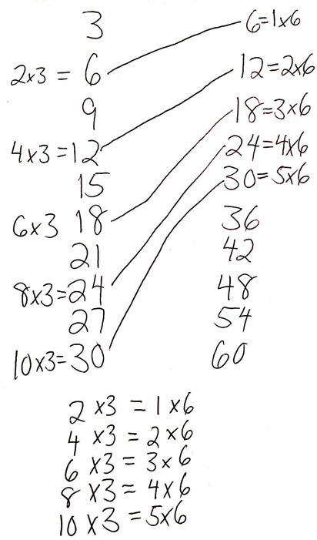
Materials: (S) Blank paper
Note: This fluency activity reviews multiplication patterns from Module 3.
T: Fold your paper in half vertically. Unfold your paper. On the left half, count by threes to 30 down the side of your paper. On the right half, count by sixes to 60 down the side of your paper. Draw a line to match the products that appear in both columns.
S: (Match 6, 12, 18, 24, and 30.)
T: (Write × 3 = 6, × 3 = 12, × 3 = 18, × 3 = 24, and × 3 = 30 next to each matched product on the left half of the paper.) Write the equations next to their products like I did, completing the unknown factors.
S: (Write equations and complete unknowns.)
T: (Write 6 = × 6, 12 = × 6, 18 = × 6, 24 = × 6, and
30 = × 6 next to each matched product on the left half of the paper.) Write the equations next to their products like I did, completing the unknown factors.
S: (Write equations and complete unknowns.)
T: (Write 2 × 3 = × 6.) Say the equation, completing the unknown factor.
S: 2 × 3 = 1 × 6.
Figures for Count the Square Units
Figure 5
Figure 1
Figure 2
Figure 3
Figure 4

T: (Write 2 × 3 = 1 × 6.) Write the remaining equal facts as equations.
S: (Write 4 × 3 = 2 × 6, 6 × 3 = 3 × 6, 8 × 3 = 4 × 6, and
10 × 3 = 5 × 6.)
T: What is the pattern in your equations?
S: Each multiple of 6 is also a multiple of 3.
Count the Square Units (6 minutes)
Note: This fluency activity reviews finding total area using square units.
T: (Project a 1 × 5 tiled array similar to Figure 1 on the right.) What’s the area of the rectangle? (Pause.)

S: 5 square units.
Continue with Figures 2–5.
Application Problem (5 minutes)
Jace uses paper squares to create a rectangle. Clary cuts all of Jace’s squares in half to create triangles.
She uses all the triangles to make a rectangle. There are 16 triangles in Clary’s rectangle. How many squares were in Jace’s shape?
The following are possible student solutions:
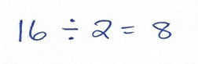
- Dividing

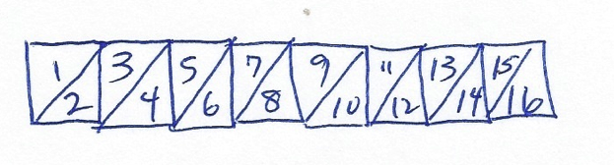
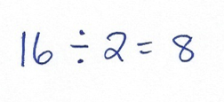
- Drawing a picture

- Skip-counting by twos
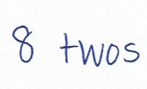
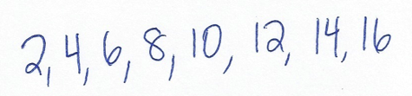

Note: This problem reviews multiplying or dividing by units of 2 from Module 1, depending on how students solve. Invite students to share their strategies for solving.
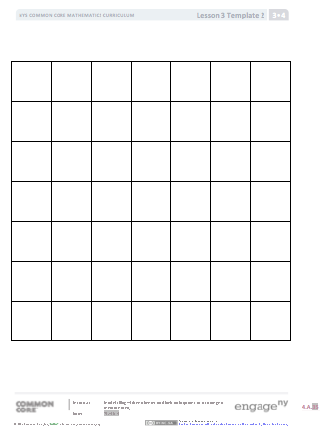
Concept Development (32 minutes)
Centimeter Grid
Inch Grid
Materials: (S) Square centimeter and square inch tiles
(from Lesson 2), centimeter grid (Template 1) and inch grid (Template 2), ruler, personal white board
Pass out 10 square centimeter tiles to each student.
T: Arrange all of your square tiles in 2 equal rows to create a rectangle. Make sure the tiles are touching and do not overlap. (Allow students time to create a rectangle.) What is the area of your rectangle?
S: 10 square units.
T: Is there another way you could arrange all of your tiles to make a rectangle?

NOTES ON
MULTIPLE MEANS
OF ACTION AND EXPRESSION:
Offer an alternative to drawing, shading, and erasing rectangles using a marker. Some students may find it easier to represent and shade rectangles using an interactive white board or personal computer.

S: We could make 5 rows of 2. Or, 1 row of 10.
T: Make 1 row of 10. (Allow students time to make a new rectangle.) What is the area of your rectangle now?
S: It is still 10 square units!
T: Use your ruler to measure all four sides of a tile in centimeters. (Wait for students to measure.)
Can we define these units more precisely?
S: Yes, they’re square centimeters. Yes, all four sides measure 1 centimeter, so they are square centimeters.
T: What is the area of your rectangle in square centimeters?
S: 10 square centimeters.

NOTES ON
MULTIPLE MEANS
OF ACTION
AND EXPRESSION:
Support English language learners as they compose their written response to Problem 3. Discussing their reasoning with a partner before writing may be advantageous. Encourage students to use area and square units in their response. Request that students clarify, if necessary, and guide the elaboration of their ideas.

T: (Pass out the centimeter grid.) Slip the grid paper into your personal white board. Each side of the squares in the grid measures 1 centimeter. How is this grid paper like the tiles we used?
S: They are both square centimeters.
T: Shade the grid paper to represent the rectangle you made with tiles.
S: (Shade grid paper.)
T: Remove a tile from your rectangle, making sure your tiles all still touch to form a rectangle. (Pause.) What is the area of the rectangle now?
S: 9 square centimeters!
T: How can you change the rectangle on the grid paper to have the same area as your new tile rectangle?
S: Erase one of the squares.
T: Go ahead and do that. (Students erase a square.) What is the area of the shaded rectangle?
S: 9 square centimeters.
Repeat this process using the inch grid and inch tiles. If time allows, students can shade a shape for a partner, who then finds the area of the shape. Then, they can erase squares to create shapes with smaller areas.
As students are ready, they can begin drawing shapes using squares rather than just erasing them.
Problem Set (10 minutes)
Inch and centimeter grid paper are required for some of these problems. Students should do their personal best to complete the Problem Set within the allotted 10 minutes. For some classes, it may be appropriate to modify the assignment by specifying which problems they work on first. Some problems do not specify a method for solving. Students should solve these problems using the RDW approach used for Application Problems.
Student Debrief (10 minutes)
Lesson Objective: Model tiling with centimeter and inch unit squares as a strategy to measure area.
The Student Debrief is intended to invite reflection and active processing of the total lesson experience.
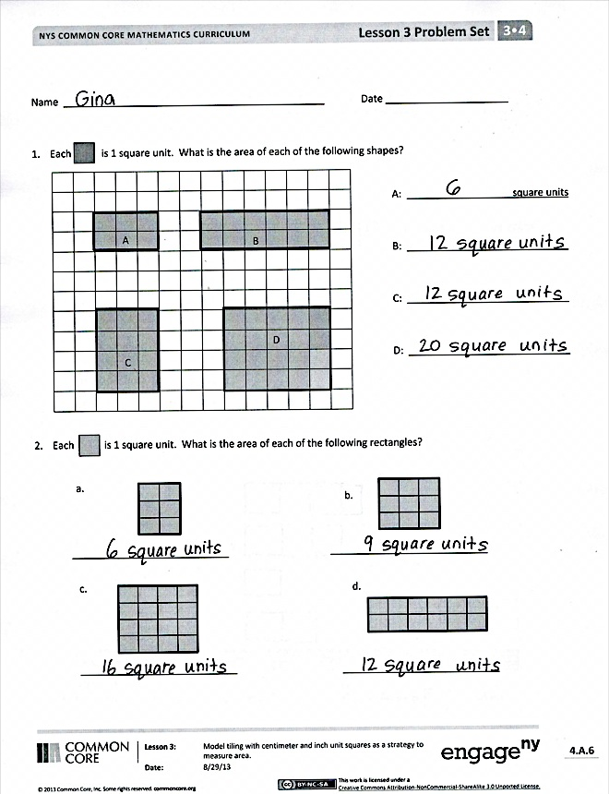
Invite students to review their solutions for the Problem Set. They should check work by comparing answers with a partner before going over answers as a class. Look for misconceptions or misunderstandings that can be addressed in the Debrief. Guide students in a conversation to debrief the Problem Set and process the lesson.
Any combination of the questions below may be used to lead the discussion.
- How are the rectangles in Problems 1(b) and 1(c) the same? How are they different?
- How are the rectangles in Problems 1(a) and 2(a) the same? How are they different?
- Which rectangle in Problem 2 has the largest area? How do you know?
- Compare the rectangles you made in Problem 4 with a partner’s rectangles. How are they the same? How are they different?

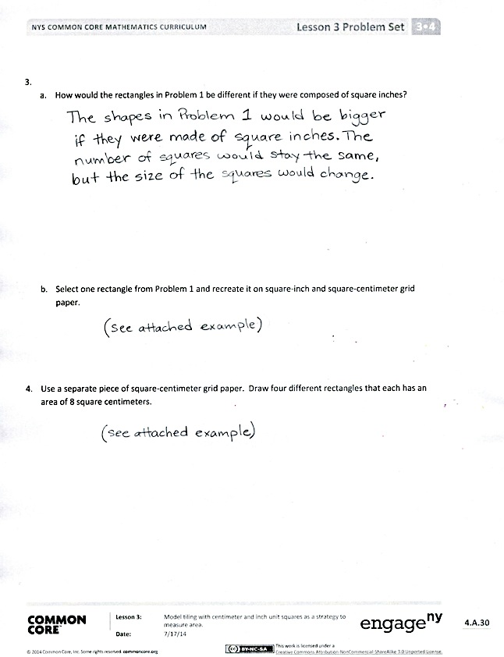
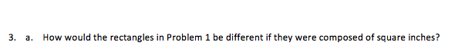
Exit Ticket (3 minutes)
After the Student Debrief, instruct students to complete the Exit Ticket. A review of their work will help with assessing students’ understanding of the concepts that were presented in today’s lesson and planning more effectively for future lessons. The questions may be read aloud to the students.

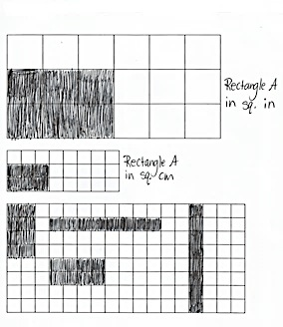
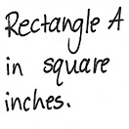
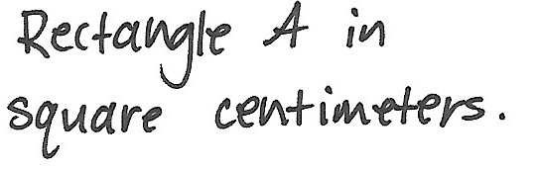
Examples of Problem 3(b) and Problem 4
Name Date
  - Each is 1 square unit. What is the area of each of the following rectangles?
A: square units

B: ___________________________

C: ___________________________

D: ___________________________
 |  |  | A |  |  |  |  |  | B
 |  |  | C |  |  |  |  |  |  | D

  - Each is 1 square unit. What is the area of each of the following rectangles?
_____________________________
d.
_____________________________
b.
_____________________________
a.
_____________________________
c.

- a. How would the rectangles in Problem 1 be different if they were composed of square inches?

- Select one rectangle from Problem 1 and recreate it on square inch and square centimeter grid paper.

- Use a separate piece of square centimeter grid paper. Draw four different rectangles that each has an area of 8 square centimeters.
Name Date
- Each is 1 square unit. Write the area of Rectangle A. Then, draw a different rectangle with the same area in the space provided.
A

Area = ____________________________

- Each is 1 square unit. Does this rectangle have the same area as Rectangle A? Explain.

Name Date
    - Each is 1 square unit. What is the area of each of the following rectangles?
 |  |  | A |  |  |  |  |  | B
 |  |  | C |  |  |  |  |  |  | D

A: square units

B: __________________

C: __________________

D: __________________

- Each is 1 square unit. What is the area of each of the following rectangles?
a.
b.
c.
d.

3. Each is 1 square unit. Write the area of each rectangle. Then, draw a different rectangle with the same area in the space provided.

A
Area = ___________________ square units
B
Area = _____________________________
C
Area = _____________________________

centimeter grid
inch grid

