Lesson 2

Objective: Decompose and recompose shapes to compare areas.

Suggested Lesson Structure

 Fluency Practice (11 minutes)

 Application Problem (5 minutes)

 Concept Development (34 minutes)

 Student Debrief (10 minutes)

**Total Time (60 minutes)**

Fluency Practice (11 minutes)

* Group Counting  **3.OA.1** (4 minutes)
* Multiply by 4 **3.OA.7** (7 minutes)

Group Counting (4 minutes)

Note: Group counting reviews interpreting multiplication as repeated addition.

Instruct students to count forward and backward, occasionally changing the direction of the count.

* Sixes to 60
* Sevens to 70
* Eights to 80
* Nines to 90

Multiply by 4 (7 minutes)

Materials: (S) Multiply by 4 (6–10) Pattern Sheet

Note: This activity builds fluency with respect to multiplication facts using units of 4. It works toward students knowing from memory all products of two one-digit numbers.

T: (Write 7 × 4.) Let’s skip-count up by fours. (Count with fingers to 7 as students count.)

S: 4, 8, 12, 16, 20, 24, 28.

T: What is 7 × 4?

S: 28.

T: Let’s see how we can skip-count down to find the answer, too. (Show 10 fingers.)   
Start at 10 fours, 40. (Count down with your fingers as students say numbers.)

S: 40, 36, 32, 28.

Continue with the following possible sequence: 9 × 4, 6 × 4, and 8 × 4.

T: (Distribute Multiply by 4 (6–10) Pattern Sheet.) Let’s practice multiplying by 4.   
Be sure to work left to right across the page.

Directions for administration of a Multiply-By Pattern Sheet are as follows:

1. Distribute Pattern Sheet.
2. Allow a maximum of two minutes for students to complete as many problems as possible.
3. Direct students to work left to right across the page.
4. Encourage skip-counting strategies to solve unknown facts.

Application Problem (5 minutes)

Wilma and Freddie use pattern blocks to make shapes as shown. Freddie says his shape has a bigger area than Wilma’s because it is longer than hers. Is he right? Explain your answer.

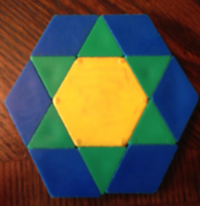

Wilma’s Shape

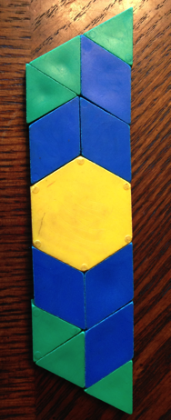

Freddie’s Shape

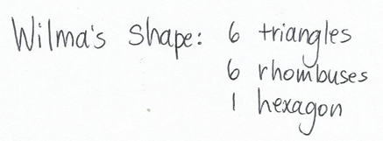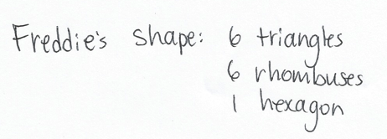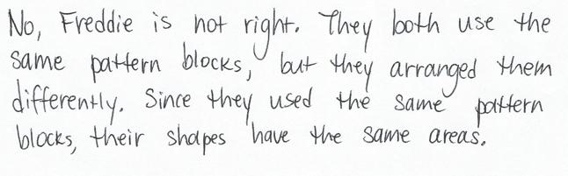

Note: This problem reviews the Lesson 1 concept that, although shapes look different, they may have the same area.

Concept Development (34 minutes)

|  |  |
| --- | --- |
|  | NOTES ON MULTIPLE MEANS OF ACTION AND EXPRESSION: |
| Make it easy for learners to mark inches and cut the strip using the following tips:   * Provide strips of thicker paper, such as cardstock. * Provide strips of grid paper to facilitate drawing lines. * If you offer paper strips with pre-drawn tick marks, guide discovery of *inches.* Darken lines for cutting. * Offer left-handed and adaptive scissors, if needed. | |

Materials: (S) Paper Strip 1: 1 in × 12 in,   
Paper Strip 2: 1 cm × 12 cm, scissors, ruler,   
Problem Set Page 1

Students begin with Paper Strip 1; it should be oriented with the long sides on the top and bottom.

T: Measure your strip. How tall is it?

S: 1 inch tall.

T: Start at the edge of your strip, and use your ruler to mark inches along the top. Do the same along the bottom. Use your ruler to connect the marks at the top to the matching marks at the bottom.

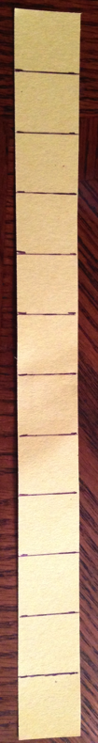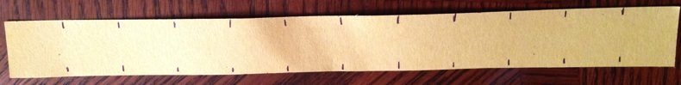

T: How many units make up your strip?

S: 12 units.

T: What shape are they?

**MP.6**

S: They’re squares. Each of the 4 sides is 1 inch.

T: What is the area of the paper strip in square units?

S: 12 square units!

T: Because the sides of the squares each measure 1 inch, we call one of these squares a square inch. What is the area of your paper strip in square inches?

S: 12 square inches.

T: Did the number of squares change?

S: No.

T: Talk to a partner. What changed about the way we talked about the area of the paper strip?

S: The units changed. 🡪 Before today, we called them square units, but now we can call them square inches because all 4 sides measure 1 inch. 🡪 We named this square unit. A square unit could have sides of any length. A square inch is always one inch on every side.

T: Cut your paper strip along the lines you drew. Now, rearrange all 12 squares into 2 equal rows. Remember, the squares have to touch but cannot overlap.

T: Draw your rectangle in the chart for Problem 1 on your Problem Set, next to where it says   
*Rectangle A.* (Model.) What is the area of the rectangle?

S: 12 square inches.

T: Record the area. You can record it by writing 12 square inches, or you can write 12 sq in.

T: Rearrange all 12 squares into 3 equal rows to make a new rectangle. Draw it in the chart for *Rectangle B* and record the area. At my signal, whisper the area of your rectangle to a partner. (Signal.)

S: 12 square inches.

T: Rearrange all 12 squares into 4 equal rows to make a new rectangle. Draw it in the chart for *Rectangle C* and record the area. At my signal, whisper the area of your rectangle to a partner. (Signal.)

|  |  |
| --- | --- |
|  | NOTES ON  MULTIPLE MEANS  OF ENGAGEMENT: |

Students working above grade level may enjoy more autonomy as they explore and compare area. Offer the choice of a partner game in which Partner A constructs a shape, after which Partner B constructs a shape with a greater or lesser area. Encourage students to modify the game or invent another that compares area.

S: 12 square inches.

T: How is it possible that these three different rectangles and our paper strip all have the same area?

S: We used the same squares for each one, so they all have the same area. 🡪 We rearranged 12 square inches each time. Just rearranging them doesn’t change the area.

Repeat the process with Paper Strip 2 (1 cm × 12 cm).   
Call attention to the change in units to centimeters. Discuss similarities and differences between the rectangular models. Students should notice that the same models can be built even though the units are different.

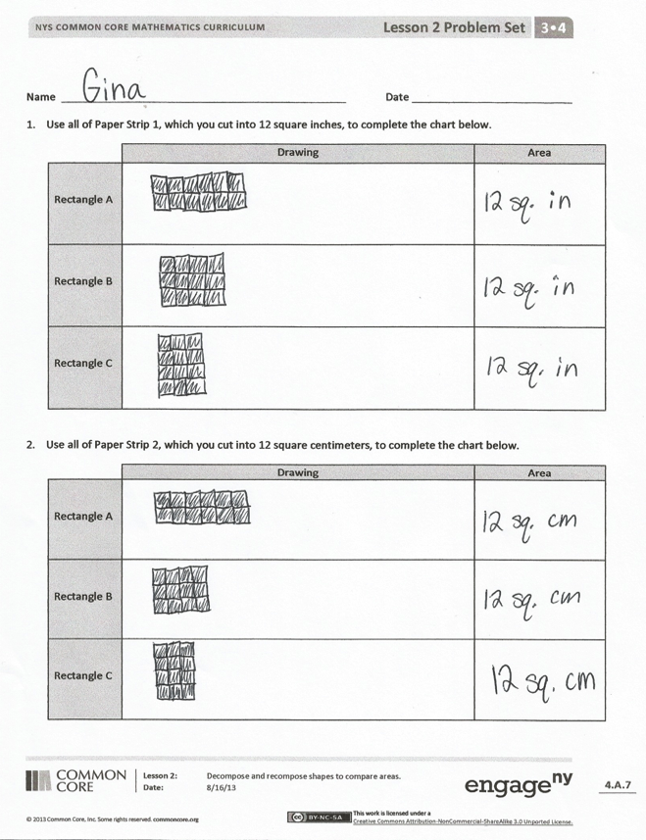Note: The square inch and square centimeter tiles will be used again in other Module 4 lessons. You may want to collect them or have students store them in a safe place.

Problem Set (10 minutes)

Students should do their personal best to complete the Problem Set within the allotted 10 minutes. Some problems do not specify a method for solving. This is an intentional reduction of scaffolding that invokes MP.5, Use Appropriate Tools Strategically. Students should solve these problems using the RDW approach used for Application Problems.

For some classes, it may be appropriate to modify the assignment by specifying which problems students should work on first. With this option, let the purposeful sequencing of the Problem Set guide the selections so that problems continue to be scaffolded. Balance word problems with other problem types to ensure a range of practice. Consider assigning incomplete problems for homework or at another time during the day.

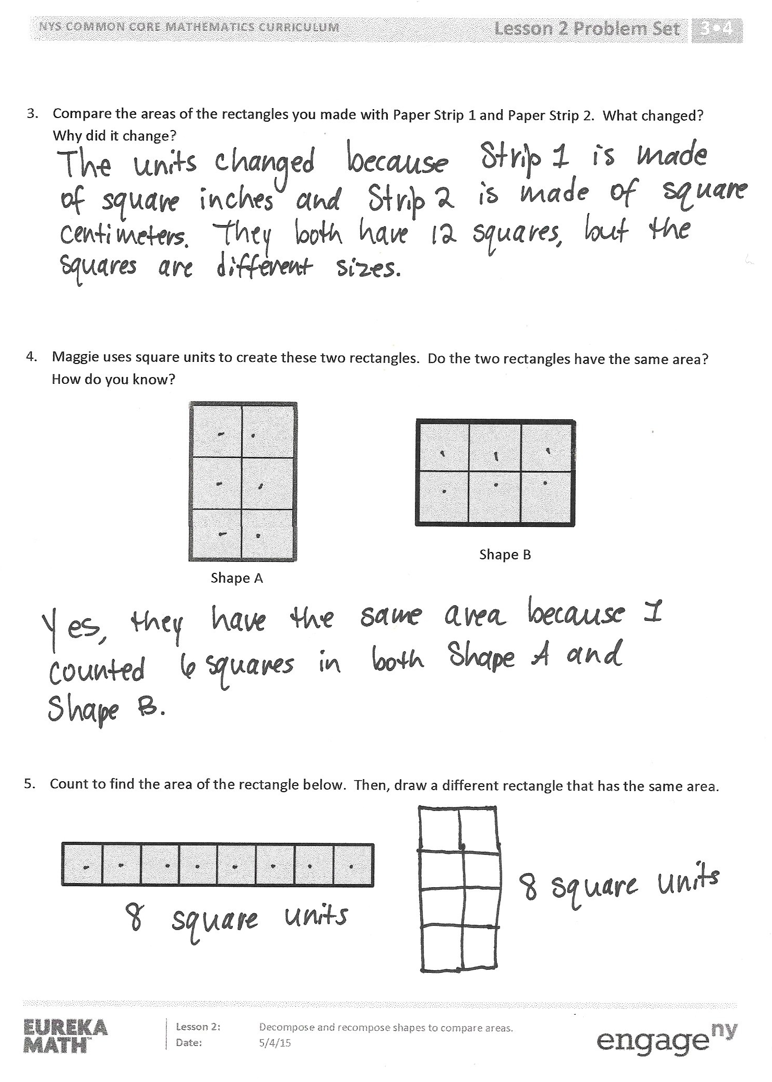Student Debrief (10 minutes)

**Lesson Objective:** Decompose and recompose shapes to compare areas.

The Student Debrief is intended to invite reflection and active processing of the total lesson experience.

Invite students to review their solutions for the Problem Set. They should check work by comparing answers with a partner before going over answers as a class. Look for misconceptions or misunderstandings that can be addressed in the Debrief. Guide students in a conversation to debrief the Problem Set and process the lesson.

Any combination of the questions below may be used to lead the discussion.

* Talk to a partner. What new units did we define today?
* Look at Problem 4. If Maggie uses square inches for Shape A and square centimeters for Shape B, which shape has a larger area? How do you know?
* Compare the shape you drew in Problem 5 to a partner’s. Are they the same? Do they have the same area? Why or why not?
* We started our lesson by using an inch ruler to break apart a rectangle into square inches. Turn and talk to a partner. Why was it important to break apart the rectangle into square inches?

Exit Ticket (3 minutes)

After the Student Debrief, instruct students to complete the Exit Ticket. A review of their work will help with assessing students’ understanding of the concepts that were presented in today’s lesson and planning more effectively for future lessons. The questions may be read aloud to the students.

Multiply.



[1]

Name Date

1. Use all of Paper Strip 1, which you cut into 12 square inches, to complete the chart below.

|  |  |  |
| --- | --- | --- |
|  | Drawing | Area |
| Rectangle A |  |  |
| Rectangle B |  |  |
| Rectangle C |  |  |

1. Use all of Paper Strip 2, which you cut into 12 square centimeters, to complete the chart below.

|  |  |  |
| --- | --- | --- |
|  | Drawing | Area |
| Rectangle A |  |  |
| Rectangle B |  |  |
| Rectangle C |  |  |

1. Compare the areas of the rectangles you made with Paper Strip 1 and Paper Strip 2. What changed? Why did it change?
2. Maggie uses square units to create these two rectangles. Do the two rectangles have the same area? How do you know?

Shape A

Shape B

1. Count to find the area of the rectangle below. Then, draw a different rectangle that has the same area.

Name Date

1. Each is a square unit. Find the area of the rectangle below. Then, draw a different rectangle with the same number of square units.

|  |  |  |  |  |  |  |  |
| --- | --- | --- | --- | --- | --- | --- | --- |
|  |  |  |  |  |  |  |  |
|  |  |  |  |  |  |  |  |

1. Zach creates a rectangle with an area of 6 square inches. Luke makes a rectangle with an area of   
   6 square centimeters. Do the two rectangles have the same area? Why or why not?

Name Date

1. Each is a square unit. Count to find the area of each rectangle. Then, circle all the rectangles with an area of 12 square units.

a. b. c.

|  |  |  |
| --- | --- | --- |
|  |  |  |
|  |  |  |
|  |  |  |

|  |  |  |  |  |  |
| --- | --- | --- | --- | --- | --- |
|  |  |  |  |  |  |
|  |  |  |  |  |  |

Area = _______ square units

Area = _______ square units

Area = _______ square units

Area = _______ square units

Area = _______ square units

Area = _______ square units

|  |  |  |  |  |  |
| --- | --- | --- | --- | --- | --- |
|  |  |  |  |  |  |
|  |  |  |  |  |  |

d.

f.

e.

1. Colin uses square units to create these rectangles. Do they have the same area? Explain.

1. Each is a square unit. Count to find the area of the rectangle below. Then, draw a different rectangle that has the same area.

1. multiply by 4 (6–10)