Lesson 1
Objective: Understand area as an attribute of plane figures.

Suggested Lesson Structure
 Fluency Practice (15 minutes)
 Application Problem (5 minutes)
 Concept Development (30 minutes)
 Student Debrief (10 minutes)
Total Time (60 minutes)
Fluency Practice (15 minutes)
- Group Counting 3.OA.1 (4 minutes)
- Identify the Shape 2.G.1 (3 minutes)
- Find the Common Products 3.OA.7 (8 minutes)
Group Counting (4 minutes)
Note: Group counting reviews interpreting multiplication as repeated addition.
Instruct students to count forward and backward, occasionally changing the direction of the count.
- Threes to 30
- Sixes to 60
- Sevens to 70
- Eights to 80
- Nines to 90
Identify the Shape (3 minutes)
Note: This fluency activity reviews properties and vocabulary that are used during today’s Concept Development.
T: (Project a triangle.) How many sides does this shape have?
S: 3.
T: Name the shape.
S: Triangle.
Continue with the following possible sequence: quadrilateral (trapezoid), quadrilateral (rhombus), quadrilateral (square), and quadrilateral (rectangle).
Find the Common Products (8 minutes)
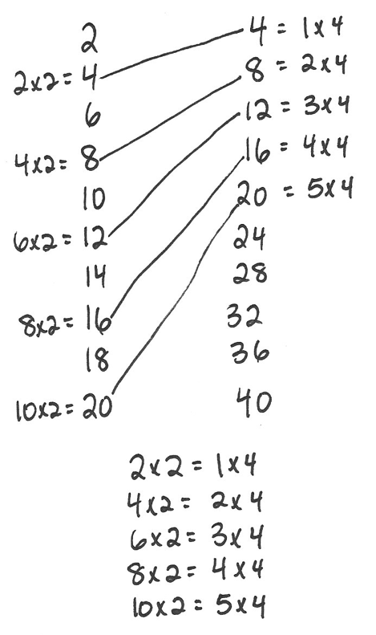
Materials: (S) Blank paper
Note: This fluency activity reviews multiplication patterns from
Module 3.
T: Fold your paper in half vertically. Unfold your paper.
On the left half, count by twos to 20 down the side of your paper. On the right half, count by fours to 40 down the side of your paper. Draw lines to match products that appear in both columns.
S: (Match 4, 8, 12, 16, and 20.)
T: (Write × 2 = 4, × 2 = 8, etc., next to each corresponding product on the left half of the paper.)
Write the complete equations next to their products.
S: (Write equations and complete unknowns.)
T: (Write 4 = × 4, 8 = × 4, etc., next to each corresponding product on the right half of the paper.)
Write the complete equations next to their products.
S: (Write equations.)
T: (Write 2 × 2 = × 4.) Say the equation, including all factors.
S: 2 × 2 = 1 × 4.
T: (Write 2 × 2 = 1 × 4.) Write the remaining equal facts as equations.
S: (Write 4 × 2 = 2 × 4, 6 × 2 = 3 × 4, 8 × 2 = 4 × 4, and 10 × 2 = 5 × 4.)
T: What patterns do you notice in your equations?
S: Each multiple of 4 is also a multiple of 2.
Application Problem (5 minutes)
Eric makes a shape with 8 trapezoid pattern blocks. Brock makes the same shape using triangle pattern blocks. It takes 3 triangles to make 1 trapezoid. How many triangle pattern blocks does Brock use?
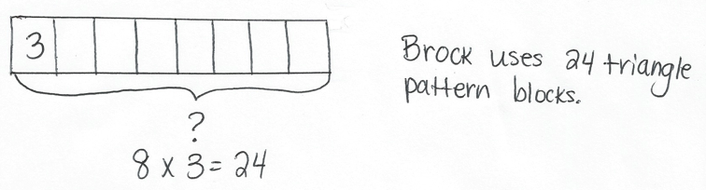
Note: This problem reviews the Module 3 concept of multiplying using units of 8.

Concept Development (30 minutes)

NOTES ON
MULTIPLE MEANS
OF ACTION AND EXPRESSION:
Manipulating pattern blocks may be a challenge for some learners. Try the following tips:
- Partner students so they can work together to cover the shapes.
- Encourage students to hold the pattern blocks in place with one hand, while they place the remaining blocks.
- Instead of using pattern blocks, provide paper shapes that can be glued, so they will not move around unnecessarily.
- Offer the computer as a resource to create and move shapes.

Materials: (S) Pattern blocks, Problem Set
Part 1: Use pattern blocks to understand area.
T: Look at Problem 1 on your Problem Set. Discuss with a partner whether you think Shape A or B takes up more space. Be prepared to explain your answer. (After students discuss, facilitate a whole class discussion.)
S: Shape A because it’s longer than Shape B. Shape B because it’s taller than Shape A.
T: Use triangle pattern blocks to cover Shapes A and B. Be sure the triangles do not have gaps between them, do not overlap, and do not go outside the sides of the shapes. (Allow time for students to work.) What did you notice about the number of triangles it takes to cover Shapes A and B?
S: It takes 6 triangles to cover each shape!
T: Answer Problem 1 on your Problem Set. (Allow time
for students to write answers.)
Do all the triangles you used to cover Shapes A and B take up the same amount of space?
S: Yes because they’re all the same size.
T: What does that mean about the amount of space taken up by Shapes A and B?
S: They are the same. It took 6 triangles to cover each shape, which means the shapes take up the same amount of space. The amount of space that Shape A takes up is equal to the amount of space taken up by Shape B.
T: The amount of flat space a shape takes up is called its area. Because Shapes A and B take up the same amount of space, their areas are equal.
Repeat the process of using pattern blocks to cover Shapes A and B with the rhombus and trapezoid pattern blocks. Students record their work on Problems 2 and 3 in the Problem Set.
T: What is the relationship between the size of the pattern blocks and the number of pattern blocks it requires to cover Shapes A and B?
S: The bigger the pattern block, the smaller the number of pattern blocks it requires to cover these shapes. The bigger pattern blocks, like the trapezoid, cover more area than the triangles. That means it takes fewer trapezoids to cover the same area as the triangles.
T: Answer Problem 4 on your Problem Set.

Part 2: Measure area using square units.

NOTES ON
MULTIPLE MEANS
OF ENGAGEMENT:
Students working above grade level can be encouraged to find other square units in the classroom that they can either use to make rectangles or that already form rectangles. Such items might include sticky notes, desktops, floor tiles, and linking cubes. Students can create a poster to share with the class that shows the areas of the rectangles made with these other square units.

T: Use square pattern blocks to cover the rectangle in Problem 5. Be sure the squares do not have gaps between them, do not overlap, and do not go outside the sides of the rectangle. (Allow students time to work.) How many squares did you need to cover the rectangle?
S: 6.
T: Answer Problem 5 on your Problem Set. (Allow time for students to write answers.) The area of the rectangle is 6 square units. Why do you think we call them square units?
S: Because they are squares! The units used to measure are squares, so they are square units!
T: Yes! The units used to measure the area of the rectangle are squares.
T: Use trapezoid pattern blocks to cover the rectangle in Problem 5. Be sure the trapezoids do not have gaps between them, do not overlap, and do not go outside the sides of the rectangle. (Allow students time to work.) What did you notice?
S: It’s not possible! The trapezoids cannot cover this shape without having gaps, overlapping, or going outside the lines.
T: Use this information to help you answer Problem 6 on your Problem Set. (Allow time for students to write answers.) I’m going to say an area in square units, and you are going to make a rectangle with your pattern blocks having that area. Which pattern blocks will you use?
S: The squares because the units for area that you are telling us are square units!
T: Here we go! Four square units.
S: (Make rectangles.)
Continue with the following possible sequence: 12 square units, 9 square units, and 8 square units. Invite students to compare their rectangles to a partner’s rectangles. How are they the same? How are they different? If time allows, students can work with a partner to create rectangles that have the same areas, but look different.
Student Debrief (10 minutes)
Lesson Objective: Understand area as an attribute of plane figures.
The Student Debrief is intended to invite reflection and active processing of the total lesson experience.
Invite students to review their solutions for the Problem Set. They should check work by comparing answers with a partner before going over answers as a class. Look for misconceptions or misunderstandings that can be addressed in the Debrief. Guide students in a conversation to debrief the Problem Set and process the lesson.
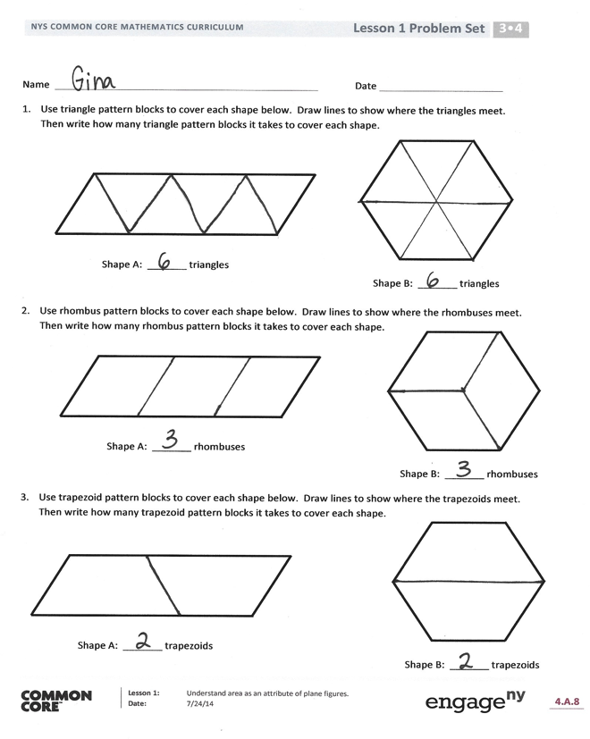
Any combination of the questions below may be used to lead the discussion.
- Talk to a partner. Do you think you can use square pattern blocks to cover Shapes A and B in Problem 1? Explain your answer.
- How many triangle pattern blocks does it take to cover a rhombus pattern block? Use that information to say a division fact that relates the number of triangles it takes to cover Shape A to the number of rhombuses it takes to cover the same shape. (6 ÷ 2 = 3.)
- Explain to a partner how you used square pattern blocks to find the area of the rectangle in Problem 5.
- What new math vocabulary did we use today to communicate precisely about the amount of space taken up by a shape? (Area.) Which units did we use to measure area? (Square units.)
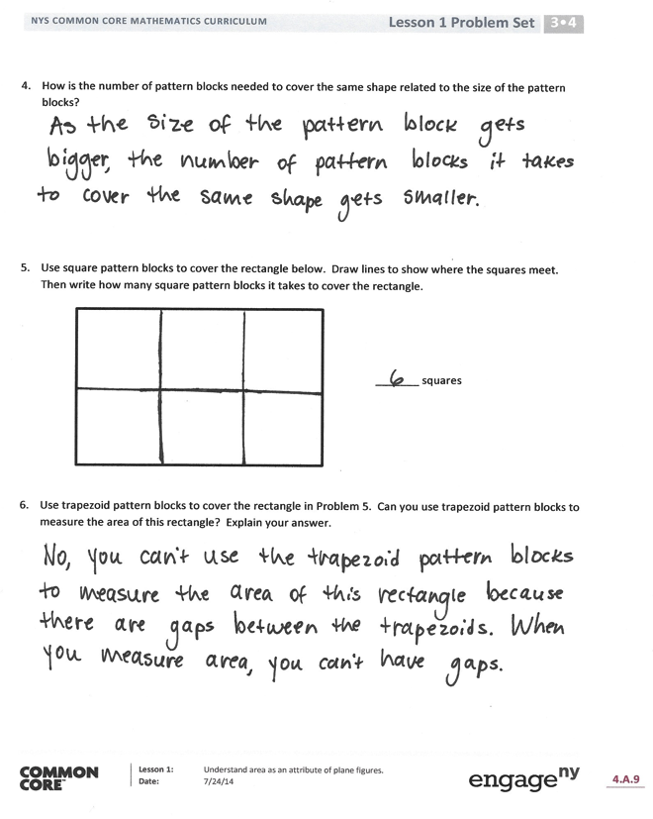
- How did the Application Problem connect to today’s lesson?
Exit Ticket (3 minutes)
After the Student Debrief, instruct students to complete the Exit Ticket. A review of their work will help with assessing students’ understanding of the concepts that were presented in today’s lesson and planning more effectively for future lessons. The questions may be read aloud to the students.

Name Date
- Use triangle pattern blocks to cover each shape below. Draw lines to show where the triangles meet. Then, write how many triangle pattern blocks it takes to cover each shape.
Shape B: _______ triangles

Shape A: _______ triangles

- Use rhombus pattern blocks to cover each shape below. Draw lines to show where the rhombuses meet. Then, write how many rhombus pattern blocks it takes to cover each shape.
Shape B: _______ rhombuses
Shape A: _______ rhombuses

- Use trapezoid pattern blocks to cover each shape below. Draw lines to show where the trapezoids meet. Then, write how many trapezoid pattern blocks it requires to cover each shape.
Shape B: _______ trapezoids

Shape A: _______ trapezoids

- How is the number of pattern blocks needed to cover the same shape related to the size of the pattern blocks?

- Use square pattern blocks to cover the rectangle below. Draw lines to show where the squares meet. Then, write how many square pattern blocks it requires to cover the rectangle.

_______ squares

- Use trapezoid pattern blocks to cover the rectangle in Problem 5. Can you use trapezoid pattern blocks to measure the area of this rectangle? Explain your answer.

Name Date

Each is 1 square unit. Do both rectangles have the same area? Explain how you know.

Name Date
- Magnus covers the same shape with triangles, rhombuses, and trapezoids.
  - How many triangles will it take to cover the shape?

_______ triangles

  - How many rhombuses will it take to cover the shape?

_______ rhombuses

  - Magnus notices that 3 triangles from Part (a) cover 1 trapezoid. How many trapezoids will you need to cover the shape below? Explain your answer.

_______ trapezoids

- Angela uses squares to find the area of a rectangle. Her work is shown below.
  - How many squares did she use to cover the rectangle?

_______ squares

  - What is the area of the rectangle in square units? Explain how you found your answer.

- Each is 1 square unit. Which rectangle has the largest area? How do you know?

Rectangle B

Rectangle A

Rectangle C

