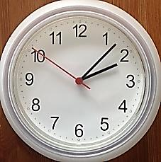
Name Date
Fatima leaves home.
- Fatima runs errands.
- The clock to the right shows what time she leaves home. What time does she leave?

- It takes Fatima 17 minutes to go from her home to the market. Use the number line below to show what time she gets to the market.
3:00 p.m.
2:00 p.m.
60
50
40
30
20
10
0

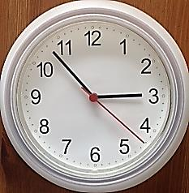
Fatima leaves the market.
- The clock to the right shows what time Fatima leaves the market. What time does she leave the market?

- How long does Fatima spend at the market?

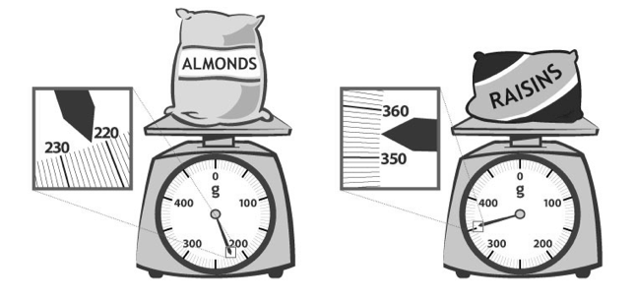
- At the market, Fatima uses a scale to weigh a bag of almonds and a bag of raisins, shown below. What is the total weight of the almonds and raisins?

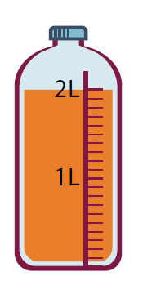
- The amount of juice in 1 bottle is shown to the right. Fatima needs 18 liters for a party. Draw and label a tape diagram to find how many bottles of juice she should buy.

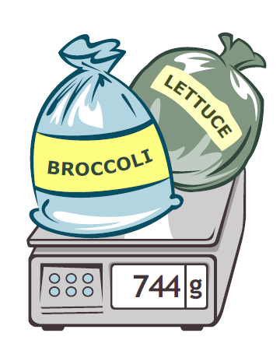
- Altogether, Fatima’s lettuce, broccoli, and peas weigh 968 grams. The total weight of her lettuce and broccoli is shown to the right. Write and solve a number sentence to find how much the peas weigh.

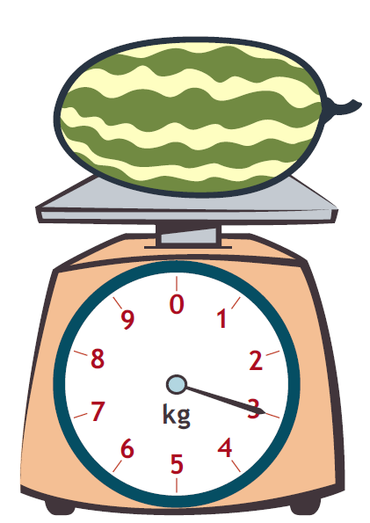
- Fatima weighs a watermelon, shown to the right.
  - How much does the watermelon weigh?

b. Leaving the store Fatima thinks, “Each bag of groceries seems as heavy as a watermelon!” Use Fatima’s idea about the weight of the watermelon to estimate the total weight of 7 bags.

c. The grocer helps carry about 9 kilograms. Fatima carries the rest. Estimate how many kilograms of groceries Fatima carries.

- It takes Fatima 12 minutes to drive to the bank after she leaves the store and then 34 more minutes to drive home. How many minutes does Fatima drive after she leaves the store?

Mid-Module Assessment Task  Standards Addressed | Topics A–B
Use place value understanding and properties of operations to perform multi-digit arithmetic. (A range of algorithms may be used.)
3.NBT.2 Fluently add and subtract within 1000 using strategies and algorithms based on place value, properties of operations, and/or the relationship between addition and subtraction.
Solve problems involving measurement and estimation of intervals of time, liquid volumes, and masses of objects.
3.MD.1 Tell and write time to the nearest minute and measure time intervals in minutes. Solve word problems involving addition and subtraction of time intervals in minutes, e.g., by representing the problem on a number line diagram.
3.MD.2 Measure and estimate liquid volumes and masses of objects using standard units of grams (g), kilograms (kg), and liters (l). (Excludes compound units such as cm³ and finding the geometric volume of a container.) Add, subtract, multiply, or divide to solve one-step word problems involving masses or volumes that are given in the same units, e.g., by using drawings (such as a beaker with a measurement scale) to represent the problem. (Excludes multiplicative comparison problems, i.e., problems involving notions of “times as many”; see CCLS Glossary, Table 2.)

Evaluating Student Learning Outcomes
A Progression Toward Mastery is provided to describe steps that illuminate the gradually increasing understandings that students develop on their way to proficiency. In this chart, this progress is presented from left (Step 1) to right (Step 4). The learning goal for students is to achieve Step 4 mastery. These steps are meant to help teachers and students identify and celebrate what the students CAN do now and what they need to work on next.

A Progression Toward Mastery
Assessment  Task Item | STEP 1  Little evidence of reasoning without a correct answer.  (1 Point) | STEP 2  Evidence of some reasoning without a correct answer.  (2 Points) | STEP 3  Evidence of some reasoning with a correct answer or evidence of solid reasoning with an incorrect answer.  (3 Points) | STEP 4  Evidence of solid reasoning with a correct answer.  (4 Points)
1  3.MD.1 | Student gives an incorrect answer. Attempt shows student may not understand the meaning of the questions. | Student gives an incorrect answer with a reasonable attempt:  - Accurately reads the clocks.  - Attempts to use a number line.  - Attempts to calculate Part (d). | Student gives a partially correct answer:  - Accurately reads clocks.  - Attempts to use a number line.  - Accurately calculates Part (d). | Student correctly answers each part of the question:  - Reads 2:07 on the clock.  - Draws a number line to show 2:24.  - Reads 2:53 on the clock.  - Calculates 29 minutes.
2  3.NBT.2  3.MD.2 | Student gives an incorrect answer. Attempt shows the student may not understand the meaning of the question. | Student gives an incorrect answer with a reasonable attempt. Student may misread one scale. | Student gives a partially correct answer:  - Accurately reads the scales.  - Writes the addition equation correctly. | Student correctly answers the question:  - Accurately reads scales,  almonds = 223 g, raisins = 355 g.  - Writes the addition expression  223 + 355.  - Solves with 578 g.
3  3.MD.2 | Student gives an incorrect answer. Attempt shows the student may not understand the meaning of the question. | Student gives an incorrect answer with a reasonable attempt:  - Accurately reads bottle at 2 liters.  - Attempts to calculate bottles. | Student gives a partially correct answer:  - Accurately reads bottle.  - Calculates 9 bottles. | Student correctly answers the question:  - Accurately reads bottle.  - Draws and labels tape diagram.  - Calculates 9 bottles.
4  3.MD.2  3.NBT.2 | Student gives an incorrect answer. Attempt shows the student may not understand the meaning of the question. | Student gives an incorrect answer, reasonable attempt:  - Accurately reads scale at 744 g.  - Attempts to solve. | Student gives a partially correct answer:  - Accurately reads scale at 744 g.  - Solves with 224 g. | Student correctly answers the question:  - Accurately reads scale at 744 g.  - Writes a number sentence to calculate the weight of the peas, 224 g. Possible number sentence: 968 – 744 = 224.
5  3.NBT.2  3.MD.1  3.MD.2 | Student gives an incorrect answer. Attempt shows the student may not understand the meaning of the questions. | Student gives an incorrect answer with a reasonable attempt. Student misreads scale but calculates other parts of the problem correctly based on mistake. | Student gives a partially correct answer. All parts are correct besides Part (c), which may not be correctly calculated. | Student correctly answers each part of the question:  - Accurately reads scale at 3 kg.  - Estimates 21 kg.  - Estimates 12 kg.  - Calculates 46 minutes.

